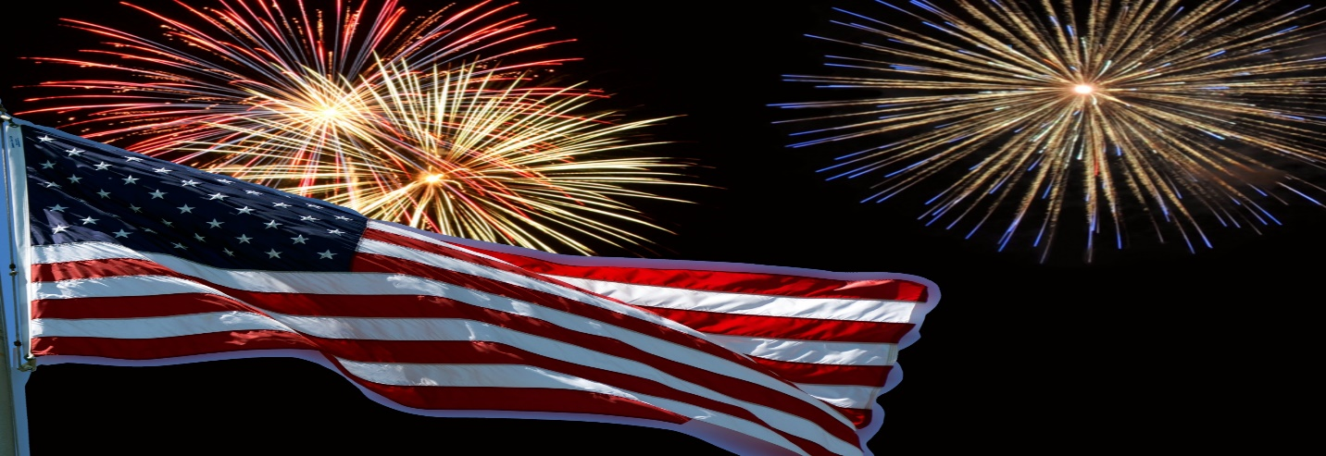

**COMMUNITY CELEBRATION**

**Sunday, September 4, 2022**

**FIREWORKS SPONSORSHIPS**

**YES!!!! We want to help with our community’s celebration!**

**$2000 Grand Finale Sponsorship**

Listed as a major sponsor in all publicity, including:

➢ The event poster

➢ Acknowledgement on the organizer’s website & social networking

➢ Mentions during the event

➢ Banner listing sponsors at event



➢ Thank you in the Press Republican, Sun Community News, and Jay Community News prior to event

**$1000 Roman Candle Sponsorship**

Listed as a major sponsor on:

➢ The event poster

➢ Acknowledgement on organizers’ website & social networking

➢ Mentions during the event

➢ Invited to have a representative present at the parade podium

➢ Banner listing sponsors at event

**$500 Firecracker Sponsorship**

➢ The event poster

➢ Listed on the organizers’ website & social networking

➢ Mentions during the event

➢ Banner listing sponsors at event

➢ Thank you in Press Republican, Sun Community News, and Jay Community News prior to event

**$250 Bottle Rocket Sponsorship**

➢ The event poster

➢ Listed on the organizers’ website & social networking

➢ Mentions during the event

➢ Banner listing sponsors at event

________________________________________ ____________________________________________

**Name of Business Contact Name**

________________________________________ ____________________________________________

**Address Contact Number**

**Please email your logo to blackbrooksupervisor@yahoo.com for all publicity purposes. JPEG or PDF**

**Please return this form by Monday, August 1st to: Town of Black Brook, PO Box 715, Au Sable Forks, NY 12912**

**Make Checks Payable to: Town of Black Brook**