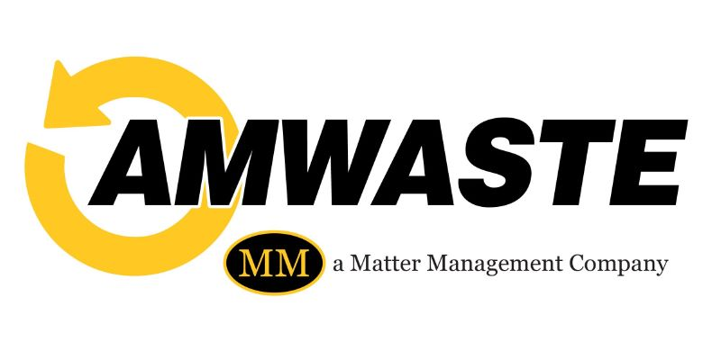

Dear Jefferson County Resident:
The fuel pricing index impact for the upcoming quarterly invoicing will be as follows:
Service | Prior Quarterly Rate | New Quarterly Rate
Single Family Residential | $71.27 | $66.66
Single Family with Yard Waste | $92.64 | $86.64
Back-Door Service (non-disabled) | $104.46 | $99.85
Back-Door Service (non-disabled) with Yard Waste | $125.83 | $19.83
Back-Door Service (disabled) | $71.27 | $66.66
Additional Cart (No Change) | $49.79 | $49.79
Backdoor (non-disabled) $33.19 $33.19
Quarterly adjustments will be made based on the published fuel pricing index for our area as calculated by Jefferson County.

We continue to be committed to providing a clean and healthy community for all Jefferson County residents. We sincerely appreciate your business and understanding during these trying times.

