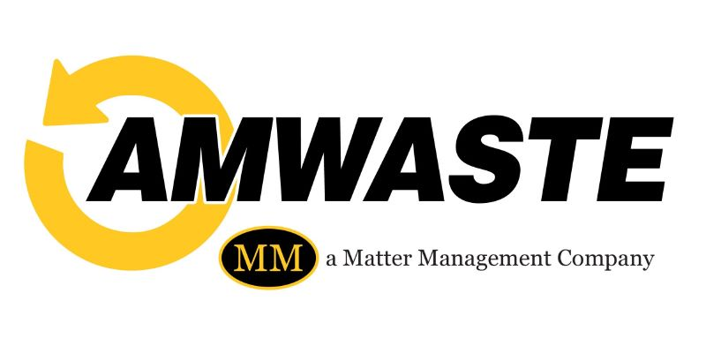

Dear Jefferson County Resident:
The fuel pricing index impact for the upcoming quarterly invoicing will be as follows:
Service | Prior Quarterly Rate | New Quarterly Rate
Single Family Residential | $70.29 | $71.27
Single Family with Yard Waste | $91.35 | $92.64
Back-Door Service (non-disabled) | $101.34 | $104.46
Back-Door Service (non-disabled) with Yard Waste | $122.40 | $125.83
Back-Door Service (disabled) | $70.29 | $71.27
Additional Cart (No Change) | $46.57 | $49.79
Backdoor (non-disabled) $31.05 $33.19
Quarterly adjustments will be made based on the published fuel pricing index for our area as calculated by Jefferson County.

We continue to be committed to providing a clean and healthy community for all Jefferson County residents. We sincerely appreciate your business and understanding during these trying times.

