MINUTES
March 21, 2019 • City of Edgewood
McGinnty’s Irish Pub ● 5406 Hansel Ave ● Orlando, FL 32809

The Tri-County League of Cities met Thursday, March 21, 2019, at McGinnty’s Irish Pub in Orlando, FL. Tri-County 2nd Vice President, Commissioner Geoff Kendrick, called the meeting to order at 12:05 p.m. Commissioner Kendrick acknowledged the sudden passing of Mayor Bagshaw and announced that part of the meeting would be dedicated to Mayor Bagshaw’s memory.

The Color Guard presented the colors for the Pledge of Allegiance. Rob Garrett of Discovery Church led the invocation.

Edgewood Acting Mayor, John Dowless, welcomed everyone to the meeting. He shared memories of Mayor Ray Bagshaw, his service to the community, his vision for the city, and the tireless dedication of Ray and his wife. Acting Mayor Dowless thanked everyone for their support during this time. He also acknowledged Edgewood City Attorney Drew Smith, City Clerk Bea Meeks, and Commissioner Alan Horne, who were in attendance. Acting Mayor John Dowless thanked the generosity of sponsors: Shepard, Smith, Kohlmyer & Hand, P.A., CPH Engineering and Jose Boscan of Waste Management. Mr. Boscan also spoke briefly in memory of Mayor Bagshaw.

2nd Vice President Kendrick asked attendees to do self-introductions. Lunch was served.

Approval of the Minutes
2nd Vice President Kendrick asked for a motion to approve the meeting minutes from the last membership meeting on February 21, 2019. A motion was made and seconded to approve the minutes. The motion passed unanimously.

Program

Past President Rosemary Wilsen introduced guest speaker Kathy Till, Tri-County League’s legislative advocacy consultant. Ms. Till highlighted some advocacy strategies when communicating with legislators. Ms. Till also gave a quick update on the bills in the House and Senate that were of most concern and interest to cities, and that aligned with the Florida League of Cities priorities, including: CRAs, Communication Service Tax, Water Quality, Short Term Rentals, and unfunded mandates.

2nd Vice President Kendrick thanked Ms. Till for her attendance, informative legislative update, and helpful advocacy strategies.

Special Recognition
2nd Vice President Kendrick offered time for members to speak of their memories of Mayor Bagshaw. Several members made public comments, and many left memory cards and words of encouragement for Ray’s family and his Edgewood family. Edgewood City Clerk, Bea Meeks, extended her gratitude for the support of the Tri-County League of Cities during this difficult time.

Announcements
2nd Vice President Kendrick announced the upcoming Tri-County League meetings on April 21, 2019 in the City of Longwood, and May 9, 2019 in the City of Casselberry, with the four-hour Ethics workshop following the May meeting. He also discussed Florida League of Cities Legislative Action Days, and encouraged members to join the FLC’s Legislative Call-Ins on Mondays at 9 am.

Adjournment
2nd Vice President Kendrick thanked everyone for their attendance and adjourned the meeting at 1:07 p.m.

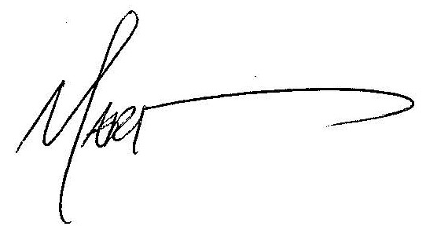

Karen Allen

Mari Rains, Executive Director Karen Allen, Institute of Government

