MINUTES
April 18, 2019 • City of Longwood
Longwood Community Building ● 200 West Warren Ave ● Longwood, FL 32750

The Tri-County League of Cities met Thursday, April 18, 2019, at the Longwood Community Building in Longwood, FL. Tri-County President, Pat Bates, called the meeting to order at 12:09 p.m.

President Bates introduced Longwood Mayor, Ben Paris who welcomed everyone to the meeting and thanked Iberia Bank for sponsoring the luncheon. He then conducted the Pledge of Allegiance and invocation.

President Bates asked attendees to do self-introductions. Lunch was served.

Approval of the Minutes
President Bates asked for a motion to approve the meeting minutes from the last membership meeting on March 21, 2019. A motion was made and seconded to approve the minutes. The motion passed unanimously.

Special Recognition
President Bates called the Board of Directors to the podium. Past President, Donny Shroyer and his wife, Darla were called forward. On behalf of the board and membership, Past President Shroyer was presented with his gavels from his time of service as President. Darla Shroyer was given flowers and thanked for her support. Past President Shroyer spoke of his honor in service to the League.

Program

2nd Vice President Geoff Kendrick introduced guest speaker, Florida League of Cities President, Leo E. Longworth, Mayor of the City of Bartow.

FLOC President Longworth spoke about his commitment to local decision making. He reiterated that citizens are best served by local leaders who can create a custom solution for local issues. He acknowledged that some decisions are appropriate for the state legislature such as roadways, uniform education requirements and statutes dealing with crime, but that one size does not fit all when dealing with CRSs, local zoning issues, and vacation rentals where citizens can best communicate directly with local officials. His initiative “We Live Local” is designed to educate Florida Citizens on Home Rule and that if he reaches only 1% of the population, that is 200 thousand people who can serves as advocates for local decision making.

2nd Vice President Kendrick thanked President Longworth for his attendance and Executive Director, Mari Rains played three videos supporting local decision making and Home Rule.

Announcements
President Bates asked Executive Director, Mari Rains to come forward to make announcements. Director Rains announced the upcoming Tri-County League meetings on May 9, 2019 in the City of Casselberry and reminded everyone that the meeting would be followed by the required 4 hour ethics training which requires a separate registration. Director Rains reminded everyone that there are no summer meetings but that the Florida League of Cities conference is in Orlando, August 14-17, 2019 and encouraged members to attend.

Director Rains also encouraged members to apply to serve on the 2019-2020 FLC Policy Committees by the May 6, 2019 deadline.

Adjournment
President Bates thanked everyone for their attendance and adjourned the meeting at 1:08 p.m.

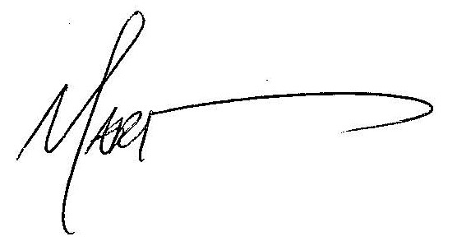

Karen Allen

Mari Rains, Executive Director Karen Allen, Institute of Government

