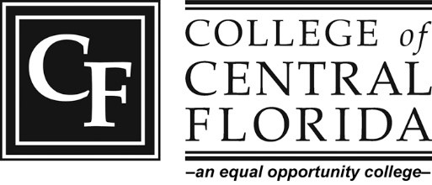
CF CITRUS STUDENT AMBASSADOR
LEADERSHIP PROGRAM
2023-2024

Scholarship Program Description: The CF Ambassadors are a team of students dedicated to promoting the college by sharing their personal testimonials to prospective and currently enrolled students. Ambassadors participate in presentations and events on and off campus. Ambassadors are responsible for giving campus tours to students interested in attending CF. They will mentor fellow CF students as well as host information sessions, workshops and seminars.

Our Mission Statement: As College of Central Florida Ambassadors, we strive to create a positive image of the college through student outreach and service. As role models, we lead by example, and convey integrity, compassion, professionalism and academic excellence. We demonstrate ambition and provide encouragement and direction to current and future CF students.

Eligibility
- Must be nominated by a CF faculty member or high school counselor
- Must have a 3.0 GPA
- Must complete a CF Ambassador Application
- Must have two letters of recommendation
- Must be able to prepare a 3-5-minute presentation or speech used to recruit potential students if selected for interview

Requirements
- Must maintain a 3.0 GPA during studies at CF
- Must attend required training and meetings
- Should have reliable transportation
- Must have flexible hours for tours and events
- Must be available one hour per week for weekly meeting
- Must be available one hour per week for office hour

Benefits
- Paid tuition scholarship (in-state rate, up to $800 each semester)
- Leadership, teamwork, communication and time management skills enhancement
- Resume builder
- Great way to meet other students, CF faculty and staff

Ambassadors will receive a CF Ambassador polo shirt and blazer to wear with required khaki pants and/or skirts to events, speaking engagements and when giving tours. Ambassadors will need to build their schedule with the Admissions & School Relations Specialist Regional Campuses, allowing time for tours and events throughout the academic year. Ambassadors will help prepare for events and campus visits, give presentations to prospective students, give tours, attend meetings and workshops, and assist with special events and receptions hosted by the president of the college. Additionally, ambassadors will be given the opportunity to participate in recruiting activities on and off campus and will be available to serve as mentors to students.

Selection Process: All applicants must be nominated and application packets must be turned in to the Admissions & School Relations Specialist Regional Campuses for review by Monday, May 1. Qualified applicants will interview before a selection committee and, if advanced, will need to prepare a five-minute presentation for the final interview.

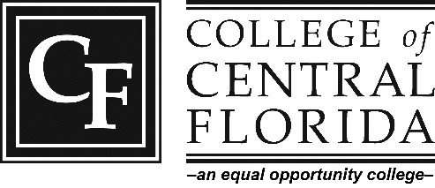
CF CITRUS AMBASSADOR APPLICATION

Application Packet: DUE Monday, May 1.
- CF Ambassador Application
- Two letters of recommendation
- Transcripts

Please see page 1 for the program description. Type or write legibly and return both pages of the application to Becca York-Alcorn, College of Central Florida, Admissions & School Relations Specialist, Charles S. Dean Sr. Educational Center, 3800 S. Lecanto Highway, Lecanto, FL 34461-9026 (yorkr@cf.edu); 352-746-6721, ext. 6181). Qualified applicants will be contacted to schedule an interview.

Student ID No.:
Legal Name:

Last First Middle (complete) Jr., etc.
Mailing
Address: Street/P.O. Box City State Zip Code
Telephone No.: GPA:
Year at CF: Freshman Sophomore Other (Credit Hours)

Please attach a letter of recommendation for each reference provided (minimum 2).
- ______________________________________________________________________________________________
- ______________________________________________________________________________________________
- ______________________________________________________________________________________________ Name Title Telephone Number

In the space provided below, please write legibly your answers to the following:
Please list reasons why you would like to be an ambassador and why you would be the best person for this position. (3-5 sentences)

Please describe your experiences that relate to any of the activities listed in the program description.

Please list your ideas for promoting CF throughout the community.

Please give a brief description of work or other obligations that you are currently involved in and describe how you balance and manage your time.

Will you have reliable transportation for off
-
campus events?

Yes

No

This leadership program is a FULL COMMITMENT for the fall 2022 and spring 2023 semesters. Up to $800 in tuition scholarship money will be awarded per semester to each ambassador chosen.

If selected, the student must attend the training session and have a flexible schedule. Leadership opportunities include monthly meetings, campus tours, preparation for events, opportunities to host and/or speak at various CF events on and off campus, meetings at high school campuses and workshops.

Please attach your unofficial transcripts of part as your application packet.

