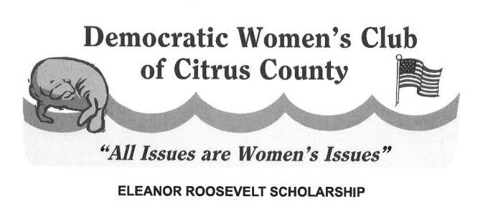
Democratic Women’s Club of Citrus County
Eleanor Roosevelt Scholarship
SCHOLARSHIP APPLICATION- $1,000.00 scholarships (2)
DUE: MARCH 15, 2023
SUBMIT TO:
The Democratic Women’s Club of Citrus County
P.O. Box 1902
Inverness, Florida 34450

ABOUT ELEANOR ROOSEVELT
Anna Eleanor Roosevelt was an American political figure, diplomat, and activist. She served as the first lady of the United States from 1933 to 1945, during her husband Franklin D. Roosevelt’s four terms in office, making her the longest serving first lady of the United States. Eleanor pressed the United States to join and support the United Nations and became its first delegate. She served as the first chair of the UN Commission on Human Rights and oversaw the drafting of the Universal Declaration of Human Rights. Later, she chaired the John F. Kennedy administration’s Presidential Commission on the Status of Women. By the time of her death at the age of 78 in 1962, Eleanor was regarded as one of the most esteemed women in the world.

SCHOLARSHIP INFORMATION

Two scholarships will be awarded to female students of Citrus County who attend any Citrus County Public High School and who embody a team spirit with regard to community activities. Scholarships may vary each year depending upon the availability of funds and the number of qualified applicants. In 2023, each scholarship is $1,000.00. One will be awarded to a graduating senior planning to attend a four year college or university. The second will be awarded to a graduating senior planning to attend a community college or technical/vocational school.

REQUIREMENTS OVERVIEW
Applicants must submit a package consisting of a resume, three letters of recommendation, an official transcript, and an essay as outlined hence. Applicants must be registered or pre-registered to vote.

DUE DATE
Applications must be received in full no later than March 15, 2023. Send the completed application package to:
The Democratic Women’s Club of Citrus County
P.O. Box 1902
Inverness, Florida 34450

REQUIREMENTS
- Applicants must be female graduating seniors at Crystal River High School, Lecanto High School, Citrus High School, the Academy of Environmental Sciences, or Withlacoochee Technical School. They must be planning to attend a college, university, community college, or technical school in the Fall of 2022. They must be registered or pre-registered to vote.
- Applicants must submit a resume containing the following information:
  - Name
  - Address
  - Email Address
  - Phone number (both home and cell)
  - Weighted GPA, signed off by school counselor (minimum 3.5 for those attending a four-year college or university and 3.0 for those attending a community college, technical or vocational school)
  - Extracurricular Activities
  - Community Service
  - Honors and Awards
  - Work Experience
  - Proposed college major or course of study
  - Schools you have been accepted to or have applied to
- Applicants must submit three (3) letters of recommendation. At least one must be written by a professional from the applicant’s high school. None may be from a family member.
- Applicants must submit an official school transcript including first semester senior year grades.
- Applicants must submit an original essay not exceeding 500 words on the following topic: Why Eleanor Roosevelt is someone I admire and how her life has influenced my life and my future plans.
ACKNOWLEDGEMENT
By applying to this scholarship, you consent for your name and photo to be used in print publications and social media as deemed appropriate by the DWCCC if you are chosen as the recipient.
For further information, please contact JoAnn Messina at jmessina@tampabay.rr.com.
“You must do the thing you think you cannot do.” – Eleanor Roosevelt

