Rainbow Springs Art Scholarship
SCHOLARSHIP APPLICATION FOR THE AMOUNT OF $1000
For Senior High School Students 2021-2022
DUE DATE: April 15, 2022
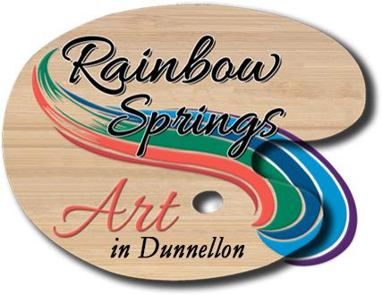

SEND TO:
Rainbow Springs Art in Dunnellon
20804 W Pennsylvania Ave Dunnellon 34431
352-445-8547
Email: rsacoop2016@gmail.com

INFORMATION AND REQUIREMENTS
- Rainbow Springs Art in Dunnellon supports our young artists, especially as they graduate from high school and consider extending their studies in the Arts. RSA will award a $1000 scholarship to eligible High School Seniors pursuing a degree in an art venue. Categories include music, theatre, interior design, dance, computerized art design, sculpture, painting, woodwork, and graphic arts. However, any type of artistic category will be considered
- The funds awarded are to be used for an accredited college, university, community college or technical school. Funds will be issued to the school of choice in the name of the applicant and not to the applicant as an individual.
- A short essay of five hundred words or less on “What are your goals for your artistic career in the next five years?”, must be attached to the application. A video clip can be substituted for a written essay.
- Two photographs of two different pieces of the applicant’s Artwork or two video clips of two different performances within the past two years must accompany the application.
- Videos can be emailed or delivered on a USB/thumb drive, or SD card to Rainbow Springs Art Gallery in Dunnellon. These will be returned.
- Deadline for applications is April 15, 2022. The scholarships will be awarded in May 2022, date to be determined.
- Any questions can be emailed to: rsacoop2016@gmail.com . Attention Donna.
- We look forward to receiving your application. Submissions can be mailed to Rainbow Springs Art in Dunnellon, 20804 W Pennsylvania Ave. Dunnellon 34431.

PERSONAL INFORMATION
ITEM | INFORMATION
NAME
ADDRESS
EMAIL
TELEPHONE NUMBER
CURRENT HIGH SCHOOL
NAME AND ADDRESS OF THE SCHOOL YOU ARE ATTENDING AFTER HIGH SCHOOL GRADUATION

On which type of Art do you plan to focus your education?

ATTACHMENTS

- LETTER OF RECOMMENDATION: Please attach a letter of recommendation from your art teacher or guidance counselor.
- ESSAY OR VIDEO FROM APPLICANT: Please attach an essay of five hundred words or less (or video clip) on the topic: “What are your goals for your artistic career in the next five years?”
- YOUR ARTWORK: Please provide two photographs of two different pieces of your Artwork or two video clips of two different performances. All work must be no older than 2 years.
- ACCEPTANCE LETTER: Please provide a copy of your acceptance letter from the school you will be attending.

INSTRUCTIONS

All above materials need to be submitted to Rainbow Springs Art, c/o Donna, 20804 West Pennsylvania Ave, Dunnellon, FL, 34431, no later than April 15, 2022. Video clips can be sent to RSACOOP2016@gmail.com. Please put “Scholarship/Donna” on subject line.
Please note, if you are selected, the check will be made out to you and the school. It must be given to the school for you education needs.

Applicant’s Signature: | Date:
☐ I understand that checking (clicking) this box constitutes a legal signature confirming that I acknowledge and warrant the truthfulness of the information provided in this document.

