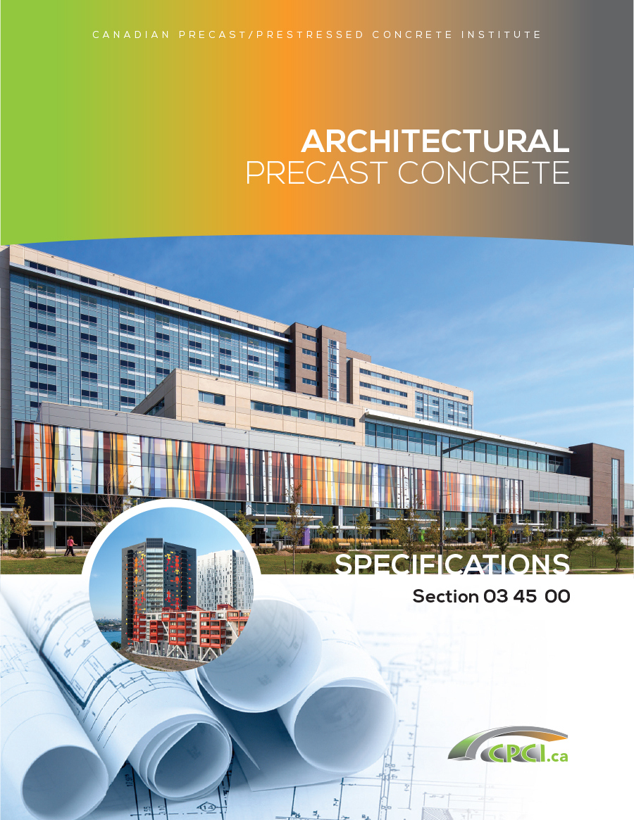
Part 1 General

1.1 SECTION INCLUDES

.1 Architectural precast concrete elements

.2 Supports, anchors and attachments

.3 [Perimeter and] intermediate joint seals [and firestops if required].

.4 [Grouting under panels if required.]

1.2 RELATED SECTIONS

.1 Section 03 30 00 - Cast-in-Place Concrete: Building structural frame.

.2 Section 03 38 00 - Post Tensioned Concrete: Building structural frame

.3 Section 03 41 00 - Structural Precast Concrete: Building structural frame.

.4 Section 03 47 13 - Site Cast Tilt-up Concrete: Building structural frame.

.5 Section 05 12 00 - Structural Steel: Building structural frame.

.6 Section 03 41 13 – Precast Concrete Hollow Core Planks: Building structural floor system.

.7 Section [_____- _____]: Supporting masonry.

.8 Section [_____- _____]: Metal flashings to fit recessed reglets in precast components.

.9 Section [_____- _____]: Surface reglets and metal flashings attached to precast components.

.10 Section 07 84 00 - Firestopping: [[Fire] [Smoke] barrier] [Air] seal between precast unit and edge of floor slab.

.11 Section 07 90 00 - Joint Sealants: Perimeter joints with sealant and backing.

.12 Section [_____- _____]: Windows [and glass] site installed in precast components.

.13 Section [_____- _____]: Placement of anchors for [embedding into] [placing in] [welding to] building structural components.

.14 Section [_____- _____]: Window units [and glass] for placement by this section.

.15 Section [_____- _____]: Flashing reglets for placement by this section.
1.3 REFERENCES

.1 ASTM A123/A123M-17 - Zinc (Hot-Dip Galvanized) Coatings on Iron and Steel Products.

.2 ASTM A153/A153M-16a - Zinc (Hot-Dip) on Iron and Steel Hardware.

.3 ASTM A307-14e1 - Standard Specification for Carbon Steel Bolts, Studs, and Threaded Rod 60000 PSI Tensile Strength.

.4 ASTM A416/A416M-18 - Steel Strand, Uncoated Seven-Wire for Prestressed Concrete.

.5 ASTM A421/A421M-15 – Stress-Relieved Steel Wire for Prestressed Concrete

.6 ASTM A555/A555M-16 - General Requirements for Stainless Steel and Wire Rods.

.7 ASTM A666-15 - Annealed or Cold-Worked Austenitic Stainless Steel Sheet, Strip, Plate, and Flat Bar.

.8 ASTM A775/A775M-19 - Epoxy-Coated Reinforcing Steel Bars.

.9 ASTM A1064/A1064M-18a - Carbon-Steel Wire and Welded Wire Reinforcement, Plain and Deformed, for Concrete.

.10 ASTM C260/C260M-10a (2016) - Air-Entraining Admixtures for Concrete

.11 ASTM C494/C494M-17 - Chemical Admixtures for Concrete.

.12 ASTM C881/C881M-15 - Epoxy-Resin-Base Bonding Systems for Concrete.

.13 ASTM D2240-15e1 - Test Method for Rubber Property - Durometer Hardness.

.14 ASTM F3125/F3125M-18 - High Strength Structural Bolts, Steel and Alloy Steel, Heat Treated, 120 ksi (830 MPa) and 150 ksi (1040 MPa) Minimum Tensile Strength, Inch and Metric Dimensions.

.15 CSA-A23.1-19/A23.2-19 - Concrete Materials and Methods of Concrete Construction / Methods of Test for Concrete.

.16 CSA-A3000-18 - Cementitious Materials Compendium.

.17 CSA-G30.18-09 (R2019) - Carbon steel bars for concrete reinforcement

.18 G40.20-13/G40.21-13 (R2018) - General Requirements for Rolled or Welded Structural Quality Steel /Structural Quality Steel.

.19 CSA-A23.3-19 - Design of Concrete Structures.

.20 CSA-A23.4-16 - Precast Concrete - Materials and Construction.

.21 CISC/CPMA Standard 2-75 - Quick-drying Primer for Use on Structural Steel

.22 CSA-W47.1-19 - Certification of Companies for Fusion Welding of Steel.

.23 CSA-W59-18 - Welded Steel Construction (Metal Arc Welding).

.24 CSA-W186-M1990 (R2016) - Welding of Reinforcing Bars in Reinforced Concrete Construction.

.25 CPCI (Canadian Precast/Prestressed Concrete Institute) - Architectural Precast Concrete Colour and Texture - Selection Guide. Colour and Texture Selection Guide

.26 CPCI (Canadian Precast/Prestressed Concrete Institute) - Architectural Precast Concrete Technical Guide. Architectural Precast Concrete Technical Guide

.27 CPCI (Canadian Precast/Prestressed Concrete Institute) Design Manual – 5th Edition.
Details - Order Offline

.28 CPCI (Canadian Precast/Prestressed Concrete Institute) – Architectural Precast Concrete Walls: Best Practice Guide. Architectural Precast Concrete Walls: Best Practice Guide

.29 CPCI (Canadian Precast/Prestressed Concrete Institute) – Precast Concrete Insulated Wall Technical Guide. Insulated Wall Panel Technical Guide

.30 RDH Building Science - Maintenance and Inspection Manual for Precast Concrete Building Enclosures. CPCI Maintenance and Inspection Manual for Precast Concrete Building Enclosures

.31 RDH Building Science – High Performing Precast Concrete Building Enclosures – Rain Control.
High Performing Precast Concrete Building Enclosures - Rain Control

.32 RDH Building Science – Meeting and Exceeding Building Code Thermal Performance Requirements. Meeting and Exceeding Building Code Thermal Performance Requirements

.33 National Building Code of Canada 2015 (NBC)

1.4 PERFORMANCE REQUIREMENTS

.1 Calculate structural properties of components in accordance with CSA-A23.3-19 [and CSA-A23.4-16].

.2 Conform to applicable requirements of [National Building Code of Canada 2015 (NBC)] [Province of _____________] Building Code, and local authorities having jurisdiction.

.3 Design and provide reinforcement, anchors and supports as required by codes for the Consultant's approval. Submit relevant design data prepared by a qualified structural engineer for approval if so requested by the Consultant.
[OR]
.4 Design components to withstand specified loads such as superimposed dead loads, live loads, wind, and thermal loads.

.5 Seismic Loads: Design and size components and connections to withstand specified seismic loads and sway displacements

.6 Design components to accommodate code allowable construction tolerances, specified deflections of building structural members, and clearances of intended openings.

.7 Insulated precast concrete components to achieve RSI values as required by contract documents.

1.5 ADMINISTRATIVE REQUIREMENTS

.1 Section 01 31 00: Project management and coordination procedures.

1.6 SUBMITTALS FOR REVIEW

.1 Section 01 33 00: Submission procedures.

SHOP DRAWINGS

Spec Note: It is not the precast manufacturer's responsibility to confirm and correlate job site dimensions. Precast concrete is a pre-fabricated material. Site dimensioning would require the structure to be complete before fabrication could commence.

.2 Prepare and submit shop drawings in accordance with the General Conditions of the contract, CSA-A23.3-19 and CSA-A23.4-16, and as specified below.

.3 Submit fully detailed and dimensioned drawings showing method of fastening [and sealing]. Indicate type of finish and other pertinent information on shop drawings.

.4 Show locations of inserts and anchors required to be cast in precast components for interface elements.

.5 Show system of identifying components for erection purposes on shop drawings and apply similar mark on components at time of manufacture.

.6 Each drawing submitted shall bear stamp and signature of qualified professional engineer registered in [Province of_______________].

.7 Samples: Provide samples of precast finish illustrating surface finish, colour and texture for approval as requested. Unless otherwise noted, provide 2 samples, minimum size 300 x 300 x 25 mm. Make samples sets until final approval is obtained. All production run work shall match approved samples.*

Spec Note: Components will have slight colour and texture variations. It is good practice to establish a series of samples to establish an acceptable finish range (colour and texture).

.8 Installation Data: Fabricator's special installation requirements, indicating special procedures, crane and truck access locations, perimeter conditions requiring special attention, and [________].

1.7 SUBMITTALS FOR INFORMATION

.1 Section 01 33 00: Submission procedures.

SUSTAINABLE DESIGN
.2 Section [01 35 18]: LEED documentation procedures.

.3 Provide required LEED documentation for Product [recycled content] [regional materials].

1.8 CLOSEOUT SUBMITTALS

.1 Section 01 78 10: Submission procedures.

.2 Maintenance Data: Indicate [surface cleaning] [________] [inspection] [joint sealant repair] instructions.

.3 Sustainable Design Closeout Documentation: [________].

1.9 QUALITY ASSURANCE

.1 Perform work in accordance with CSA-A23.1-19/A23.2-19, and CSA-A23.3-19, and CPCI Architectural Precast Concrete Walls: Best Practice Guide

.2 Welding: CSA-W59-18 and CSA-W186-M1990 (R2016)

.3 Welders: Certified to CSA-W47.1-19. Submit certificates for each welder.

.4 Fabricator:

.1 Precast concrete manufacturers to be certified to Canadian Precast Concrete Quality Assurance (CPCQA) Certification Program in [Architectural Precast Concrete Products, A1,] [Subcategory AT] prior to the time of bid.

.2 Precast fabrication to meet the requirements of CSA-A23.4-16, including Annexes A and B, together with PCI MNL-116 and 117 and CPCQA certification requirements.
.3 Only precast elements fabricated under the CPCQA plant certification program to be acceptable, and plant certification is to be maintained for the duration of fabrication, [erection,] and until warranty expires.
.5 Erector: Company specializing in performing the work of this section with minimum [five (5)] [_____ (__)] years [documented experience.]

.6 Design precast concrete members under direct supervision of a Professional Structural Engineer experienced in design of this Work and licensed at the place where the Project is located.

1.10 MOCK-UP

.1 Section 01 43 00: Requirements for mock-up if required.

.2 Construct <[____] m> <<[_____] feet>> long by <[____] m> <<[______] feet>> wide field sample panel, with lifting device, and attachment points, and finish in accordance with approved sample.

.3 Fabricate and erect [at site] [in plant], [one (1)] [____] full size panel, illustrating shape, lifting device, and attachment points, and finish in accordance with approved sample.

.4 Include mock-up panel with [typical window,] [fully glazed,] [insulated panel,] [sealants,] [and] [________].
.5 Locate [where directed by Consultant.] [________.]

.6 Approved mock-up may [not] remain as part of the Work.

1.11 DELIVERY, STORAGE, AND PROTECTION

.1 Section 01 61 00: Transport, handle, store, and protect products.

.2 Deliver, handle and store precast components in method approved by manufacturer and position, consistent with their shape and design. Do not permit components to contact earth or staining influences or to rest on corners. Do not stockpile defective components but remove from site. Lift and support only from support points.

.3 Blocking and Lateral Support during Transport and Storage: Clean, non-staining, spacers between each unit, that do not cause harm to exposed surfaces. Provide temporary lateral support to prevent bowing and warping.

.4 Protect components to prevent staining, chipping, or spalling of concrete. Protect holes and reglets from water and ice during freezing weather.

.5 Mark components with date of production in location not visible to view when in final position in structure

PART 2 Products

2.1 MANUFACTURER

.1 [ ] [Product] [ ].

.2 Substitutions: [Refer to Section 01 62 00.] [Not permitted.]

2.2 MATERIALS

.1 Portland cement: CSA-A3000-18, Concrete Materials: As per [CSA-A23.4-16] [and] [CSA-A23.1-19/A23.2-19]

.2 Reinforcing Steel Bars: [CSA-G30.18-09 (R2019), deformed steel, unfinished,] [ASTM A555/A555M-16, stainless steel,] [ASTM A775/A775M-19 epoxy coated reinforcing,] strength and size commensurate with precast unit design.

.3 Welded Steel Wire Fabric: ASTM A1064/A1064M-18a, welded steel wire fabric, in [unfinished.] [hot dip galvanized.]

.4 Tensioning Steel Strands: [ASTM A416/A416M-18,] [ASTM A421/A421M-15,] Grade [250] [270] [____] Ksi

.5 Air Entrainment Admixture: [CSA-A23.4-16] [ASTM C260/C260M-10a (2016)]

.6 Surface Finish Aggregate as required to produce the desired finish from single source throughout.

Spec Note: Due to the variety of exposed aggregate finishes for precast concrete and availability of local aggregates, it may be necessary to preselect colour, texture and finish in cooperation with CPCI member producers. This should be done before the specification is written. Include the generic name of the selected aggregates, and sizes of aggregates.
[OR]
.7 Surface Finish Aggregate: Conforming to sample [in office of Consultant.] [________.]

.8 [Pigment] [Colouring Agent]: [________] type, [________] colour resistant to alkalis; [________]

2.3 SUPPORT DEVICES

.1 Connecting and Supporting Devices: [G40.20-13/G40.21-13 (R2018) carbon steel;] [ASTM A666-15 stainless steel;] [ASTM A123/A123M-17 hot dip galvanized] plates, angles, [items cast into concrete,] [items connected to steel framing members,] and inserts; fasteners to ASTM F3125/F3125M-18.

.2 Miscellaneous Plates, Angles, Inserts: CSA-A23.1-19/A23.2-19.

.3 Protective Finish: [Prime painted.] [Hot-dip galvanized [to ASTM A123/A123M-17].] [Electroplated.] [Unfinished.]

.4 Bolts, Nuts, and Washers: [ASTM A307-14e1,] [ASTM F3125/F3125M-18]

.5 Prime Paint: [CISC/CPMA Standard 2-75 - Quick-drying Primer for Use on Structural Steel]

2.4 ACCESSORIES

.1 Integral Insulation Rigid [extruded polystyrene] [expanded polystyrene] [polyisocyanurate] Insulation, [[________] thick] [value <RSI of [____]> <<R of [____]>>]

.2 Bearing Pads: [High density plastic,] [Steel,] [Vulcanized elastomeric compound moulded to size,] [Neoprene (Chloroprene), to ASTM D2240-15e1, Shore A Durometer [____],] [Tetrafluoroethylene (TFE),] <[3] [____] mm> <<[1/8] [____] inch>> thick, smooth both sides.

.3 Shims: [Plastic.] [Steel.]

.4 Recessed Reglets: [Galvanized steel] [Stainless steel] [Plastic], shaped and flanged to remain in place once cast, [foam plastic filled] [taped closed] to eliminate wet concrete intrusion.
.5 Sealant: [________] type specified in Section 07 90 00.

2.5 MIXES

.1 Concrete designed to CSA-A23.4-16 Clause 16.2. Cure in accordance with CSA-A23.4-16.
[OR]
.2 Separate face mix and backup mix:
.1 Face mix (exterior exposure): Minimum Class F1 concrete as per CSA-A23.1-19
.2 Backup mix (interior exposure): Minimum Class N concrete as per CSA-A23.1-19
2.6 FABRICATION

.1 Fabricate architectural precast components to CSA-A23.4-16.

.2 Maintain plant records and quality control program during production of precast components. Make records available upon request.

.3 Use rigid moulds, constructed to maintain precast components uniform in shape, size, and finish.

.4 [Utilize form liners in accordance with manufacturer's written instructions.]

.5 Maintain consistent quality during manufacture.

.6 Fabricate connecting devices, plates, angles, [items fit to steel framing members,] inserts, bolts, and accessories. Fabricate to permit initial placement and final attachment.

.7 Embed reinforcing steel, anchors, inserts plates, angles, and other cast-in items.

.8 Install [window units] [________] in place while fabricating precast components. Protect assembly from damage.

.9 Cast rigid insulation into components as required.

.10 Design and locate hoisting devices so that they can be concealed when the structure is in service. These devices shall be treated so they will not corrode in service.

.11 Cure components to develop concrete quality, and to minimize appearance blemishes such as non-uniformity, staining, or surface cracking. Cure according to CSA-A23.4-16.

.12 [Minor patching in plant and field is acceptable, providing structural adequacy and appearance of components is not impaired.]

2.7 FINISHES

.1 Precast Concrete Surface Finish: Conform to approved range samples.

.2 [Fluted] [Smooth] [Exposed Aggregate] [________]

.3 Connecting Supporting Steel Devices: [Prime painted.] [Hot dip galvanized.] [Electroplated.] [Unfinished.] [Stainless Steel Grade 304L/ 316L.]

2.8 FABRICATION TOLERANCES

.1 Conform to CSA-A23.4-16.

2.9 SOURCE QUALITY CONTROL [AND TESTS]

.1 Provide [testing] [and] [analysis] of plant and site placed concrete and grout as required by contract documents.

.2 Provide shop [inspection] [and] [testing] for stressing strands.

.3 Test samples in accordance with specified standards.

PART 3 Execution

3.1 EXAMINATION

.1 Section 01 70 00: Verification of existing conditions prior to beginning work.

.2 Erect precast work in accordance with CSA-A23.4-16.

.3 General Contractor to verify that site conditions and supporting materials are ready to receive work and field measurements are as indicated on approved drawings.

.4 Supply anchors for precast components required to be cast into the concrete frame to the general contractor for installation. Provide such items in ample time to meet construction program. Supply layout drawings locating all cast-in items to be installed by other Sections.

.5 [Engineer of Record] [General Contractor] to sign off on building stability prior to precast erection.

3.2 PREPARATION

.1 Provide and install sufficient temporary bracing to brace precast components adequately, at all stages of construction, so that precast components will safely withstand loads to which they may be subjected. This temporary bracing shall remain in position until required connections have been completed. Any bracing required to the structural frame supporting the architectural precast concrete is to be provided by the General Contractor.

3.3 ERECTION

.1 Erect components without damage to shape or finish. Replace or repair damaged panels.

.2 Erect components level, square and plumb within allowable tolerances.

.3 Align and maintain uniform horizontal and vertical joints, as erection progresses.

.4 When components require adjustment beyond design or tolerance criteria, discontinue affected work; advise [Contractor] [Consultant].

.5 [Fasten] [and] [Weld] component securely in place. [Perform welding in accordance with CSA-W59 for welding to steel structures and CSA-W186, for welding of reinforcement.]. Where bolts are used for installation, tighten with equal torque. Secure bolts by damaging threads, with lock washers, jam nuts, or tack-weld nut to bolt.

.6 Touch up [field welds and] scratched or damaged [primed painted] [galvanized] surfaces.

.7 Set vertical components dry, without grout, attaining joint dimension with spacers. [Grout to base of unit if required.]

.8 Apply sealant and joint backing in accordance with Section 079000 as per details on Contract documents. All exterior joints are to be vented.

3.4 ERECTION TOLERANCES

.1 Section 01 73 00: Tolerances.

.2 Erect members level, square and plumb, within allowable tolerances as per CSA-A23.4-16.

3.5 CLEANING

.1 Section 01 74 00: Cleaning installed work.

.2 Precast to be erected in clean condition but total wash up shall be the responsibility of the General Contractor.

.3 Clean weld marks, dirt, or blemishes from surface of exposed components, caused by the work of this trade.

.4 Clean field welds with wire brush and touch up with [primer] [galvanized] paint.

.5 Upon completion of the work in this section, all surplus materials and debris shall be removed from this site.

3.6 PROTECTION OF FINISHED WORK

.1 Section 01 78 40: Protecting installed work.

.2 Protect components from damage caused by field welding or erection operations performed by work of this trade. Protection of work after the precast erection is complete is to be the responsibility of the General Contractor.

.3 Provide non-combustible shields during welding operations, as required.

END OF SECTION

