Lockdown 3.0 has been a struggle for us all, but there are glimmers of hope and joy that we at St. Philip Howard Catholic School Barnham have been clinging onto throughout the year so far. The majority of students and staff have, once again, taken their education online, with daily lessons in all subjects being delivered in creative and encouraging ways through the wonders of technology. And although everyone here can definitely feel the effects of “screen fatigue” from time to time, it has been a real blessing to be in touch with our students on a daily basis even in these strangest of times.
There are so many wonderful things happening through the efforts of our hardworking teachers that it’s difficult to name only a few! From the Art Competitions to PE Couch to 5k Challenge, the community spirit of the school will definitely not be damaged due to the pandemic.
As a Chaplaincy Team we have been busy supporting our students remotely through our Small Groups programme where students across the school come together with others in their year group to unwind, chat, play games, and explore their faith together. The students love these catch-ups and love chatting with each other about their week – even when we can’t provide the hot chocolate and snacks!! The Lockdown hasn’t stopped us from sharing the Good News through our Days of Reflection either with our scheduled retreat days moving online this term too. Although we’ve had a strange few months, we most certainly haven’t let it slow us down in our outreach to the students at SPH.
Here at SPH we’re also looking ahead to September 2021 and what this will bring for our Chaplaincy Team. The three Chaplaincy Team members who have been working with us since 2019 are due to move on to ventures new at the end of this academic year. Therefore, we have already started the recruitment process to find others discerning a vocation in chaplaincy, who need some support in the early stages of their career. Each member of our current Chaplaincy Team will now share some insight into how they have found their time at SPH so far.
Joe Farrell
My time on the Chaplaincy Team at St Philip Howard has been like an extension of my time there as a student; full of development and opportunities, but rather than an educational focus, my aim over the past 18 months has been to develop my skills and knowledge in School Chaplaincy. We, as chaplains, have been given so much trust to do what we feel was necessary to increase the spiritual life of the school. I believe that the introduction of a team was amazing, and allowed us all to think differently and gather perspectives of our fellow chaplains, widening our skillset tenfold, and providing engaging content for all our students. With the supporting Youth Ministry and School Chaplaincy foundation degree I have been working towards, I hope to take my academia further, to develop into a full time chaplain in the future.

Mary George
I’m in my second year on the Chaplaincy Team at St Philip Howard Catholic School and I have loved getting to know the students and working as part of a team. The role is very varied and each day is different, so I’ve done everything from leading assemblies and planning days of reflection, to mentoring and working with small groups of students. It’s great to have had the opportunity to gain experience of providing pastoral care to young people, particularly as I am hoping to train as a counsellor when I leave SPH at the end of this academic year.
Bethan Townsend
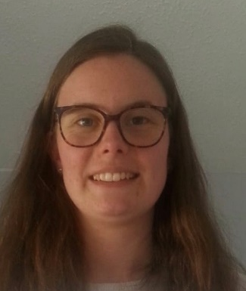
I joined the Chaplaincy Team at quite short notice after having been part of the Wellspring Community in Brighton. Being a past-pupil of SPH, it was all quite familiar coming back into the school and the welcome back I received from fellow staff was incredible. I have thoroughly enjoyed my time on the team so far, building up my confidence working with the staff and students in the school. My highlight of my time on the team is my small group which I meet with each week. We talk about and share our experiences of the Christian faith, and pray together too. With the experience and skills that I have gained during my time on the team, I hope to find a full time position as a school chaplain from September 2021 and the Leadership at SPH has been doing all they can to help me achieve this goal. It has been wonderful to spend this time working as part of a team, but I now feel well equipped to use the experiences and skills I’ve gained in a Chaplaincy role elsewhere.

If you’d like to stay connected to the SPH Chaplaincy Team, you can do so in the following ways:
Subscribe to our YouTube – SPH Chaplaincy
Follow us on Instagram – @sph_chaplaincy
Email us on – chaplaincy@sphcs.co.uk

