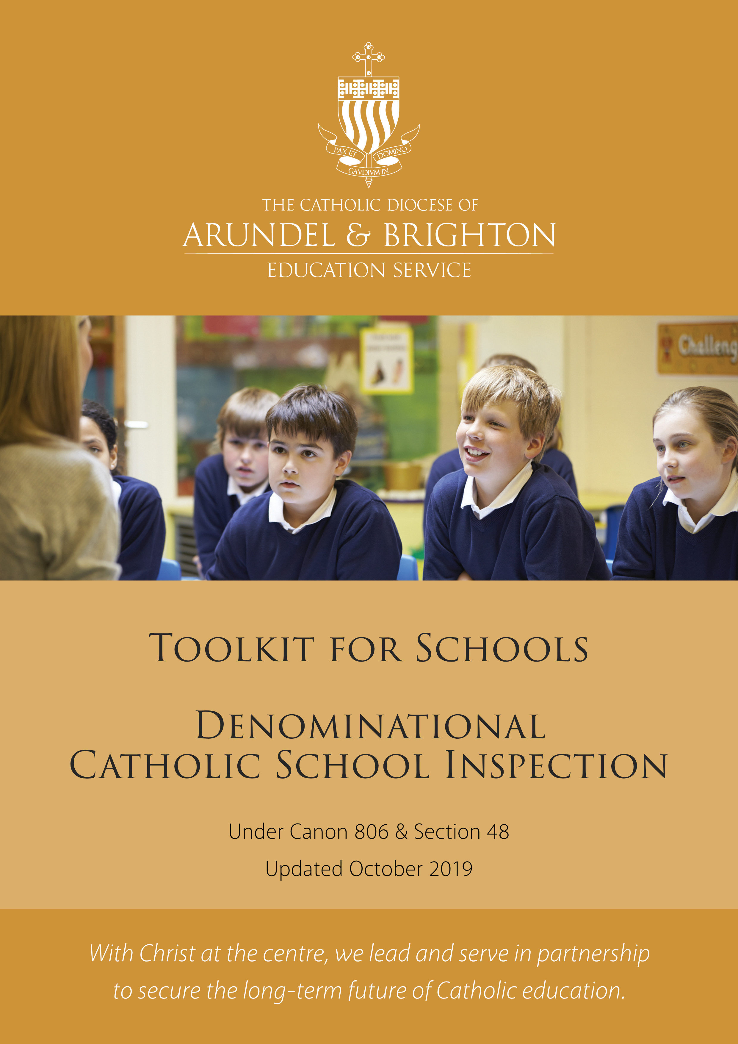

Contents

Introduction

FOR INTERNAL SCHOOL USE ONLY:
Catholic Life
CL1 - The extent to which pupils contribute to and benefit from the Catholic Life of the School
CL2 - The quality of provision for the Catholic Life of the school
CL3 - How well leaders and governors promote, monitor and evaluate the provision for the Catholic Life of the school
Catholic Life Headline Judgement
Religious Education
RE1 - How well pupils achieve and enjoy their learning in Religious Education
RE2 - The quality of teaching and assessment in Religious Education
RE3 - How well leaders and governors monitor and evaluate the provision for Religious Education
Religious Education Headline Judgement
Collective Worship
CW1 - How well pupils respond to and participate in the schools’ Collective Worship
CW2 - The quality of Collective Worship provided by the school
CW3 - How well leaders and governors promote, monitor and evaluate the provision for Collective Worship
Collective Worship Headline Judgement

Overall Effectiveness Judgement

introduction

This toolkit has been designed to assist school leaders in their duty to self-evaluate the quality of Catholic Education in their school. There is no requirement to use this SEF48 toolkit but it is offered in good faith as a tool which many leaders may find useful.
The toolkit follows the shape of the revised schedule (September 2019). The shape of this schedule is as follows:
Catholic Life
The extent to which pupils contribute to and benefit from the Catholic Life of the school | CL1
The quality of provision for the Catholic Life of the school | CL2
How well leaders and governors promote, monitor and evaluate the provision for the Catholic Life of the school | CL3
Religious Education
How well pupils achieve and enjoy their learning in Religious Education | RE1
The quality of teaching and assessment in Religious Education | RE2
How well leaders and governors monitor and evaluate the provision for Religious Education | RE3
Collective Worship
How well pupils respond to and participate in the schools’ Collective Worship | CW1
The quality of Collective Worship provided by the school | CW2
How well leaders and governors promote, monitor and evaluate the provision for Collective Worship | CW3

For each of the nine judgements there are four sections of the SEF48 toolkit:
- Criteria and evidence
- Differentiated judgement descriptors
- Writing frame
- Grade and Summary
At the end of each headline area of the schedule there is a Headline Judgement grid.
Finally at the end of the toolkit there is an Overall Effectiveness Judgement grid.
In addition there is an Appendix:
- Appendix 1 contains a detailed guide, with examples, on how to complete the toolkit

Beginning with Catholic Life, the process of completing the SEF 48 toolkit, therefore has the following steps:
Read CL1 criteria and evidence sources
Highlight CL1 differentiated descriptor grid
Complete CL1 writing frame
Assign a CL1 grade and complete a summary evaluation
Complete Catholic Life headline judgement grid
Assign a CL2 grade and complete a summary evaluation
Complete CL2 writing frame
Highlight CL2 differentiated descriptor grid
Read CL2 criteria and evidence sources
Assign a CL3 grade and complete a summary evaluation
Complete CL3 writing frame
Highlight CL3 differentiated descriptor grid
Read CL3 criteria and evidence sources
9.
10.
11.
12.
8.
1.
2.
3.
4.
13.
5.
6.
7.

Repeat this process for both the Religious Education and Collective Worship sections of the toolkit.
Finally, using each of the headline judgement grids, complete the Overall Effectiveness grid at the back of the tool kit
Catholic Life

CL1 - The extent to which pupils contribute to and benefit from the Catholic Life of the School

Criteria and Evidence Sources

Criteria
Inspectors will evaluate and report on:
- Pupils’/students’ sense of belonging to the school community and their relationship with those from different backgrounds.
- The extent to which pupils/students take on responsibilities for developing the Catholic character of the school.
- The extent to which pupils/students contribute to the common good in the school and wider community.

Suggested Evidence Sources
- Pupil questionnaires to establish:
  - Pupil awareness of the school’s mission statement and what this means in practice
  - How pupils feel about the school community and how committed they are to its mission
  - Whether pupils feel embraced by the community; how valued they feel; how much they are encouraged to grow and develop responsibly
  - Pupil attitudes to the religious character of the school, to religious objects, to the sincerely held beliefs of others who do not share their own faith commitments
  - How inclusive the school is of all pupils whatever their faith background
  - The participation of pupils in activities that reflect the school’s ethos, such as assemblies, collective worship, retreats, pastoral programmes, diocesan events etc
- Parent/carer questionnaires to establish:
  - Involvement of pupils in the Catholic Life of the school
  - Pupil behaviour
  - How safe secure pupils feel in expressing their own faith commitments
- Evidence of the quality of pupil behaviour, such as:
  - School behaviour incident logs
  - Minutes from school council meetings
  - Merits and rewards records
  - Lesson observations
  - Staff questionnaires
- Observation records for assemblies
- Photographic records of assemblies, fund-raising activities, involvement in community projects etc

CL1 Differentiated Judgement descriptors
The extent to which pupils contribute to and benefit from the Catholic Life of the School
 | 1 (outstanding) | 2 (good) | 3 (requires improvement) | 4 (inadequate)
Mission and ethos | Almost all pupils are at the centre of shaping the school’s mission and ethos. | Most pupils are involved in shaping the school’s mission and ethos. | A minority of pupils have a superficial involvement in shaping the school’s mission and ethos. | Pupils have no say in shaping the school’s mission and ethos
Evaluation | Pupils contribute in a planned and systematic way to the school’s evaluation of its Catholic Life take a lead in planning improvements to it. | Pupils participate in the school’s evaluation of its Catholic Life and are part of planning improvements to it. | Pupils participate in the school’s evaluation of its Catholic Life in some way but their involvement is infrequent and/or they lack a sense of the difference their contributions make. | Pupils are not involved in evaluating the Catholic Life of the school
Sense of belonging | Almost all pupils have a deep experience of belonging and enthusiastically embrace the demands that membership of the community entails. | Most pupils appreciate the community to which they belong and accept the demands that accompany this. | Most pupils have some sense of belonging to the community but find it difficult to articulate or appreciate the demands that belonging to a community entails. | A majority of pupils have a sense of alienation from the school community and feel no obligation to support the school or its values
Involvement in activities | Pupils take a leading role in those activities which promote the school’s ethos within school and in the wider community. | Pupils are regularly involved with those activities which promote the school’s ethos within school and the wider community. | Pupils are only infrequently and passively involved with those activities which promote the school’s ethos within school and the wider community. | Pupils are reluctant to engage in those activities which promote the school’s ethos within and beyond the school
Behaviour | The behaviour of almost all pupils is exemplary at all times. | The behaviour of most pupils is good almost all of the time. | The behaviour of most pupils at times requires improvement. | Pupil behaviour is inadequate in at least some respects
Caring for others | They are alert to the needs of others and seek justice for all within and beyond the school community. | They are considerate to others and caring to anyone in apparent need. They are enthusiastic in their response to charitable campaigns. | They sometimes lack an appreciation of the uniqueness of others and can be insensitive to their needs within their own community. They co-operate passively when the school organises charitable campaigns to address the needs of others beyond the community. | A majority of pupils behave insensitively and show little understanding of the effect of their behaviour on others  Pupils show little interest in the needs of others and the wider world
Personal development | Almost all pupils take full advantage of the opportunities the school provides for their personal support and development and as a result they are happy, confident and secure in their own stage of spiritual and emotional growth. | Most pupils respond well to the opportunities the school provides for their personal support and development and as a result they are mostly happy, confident and largely secure in their own stage of spiritual and emotional growth. | A minority of pupils show some response to the opportunities the school provides for their personal support and development and so they are happy and largely secure in their own stage of spiritual and emotional growth. Not all pupils benefit from the schools’ pastoral and spiritual development programmes. | Pupils feel unsupported in their emotional or spiritual development
Sense of vocation | Almost all pupils have a profound understanding of what it means to have a vocation and they joyfully offer their gifts in the service of others. | Most pupils have an understanding of what it means to have a vocation and they recognise the importance of using one’s gifts in the service of others. | A minority of pupils have some understanding of what it means to have a vocation, though have difficulty in connecting this with their own lives. | Pupils lack a sense of vocation and the responsibilities that accompany their giftedness
Sense of identity | Almost all pupils, including those who are not Catholic, are proud of their own religious identity and beliefs and have a strong sense of personal worth. They recognise the validity of these feelings in others even when they do not share their convictions. | Whatever their own convictions, most pupils understand that religious belief and spiritual values are important for many people. They show interest in the religious life of others. | A minority of pupils know that for some people religion is important and affects the way they live; although there are some pupils who have no understanding of the importance religion has for others. | Pupils are unclear about their own and others’ beliefs and they show little respect for the religious practices of others
Attitude to Religious artefacts | They treasure the outward signs of the school’s Catholic identity. | Pupils show care and respect for religious artefacts in the school. | Religious artefacts in school have become anonymous and some pupils treat them with a lack of appropriate respect. | Pupils show little or no respect for the religious artefacts in school
Involvement in parish/diocese | Pupils deeply value and respect the Catholic tradition of the school and its links with the parish community(ies) and the diocese. They are enthusiastically and regularly involved with parish and diocesan celebrations and activities, irrespective of their own faith commitments. | Pupils understand the importance of key celebrations in school throughout the liturgical year and in the parish community and have some involvement with parish and diocesan activities and celebrations. | Pupils can identify the religious aspects of their school and know about religious practice in their parish and/or local community, though lack a sense of connection to these. | Pupils show little respect for the religious life of the school and have little or no involvement with the parish and/or diocese

CL1 Writing frame
The extent to which pupils contribute to and benefit from the Catholic Life of the School
Schedule  sub-judgement | Key phrases from the descriptors | Main strengths and weaknesses | Evidence | Grade
Mission and ethos
Evaluation
Sense of belonging
Involvement in activities
Behaviour
Caring for others
Personal development
Sense of vocation
Sense of identity
Attitude to Religious artefacts
Involvement in parish/diocese

CL1 Grade and Summary
The extent to which pupils contribute to and benefit from the Catholic Life of the School
Grade:
Reasons for grade given:
Areas for development:

CL2 - The quality of provision for the catholic life of the school

Criteria and Evidence sources

Criteria
Inspectors will evaluate and report on:
- The centrality and efficacy of the school’s mission statement.
- The extent to which the school makes its Catholic identity and ethos explicit through the learning environment, chaplaincy provision and community cohesion.
- The quality of community life evident in the pastoral care shown to all members of the community, both pupils/students and staff.
- The extent to which the school promotes standards of behaviour that reflect Gospel values and how effectively develops positive relationships between all members of the school community.
- The quality of pastoral programmes, including PSHE and Relationships and Sex Education(RSE)and Spiritual and Moral education.

Suggested Evidence Sources
- School mission statement and the school development plan to establish:
  - The extent to which the school’s mission statement reflects the Church’s mission in education
  - The centrality of the school mission statement to the school’s priorities
- Staff questionnaires, to establish:
  - The amount, frequency and inclusivity of staff training time devoted to ethos development
  - The extent of staff commitment to the implementation of the mission statement across the curriculum and throughout school life
  - The quality of induction and continued professional development for new members of staff and/or those who are not Catholic
  - How included non-teaching staff feel in the school’s mission and community
- Pupil questionnaires, to establish:
  - The quality of pastoral support
  - The quality of PSCHE and SRE lessons and the amount of time given to them
  - The efficacy of behaviour management policies
  - The quality of non-worship assemblies and the extent to which they focus on the mission of the school to the local and global community
- Policy documents:
  - Schemes of work or long term planning documents for PSCHE and SRE
  - Behaviour management policy
  - Chaplaincy development plan
- Observations records for non-worship assemblies, pastoral lessons and other activities that are focused on developing the school’s mission and ethos
- Performance management summaries as an indication of where in the school’s priorities the sustenance of the Catholic Life of the school features.

CL2 Differentiated Judgement descriptors
The quality of provision for the catholic life of the school
 | 1 (outstanding) | 2 (good) | 3 (requires improvement) | 4 (inadequate)
Mission statement | The school mission statement is a clear and inspiring expression of the educational mission of the Church. | The school mission statement is a good expression of the educational mission of the Church. | Whilst the school mission statement is not contrary to the educational mission of the Church this is not well thought through or its expression lacks depth. | The school’s mission is contrary to the educational mission of the Church
Staff commitment | All staff are fully committed to its implementation across the curriculum and the whole of school life. | Most staff are committed to its implementation across the curriculum and the whole of school life. | Whilst most staff understand some of the demands of the school’s mission statement there are inconsistencies in its application across the curriculum and/or to the rest of school life. | The school mission is not shared by all members of staff with some actively opposed to it
Sense of community | There is a tangible sense of community at all levels, evident in the quality of relationships that exist between almost all colleagues, support staff and students. | Good relationships exist between most colleagues, support staff and students. | Whilst relationships have not broken down, tensions do exist between colleagues, support staff and students and this has not been tackled. | Relationships within the community have broken down and this is having a detrimental effect on morale and commitment
Morale | The school is a supportive and joyful community. | Morale is high. | Whilst members of staff are not completely disaffected, their work in school has become a duty rather than a joy. | Staff are deeply unhappy and find their work in school detrimental to their spiritual, physical or emotional health
Learning environment | The learning environment reflects the school’s mission and identity through concrete and effective signs of the school’s Catholic character. | The learning environment reflects the school’s mission and identity through clear signs of the school’s Catholic character. | There are visible signs of the school’s Catholic identity throughout the school site, although these have become routine and anonymous, without any felt impact on the life of the school. | The school has few outward signs of its Catholic identity
Pastoral policies | Clear policies and structures are in place, which provide the highest levels of pastoral care to almost all pupils, | The school provides high levels of pastoral care to most pupils, | The school provides limited pastoral care to all pupils | There is no planned pastoral programme, or the schemes that are in place are routinely ignored by staff
Commitment to those in need | There is an explicit and concrete commitment to the most vulnerable and needy in both policy and practice. | There is a commitment to the most vulnerable and needy in both policy and practice. | Commitment to the most vulnerable and needy is more evident in policy than in practice, with some gaps in identifying and supporting pupils in need. | There are some pupils who receive no pastoral care from the school or whose particular needs are ignored
PSCHE and SRE programmes | Pastoral programmes, PSCHE and SRE are thoughtfully designed, carefully planned, consistently well taught and celebrate Catholic teachings and principles. | Pastoral programmes, PSCHE and SRE are planned and mostly well taught and refer explicitly to Catholic teachings and principles. | There are programmes in place for the delivery of PSCHE and SRE and these are delivered in a timely fashion, but are not always given equal priority to other lessons by teachers in planning and delivery. They make reference to Catholic teachings and principles, although these are not explored or are treated with scepticism or caution. | Pupils have not received any formation in SRE or this has been received without any reference to Catholic values and principles
Pastoral care of staff | The school is equally attentive to the pastoral needs of members of staff and ensures that almost every member’s needs are understood and catered for. | The school is attentive to the pastoral needs of members of staff and strives to meet the needs of every member of the community. | The school is aware of the pastoral needs of most members of staff although some feel that their needs are ignored. | The pastoral needs of members of staff are not recognised or there is no effort to address them
Behaviour expectations | The highest standards of moral and ethical behaviour are promoted through the clear and consistent communication of the school’s expectations. | The school regularly communicates high expectations of behaviour to its pupils. | The school expectations of behaviour are not high enough and/or the school has mixed success in communicating these to pupils. | The school’s expectations of behaviour are too low and poor behaviour is rarely challenged. As a consequence behaviour within the school is inadequate in at least some respects
Behaviour policies | Behaviour policies are rooted in Gospel values and the teaching of the Catholic Church. These policies embody throughout the importance of personal responsibility and the need for justice but also facilitate healing and reconciliation. | Behaviour policies take into account Gospel values and the teaching of the Catholic Church. These policies demonstrate the importance of personal responsibility and the need for justice but also encourage healing and reconciliation. | Behaviour policies reflect Gospel values and the teaching of the Catholic Church unconsciously and in an unsystematic way. These policies either emphasise personal responsibility to such an extent that poor behaviour is not always challenged or they concentrate too heavily on sanctions and do not make the need for healing and reconciliation explicit. | The school lacks a coherent behaviour policy, or the policy is ineffective, or it is contrary in some respects to Gospel values. As a consequence behaviour within the school is inadequate in at least some respects

CL2 Writing frame
The quality of provision for the catholic life of the school
Schedule  sub-judgement | Key phrases from the descriptors | Main strengths and weaknesses | Evidence | Grade
Mission statement
Staff commitment
Sense of community
Morale
Learning environment
Pastoral policies
Commitment to those in need
PSCHE and SRE programmes
Pastoral care of staff
Behaviour expectations
Behaviour policies

CL2 Grade and Summary:
The quality of provision for the catholic life of the school
Grade:
Reasons for grade given:
Areas for development:

CL3 - How well leaders and governors promote, monitor and evaluate the provision for the Catholic Life of the school

Criteria and Evidence sources

Criteria
Inspectors will evaluate and report on:
- The effectiveness of leaders and governors in promoting the Catholic life of the school.
- How well leaders and governors monitor and evaluate the Catholic life provision and outcomes in order to plan future improvements.
- The extent to which leaders offer models of good practice as leaders of Catholic life.
- How well leaders and governors implement improvement in respect of the Catholic life of the school.
- How well leaders and governors ensure that the whole curriculum contributes to pupils’/students’ spiritual life.

Suggested Evidence Sources
- Staff questionnaires to establish:
  - The extent to which leaders in school witness to the Catholic mission of the Church
  - How involved staff are in its evaluation and promotion
  - How central Catholic ethos is amongst the school’s other priorities
  - How much contact staff have with leaders, including governors
  - The visibility of leaders and their efficacy
- Parental questionnaires, to establish:
  - How well parents/carers understand the mission of the school
  - How supportive they are of the school’s Catholic ethos
  - How involved they are in its evaluation
  - How visible leaders, including governors, are in their leadership of Catholic Life
- Minutes of governors’ meetings, to establish:
  - How well governors understand the mission of the Church in education
  - How involved governors are in evaluating and promoting the Catholic Life of the school
  - How confident governors are in holding the leadership team to account as well as supporting it in its mission
  - The extent of governor knowledge of and passion for Catholic education
- Records of attendance by governors at diocesan training relating to the mission of Catholic education
- Governors’ skills audit to indicate contributions made by governors to the Catholic life of the school
- Any other records (photographic, testimonial etc.) that point to the involvement of governors in the Catholic Life of the school
- Self–evaluation documents and school improvement plans which demonstrate the high priority given to Catholic Life
- School development plan and records of performance management processes
- Minutes of leadership meetings to establish the centrality of the Catholic Life of the school as a strategic priority

CL3 Differentiated Judgement descriptors
How well leaders and governors promote, monitor and evaluate the provision for the Catholic Life of the school
 | 1 (outstanding) | 2 (good) | 3 (requires improvement) | 4 (inadequate)
Commitment of leaders | The school’s leadership is deeply committed to the Church’s mission in education. Leaders are energised by the task and are a source of inspiration for the whole community. | Leaders and governors demonstrate a public commitment to the mission of the Church. They are well regarded by staff as models of Catholic leadership by both staff and pupils. | Leaders and governors express their support for the Church’s mission in education but rely heavily on guidance to give it direction. | Leaders and governors are reluctant to promote the Church’s mission in education
Catholic ethos | The development and sustenance of an authentic Catholic ethos is viewed as a core leadership responsibility. | The development and sustenance of an authentic Catholic ethos is taken seriously by all leaders. | The development and sustenance of the Catholic ethos is acknowledged as a leadership responsibility but perhaps only implicitly with only a minimal reference to it in strategic leadership meetings. | Leaders are apathetic in their development and sustenance of the Catholic ethos
Priority | The provision for the Catholic Life of the school is given the highest possible priority by leaders. | The provision for the Catholic Life of the school is given high priority by leaders in the school’s self-evaluation cycle. | The provision for the Catholic Life is included only incidentally by leaders in the school’s self-evaluation cycle or it has only peripheral importance. | Provision for the Catholic Life of the school is not included in the self-evaluation cycle.
Self-evaluation | The schools self-evaluation is a coherent reflection of rigorous monitoring, searching analysis and self-challenge and is clearly and explicitly focused on the Catholic Life of the school. | Leaders conduct a range of monitoring activities relating to provision and outcomes for the Catholic Life of the school. Their analysis provides a firm basis for accurate diagnosis of the school’s strengths and areas for development in these areas. | Leaders rarely monitor the impact of the Catholic Life of the school on pupil development. | Evaluation of the Catholic Life of the school is casual and lacks rigour.
Improvement planning | This leads to well-targeted planned improvements, often creatively conceived with key partners to further enhance the communal life and ethos of the school. | Planning for improvements to the Catholic Life of the school involves key partners in tackling key areas for development systematically and building on areas of strength. | Leaders are implementing plans that are aimed at improving pupils’ spiritual and moral development and other outcomes for pupils but these still require improvement and are not imaginative in their involvement of key partners. | Leaders have not included Catholic Life in their school improvement plans
Shared understanding | Staff and pupils’ understanding of the school’s mission is outstanding. They share its purpose and are keenly and actively involved in shaping and supporting it. | Pupils are able to articulate the school’s distinctive mission with understanding and appreciation. Staff and pupils have a high regard for the Catholic Life of the school. | The Catholic Life of the school, whilst not absent, has little impact on the daily experience of staff and pupils. | Pupils and staff are unclear about what it means to be part of a Catholic school community or actively opposed to its Catholic nature.
Parental engagement | The school has highly successful strategies for engaging with almost all parents/carers to the very obvious benefit of pupils, including those who might traditionally find working with the school difficult. | The school usually works well with most parents/carers, including those who might traditionally find working with the school difficult, to achieve positive benefits for pupils. | The school usually works with parents/carers, although is less successful in engaging those who might traditionally find working with the school difficult. | There has been a general breakdown of relationships between the school and its parents/carers
Parental support | Parents/carers have a thorough understanding of the school’s mission and are highly supportive of it. | Parents/carers have a good grasp of the school’s mission and are supportive of it. | As a result, whilst all parents/carers will be aware of the school’s distinctive mission and identity, not all parents/carers are fully supportive of it. | Parents/carers are actively opposed to the school’s mission.
Governor ambition | As leaders, the governing body is highly ambitious for the Catholic Life of the school and leads by example in its consistent emphasising of Catholic Life as a school improvement priority. | As leaders, the governing body consistently communicates high expectations of the Catholic Life of the school and refers to it frequently as a school improvement priority. | Whilst the governing body makes limited efforts to maintain the Catholic Life and identity of the school these efforts are not concerted or maintained. | The governing body largely ignores the Catholic character of the school they lead
Governor contribution | Governors make a highly significant contribution to the Catholic Life of the school. | Governors are influential in determining the direction of the Catholic life of the school. | Governors make a limited contribution to the Catholic Life of the school. | Governors have little impact on the direction and work of the school.
Governor evaluation | Governors are passionate about the school’s mission, are actively involved in its evaluation and are ready to challenge as well as support where necessary. | Governors discharge their duties effectively and are fully involved in evaluating the Catholic life of the school, offering challenge and support. | Governors are only superficially involved in the self-evaluation of the Catholic Life of the school and are more comfortable in a supportive role than they are with offering challenge. | Governors do not challenge the school to address areas for development in the Catholic Life of the school

CL3 Writing frame
How well leaders and governors promote, monitor and evaluate the provision for the Catholic Life of the school
Schedule  sub-judgement | Key phrases from the descriptors | Main strengths and weaknesses | Evidence | Grade
Commitment of leaders
Catholic ethos
Priority
Self-evaluation
Improvement planning
Shared understanding
Parental engagement
Parental support
Governor ambition
Governor contribution
Governor evaluation

CL3 Grade and Summary:
How well leaders and governors promote, monitor and evaluate the provision for the Catholic Life of the school
Grade:
Reasons for grade given:
Areas for development:

Catholic Life Headline Judgement
Catholic Life
- The extent to which pupils contribute to and benefit from the Catholic Life of the school.
- The quality of provision for the Catholic Life of the school
- How well leaders and governors promote, monitor and evaluate the provision for the Catholic Life of the school.

Outstanding  (1) | Of the three judgements:  - The extent to which pupils contribute to and benefit from the Catholic Life of the school  - The quality of provision for the Catholic Life of the school  - How well leaders and governors promote, monitor and evaluate the provision for the Catholic Life of the school  “The extent to which pupils contribute to and benefit from the Catholic Life of the school” must be outstanding. Of the other two judgements, one must be outstanding and one must be at least good.
Good  (2) | Of the three judgements:  - The extent to which pupils contribute to and benefit from the Catholic Life of the school  - The quality of provision for the Catholic Life of the school  - How well leaders and governors promote, monitor and evaluate the provision for the Catholic Life of the school  “The extent to which pupils contribute to and benefit from the Catholic Life of the school” must be at least good. Of the other two judgements, one must be at least good and one must at least require improvement.
Requires Improvement  (3) | All three of the following judgements must at least require improvement:  - The extent to which pupils contribute to and benefit from the Catholic Life of the school  - The quality of provision for the Catholic Life of the school  - How well leaders and governors promote, monitor and evaluate the provision for the Catholic Life of the school
Inadequate  (4) | The quality of Catholic Life is likely to be inadequate if any of the following are inadequate:  - The extent to which pupils contribute to and benefit from the Catholic Life of the school  - The quality of provision for the Catholic Life of the school  - How well leaders and governors promote, monitor and evaluate the provision for the Catholic Life of the school

Religious Education

RE1 - How well pupils achieve and enjoy their learning in Religious Education

Criteria and Evidence sources

Criteria
Inspectors will evaluate and report on:
- The quality of pupils’/students’ achievement, learning and progress in Religious Education and any variations between groups of pupils/students.
- The extent to which pupils/students are becoming religiously literate.
- The quality of learning for pupils/students with particular learning needs and/or disabilities and their progress
- Pupils’/students’ attainment in Religious Education at the end of each Key Stage.

Suggested Evidence Sources
- Lesson observation records for Religious Education lessons, noting clearly grades for enjoyment and progress in the lesson
- Work scrutiny records, noting clearly grades for standards, progress and the quality of learning of pupils in Religious Education currently in the school
- School’s moderated assessment portfolio (with record of diocesan moderation outcomes included)
- Pupil questionnaires to establish the level of enjoyment and engagement in Religious Education lessons and how much progress is made in Religious Education in comparison with other core subjects
- Measures of progress for all pupils for up to three previous academic years, as shown by the Annual Diocesan Data Return (ADDR), RAISEonline and, where relevant, the sixth form PANDA
- Other sub-levelled progress and tracking information collected by the school
- The progress made by disabled pupils and those who have special educational needs compared with diocesan benchmarks – evidenced in the ADDR and in the schools own tracking and progress data
- Standards attained by all pupils as shown by national test and examination results (where appropriate) and submitted teacher assessment, set against diocesan benchmarks as indicated in the ADDR for up to three previous academic years, such as:
For Primary Schools:
Teacher assessment of standards of attainment using the descriptors from the Bishops’ Conference document New Interim Standards of Assessment in Religious Education for Catholic Schools and Colleges.
The percentage of students achieving age related expectations and above at the end of KS1
The percentage of students achieving age related expectations and above at the end of KS2

For Secondary Schools:
At Key Stage3: Teacher assessment of standards of attainment using the descriptors from the Bishops’ Conference document New Interim Standards of Assessment in Religious Education for Catholic Schools and Colleges.
The percentage of students achieving age related expectations and above at the end of KS3

At Key Stage 4:
o GCSE results
o Thepercentage of students (of the full cohort) achieving:
- Grades9-7
- Grades9-4
- Grades9-1
at GCSE measured against diocesan and national averages

At Key Stage 5:
o GCE AS & A2 results
o Entry as a percentage of cohort for AS & A2, against diocesan averages
o Percentage completion rate for AS & A2 taken from May to October of each year, against diocesan averages
o The percentage of students achieving:
A*-E
A*-B also
APS per entry
at GCE AS & A2 measured against diocesan averages

- Standards attained and progress made by different groups of pupils, compared with the standards and progress of all pupils in the diocese and nationally (where national data is available)
- Standards attained and progress made by different groups of pupils, compared with different groups within the school
- Any robust attainment and progress data and its analysis presented by the school, including information provided by external organisations such as FFT, ALIS, ALPS etc
- Any evidence of past progress analysed by the school, including whether pupils reached challenging targets
- The school’s evaluation of the attainment and progress of:
- all pupils and groups of pupils
- pupils who have received intervention and/or additional support
- any pupils who are educated wholly or partly off site
- any pupils who joined the school at times other than the usual phase transfer times.
- The school’s track record in assessing standards of attainment, including the accuracy and the quality of teacher assessment. This should be done through:
- an analysis of previous years’ predictions against actual outcomes,
- feedback from diocesan moderation meetings
- by using percentage uplift calculations on the validated data of a current cohort for those pupils who do not yet have end of key stage results
RE1 Differentiated Judgement descriptors
How well pupils achieve and enjoy their learning in Religious Education
 | 1 (outstanding) | 2 (good) | 3 (requires improvement) | 4 (inadequate)
Enjoyment | Pupils demonstrate passion and commitment in their learning in Religious Education and view it as one of their most important lessons. | Pupils enjoy Religious Education and can explain its value. | Whilst pupils are not uninterested in Religious Education they show few outward signs of enthusiasm for it. | Pupils lack all interest and enthusiasm for Religious Education.
Focus | Most pupils concentrate very well and are rarely off task even in extended periods without direction from an adult. | Pupils are keen to do well, generally apply themselves diligently in lessons and work at a good pace. | Pupils work steadily but they are not completely focussed and the lesson is such that pupils are often inattentive. | Pupils are unable to work independently and are frequently off-task.
Behaviour for Learning | Behaviour for learning is outstanding and almost all lessons proceed without any interruptions. | Behaviour for learning is good and disruption to lessons is unusual. | Behaviour for learning requires improvement since there are at least some examples of low-level disruption that are not addressed often enough to prevent impediments to learning for some pupils. | Persistent low level disruption occurs more than occasionally and hinders learning for many pupils. Lessons tend to be disorderly.
Progress | Almost all pupils are making rapid and sustained progress in Religious Education over time given their starting points. | Pupils are making better progress over time in Religious Education than other pupils in the diocese given their starting points. | Whilst progress is inadequate in no major respect pupils are not progressing as well as they should given their starting points or good progress has not yet been sustained over time. | Pupils’ progress overall is consistently well below that of other pupils in the diocese and/or nationally given their starting points.
Progress of vulnerable groups | Groups of pupils, including disabled pupils and those with special educational needs are also making rapid and sustained progress when compared with similar groups of pupils within the diocese. | Groups of pupils, including disabled pupils and those with special educational needs, are also making better progress than similar groups of pupils within the diocese. | Groups of pupils, including disabled pupils and those who have special educational needs, are making progress that is at best in line with and sometimes below that of similar groups of pupils within the diocese. | Progress of particular groups is consistently well below those of other pupils in the diocese and/or nationally given their starting points.  There are wide gaps in attainment and in learning and progress between different groups of pupils when compared with similar cohorts within the diocese and/or nationally that are showing little sign of closing or are widening.  There are wide gaps in attainment and in learning and progress between different groups of pupils within school that are barely closing or are widening.
AT1 – learning about religion | Pupils learn exceptionally well and as a result acquire knowledge quickly and in depth and are developing their understanding rapidly (AT1). | Pupils acquire knowledge quickly and are secure in their understanding (AT1). | Whilst pupils acquire knowledge and understanding over time, the pace of learning requires improvement (AT1). | Insufficient new knowledge and understanding is gained in individual lessons or across a sequence of lessons (AT1).
AT2 – learning from religion | They develop and apply a wide range of skills to great effect, including independence, originality, imagination, the ability to interpret sources and symbol, the ability to ask deeper questions, the ability to understand nuance and subtlety, the ability to reflect and evaluate, the ability to engage with religious ideas and integrate them into their lives and the ability to apply all of these skills across the curriculum (AT2). | They develop and apply a range of skills well, including independence, imagination, the ability to interpret sources and symbol, the ability to reflect and evaluate, the ability to engage with religious ideas and integrate them into their lives and the ability to apply many of these skills across the curriculum(AT2). | Pupils are developing skills appropriate to their age and ability, although the pace of this skill acquisition requires improvement (AT2). | Skill acquisition is neglected or its pace is inadequate and pupils demonstrate little or no ability to apply learning about religion to their own lives in any meaningful way (AT2).
Attainment | The standards of attainment of almost all groups of pupils are likely to be at least in line with diocesan and/or national averages for all pupils with many above average. In exceptional circumstances where standards of attainment of any group of pupils are below the diocesan or national averages, the gap is closing dramatically. | The standards of attainment of the large majority of groups of pupils are likely to be at least in line with diocesan and/or national averages for all pupils. Where standards of any group of pupils are below diocesan or national averages, the gaps are closing. | The standards of attainment of the majority of groups of pupils are at best in line with diocesan and/or national averages with many pupils below these benchmarks. Where standards of groups of pupils are below diocesan or national averages, the gaps are closing overall but not quickly enough. | Learning and progress in any one key stage, including the sixth form, leads to underachievement.  Attainment is consistently low, showing little, fragile or inconsistent improvement, or is in decline. Considerable numbers of pupils underachieve in one or more key stages.

RE1 Writing frame
How well pupils achieve and enjoy their learning in Religious Education
Schedule  sub-judgement | Key phrases from the descriptors | Main strengths and weaknesses | Evidence | Grade
Enjoyment
Focus
Behaviour for Learning
Progress
Progress of vulnerable groups
AT1 – learning about religion
AT2 – learning from religion
Attainment

RE1 Grade and Summary:
How well pupils achieve and enjoy their learning in Religious Education
Grade:
Reasons for grade given:
Areas for development:

RE2 - The quality of teaching and assessment in Religious Education

Criteria and Evidence sources

Criteria
Inspectors will evaluate and report on:
- How well teaching promotes:
o engagement and enjoyment
o purposeful learning
o progress and attainment of pupils/students in Religious Education

- How well assessment is used to inform appropriate teaching and learning strategies.

Suggested Evidence Sources
- Lesson observation records, graded with a focus on the quality of teaching and assessment and its impact on learning
- Work scrutiny, focussing on:
  - the frequency and quality of marking
  - its impact on pupil progress
  - level of challenge provided
  - evidence of differentiation
- Scrutiny of teacher planning documentation
- Pupil questionnaires
- Staff questionnaires
- Pupil outcomes in terms of end of Key Stage data and interim data for individuals and whole cohorts

RE2 Differentiated Judgement descriptors
The quality of teaching and assessment in Religious Education
 | 1 (outstanding) | 2 (good) | 3 (requires improvement) | 4 (inadequate)
Teaching | A majority of the teaching is outstanding and never less than consistently good; it is highly effective in enthusing pupils and ensures that they learn extremely well. | Teaching is mainly good, with examples of outstanding teaching. | Whilst teaching is never inadequate it is mostly not good. | As a result of weak teaching over time, pupils or groups of pupils currently in the school are making inadequate progress.
Impact | As a result, almost all pupils are making rapid and sustained progress. | As a consequence, most pupils and groups of pupils, including disabled pupils and those who have special educational needs, make good progress over time. | Teaching results in pupils, and groups of pupils, making progress that is at best broadly in line with diocesan and/or national averages, whilst many pupils make progress that is below these benchmarks. | As a result of weak teaching over time, pupils or groups of pupils currently in the school are making inadequate progress.
Expectations | Teachers communicate high expectations, enthusiasm and passion about Religious Education to pupils. | Teachers have a clear understanding of the value of Religious Education which they communicate effectively to pupils. | Teachers have a basic but limited understanding of how to maintain pupils’ interest in Religious Education. | Teachers do not have sufficiently high expectations and/or teaching over time fails to excite, enthuse, engage or motivate particular groups of pupils, including the most able, disabled pupils and those who have special educational needs.
Knowledge and expertise | Teachers have a high level of confidence and expertise both in terms of their specialist knowledge and their understanding of effective learning in Religious Education. As a result, they use a very wide range of innovative and imaginative resources and teaching strategies to stimulate pupils’ active participation in their learning and to secure outstanding progress. | Teachers have a confident level of specialist expertise which they use well in planning and teaching Religious Education. As a result, they use an appropriate range of resources and teaching strategies to promote good learning. | Whilst teachers have some specialist expertise which they use in their planning and teaching, this lacks depth and breadth. As a result, they use only a limited range of resources and teaching strategies to which leads to at best a minimal level of learning. | Specialist expertise is limited and, as a result, teachers do not provide the resources or teaching strategies necessary to ensure a basic minimum level of learning.  Learning activities are not sufficiently well matched to the needs of pupils so that they make inadequate progress.
Use of time | Teachers consistently use time effectively to maximise learning opportunities in lessons and across sequences of lessons. | Teachers manage time well and secure good learning in lessons and across sequences of lessons. | Time management requires improvement since the pace of learning in lessons or across a sequence of lesson is too slow. | Time is grossly mismanaged; learning experiences within lessons and across sequences of lessons remain incomplete; pupils’ time is wasted
Homework | From KS3 onwards, regular homework contributes very well to pupils’ learning, providing stretch and challenge for the most able and consolidation for the least. | From KS3 onwards, regular homework contributes well to pupils’ learning, allowing all pupils to consolidate their learning. | From KS3 onwards, homework is sometimes set and when it is, it contributes reasonably well to the quality of learning for most pupils. However, homework is not set frequently enough and is not well planned enough to make significant contributions to learning. | Even where the setting of homework is required it is set very infrequently, if at all and/or the demands it makes on pupils has no measurable impact on the quality of their learning.
AfL | Teachers regularly listen astutely to, carefully observe and skilfully question groups of pupils and individuals during lessons in order to re-shape tasks and explanations to maximise learning for every pupil. | Teachers systematically and effectively check pupils’ understanding throughout lessons, anticipating where they need to intervene and do so with notable impact on the quality of learning. | Whilst teachers monitor pupils’ work during lessons, adaptations made as a consequence require improvement since they are not timely or relevant enough and hence do not impact effectively on pupils’ learning. | Teachers do not assess learning during lessons and/or do not reshape learning in response to recognising where learning is slower.
Assessment & Planning | Teachers and other adults plan challenging and focussed learning activities based on systematic and accurate assessment of pupils’ prior skills, knowledge and understanding. | As a result of good assessment procedures, teachers and other adults have a good awareness of their pupils’ prior learning and capabilities and plan well to meet the needs of all pupils, both the most and the least able. | Teachers and other adults use assessment to arrive at a broadly accurate understanding of the prior learning and capabilities of the class, though it is not refined enough to fully meet the needs of all students. | Teachers do not assess regularly enough and/or they do not take account of this assessment of prior learning in their planning.
Differentiation | Fine-tuned differentiation ensures that the particular needs of almost every pupil are consistently and effectively addressed. | Teachers differentiate tasks well in order to meet the variety of pupil needs. | Differentiation is more often achieved through outcome rather than through the designing of individually targeted learning activities and so does not meet the needs of all pupils. | There is little evidence of differentiation and/or little or no accommodation is made for the breadth of ability range across a cohort.
Marking and feedback | Marking and constructive feedback are frequent and of a consistently high quality, leading to high levels of engagement, interest, learning and progress. Pupils have a detailed understanding of what they need to do to improve and are given the opportunity to respond to advice in a systematic and planned way. | Marking and constructive feedback are performed regularly and accurately so that pupils know how well they have done and what they need to do to improve. They are given time to respond to advice on improvement. | Marking and feedback is sometimes given so that pupils are informed about the progress they are making and how to improve. This does not occur frequently enough, or the gap between it and the completion of the learning activity is too great to allow it to be fully effective. Whilst advice on improvement is given, there are few opportunities provided for pupils to respond to this advice. | Marking and feedback are either too infrequent or insufficiently focussed to have any impact on learning or progress.
Self-assessment | Pupils are consistently involved in evaluating how well they achieve. This contributes to their improved achievement and provides them with a high level of confidence in making further improvements. | Pupils are often involved in evaluating how well they achieve which gives them greater confidence in making improvements. | Pupils are only sometimes involved in assessing how well they are achieving. | Pupils are never involved in evaluating their own learning
Celebrating achievement | Celebration of achievement and effort are central to the teachers’ assessment strategy. | Achievement and effort are often celebrated. | Achievement and effort are only sometimes celebrated. | Achievement and effort are rarely, if ever celebrated.

RE2 Writing frame
The quality of teaching and assessment in Religious Education
Schedule  sub-judgement | Key phrases from the descriptors | Main strengths and weaknesses | Evidence | Grade
Teaching
Impact
Expectations
Knowledge and expertise
Use of time
Homework
AfL
Assessment & Planning
Differentiation
Marking and feedback
Self-assessment
Celebrating achievement

RE2 Grade and Summary:
The quality of teaching and assessment in Religious Education
Grade:
Reasons for grade given:
Areas for development:

RE3 - How well leaders and governors monitor and evaluate the provision for Religious Education

Criteria and Evidence sources

Criteria
Inspectors will evaluate and report on:
- That the Religious Education curriculum meets Bishops’ Conference requirements.
- That the curriculum meets any additional requirements of the diocesan Bishop.
- How well leaders and governors use monitoring data to evaluate the school’s performance in Religious Education in order to plan future improvements.
- How well leaders and governors plan improvement in provision and in pupils’/students’ outcomes, and how effectively these plans are implemented at all levels.
- The effectiveness of the subject leader(s). How effectively assessment is used in monitoring and securing improvements. How well scheme and specification choices support the learning and achievement of different groups of pupils/students.

Suggested Evidence Sources
- Staff questionnaires, to establish:
  - How effective leadership is in supporting teaching and learning
  - How well resourced Religious Education is in comparison to other core subjects
  - The effectiveness of monitoring and evaluation
  - The effectiveness of the RE co-ordinator/head of department on the whole community
  - The extent to which staff are engaged by and contribute to realising the vision and ambition of leaders, governors and governors
- Pupil questionnaires, to establish:
  - How well the RE curriculum meets pupil needs
  - The effectiveness of the RE co-ordinator/head of department as a supporter of pupil learning and spiritual development
  - How much of each curriculum week is given to Religious Education, to ensure that the 10% requirement is met for all classes and all teachers
  - The extent to which pupils are engaged by and contribute to realising the vision and ambition of leaders, governors and governors
- For secondary schools:
  - Religious Education schemes of work,
  - School and subject improvement plans
  - Other relevant policy documents
- For primary schools:
  - Religious Education planning documents,
  - Relevant sections of the school improvement plan
  - Other relevant policy documents for which the RE co-ordinator may be responsible
- The school’s data tracking and intervention systems which should include a record of impact on outcomes, to establish:
  - How effective leadership and management is in identifying and supporting disabled pupils, those who have special educational needs and pupils who are gifted and talented in Religious Education so that their progress is maximised
  - How effective leadership and management is in identifying and supporting disabled pupils, those who have special educational needs and pupils who are gifted and talented in Religious Education so that their progress is maximised
- Records of Performance Management and Lesson Observation logs, which should include evidence of interventions and impact on teaching, to establish:
  - How effective leadership and management is in managing performance
  - How effective leadership is in tackling areas of underperformance
  - How effective leadership is in tackling weaknesses in the quality of teaching and the curriculum
- Evidence of strategies and in-house CPD to improve the quality and impact of teaching, such as:
  - Seeking out and modelling best practice
  - Monitoring the quality of teaching and learning and acting on its findings
  - Developing staff through dialogue, coaching, training, mentoring and support
  - Leading a coherent programme of professional development
  - Using appropriate procedures for tackling underperformance
- Minutes of Governors’ meetings, to establish:
  - How effectively the governing body acts as a critical friend and holds senior and subject leaders to account for all aspects of performance in Religious Education
  - How effectively leadership and management at all levels, including governance evaluate and promote the impact of Religious Education on the spiritual and moral development of all pupils, including the discernment of individual vocation
- Evidence of school’s work with other schools, agencies, the community and local parishes to extend the curriculum and increase the range and quality of learning opportunities for pupils

RE3 Differentiated Judgement descriptors
How well leaders and governors monitor and evaluate the provision for Religious Education
 | 1 (outstanding) | 2 (good) | 3 (requires improvement) | 4 (inadequate)
Self-evaluation | The self-evaluation of Religious Education by leaders and governors is a coherent reflection of rigorous monitoring, searching analysis and self challenge which is well-informed by current best practice in Religious Education and in education generally. | Leaders and governors conduct a range of systematic monitoring activities relating to provision and outcomes in Religious Education. Their analysis provides a firm basis for appropriate diagnosis of the school’s strengths and areas for development. | Whilst leaders and governors monitor the progress of all pupils in Religious Education, the analysis of the results of this monitoring is not well understood or is not fine-grained enough to provide a firm basis for self-evaluation judgements. | Leaders and governors do not monitor provision and outcomes in Religious Education.
Improvement planning | This results in well targeted planning and strategic action taken by the school which lead to outstanding outcomes in Religious Education. | As a result, planning is founded on sound evidence and data. It tackles key areas for development systematically, while celebrating and building on areas of strength. Thus outcomes are at least good in Religious Education. | The school has implemented plans that are aimed at improving relevant outcomes although these have not yet had a sustained impact on outcomes. | Leaders and governors do not respond to the issues raised by monitoring.  Outcomes in Religious Education are inadequate;
Expertise and vision | Leadership of Religious Education is informed by a high level of expertise and vision which focuses relentlessly on improving teaching and learning in Religious Education, resulting in teaching that is likely to be outstanding and at least consistently good. | Leadership is well-informed by current developments in RE and this demonstrably affects work to monitor, improve and support teaching, encouraging the enthusiasm of staff and channelling their efforts and skills to good effect. As a result, teaching is improving with nothing that is inadequate and much that is good. | Leadership is aware of current developments in Religious Education but has not fully incorporated these into its practice of monitoring and evaluating provision. As a consequence, whilst planned actions by leaders and governors have improved the quality of teaching so that very little, if any, is inadequate, much still requires improvement. | Leaders and governors are not taking effective steps to eradicate any inadequate teaching for every group of pupils, including disabled pupils, those who have special educational needs and those who are gifted and talented
Leadership of RE | The leadership of Religious Education inspires confidence and whole-hearted commitment from pupils and colleagues. As a consequence, Religious Education has a very high profile in the life of the school and is actively involved in initiatives within the school, having a profound impact on the moral and spiritual development of pupils and on their ability to discern their own unique vocations. | Due to good quality leadership of Religious Education, there is a shared common purpose amongst those involved in its teaching. As a consequence, it has a prominent profile in the school and makes a positive contribution to the moral and spiritual development of pupils and to their ability to discern their own unique vocations. | Whilst leadership of Religious Education is not inadequate and all those involved in its teaching are committed to its importance, some find it difficult to articulate a shared vision for the subject. As a result, it has only a superficial influence on the life of the school, on the moral and spiritual development of pupils and on pupils’ ability to discern their unique vocations. | Poor leadership and management of Religious Education has a detrimental effect on the moral and spiritual development of pupils and hinders their ability to discern their unique vocation.
RE curriculum | The imaginative and stimulating Religious Education curriculum is skilfully designed to match the full range of pupils’ needs and to ensure highly effective continuity and progression in their learning. | The Religious Education curriculum is thoughtfully designed to match to a range of pupils’ needs and ensure effective continuity and progression in their learning. | The Religious Education curriculum is planned to match to pupils’ needs, interests and aspirations but with mixed success. | No accommodation of particular pupil needs, interests and aspirations has been made in the designing of the Religious Education curriculum.
External Links | Numerous and varied links are forged with other agencies, the wider community and local parishes to provide an outstanding range of enrichment activities to promote pupils’ learning and engagement. | Good links are forged with other agencies, the wider community and local parishes to provide a range of enrichment activities to promote pupils’ learning and engagement with the subject. | Some links are forged with other agencies, the wider community and local parishes, although the range of activities provided to enrich pupils’ interest and learning is limited. | No links are made with other agencies, the wider community or the parish and so pupils experience of Religious Education is entirely classroom oriented.
Extra-curricular | The curriculum enables pupils to gain first hand and quality experiences of the liturgical life of the Catholic Church and of a wide diversity of religious and belief communities. | The curriculum enables pupils to gain first hand experiences of the liturgical life of the Catholic Church and of other local religious and belief communities. | The curriculum enables pupils to gain some firsthand experiences of the liturgical life of the Catholic Church and of other local religious and belief communities, however these opportunities are limited and of variable quality. | Pupils are given no firsthand experiences of the liturgical life of the Catholic Church and/or of other local religious and belief communities.
Resourcing | Religious Education is extremely well resourced in terms of staffing, physical resources, capitation and curriculum time when compared with other core curriculum subjects within the school. It meets the requirements of the Bishops’ Conference fully, including in the sixth form where relevant. | Religious Education compares favourably with other core curriculum subjects in terms of staffing, physical resources, capitation and curriculum time with only minor disparities. It meets the requirements of the Bishops’ Conference in almost every respect. | When compared with other core curriculum subjects there are significant disparities in provision in terms of staffing, physical resources, capitation and curriculum time. The curriculum meets the requirements of the Bishops’ Conference in some respects, though there are areas of provision that fall short. | Religious Education is significantly under resourced in terms of staffing, capitation, physical resources or curriculum time with no prospect of improvement.  The curriculum fails completely to meet the requirements of the Bishops’ Conference and there are no plans to address this.
Sacramental preparation | Leaders ensure that pupils have access to outstanding sacramental preparation in accordance with diocesan policy. Sacramental preparation is given high priority by leaders. It is extensively resourced, creatively delivered and is fully embedded in the RE curriculum. | Leaders ensure that pupils have very good sacramental preparation in accordance with diocesan policy. | Leaders ensure that pupils receive sacramental preparation in accordance with diocesan policy, although this is not as well supported as it should be in terms of time, planning or resources. | Leaders do not ensure that pupils receive sacramental preparation in accordance with diocesan policy.

RE3 Writing frame
How well leaders and governors monitor and evaluate the provision for Religious Education
Schedule  sub-judgement | Key phrases from the descriptors | Main strengths and weaknesses | Evidence | Grade
Self-evaluation
Improvement planning
Expertise and vision
Leadership of RE
RE curriculum
External Links
Extra-curricular
Resourcing
Sacramental preparation

RE3 Grade and Summary:
How well leaders and governors monitor and evaluate the provision for Religious Education
Grade:
Reasons for grade given:
Areas for development:

Religious Education Headline Judgement
Religious Education
- How well pupils achieve and enjoy their learning in Religious Education.
- The quality of teaching and assessment in Religious Education
- How well leaders and governors monitor and evaluate the provision for Religious Education

Outstanding  (1) | Of the three judgements:  - How well pupils achieve and enjoy Religious Education  - The quality of teaching and assessment in Religious Education  - How well leaders and governors monitor and evaluate the provision for Religious Education  “How well pupils achieve and enjoy Religious Education” must be outstanding. Of the other two judgements, one must be outstanding and one must be at least good.
Good  (2) | Of the three judgements:  - How well pupils achieve and enjoy Religious Education  - The quality of teaching and assessment in Religious Education  - How well leaders and governors monitor and evaluate the provision for Religious Education  “How well pupils achieve and enjoy Religious Education” must be at least good. Of the other two judgements, one must be at least good and one must at least require improvement.
Requires Improvement  (3) | All three of the following judgements must at least require improvement:  - How well pupils achieve and enjoy Religious Education  - The quality of teaching and assessment in Religious Education  - How well leaders and governors monitor and evaluate the provision for Religious Education
Inadequate  (4) | The quality of Religious Education is likely to be inadequate if any of the following are inadequate:  - How well pupils achieve and enjoy Religious Education  - The quality of teaching and assessment in Religious Education  - How well leaders and governors monitor and evaluate the provision for Religious Education

Collective Worship and Prayer Life

CW1 - How well pupils respond to and participate in the schools’ Collective Worship and Prayer Life

Criteria and Evidence sources

Criteria
Inspectors will evaluate and report on:
- The quality of pupil/student response to Collective Worship
- To what extent pupils/students are acquiring skills in planning and leading Collective Worship
- How well Collective Worship contributes to the spiritual and moral development of pupils/students.

Suggested Evidence Sources
- Observation records of whole school and large group Collective Worship and class prayer times
- Displays, photographs or other records of major liturgical celebrations or events
- Pupil questionnaires, to establish:
  - How involved pupils are in planning and leading worship
  - The quality and variety of these experiences
  - How enthused they are by the experiences
  - How inclusive of difference these experiences are
  - The depth of pupil understanding of prayer, liturgy and worship
- Portfolio of planning grids showing pupil participation in planning and leading liturgy
- Parental questionnaires, to establish:
  - The impact of collective worship on the moral and spiritual development of pupils
  - The quality of collective worship as witnessed by those who visit the school
  - The extent of pupil involvement and enthusiasm for collective worship
CW1 Differentiated Judgement descriptors
How well pupils respond to and participate in the schools’ Collective Worship
 | 1 (outstanding) | 2 (good) | 3 (requires improvement) | 4 (inadequate)
Pupil engagement | Acts of worship engage all pupils’ interest and inspire in them deep thought and heartfelt response. There is a palpable enthusiasm for collective worship, reflected in the quality of communal singing, the quality of prayerful silence and the depth of participation in community prayers. | Pupils act with reverence and are keen to participate. They sing joyfully, reflect in silence and join in community prayers appropriately and with confidence. | Pupils take part in the regular prayer life of the school, although not always readily. They participate in opportunities to sing, to pray quietly and to join in community prayers although not all pupils are engaged. | The majority of pupils are not engaged by the school’s Collective Worship. Most pupils are restless during acts of worship and are uninterested in the prayer life of the school
Pupil leadership | Pupils take the initiative in leading Collective Worship. They are creative and resourceful in their planning of liturgy and they want it to be the best it can be. | Pupils regularly prepare and lead worship with confidence, enthusiasm and a degree of independence. | Pupils rarely prepare and lead acts of worship and/or this preparation is superficial, does not engage pupils creatively and is overly reliant on the adults in school. | Pupils never lead the planning and delivery of Collective Worship.
Creativity and Variety | They display confidence in their use of a variety of approaches to prayer such as prayer which uses scripture, religious artefacts, liturgical music and other forms of prayer, both traditional and contemporary. | Pupils use a variety of approaches to prayer which include scripture, religious artefacts, liturgical music and other forms of prayer. | Pupils use only a basic variety of approaches to prayer and whilst prayer may include scripture, artefacts or music, the selection of these is limited and repetitive | Pupils do not use of a variety of approaches to prayer. Prayer has become monotonous.
Creating space for prayer | Appropriate to their age and ability, many pupils are able to create an atmosphere conducive to prayer through the skilful use of prayer focuses, music and silence. | Appropriate to their age and ability, some pupils are able to create an atmosphere conducive to prayer, using silence and visual prompts. | Pupils’ ability to create an atmosphere conducive to prayer is limited and whilst attempts are made to use silence and other visual aids to create the right atmosphere, this has mixed success. | Pupils are unable to create the correct atmosphere for prayer; the space for prayer is untidy and/or distracting.
Quality of pupil led worship | The worship opportunities pupils create are imaginative, varied and inspirational. Most other pupils are visibly uplifted by the worship opportunities created by their peers. | The worship opportunities pupils create are varied and well-planned. Other pupils are engaged by the worship opportunities planned by their peers. | Pupil-led collective worship is formulaic, lacking variety or interest both for those who plan it and for those who participate in it. | If pupils do lead collective worship, they do so with evident reluctance. These worship opportunities are at best merely tolerated by their peers.
Liturgical Sensitivity | Almost all pupils have an excellent understanding of the Church’s liturgical year, its seasons and feasts. Accordingly, in a way that is appropriate to their age and ability, they are able to prepare collective worship which reflects this understanding. | Most pupils have a good understanding of religious seasons and feasts and the different demands this makes on the planning of appropriate worship opportunities. | Many pupils have a limited understanding of the Church year and have little appreciation of the effect of this on planning appropriate types of worship. | Pupils are almost wholly ignorant of the Church year and have no liturgical expertise in planning worship appropriately
Inclusivity | There is a deep sense of respect for different faiths and this is reflected in the inclusive manner in which pupils prepare the liturgy. Pupils are confident enough to celebrate difference and act with integrity when praying with others who do not share their beliefs. | In the planning of liturgy the needs and sensitivities of those of other faiths are respected and accommodated. Pupils are at ease in sharing prayer experiences with those of different faiths. | Whilst pupils are never disrespectful towards others of different beliefs, they do not have any real awareness of the existence of difference or the need to accommodate it. | Some pupils are openly critical of the faith commitments of other pupils. Some pupils disrupt others when at prayer and/or ridicule pupils for whom prayer is an important activity.
Impact on personal development | The experience of living and working in a praying community has had a profound and visible effect on the development of all pupils, irrespective of ability or faith background. | Pupils are able to clearly articulate the difference that a community of prayer has made to their own sense of identity, security and growth. | Whilst never rejected, prayer opportunities are not always fully appreciated. Some pupils speak positively about the school’s prayer life but find it difficult to articulate the effect it has had on their personal development. | Collective worship has been irrelevant to the development and growth of many pupils

CW1 Writing frame
How well pupils respond to and participate in the schools’ Collective Worship
Schedule  sub-judgement | Key phrases from the descriptors | Main strengths and weaknesses | Evidence | Grade
Pupil engagement
Pupil leadership
Creativity and Variety
Creating space for prayer
Quality of pupil led worship
Liturgical Sensitivity
Inclusivity
Impact on personal development
CW1 Grade and Summary:
How well pupils respond to and participate in the schools’ Collective Worship
Grade:
Reasons for grade given:
Areas for development:

CW2 - The quality of Collective Worship and Prayer Life provided by the school

Criteria and Evidence sources

Criteria
Inspectors will evaluate and report on:
- The centrality, quality and variety of Collective Worship opportunities provided by the school.
- How skilled the school is in helping pupils/students to experience a richness of liturgical experience that includes the liturgical life of the Church without excluding any members of the community.
- How well the school provides opportunities for the pupils/students to develop spiritually through acts of Collective Worship, taking into account their age, aptitudes, family backgrounds and the Catholic character of the school.

Suggested Evidence Sources
- Observation records of:
  - Whole school and large group Collective Worship
  - Class prayer times
  - The lessons in which collective worship is planned and prepared
- Staff questionnaires, to establish:
  - How central prayer is to the life of the school
  - The priority given to Collective Worship in terms of planning and resourcing
  - The impact of Collective Worship on the life of the community
  - Staff skill in preparing Collective Worship
- Pupil questionnaires, to establish:
  - The amount of time and energy devoted to supporting pupils in their planning of their collective worship
  - The frequency and centrality of prayer and worship
  - How inclusive Collective Worship is of all pupils whatever their faith backgrounds
- Parental questionnaires, to establish
  - How central prayer is to the life of the school
  - How welcome parents/carers are to attend Collective Worship
  - The quality of Collective Worship offered by the school
- Displays, logs and other physical records of the school’s shared prayer life
- Whole school and individual teachers’ long term planning

CW2 Differentiated Judgement descriptors
The quality of Collective Worship provided by the school
 | 1 (outstanding) | 2 (good) | 3 (requires improvement) | 4 (inadequate)
Centrality of worship | Collective Worship is central to the life of the school and forms the heart of every school celebration. Praying together is part of the daily experience for all pupils and staff. | Staff and pupils pray together regularly and prayer is part of almost all school celebrations. | Staff and pupils do sometimes pray together, however this is no more often than two or three times each half term. Whilst some school celebrations do include opportunities for prayer, many do not. | Acts of worship are infrequent and/or are not central to the school’s daily activity
Staff prayer | Staff prayer is equally an integral part of all school activity, is creatively planned and is an inspiration to the whole community. | Staff regularly pray together and find these experiences helpful to their work. These experiences have a significant positive impact on the school’s sense of community. | There is a shared school prayer life for staff as well as pupils, though this has become routine and ceased to impact on the school’s sense of community. | Staff rarely pray together or some members of staff are always absent from such occasions.
Planning worship | Collective Worship is given the highest possible priority in terms of planning and resourcing | Acts of Collective Worship are well resourced and planned | Whilst acts of Collective Worship are planned and resourced, most other aspects of school life are given greater priority | There is little or no planning and preparation of collective worship and/or few or no resources are devoted to it
Quality of Worship | Experiences of Collective Worship are of such a high quality that they are universally cherished by every member of the community – both pupils and staff. | Collective Worship is almost always engaging and almost all members of the community – both pupils and staff – speak positively about these opportunities and are able to point out particular examples which were inspiring and engaging. | Collective Worship is adequate but is often routine, lacking in variety and interest. Most members of the community – pupils and staff – speak well of Collective Worship but have no examples of inspiring or engaging examples to which to refer. | Acts of Collective Worship are almost all routine, lacking all variety and interest; they have little or no impact on the members of the community
Purpose & Themes | Collective Worship has a clear purpose, message and direction. | Collective Worship is centred on clear themes and messages. | Collective Worship is themed but sometimes the message conveyed is unclear or confused. | Collective Worship is incoherent in the communication of its purpose and message
Reflection of Mission | The themes chosen for worship reflect a deep understanding of the Church’s mission | Chosen liturgical themes are consistent with the Catholic character of the school | Whilst key seasons of the Church’s Year are recognised and other religious festivals acknowledged, there is a lack of depth and breadth in responding to the liturgical seasons. | Themes chosen do not reflect the liturgical season or the Church’s mission.
Inclusivity | Themes chosen for worship include the spiritual aspirations of all pupils. | Themes chosen for worship are responsive to the religious diversity among pupils. | There is a limited acknowledgement of the diversity of pupil backgrounds in selecting themes for worship. | The faith backgrounds of pupils are largely ignored in acts of Collective Worship
Attendance by stakeholders | Prayer opportunities are planned in a manner that attracts and facilitates attendance by other adults associated with the pupils and school and response to this invitation is outstanding. For primary schools this will include parents/carers. | Attendance by other adults associated with the pupils and school is facilitated and encouraged and response to this invitation is mostly good. For primary schools this will include parents. | Adults associated with the school are invited to attend and some do respond. For primary schools this will include parents. | Other adults associated with the school are rarely invited to pray with the school or response to these invitations is poor
Staff skill | Class teachers, pastoral tutors and the chaplain are highly skilled in helping pupils to plan and deliver quality worship. They have a thorough and comprehensive understanding of the purpose of Collective Worship and the wide variety of forms it can take. | Class teachers, pastoral tutors and the chaplain are skilled in helping pupils to plan and deliver quality worship. They have a good understanding of the purpose of Collective Worship and of the various forms it can take. | Class teachers, pastoral tutors and the chaplain accept responsibility for leading prayer and involve pupils in its delivery but little time is spent on innovation and encouraging pupils’ leadership. Staff understanding of the purpose and variety of Collective Worship is limited. | Staff are unskilled in leading prayer and some demonstrate a lack of interest
Liturgical expertise | Relevant staff have an excellent understanding of the Church’s liturgical heritage, its rites and seasons and are passionate about ensuring that pupils have high quality experiences of the Church’s liturgical life. | Relevant staff have a good understanding of the Church’s liturgical heritage, its rites and seasons and ensure that pupils have good experiences of the Church’s liturgical life. | Whilst relevant staff support pupils in their experiences of the Church’s liturgical life, they have a limited understanding of the Church’s liturgical heritage, its rites and seasons. | Relevant staff lack an understanding of liturgical forms, varieties of worship styles and experiences and have very little understanding of the Church’s liturgical heritage, its rites and seasons

CW2 Writing frame
The quality of Collective Worship provided by the school
Schedule  sub-judgement | Key phrases from the descriptors | Main strengths and weaknesses | Evidence | Grade
Centrality of worship
Staff prayer
Planning worship
Quality of Worship
Purpose & Themes
Reflection of Mission
Inclusivity
Attendance by stakeholders
Staff skill
Liturgical expertise

CW2 Grade and Summary:
The quality of Collective Worship provided by the school
Grade:
Reasons for grade given:
Areas for development:

CW3 - How well leaders and governors promote, monitor and evaluate the provision for Collective Worship and Prayer Life

Criteria and Evidence sources

Criteria
Inspectors will evaluate:
- How skilled leaders are in planning worship and how knowledgeable they are about the liturgical rhythms of a Catholic community
- The extent to which leaders offer models of good practice as leaders of Collective Worship
- How well leaders and governors monitor and evaluate provision for Collective Worship in order to plan future improvements

Suggested Evidence Sources
- Observation records of whole school and large group Collective Worship
- Observation records of class prayer times
- Observation records of the lessons in which collective worship is planned and prepared
- Chaplaincy/Collective Worship development plans
- Whole school development plan with relevant section highlighted
- Performance management summaries to indicate the priority given to Collective Worship in staff development
- Minutes of Governors’ meetings, to establish:
  - That Collective Worship forms part of Governors’ regular reviews of school performance
  - The regularity with which they seek the views of other stakeholders in their evaluation of Collective Worship
- Staff questionnaires, to establish:
  - The skill of leaders in leading the school in worship
  - The priority given to staff training in liturgical and spiritual development
  - The visibility of leaders as leaders of worship
  - How well leaders model good practice in the leadership of worship and the frequency of it
  - The extent to which leaders assist them in their task of helping pupils to plan and prepare quality Collective Worship
  - Whether leaders view this aspect of school life as important
- Summary of staff, pupil and parental questionnaires as part of the self-evaluation of Collective Worship
- CPD records of training provided for staff in planning and leading Collective Worship

CW3 Differentiated Judgement descriptors
How well leaders and governors promote, monitor and evaluate the provision for Collective Worship
 | 1 (outstanding) | 2 (good) | 3 (requires improvement) | 4 (inadequate)
Leadership Expertise | Leaders and governors, including senior leaders and chaplains, have expert knowledge of how to plan and deliver quality experiences of Collective Worship. | Leaders and governors, including senior leaders and chaplains, know how to plan and deliver quality experiences of Collective Worship. | Whilst leaders and governors, including senior leaders and chaplains, have some understanding of how to plan and deliver Collective Worship, they do not have a complete grasp of how to ensure that these experiences are always of a high quality. | Leaders and governors, including senior leaders and chaplains, have limited understanding of how to plan collective worship.
Liturgical Understanding | Leaders and governors have a thorough understanding of the Church’s liturgical year, its seasons, rites and symbols | Leaders and governors understand the Church’s liturgical year, its seasons, rites and symbols | Leaders and governors have a superficial knowledge of the Church’s liturgical year, its seasons, rites and symbols. | Leaders and governors have little or no liturgical understanding. The liturgical seasons, rites and symbols of the Church are rarely if ever referred to in school.
Making prayer relevant | Leaders are able to lead the school in a deepening appreciation of these traditions in a way that is relevant to pupils in a contemporary context. | Leaders are able to lead the school into an appreciation of these traditions in a way that engages pupils. | Leaders are able to lead the school appropriately into participating with these traditions. However, they do not understand how to make these traditions wholly accessible. | Leaders, including senior leaders and chaplains, are not able to make liturgical experiences accessible to pupils.
Spiritual development of leaders | Liturgical and spiritual development is seen as a priority in the professional development of school leaders and quality time is devoted to it. | Liturgical and spiritual development is part of the professional development cycle for leaders. | Whilst liturgical and spiritual development has occasionally been the focus of the professional development of leaders, attention given to it is infrequent and unfocused. | Rarely, if ever, is time given to the spiritual and liturgical development of leaders.
Spiritual development of staff | Leaders also ensure that all staff in the school receive formation in the development of spiritual and liturgical understanding as a staff training priority. | Leaders also offer staff in the school regular opportunities to receive formation in the development of their spiritual and liturgical understanding. | Whilst leaders have also occasionally offered staff opportunities to receive formation in the development of their spiritual and liturgical understanding, these opportunities have been infrequent | There is little or no spiritual or liturgical development for staff
Staff response | Due to the culture of receptivity that leaders have created, response to this training is wholehearted and enthusiastic | Staff response to these opportunities is good. | Staff response to these opportunities has been limited. | Response to these opportunities is inadequate.
Visibility as exemplars | Leaders and governors, including senior leaders and chaplains, are highly visible as leaders of collective worship within school. As leaders of Collective Worship they are models of outstanding practice for staff and pupils. | Leaders and governors, including senior leaders and chaplains, regularly lead collective worship within school. As leaders of Collective Worship they are models of good practice for staff and pupils. | Whilst leaders and governors, including senior leaders and chaplains, occasionally lead collective worship within school this happens infrequently and with variable quality. | Leaders and governors, including senior leaders and chaplains do not lead Collective Worship or their leadership of it is poor.
Evaluation of worship | Leaders and governors place the highest priority on the development of quality experiences of Collective Worship in their regular reviews of school performance. | Leaders and governors regularly review Collective Worship as part of their self-evaluation processes and are keen to continue to improve the quality of the provision for Collective Worship. | Leaders and governors have reviewed Collective Worship as part of their self-evaluation processes intermittently though it does not make up part of the routine process of self-evaluation. | Leaders do not monitor and evaluate Collective Worship.
Seeking the views of stakeholders | Leaders and governors regularly seek the views of pupils, staff and parents/carers regarding the quality and significance of Collective Worship in school and are quick to respond to these findings in a systematic and thorough way. | Leaders and governors seek the views of pupils, staff and parents/carers regarding the quality and significance of Collective Worship in school and respond to these findings appropriately. | Whilst leaders and governors sometimes seek the views of pupils, staff and parents/carers regarding the quality and significance of Collective Worship this is not done systematically or frequently. Whilst responses to these findings have been made, the gap between analysing weaknesses and implementing improvements is too great. | Leaders and governors do not seek the views of pupils, staff and parents/carers in reviewing the quality of Collective Worship or they do not respond to these findings

CW3 Writing frame
How well leaders and governors promote, monitor and evaluate the provision for Collective Worship
Schedule  sub-judgement | Key phrases from the descriptors | Main strengths and weaknesses | Evidence | Grade
Leadership Expertise
Liturgical Understanding
Making prayer relevant
Spiritual development of leaders
Spiritual development of staff
Staff response
Visibility as exemplars
Evaluation of worship
Seeking the views of stakeholders

CW3 Grade and Summary:
How well leaders and governors promote, monitor and evaluate the provision for Collective Worship
Grade:
Reasons for grade given:
Areas for development:

Collective Worship and Prayer Life Headline Judgement
Collective Worship and Prayer Life
- How well pupils respond to and participate in the schools’ Collective Worship
- The quality of Collective Worship provided by the school
- How well leaders and governors promote, monitor and evaluate the provision for Collective Worship

Outstanding  (1) | Of the three judgements:  - How well pupils respond to and participate in the schools’ Collective Worship  - The quality of Collective Worship provided by the school  - How well leaders and governors promote, monitor and evaluate the provision for Collective Worship  “How well pupils respond to and participate in the schools’ Collective Worship” must be outstanding. Of the other two judgements, one must be outstanding and one must be at least good.
Good  (2) | Of the three judgements:  - How well pupils respond to and participate in the schools’ Collective Worship  - The quality of Collective Worship provided by the school  - How well leaders and governors promote, monitor and evaluate the provision for Collective Worship  “How well pupils respond to and participate in the schools’ Collective Worship” must be at least good. Of the other two judgements, one must be at least good and one must at least require improvement.
Requires Improvement  (3) | All three of the following must at least require improvement:  - How well pupils respond to and participate in the schools’ Collective Worship  - The quality of Collective Worship provided by the school  - How well leaders and governors promote, monitor and evaluate the provision for Collective Worship
Inadequate  (4) | The quality of Collective Worship is likely to be inadequate if any of the following are inadequate:  - How well pupils respond to and participate in the schools’ Collective Worship  - The quality of Collective Worship provided by the school  - How well leaders and governors promote, monitor and evaluate the provision for Collective Worship

Overall Effectiveness Judgement

Outstanding  (1) | Each of the following must outstanding:  - Religious Education  - The Catholic Life of the school  - Collective Worship and Prayer Life
Good  (2) | Each of the following must at least require improvement:  - Religious Education  - The Catholic Life of the school  - Collective Worship and Prayer Life  And two out of the three must be at least good.
Requires Improvement  (3) | Each of the following must at least require improvement:  - Religious Education  - The Catholic Life of the school  - Collective Worship and Prayer Life
Inadequate  (4) | The overall effectiveness of the school in providing Catholic education is likely to be inadequate if any of the following are inadequate:  - Religious Education  - The Catholic Life of the school  - Collective Worship

Overall Effectiveness

Catholic Life
- The extent to which pupils contribute to and benefit from the Catholic Life of the school.
- The quality of provision for the Catholic Life of the school
- How well leaders and governors promote, monitor and evaluate the provision for the Catholic Life of the school.

Religious Education
- How well pupils achieve and enjoy their learning in Religious Education.
- The quality of teaching and assessment in Religious Education
- How well leaders and governors monitor and evaluate the provision for Religious Education

Collective Worship and Prayer Life
- How well pupils respond to and participate in the school’s Collective Worship.
- The quality of provision for Collective Worship
- How well leaders and governors promote, monitor and evaluate the provision for Collective Worship.

Appendix 1: Guidance on completion of the SEF48 toolkit

1. Using the differentiated judgement descriptors
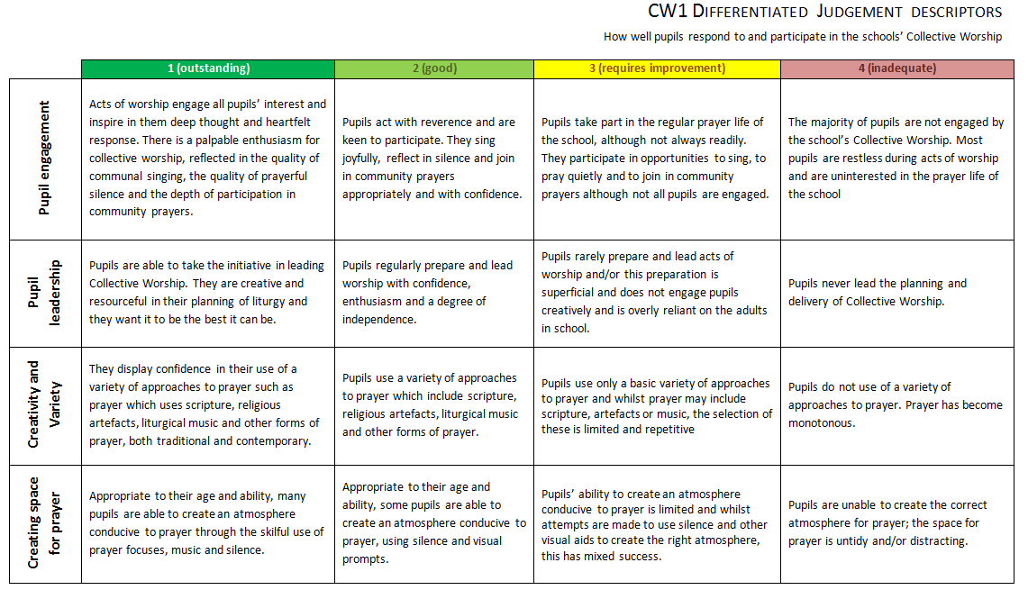
When beginning to arrive at a judgement about the quality of each area of school life, begin with the differentiated judgement grid and come to a decision about which descriptor best describes your school and indicate this by highlighting the grid in some way, e.g.:

2. Filling in the writing frame
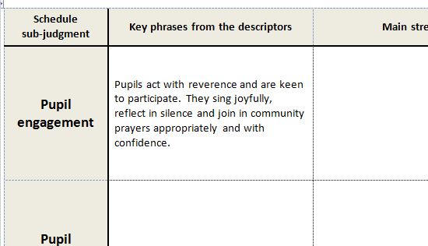
Key phrases from the descriptors: Once the differentiated judgement descriptor grid has been appropriately highlighted, take each circled judgement in turn and paste it into the writing frame in the appropriate place, e.g.:
Cut and pasted from differentiated judgement descriptors’ grid
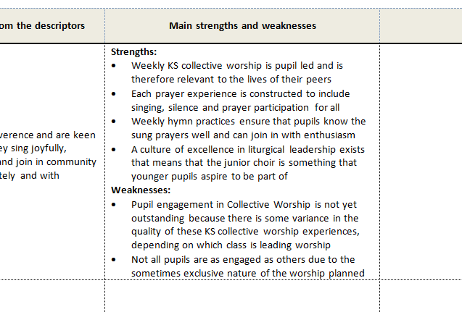
Main strengths and weaknesses: Next, indicate why you have given this area of the schedule the grade you have given it – and specifically why you have not judged it to be higher (if it is anything less than outstanding), e.g.:
Key strengths made clear in this area
Be clear on why this area has not been given a higher judgement
Evidence: Once this evaluation has been made, the evidence sources need to be listed in order to establish how certain the judgement is concerning this area of school life. This will also help an inspector during inspection to understand why you have given this grade for this area of the schedule. Evidence sources are stronger or weaker depending on how recent they are, how comprehensive they are and how objective and measurable the information they record is. E.g:
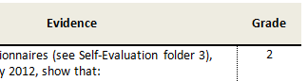
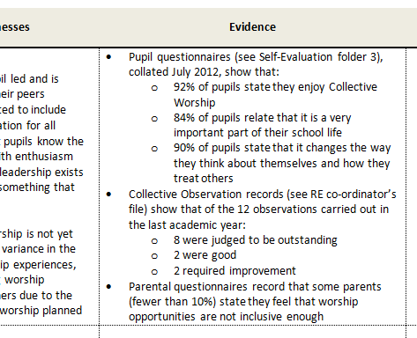
Grade: Assign a refined grade for this sub-judgement that reflects where you are in relation to this aspect of school life. E.g.:
Grade assigned
Evidence is listed – the more objective and measurable the better
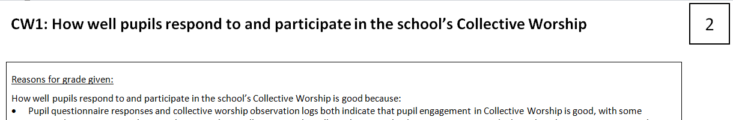
Summary: Once all sub-judgement areas of the schedule have been evaluated and written up in this way, then the overall judgement for the section of the schedule which these sub-judgements inform can then be filled in. First of all, looking at a balance of the grades given throughout this section of the toolkit, give youself an overall grade for this section of the schedule (E.g. CW1 – How well pupils respond to and participate in Collective Worship). The grade should reflect the balance of grades given across each of the sub-judgements:
Summary Grade assigned
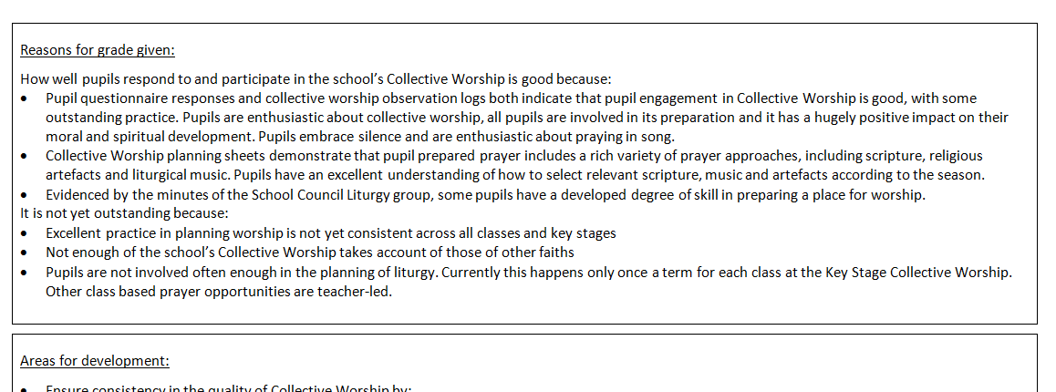
The summary text beneath should give an overall evidenced explanation of why you have assigned the grade you have to this section of the schedule, making it clear why you have not given it a higher grading:
Why it has not been given a higher grade
Summary reasons
Finally, areas for development should address the reasons given for not reaching the higher grade. These can then be cut and pasted to populate a school improvement plan:
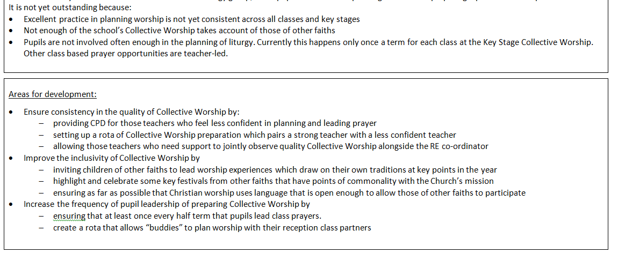
There should be a match between areas for development and the reasons given for not awarding a higher grade

3. Arriving at Headline and Overall Judgements
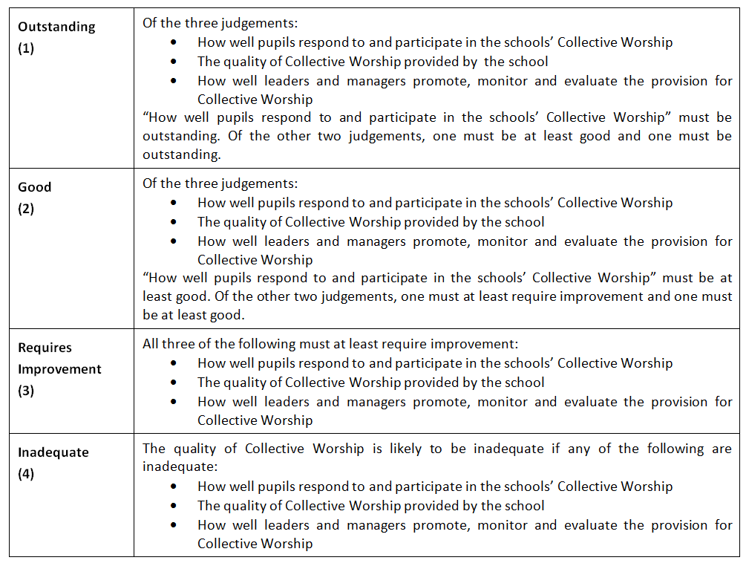
Headline Judgements. For each of the main sections of the schedule (Catholic Life, Collective Worship, Religious Education) you need to calculate a headline judgement. This does not require any additional text or evidence but is merely a summary of the three judgements in each section, arrived at by employing the descriptor given for each headline judgement:
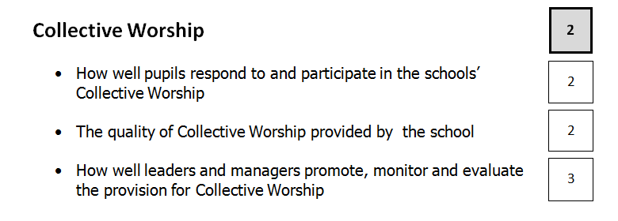
So each of these headline judgement tables would look something like this:
Overall effectiveness judgement. Finally, each of these headline judgement tables is used to populate the Overall Effectiveness summary table at the end of the toolkit. This again does not require any additional evidence or judgements but is merely a summary of each of the headline judgements, according to the descriptor given for Overall Effectiveness:
So each Overall Effectiveness summary table will look something like this:

4. SEF48 submission prior to inspection
Prior to each inspection, the inspector will request that you send the SEF48 to them. Completing this document is simply a matter of cutting and pasting the “Reasons for grade given” section for each of the nine SEF48 toolkit sections. This includes an additional first page that contains the relevant school data and information required for inspection, but which would not make up part of an annual self-evaluation.

