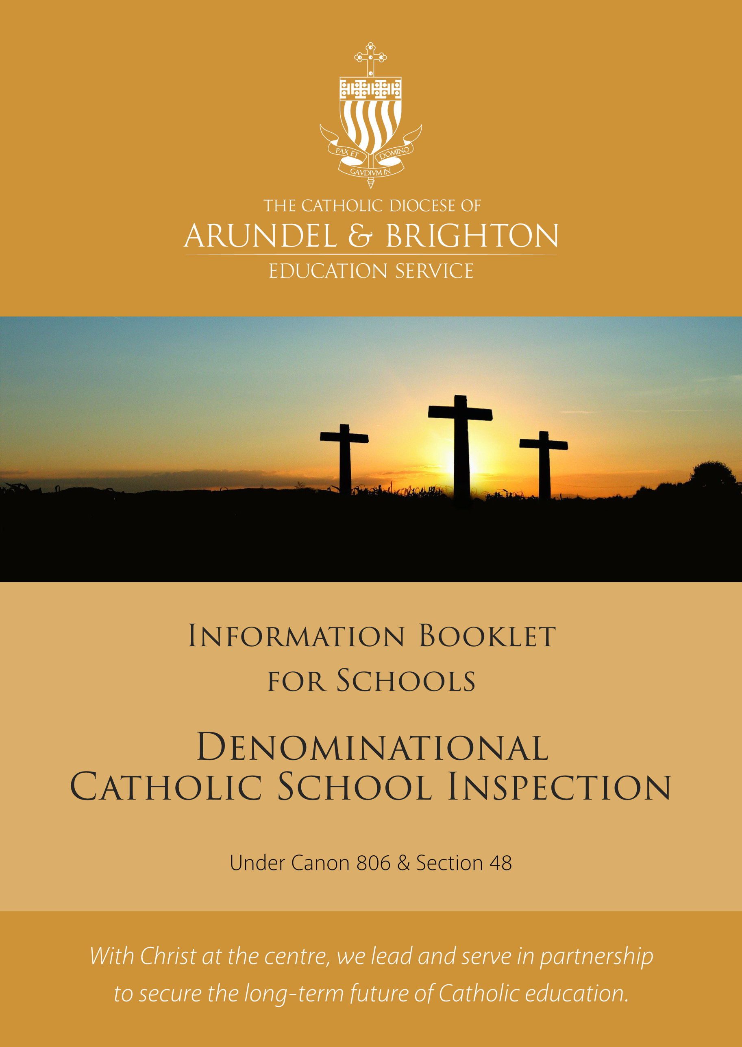
Introduction

All Catholic schools and academies (including Catholic independent and special schools) are subject to a diocesan inspection at least every five years. These inspections will be carried out by diocesan inspectors appointed by the bishop (Education Act 2005).

In July 2017, NBRIA (National Board of Inspectors and Advisers) produced updated guidelines for Canon 806 & Section 48 Inspection in Catholic schools. In response to the revised guidelines, the Education Service took the opportunity to review its existing policy and protocols for the inspection of diocesan schools and produced an updated evaluation schedule to be used from September 2019.

Policy Statement

The decoupling of inspections has remained since Ofsted’s recent notice to inspect all ‘Outstanding’ schools. 1 September 2019 DfE

What does this mean for Catholic School Inspection (Canon 806 & Section 48) Inspection?

The statutory position on the requirement for an inspection to be carried out as set in Section 48 of the Education Act 2005, has not changed. The Education (School Inspection) (England) Regulations 2009 (SI1564) set out the interval within which the inspections are required to take place is:

‘within 5 school years from end of the school year
within which the last inspection took place’.

All Catholic School Inspections (Under Canon 806 & Section 48) are scheduled independently from Ofsted’s Section 5, with the timing being determined by the outcome of the school’s last Catholic School Inspection as exemplified below:

Revised Schedule

- Every school judged ‘Good’ or ‘Outstanding’ at their last Catholic School Inspection will be scheduled for its next inspection within 5 school years from end of the school year within which they were last inspected. For example, if a school was inspected at any time during the academic year September 2014 - July 2015, the next inspection would be scheduled during the academic year September 2019 – July 2020. This means that an inspection should not normally take place at an interval of less than 5 years from the date of the previous inspection.

- Any school with a Catholic School Inspection (CSI) judgement that was less than ‘Good’ will be scheduled for a CSI at any point after 3 years from the date of its last CSI, but no later than 5 school years from the end of the school year within which the CSI took place. For example, if a school was inspected under Canon 806 and Section 48 in January 2015 the earliest it should be inspected again is September 2019. The latest date that the inspection could take place would be July 2020.

- Schools will be notified that a Catholic School Inspection will take place at the end of the preceding term of the inspection by email followed by a hard copy letter. Schools will then identify any unavailable dates in the term and communicate them to the Education Service at the St Philip Howard Centre, Crawley. Notice for the date that the Catholic School Inspection will take place is 5 working days. This notice will be given by the Lead Inspector by means of a pre-inspection phone call to the Headteacher.

Catholic School Inspection under Section 48 and Payment of Fees

At present, the Diocese receives funding to carry out Catholic School Inspections under Section 48 from the Department for Education. The funding covers a proportion of the inspection costs and the remainder is payable by the school once the inspection is completed and the report published.

In practice, the majority of primary schools will be inspected by 2 inspectors for one day and the majority of secondary schools will be inspected by 2 inspectors for one day and one inspector on two days. For each inspection a Lead Inspector (LI) and an Associate Inspector (AI) will be deployed to carry out the inspection.

Academies

Where an Academy is formally designated as having a religious character and delivers denominational education, this should be specified in the funding agreement for that Academy. The funding agreement should also specify the requirement for the Academy to arrange for the inspection of denominational education and collective worship to take place in line with the statutory position set out in Section 48 of the Education Act 2005 and the supporting regulations as specified above.

Where a school chooses to convert to Academy status, the date and the outcome of the last Catholic School Inspection for the predecessor school will be used to determine the timing of the first Catholic School Inspection of the Academy.

New Schools

Where a new voluntary-aided or academy / free school opens, Section 48 inspection should be scheduled no earlier than 2 years and no later than 3 years from the date of opening. Thereafter, the timing of inspections should be in line with the general guidance above.

Support for Schools

Catholic School Inspection Paperwork
Supporting documents and paperwork will be produced for schools providing information about the Catholic School Inspection process; in particular, highlighting what happens on the day(s) of an inspection. This can be found under the Education tab on the Diocesan website www.abdiocese.org.uk/education

Catholic School Inspection Self Evaluation Toolkit
A Self Evaluation Toolkit will be available for schools as an aid to preparations for inspection. Training for Senior Leaders, Governors, Heads of RE and RE coordinators will be available – details of which can be found in the annually updated CPD Handbook.

Diocesan Website
There is a section dedicated to Catholic School Inspection and will include a range of documents relating to the inspection process. www.abdiocese.org.uk/education

Recruitment and Training of Catholic School Inspectors
The Education Service has extended its pool of trained Catholic School Inspectors. All serving inspectors receive CPD throughout their term of office to ensure they are fully equipped for their role.

Sharing Best Practice
At the end of each academic year, a detailed analysis of schools’ Catholic School Inspection Reports will be carried out and used to inform future training for both schools and inspectors. Examples of best practice will be shared with schools through RE Coordinator meetings and Heads of RE meetings at the Education Service.

Please visit the Education Section on the Diocesan website regularly to keep up to date with available training opportunities and resources. www.abdiocese.org.uk/education

