Viewing and Adjusting Restricted Funds at Year End

To review changes to restricted funds during the year you need to use an “Extended Business Analysis: reporting by BI Code/Dimension” report. This will allow you to review income and expenditure according to the different funds affected.

GL Reports – Extended Business Analysis – Extended Business Analysis – Reporting By BI Code/Dimension

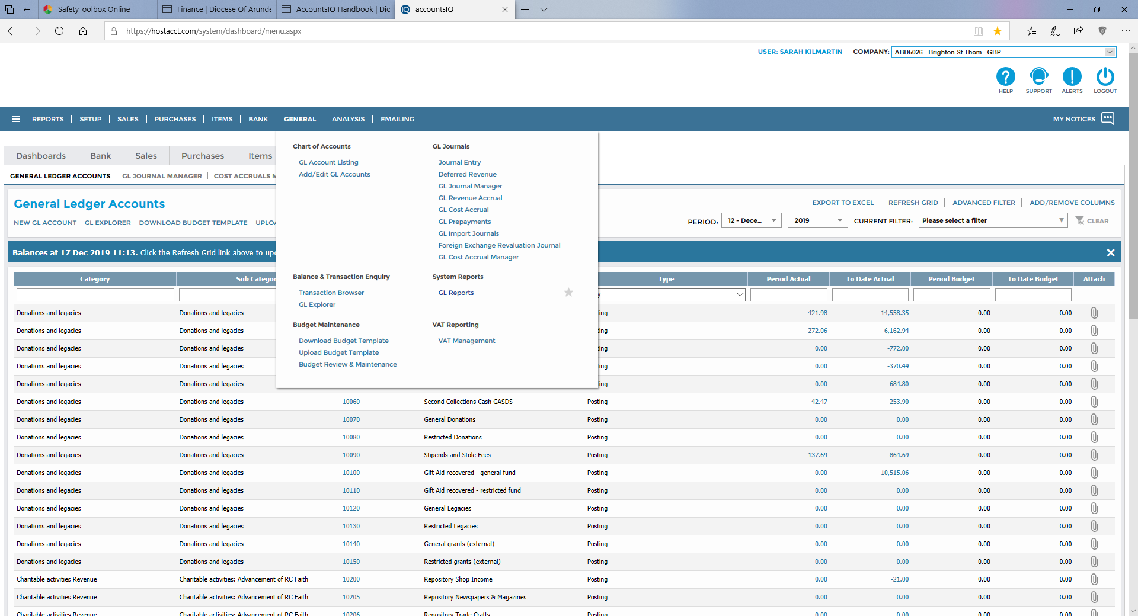

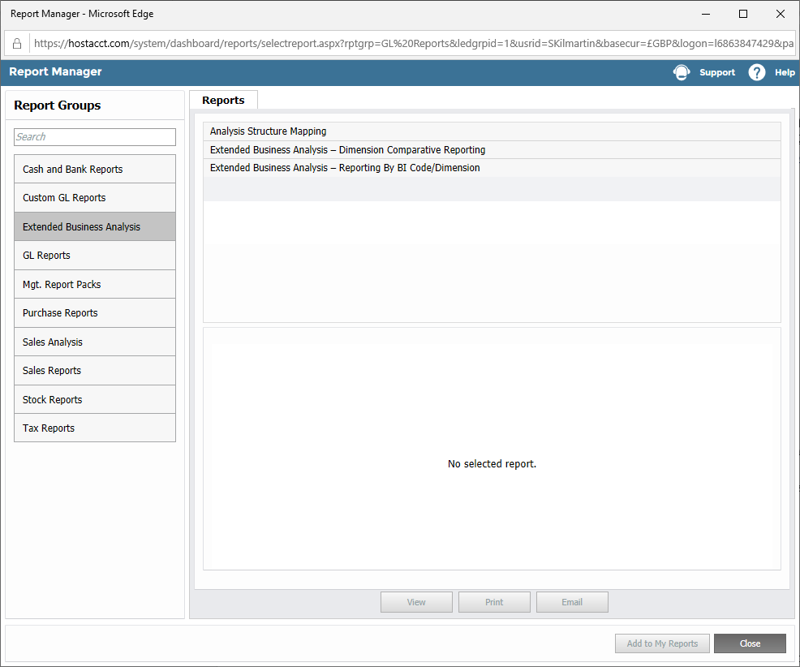

Enter Parameters for the report as per the screen shot below

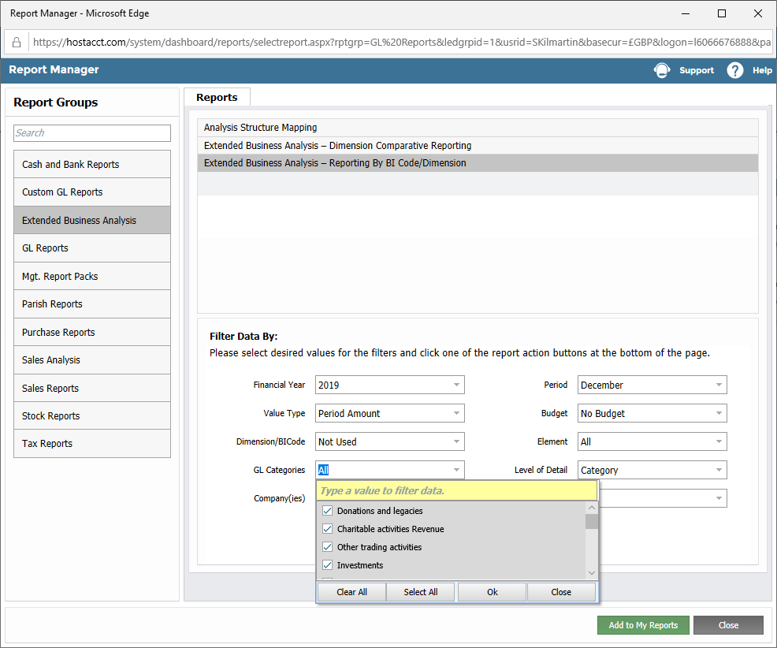

Note that **GL Categories required are the Profit and Loss general ledger codes**: so Tangible Fixed Assets, Financial Assets, Current Assets, Creditors and Charitable funds should be unticked within the GL Categories drop down list below. For “Element” SELECT ALL

This will then produce a report similar to this (after a short wait)



Then create a journal to account for restricted fund movements as follows, numbers taken from above report: -



Instructions for posting a Journal are on the Finance Website.

**Please note that positive funds on the balance sheet are negative. So to increase the restricted maintenance fund in the example above you will post a credit to the 90200 Account, using the relevant BI code for fund accounting.**

After processing the journal re-run the Extended Business Analysis report.

The report should now show restricted fund columns resulting in zero. The balance sheet will now reflect correct Restricted and General Funds. **The balance sheet can be run as part of the Parish Management Accounts pack.**



**If you need help with running reports or creating the year end fund journal please contact the finance team in Hove.**