5-Year Plan (2019 to 2024)
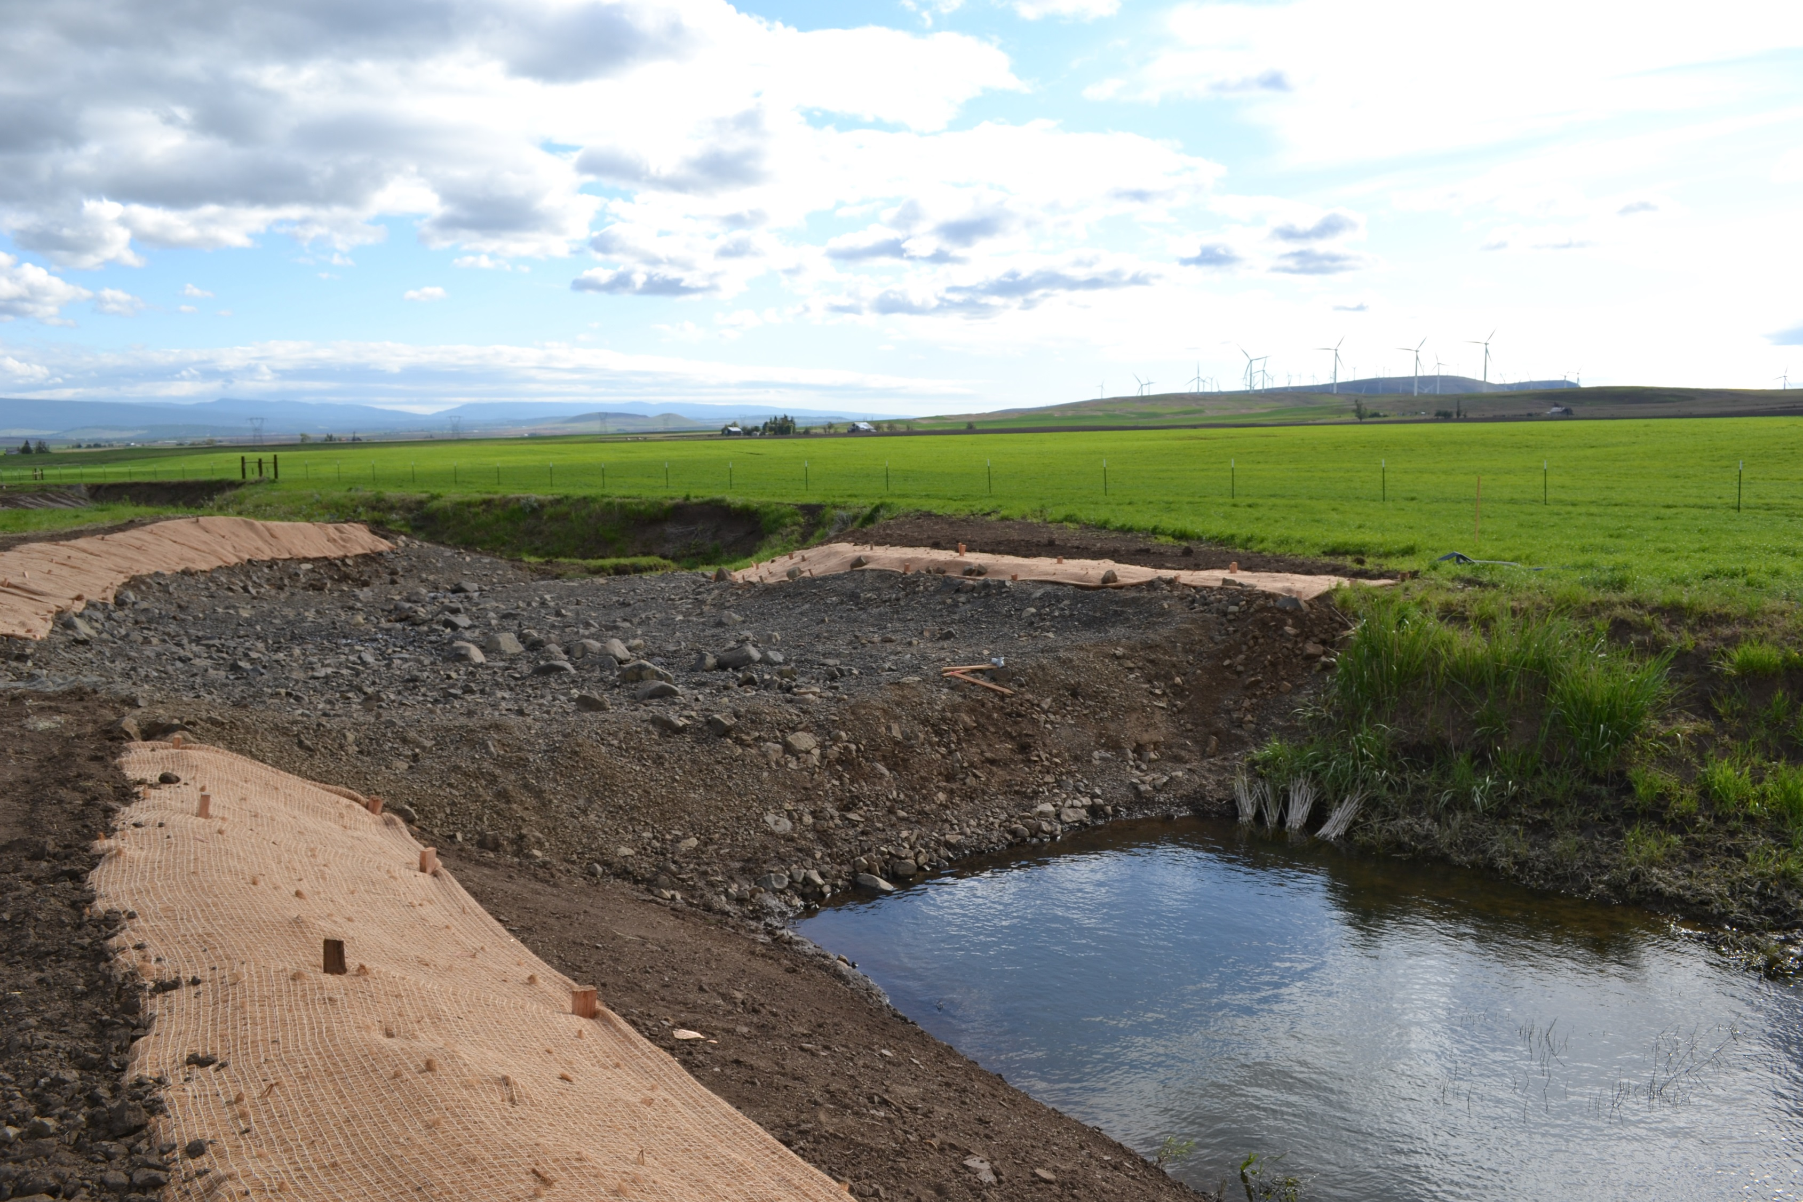

Central Klickitat Conservation District
For More Information Contact: Loren Meagher, P.E 509.773.5823, LM@CKCD.org
Organization of the Central Klickitat Conservation District
A political subdivision of the State of Washington – authorities, powers and structure contained in RCW 89.08.
- Established in 1946, CKCD has a full and varied history of conservation in Klickitat County. Our ultimate goal has always been and continues to be, cooperation with landowners to provide the most on-the-ground conservation for the dollars spent. As conservation practices progress, we have adopted the new technology to provide the best in conservation to our constituents.
Function of the Central Klickitat Conservation District
- To take available technical, financial and educational resources, whatever their source, and focus or coordinate them so that they meet the needs of the local land manager with conservation of soil, water and related natural resources.
Who We Serve & Why
- Citizens of Klickitat County between the Klickitat River and Rock Creek with a desire to conserve natural resources. Landowners and land managers who request assistance with natural resource concerns. Our goal is to improve, conserve and wisely use natural resources by providing technical assistance and financial resources to share in the cost of natural resource enhancement and conservation. CKCD seeks out opportunities to work with private landowners on a voluntary basis. CKCD is available to assist landowners’ by mediating and providing alternatives to outside regulatory requirements. CKCD demonstrates stewardship by example on district managed lands.
Mission of the Central Klickitat Conservation District
- The mission of the Central Klickitat CD is to improve, conserve and promote the wise use of natural resources by serving citizens within the CKCD through educational programs, public information, technical advice, and financial assistance.
Vision of the Central Klickitat Conservation District
- Increase financial stability through operational efficiencies, community support, and increased grant competitiveness via demonstrated success and project development.
Values of the Central Klickitat Conservation District
We believe in:
- Locally led grass roots conservation.
- Being a trusted local resource for natural resource management.
- Respecting private landowner rights.
- Sustaining working lands in Klickitat County.
- Implementing conservation projects that are beneficial to natural resources, landowners and the local community.
- Maintaining the respect and appreciation of our community.
- Promoting the understanding of landowner commitments and CKCD’s obligations to conservation efforts.
- The value of voluntary cooperation between CKCD and landowners.
- The wise use of natural resources.
- Cooperative, voluntary, incentive based conservation programs.
- Assisting landowners in being proactive in addressing natural resource conservation.
- Being a voluntary third party to assist landowners to comply with regulatory requirements.
- Cooperative partnerships with agencies and organizations that advance conservation.
Priority Natural Resource Conservation Needs & Geographic Areas, Measures of Success and Goals

Priority Natural Resource Conservation Need | Geographic Area
Forest & Rangeland Health Management  (forest health, fire prevention, wildlife habitat) | - East Simcoe Mountains  - Simcoe Mountains to Grayback  - Columbia Hills
Small Acreage Landowner Education  (small plots & fragmentation) | - Simcoe Mountains  - Little Klickitat Watershed  - Rock Creek upper watershed  - Old Mountain Road Area  - Pleasant Valley Area
Conservation Easements | - Swale Creek  - Luna Gulch  - Spring Creek  - Rock Creek  - Other prime agricultural land still in contiguous blocks  - Wildlife habitat areas in contiguous blocks
Soil Health (fertility, structure, PH, erosion) | - Agricultural land
Water Resources (quality and quantity) | - Little Klickitat watershed focus  - Rock Creek watershed focus  - Swale Creek watershed focus  - District wide
Wildlife Habitat Areas and Populations | - Simcoe Mountains  - Breaks of the Klickitat River  - Rock Creek Watershed  - Columbia River corridor  - District wide  - Mule Deer, Elk, Salmonids and others

Measures of Success & Measurable Goals: Format “By {date} the {natural resource} will {outcome}
Natural Resource Conservation Need | Measures of Success | Goals (by {date} {accomplishments}
Forest & Rangeland Health & Management  (forest health, fire prevention, wildlife habitat) | - Agreement(s) signed with partnering agencies to co-mange lands  - Implementation of Simcoe Unit management plan with DFW  - Public awareness  - Practices implemented & related impact (improvements)  - Education events, attendance & result  - CRM acres maintained | - Ongoing…continue to develop relationship with DFW, DNR, Klickitat County and others.  - By Dec 2019 have signed partnership plan with WDFW  - By January 2020 develop the management plan for CKCD and EKCD’s East Simcoe acquisition using the Simcoe Unit CRM developed plan as a guidance document.  - By April 2020 begin working with DNR on joint programs and projects benefiting Klickitat County  - By May 2021 develop a consistent funding source for land owners for forest health, technical assistance and cost share
Small Acreage Landowner Education (small plots & fragmentation) | - Increased participation in CD Programs  - Increased staff availability to respond to landowner requests | - By May 2021 expanded outreach with small landowners and engage them in addressing natural resource concerns.
Conservation Easements | - Implemented easements  - Have a local template for easements including milestones, timeline, criteria, and actions in partnership with CKCD and SCC  - Establish a funding source to support working with landowners to pursue conservation easements  - Landowner supported stewardship funds. | - Starting now, develop a plan for establishing C Klickitat legislatively at the state level and have sustainable funding by May 2024 including funding SCC’s OFP program to support local conservation easements  - By July 2020 complete a conservation easement purchase.  - By May 2021 figure out how to implement easement project(s) that are self-supporting, ie stewardship is funded.  - By May 2021 complete work to increase public land access. Evaluate alternatives to increase land user access to conservation easement areas.  - By May 2024 have multiple conservation easements completed on major tracks of agricultural ground under pressure from development in small watersheds with better farm ground.
Soil Health (fertility, structure, PH, erosion) | - Test & field trial results  - Productivity increased  - Soil Condition Index improvements  - Alternative Crops  - Specialty Crops | - By May 2020 increase tools available to assist landowners with soil health productivity.  - By June 2021 be successful in acquiring funding and implementing 1-2 soil health projects such as reduced tillage, alternative cropping methods or others.
Water Resources (quality and quantity) | - Aquifer levels  - Off stream storage  - Water chemistry (standards) | - By May 2024 have a demonstrated increase in BMPs implemented to improve water quality and/or water quantity
Wildlife Habitat and Populations | - Population numbers  - Reduction in invasive species  - Improved CD & Community relationships w agencies | - By May 2024 complete 3 habitat restoration projects
District Operations | - Accomplishing goals  - Increase funding levels (grants, rates & charges, SCC funds)  - Organization structure redefinition (chart)  - Adequate staffing capacity for program delivery  - Leverage funding to support project implementation and program services  - Community outreach | - By December 2019 hire an administrative assistant  - By December 2019 have a system of rates and charges implemented  - By January 2020 have an established a stable retirement plan and health plan for CD employees  - By Jan 2020 have agreements with partnering districts and CTD to have certified conservation planners available in CKCD  - By May 2020 develop a plan for establishing CKCD legislatively at the state level and have sustainable funding by May 2024  - By May 2021 have community outreach programs that address the resource issues in the district  - By Jan 2021 have our own certified conservation planner on staff  - By May 2022 get ahead of the curve – proactive in natural resource conservation work…leaders  - By May 2022 have youth development program for involving next generation in conservation activities, projects, activities, employment and new supervisors, into the district  - Maintain or obtain district staff as needed to accomplish funded activities  - Ongoing recruitment of associate supervisors and potential new supervisors

Land Manager Needs
- Financial assistance for conservation projects that meet the local landowner needs and interest.
- CD staff time to assist with project development, funding, permitting and implementation.
- Sustained access to quality technical assistance.
- Willing landowners (absentee)
- A resource to develop coordination & partnership with other organizations and agencies.
- Partner relations managers or ambassador
- Knowledge and education
- Field trials of working conservation – eg no-till, PH, pest control, cropping
- Recognition for good conservation work done…conservationist of the year
- Trusted CKCD contact to assist with government relations and identifying resources to assist with landowner needs.
- Conservation program identification and application assistance.
- Wildfire fuel reduction day and fuels reduction cost share.
- Technical assistance for plant species identification, planting recommendations and weed control.
- Regulatory certainty
- Information on good places to buy seed and program rules
- A guide (person) to help navigate through available programs.
- Contact with district technical staff for assistance.
- Policy champion to provide emphasis on state, local and federal policies that effect land owners…effectively and efficiently use resources.
- Education on land use for small acreage owners.
- Fiscal assistance for land owners/operators to try new technology, conservation practice (safety net).
- Good natural resource data and connection with landowner’s interest.
- Flexibility to prescribe practices to meet local needs.
- Be a facilitator from one land owner to another on resource needs and solutions.
- Relate cost share opportunities to land owners-operators.
- Farmland preservation techniques and information.
- Good working relationships and trust.
- Producer social network established and nurtured.
Milestones, Timeline & Actions

Natural Resource Conservation Need:
Forest & Rangeland Health Management (forest health, fire prevention, wildlife habitat)
Measurable Goal:
- Ongoing…continue to develop relationship with DFW, DNR, Klickitat County and others.
- By Dec 2019 have signed partnership plan with WDFW
- By January 2020 develop the management plan for CKCD and EKCD’s East Simcoe acquisition using the Simcoe Unit CRM developed plan as a guidance document.
- By April 2020 begin working with DNR on joint programs and projects benefiting Klickitat County
- By May 2021 develop a consistent funding source for landowners for forest health, technical assistance and cost share
Milestones | Timeline | Actions
Agreement drafted and presented to WDFW | By June 1, 2019 | - Completed
Management Team Meeting | Meet by July 30 | - Completed
Send signed partnership plan to DFW | By December 2019 | - Sign and send
Signed by WDFW | By August 10 | - Work with DFW to edit to mutual satisfaction
Working Draft – Forest Management Plan Developed | June 2020 | - Staff draft plan utilizing Simcoe Unit CRM as guideline  - Review and edit with forestry committee  - Present to CKCD and EKCD boards
Funded and planned fuels reduction projects | April 2020 | - Set up meeting with DNR to ID funding sources for project implementation  - Determine partnership roles  - Work with landowners to plan projects

Natural Resource Conservation Need
Small Acreage Landowner Education (small plots & fragmentation)
Measurable Goal:
- By May 2021 expanded outreach with small landowners and engage them in addressing natural resource concerns.
Milestones | Timeline | Actions
Contact landowners to establish degree of need for fuels reduction funding. | September 2020 | - Update list of landowners interested in fuels reduction projects to support legislative as for funds. Highlight repeat customers who have been unable to access funding to implement.
Public knowledge of land owner assistance available | June 2020 | - Send out annual newsletter with information on cost share program availability
Projects driven by land owner requests | May 2021 | - Seek out landowner concerns  - Find funds to address concerns  - Develop projects to research solutions or implement solutions

Natural Resource Conservation Need:
Conservation Easements
Measurable Goal:
- Starting now, develop a plan for establishing C Klickitat legislatively at the state level and have sustainable funding by May 2024 including funding SCC’s OFP program to support local conservation easements
- By July 2020 complete a conservation easement purchase.
- By May 2021 figure out how to implement easement project(s) that are self-supporting, ie stewardship is funded.
- By May 2021 complete work to increase public land access. Evaluate alternatives to increase land user access to conservation easement areas.
- By May 2024 have multiple conservation easements completed on major tracks of agricultural ground under pressure from development in small watersheds with better farm ground.
Milestones | Timeline | Actions
Secure agreement from SCC leadership to support and prioritize SCC funding | By August 2019 | - Invite SCC ED and OFP lead to attend CKCD board meeting to discuss
Complete conservation easement appraisals |  | - Solicit and secure appraisers  - Review and approve final report
Complete 1 conservation easement | By July 2020 | - Mediate between landowner and other entities to ensure progress is made and to assist in developing easement conditions that satisfy grant requirements and landowner needs.
Identify and submit multiple conservation easements for funding | By December 2020 | - Develop a list of interested landowners  - Have landowners complete an interest form  - Develop a ranking matrix to determine which easements to pursue based on likelihood of implementation success

Natural Resource Conservation Need
Soil Health (fertility, structure, PH, erosion)
Measurable Goal:
- By May 2020 increase tools available to assist landowners with soil health productivity.
- By June 2021 be successful in acquiring funding and implementing 1-2 soil health projects such as reduced tillage, alternative cropping methods or others.
Milestones | Timeline | Actions
Secure funding to work on soil health issues | By May 2020 | - Secure rates and charges  - ID and apply to grant resources
Identify potential landowners to have a working discussion of what they need for soil health activities | By June 2021 | - Contact local producers  - Send out a questionnaire  - Select 1-2 fundable projects and implement

Natural Resource Conservation Need:
Water Resources (quality and quantity)
Measurable Goal:
- By May 2024 have a demonstrated increase in BMPs implemented to improve water quality and/or water quantity
Milestones | Timeline | Actions
Develop a scope of work to submit for a grant application | December 2019 | - ID and develop projects that will compete well for statewide ecology grants
Increase the competitiveness of CKCD grant applications | May 2020 | - Develop projects to the conceptual design level to increase ability to compete for grant funds
CKCD funded to implement WQ improvement BMPs | October 2020 | - Submit grant to Ecology
Water Quality improvements completed | May 2024 | - Implement awarded projects

Natural Resource Conservation Need
Wildlife Habitat and Populations
Measurable Goal:
- By May 2024 complete 3 habitat restoration projects
Milestones | Timeline | Actions
ID habit restoration projects | By July 2020 | - Contact landowners with potential habitat restoration projects  - Conduct site visits to determine suitability of project  - Select projects to pursue
Secure landowner agreements to implement | By September 2020 | - Work with landowners to determine suitable funding source with acceptable landowner agreement requirements
Work with DFW to partner on implementing project | By December 2020 | - Meet regularly with DFW staff to develop good working relationships and projects
Secure funding for project | By July 2021 | - ID funding source  - Develop grant application  - Win grant funding award
Complete final report | By May 2024 | - Design habitat project  - Implement habitat project  - Document final results

Natural Resource Conservation Need
District Operations
Measurable Goal:
- By June 2019 hire an administrative assistant
- By December 2019 have a system of rates and charges implemented
- By January 2020 have an established a stable retirement plan and health plan for CD employees
- By Jan 2020 have agreements with partnering districts and CTD to have certified conservation planners available in CKCD
- By May 2020 develop a plan for establishing CKCD legislatively at the state level and have sustainable funding by May 2024
- By May 2021 have community outreach programs that address the resource issues in the district
- By Jan 2021 have our own certified conservation planner on staff
- By May 2022 get ahead of the curve – proactive in natural resource conservation work…leaders
- By May 2022 have youth development program for involving next generation in conservation activities, projects, activities, employment and new supervisors, into the district
- Ongoing, expand district staff to accomplish the goals
- Ongoing, recruitment of associate supervisors and potential new supervisors

Milestones | Timeline | Actions
Hire administrative position | July 2019 | Solicit for position, review applications, select applicants for interviews, schedule and hold interviews, check references, hold second interview if necessary, select administrative hire.
Rates and Charges Implemented | June 2019 | Develop required system of rates and charges, establish level of community support, present to county commissioners, hold public hearings by CD boards, inform landonwers, seek out support or concerns to address, request county commissioners to hold a public hearing and consider CD’s request to implement rates and charges.
Partner CD’s available to provide conservation planning |  | Establish MOU’s to share staff with CD’s that have employees capable and certified to write conservation plans
Be prepared for 2021 legislative session |  | ID priority legislative action areas  ID key contacts  Garner WACD and SCC support for CKCD legislative actions
Work with local school districts to involve students with CKCD programs/activities
Key Decision Makers
- Local landowners
- District Supervisors
- County Commissioners
- Each state and federal legislator
- Committees of state legislature
- WSCC
- Agencies we work with – local, state, federal
- WACD
- Presidents and Executive Directors of commodity organizations
Use of Strategic Plan:
- Share with elected officials.
- Base for stable funding proposals.
- Begin process for stable funding proposals.
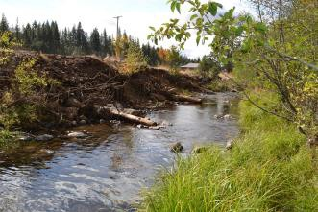
Washington Conservation Districts assisting land managers with their conservation choices

