Story Call-Out

Easy English Version

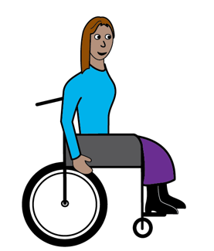

Are you a woman with disability?

Are you a girl with disability?

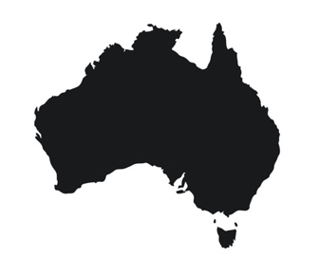

Do you live in Australia?

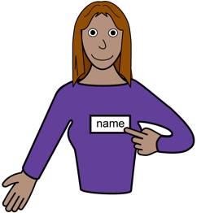
Yes?
We want to hear from you!

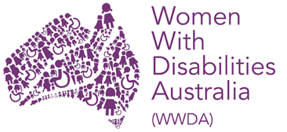
We are Women With Disabilities Australia. We will write WWDA to talk about us.

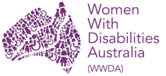
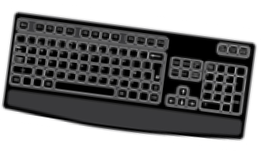
Our Site has a section called Real Stories. The Real Stories section is on Our Site.
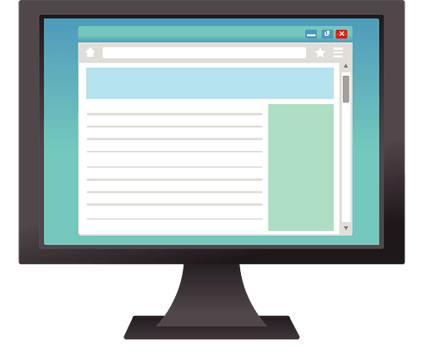
A story is where people share their stories about their lives and lived experiences.

Our Site Real Stories is about
- women and girls with disability
- who have a story to share.

Tell us your stories. We will put them on Our Site. Your story can be about different things, such as your experience as a woman or girl with disability in the workplace.
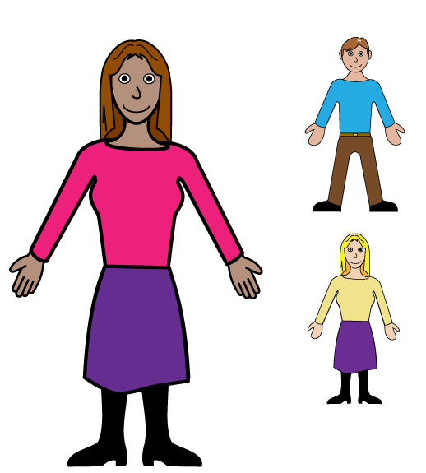
Your story can be about:
- a new job
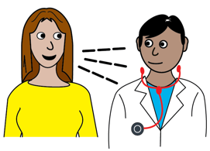
- speaking up for yourself
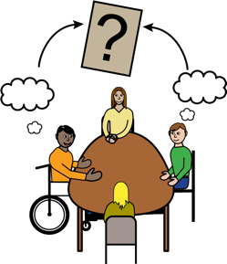
- going to a big event.

You can tell us your story using:
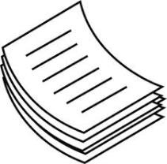
- words
- video
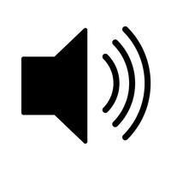
- sound
- pictures.

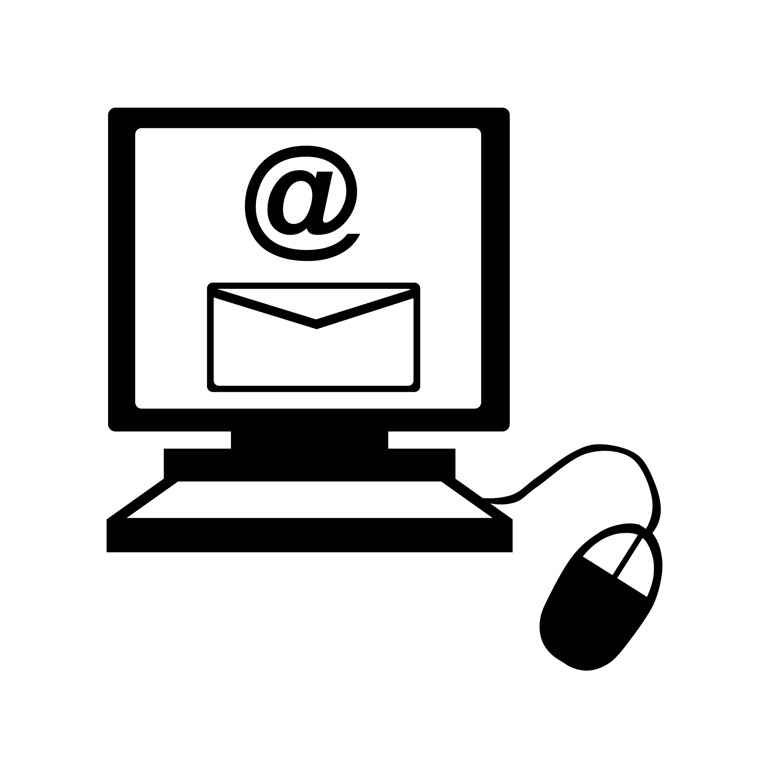
Send your story to WWDA by email.
Email oursite@wwda.org.au.

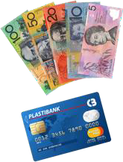
We will pay you $100 for your story.

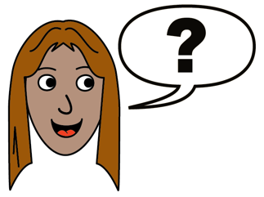
Do you have questions?
Email oursite@wwda.org.au.
Call 0476 540 751

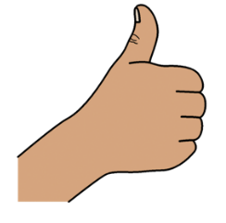
Thank you

Who wrote this document?
Women with Disabilities Australia wrote this document in 2020. This document is for information purposes only.

Copyright
© Copyright
Women with Disabilities Australia (WWDA) Inc. 2023.

All intellectual property rights, including copyright and patents, in this book is owned and licensed by Women with Disabilities Australia Inc.

The images used in this document
Easy on the I Images © 2018 Leeds and York Partnership NHS Foundation Trust. Used with permission. www.easyonthei.nhs.uk

