Women with
Disabilities Australia (ܢܸܫܹ̈ܐ ܕܐܝܼܬ ܠܗܘܿܢ ܫܲܦܠܘܼܬܵܐ ܐܘܿܣܬܪܵܠܝܼܵܐ)

ܓܸܢܣܵܐ ܘܦܲܓ݂ܪܵܟ݂ܝ

ܓܵܘ ܩܸܢܛܵܐ ܝܘܲܬܝ ܗܵܕܝܼܵܐ
ܩܪܝܼ ܩܵܐ 000

 | ܐܲܚܢܲܢ ܝܼܘܲܚ Women with Disabilities Australia (ܢܸܫܹ̈ܐ ܕܐܝܼܬܠܗܘܿܢ ܫܲܦܠܘܼܬܵܐ ܐܘܿܣܬܪܵܠܝܼܵܐ). ܒܸܕ ܟܵܬܒܲܚ WWDA ܐܝܼܡܲܢ ܕܗܲܡܙܸܡܲܚ ܒܘܼܬ ܓܵܢܲܢ.
 | ܐܵܗܵܐ ܟܬܵܒ݂ܵܐ ܝܼܠܹܗ ܒܘܼܬ ܓܸܢܣܵܐ ܘܦܲܓ݂ܪܵܟ݂ܝ.
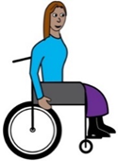  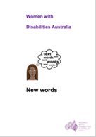 | ܐܲܚܢܲܢ ܟܬܝܼܒ݂ܠܲܢ ܐܵܗܵܐ ܟܬܵܒ݂ܵܐ ܩܵܐ ܢܸܫܹ̈ܐ ܘܒܢܵܬܹ̈ܐ ܕܐܝܼܬܠܗܘܿܢ ܫܲܦܠܘܼܬܵܐ. ܩܪܝܼ ܒܘܼܫ ܙܵܘܕܵܐ ܒܘܼܬ ܫܲܦܠܘܼܬܵܐ ܓܵܘ ܟܬܵܒ݂ܵܐ New words (ܚܲܒܪܵܢܹܵܐ ܚܲܕܬܹ̈ܐ).  .
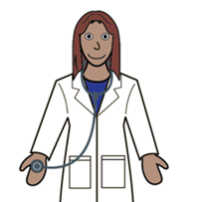 | ܙܸܕܩܵܟ݂̈ܝ ܕܚܘܼܠܡܵܢܵܐ  ܐܲܢ݇ܬܝ ܐܝܼܬܠܵܟ݂ܝ ܙܸܕܩܵܐ
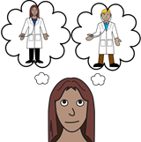 | - ܕܓܲܒܝܲܬܝ ܠܹܗ ܐܵܣܝܵܟ݂ܝ.
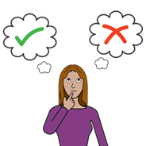 | - ܕܥܵܒ݂ܕܲܬܝ ܓܘܼܒܵܝܹ̈ܐ ܒܘܼܬ ܦܲܓ݂ܪܵܟ݂ܝ.
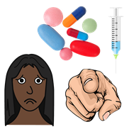 | - ܕܐܵܡܪܲܬܝ ܠܵܐ ܩܵܐ ܕܲܪ̈ܡܵܢܹܐ ܕܠܹܐ ܒܵܥܝܲܬܝ ܠܗܘܿܢ.

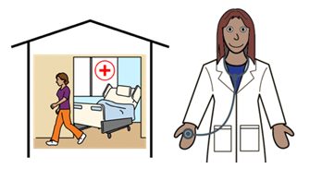 | ܚܸܠܡܲܬܹ̈ܐ ܕܚܘܼܠܡܵܢܵܐ  ܐܲܢ݇ܬܝ ܐܝܼܬܠܵܟ݂ܝ ܙܸܕܩܵܐ ܕܩܲܒܠܲܬܝ ܡܲܣܲܡܬܵܐ ܕܒܵܠܵܐ ܠܚܘܼܠܡܵܢܵܐ ܕܣܢܝܼܩܬܵܐ ܝܘܲܬܝ ܐܸܠܵܗ̇. ܐܲܝܟ݂
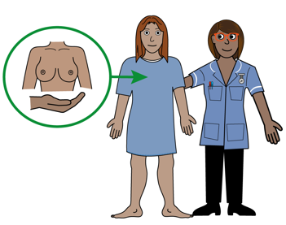 | - ܨܲܚܨܵܝܬܵܐ ܕܨܲܕܪܵܐ
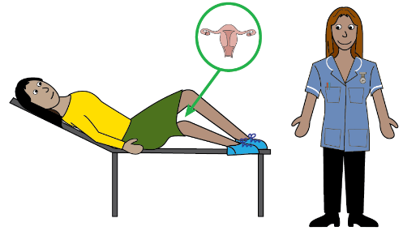 | - ܘܲܥܕܹ̈ܐ ܥܲܡ ܐܵܣܝܹ̈ܐ ܘܨܲܚܨܵܝܵܬܹ̈ܐ ܕܩܕܵܠܵܐ ܕܪܲܚܡܵܐ
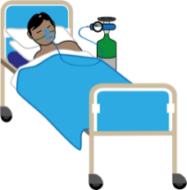 | - ܦܝܵܫܬܵܐ ܓܵܘ ܒܹܝܬ ܟܪ̈ܝܼܗܹܐ ܘܨܵܪܘܿܝܘܼܬܵܐ.
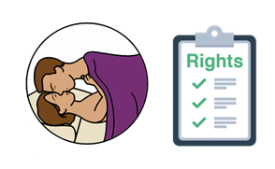 | ܙܸܕܩܵܐ ܕܫܲܘܬܲܦܬܵܐ ܓܸܢܣܵܢܵܝܬܵܐ
 | ܐܲܢ݇ܬܝ ܐܝܼܬܠܵܟ݂ܝ ܙܸܕܩܵܐ ܕܓܲܒܝܲܬܝ ܩܵܐ ܡܵܢܝܼ ܕܒܵܥܝܲܬܝ.
 | ܐܲܢ݇ܬܝ ܐܝܼܬܠܵܟ݂ܝ ܙܸܕܩܵܐ ܕܫܲܘܬܲܦܬܵܐ ܓܸܢܣܵܢܵܝܬܵܐ.
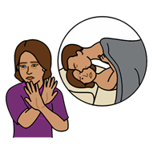 | ܐܲܢ݇ܬܝ ܐܝܼܬܠܵܟ݂ܝ ܙܸܕܩܵܐ ܕܐܵܡܪܲܬܝ ܠܵܐ ܩܵܐ ܫܲܘܬܲܦܬܵܐ ܓܸܢܣܵܢܵܝܬܵܐ.

ܡܲܟܠܵܝܬܵܐ ܕܒܛܝܼܢܘܼܬܵܐ
ܡܲܟܠܵܝܬܵܐ ܕܒܛܝܼܢܘܼܬܵܐ ܒܸܚܒ݂ܵܫܵܐ ܝܠܵܗ̇ ܡܸܢܕܝܼܵܢܹ̈ܐ ܕܡܲܦܠܸܚܲܬܝ ܠܗܘܿܢ
ܝܲܢ ܕܥܵܒ݂ܕܲܬܝ ܠܗܘܿܢ ܕܠܵܐ ܡܵܪܥܲܬܝ ܝܲܢ ܕܠܵܐ ܒܵܛܢܲܬܝ ܐܝܼܡܲܢ
ܕܫܲܘܬܘܼܦܹܐ ܝܘܲܬܝ ܓܸܢܣܵܢܵܐܝܼܬ.
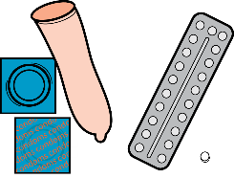 | ܐܝܼܬܠܵܟ݂ܝ ܙܸܕܩܵܐ ܕܓܲܒܝܲܬܝ ܐܘܼܪܚܵܐ ܕܡܲܟܠܵܝܬܵܐ ܕܒܛܝܼܢܘܼܬܵܐ. ܐܲܝܟ݂
 | - ܡܟܲܣܝܵܢܹ̈ܐ ܕܙܘܼܠܒܵܢܵܐ (ܟܘܿܢܕܘܿܡܣ)
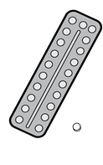 | - ܚܲܒܹ̈ܐ
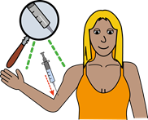 | - ܢܨܵܒ݂ܬܵܐ ܕܚܲܕ ܡܵܐܢܵܐ ܠܓܵܘ ܦܲܓ݂ܪܵܐ ܥܲܡ ܚܕܵܐ ܚܡܵܛܵܐ.

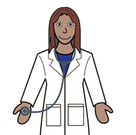 | ܡܵܨܝܲܬܝ ܕܗܲܡܙܸܡܲܬܝ ܥܲܡ ܐܵܣܝܵܟ݂ܝ ܒܘܼܬ ܓܘܼܒܵܝܹ̈ܐ ܕܩܵܐ ܡܲܟܠܵܝܬܵܐ ܕܒܛܝܼܢܘܼܬܵܐ.
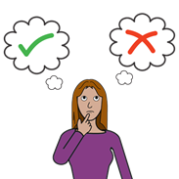 | ܐܵܗܵܐ ܚܲܕ ܓܘܼܒܵܝܵܐ ܕܕܝܼܵܟ݂ܝ ܝܠܸܗ!

ܒܛܝܼܢܘܼܬܵܐ ܘܓܘܼܒܵܝܹ̈ܐ
ܐܸܢ ܒܛܝܼܢ ܠܵܟ݂ܝ، ܐܲܢ݇ܬܝ ܐܝܼܬܠܵܟ݂ܝ ܙܸܕܩܵܐ ܕܓܲܒܝܲܬܝ ܒܘܼܬ ܡܘܿܕܝܼ ܥܵܒ݂ܕܲܬܝ.

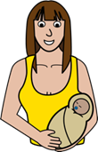 | ܡܵܨܝܲܬܝ ܕܝܵܠܕܲܬܝ ܚܲܕ ܝܵܢܘܿܩܵܐ ܘܕܗܵܘܝܲܬܝ ܚܕܵܐ ܝܸܡܵܐ.
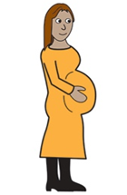 | ܡܵܨܝܲܬܝ ܕܡܲܪܝܸܙܲܬܝ ܚܕܵܐ ܡܲܪܚܲܫܬܵܐ ܕܒܛܝܼܢܘܼܬܵܐ. ܐܵܗܵܐ ܡܲܥܢܵܝܹܗ ܝܠܹܗ ܕܐ݇ܚܹܪ݇ܢܵܐ ܠܹܐ ܗܵܘܝܲܬܝ ܒܛܝܼܢܬܵܐ.
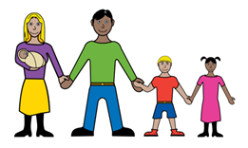 | ܡܵܨܝܲܬܝ ܕܝܵܠܕܲܬܝ ܠܹܗ ܝܲܢܩܵܐ ܘܕܝܵܗܒܲܬܝ ܠܹܗ ܩܵܐ ܣܝܵܡܬܵܐ ܕܒܢܘܿܢܹ̈ܐ. ܐܵܗܵܐ ܡܲܥܢܵܝܹܗ ܝܠܹܗ ܕܝܵܗܒܲܬܝ ܠܹܗ ܝܵܢܘܿܩܵܐ ܩܵܐ ܚܕܵܐ ܒܲܝܬܘܼܬܵܐ ܐ݇ܚܹܪ݇ܬܵܐ ܕܡܲܣܸܡܵܐ ܒܵܠܵܐ ܐܸܠܹܗ.

 | ܫܘܼܠܛܵܢܵܐ ܐܘܿܣܬܪܵܠܵܝܵܐ ܓܵܪܲܓ:
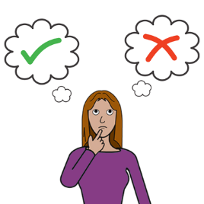
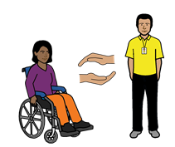 | - ܕܣܵܢܸܕܠܵܟ݂ܝ ܕܥܵܒ݂ܕܲܬܝ ܠܗܘܿܢ ܓܘܼܒܵܝܹ̈ܐ ܕܓܵܢܵܟ݂ܝ ܒܘܼܬ ܚܘܼܠܡܵܢܵܐ ܘܓܸܢܣܵܐ
 | - ܕܝܵܗܸܒ݂ܠܵܟ݂ܝ ܡܲܘܕܥܵܢܘܼܬܵܐ ܒܘܼܬ ܓܸܢܣܵܐ ܘܚܘܼܠܡܵܢܵܐ.
 | - ܕܚܲܬܸܬ (ܕܐܲܟܸܕ) ܕܐܲܢ݇ܬܝ ܡܵܨܝܲܬܝ ܕܡܵܛܝܲܬܝ ܠܚܸܠܡܲܬܹ̈ܐ ܕܚܘܼܠܡܵܢܵܐ ܕܣܢܝܼܩܬܵܐ ܝܘܲܬܝ ܐܸܠܲܝܗܝ.
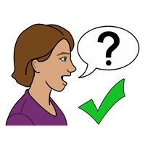 | ܠܸܝܕܵܥܝܵܐ ܒܘܼܫ ܙܵܘܕܵܐ  ܐܲܢ݇ܬܝ ܡܵܨܝܲܬܝ ܕܗܲܡܙܸܡܲܬܝ ܥܲܡ
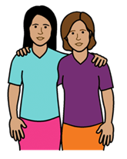 | - ܚܕܵܐ ܚܲܒܸܪܬܵܐ  - ܚܲܕ ܗܲܕܵܡܵܐ ܕܒܲܝܬܘܼܬܵܐ
- ܚܲܕ ܐܵܣܝܵܐ \ ܚܕܵܐ ܐܵܣܝܼܬܵܐ

- ܚܸܠܡܲܬܵܟ݂ܝ ܕܩܲܪܩܲܙܬܵܐ ܕܒܲܝܬܘܼܬܵܐ (Family Planning) ܕܓܵܘ ܦܢܝܼܬܵܟ݂ܝ.
ܣܲܚܒܸܪܝ ܠܫܵܘܦܵܐ www.familyplanningallianceaustralia.org.au/services
ܡܵܨܝܲܬܝ ܕܡܲܦܠܸܚܲܬܝ National Relay service (ܚܸܠܡܲܬ ܐܘ݂ܡܬܵܝܬܵܐ ܕܡܲܡܛܵܝܬܵܐ) ܐܝܼܡܲܢ ܕܡܲܚܒܘܼܪܹܐ ܝܘܲܬܝ ܩܵܐ ܚܕܵܐ ܚܸܠܡܲܬ ܒܬܹܠܝܼܦ̮ܘܿܢ
ܩܪܝܼ ܥܲܠ ܡܸܢܝܵܢܵܐ 1800 555 677
TTY 133 677

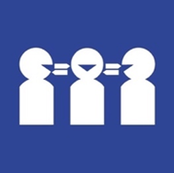 | ܣܢܝܼܩܬܵܐ ܝܘܲܬܝ ܠܚܲܕ ܡܬܲܪܓܡܵܢܵܐ  ܩܪܝܼ ܥܲܠ ܡܸܢܝܵܢܵܐ 131 450
ܗܵܘܝܲܬܝ ܒܲܣܝܼܡܬܵܐ

ܡܵܢܝܼ ܟܬܝܼܒ݂ܠܹܗ ܐܵܗܵܐ ܟܬܵܒ݂ܵܐ؟
Women with Disabilities Australia (ܢܸܫܹ̈ܐ ܕܐܝܼܬܠܗܘܿܢ ܫܲܦܠܘܼܬܵܐ ܐܘܿܣܬܪܵܠܝܼܵܐ) ܟܬܝܼܒ݂ܠܗܘܿܢ ܐܵܗܵܐ ܟܬܵܒ݂ܵܐ ܒܫܹܢ݇ܬܵܐ 2019-2020.
ܐܵܗܵܐ ܟܬܵܒ݂ܵܐ ܝܼܠܹܗ ܐܲܚܟ̰ܝܼ ܩܵܐ ܝܘܼܠܦܵܢܵܐ ܘܡܲܘܕܥܵܢܘܼܬܵܐ ܓܵܘܵܢܵܝܹ̈ܐ.

ܙܸܕܩܹ̈ܐ ܕܣܝܵܡܵܐ
© ܙܸܕܩܹ̈ܐ ܕܣܝܵܡܵܐ
Women with Disabilities Australia (WWDA) Inc. 2020
=
 | ܟܠܲܝܗܝ ܙܸܕܩܹ̈ܐ ܕܡܘܼܠܟܵܢܵܐ ܣܲܟܘܼܠܬܵܢܵܐ، ܒܸܚܒ݂ܵܫܵܐ ܙܸܕܩܸ̈ܐ ܕܣܝܵܡܵܐ ܘܙܘܼܕܵܩܹ̈ܐ ܕܒܵܪܘܿܝܘܼܬܵܐ، ܕܓܵܘ ܐܵܗܵܐ ܟܬܵܒ݂ܵܐ ܝܼܢܐ ܡܵܪܘܼܬܵܐ ܘܦܣܝܼܣܹܐ ܒܝܲܕ Women with Disabilities Australia Inc.
ܗܵܘܝܼܬܘܿܢ ܒܲܣܝܼܡܹܐ ܩܵܐ ܙܘܼܙܹ̈ܐ ܠܸܟܬܵܒܹܗ ܐܵܗܵܐ ܟܬܵܒ݂ܵܐ.
The National Disability Insurance Scheme (ܐܸܣܟܝܼܡܵܐ ܐܘܼܡܬܵܝܵܐ ܕܥܲܪܵܒ݂ܘܼܬܵܐ ܕܫܲܦܠܘܼܬܵܐ) ܝܗܝܼܒ݂ܠܗܘܿܢ ܚܕܵܐ ܟܡܵܝܘܼܬܵܐ ܕܙܘܼܙܹ̈ܐ ܩܵܐ Women with Disabilities Australia (ܢܸܫܹ̈ܐ ܕܐܝܼܬܠܗܘܿܢ ܫܲܦܠܘܼܬܵܐ ܐܘܿܣܬܪܵܠܝܼܵܐ) ܠܗܲܝܘܼܪܹܐ ܒܒܢܵܝܬܵܐ ܕܐܵܗܵܐ ܫܵܘܦܵܐ ܐܹܠܸܟܪܘܿܢܵܝܵܐ.

ܨܘܼܪ̈ܝܵܬܹܐ ܡܘܼܦܠܸܚܹܐ ܓܵܗ ܐܵܗܵܐ ܟܬܵܒ݂ܵܐ
Easy on the I Images © 2019 Leeds and York Partnership NHS Foundation Trust. ܦܝܼܫܹܐ ܝܢܵܐ ܡܘܼܦܠܸܚܹܐ ܒܦܣܵܣܵܐ. www.easyonthei.nhs.uk
The Picture Communication Symbols © 2019 by Mayer Johnson LLC a Tobii Dynavox company. ܦܝܼܫܹܐ ܝܢܵܐ ܡܘܼܦܠܸܚܹܐ ܒܦܣܵܣܵܐ. www.tobiidynavox.com
ܨܲܠܡܹ̈ܐ. ܦܝܼܫܹܐ ܝܢܵܐ ܡܘܼܦܠܸܚܹܐ ܒܦܣܵܣܵܐ.

