Women with
Disabilities Australia (ܢܸܫܹ̈ܐ ܕܐܝܼܬ ܠܗܘܿܢ ܫܲܦܠܘܼܬܵܐ ܐܘܿܣܬܪܵܠܝܼܵܐ)
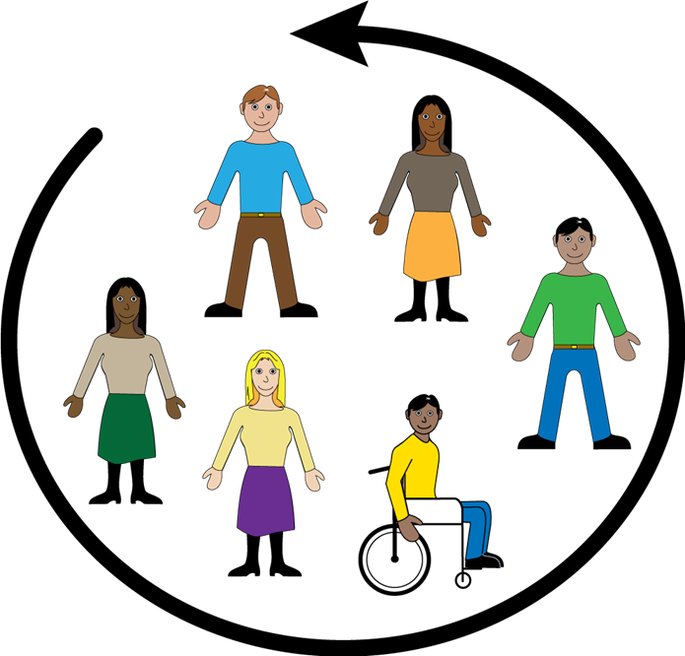

ܡܗܲܕܝܼ ܘܫܲܘܬܸܦ
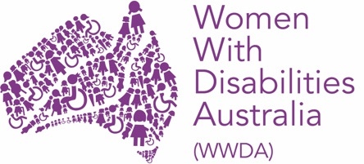

ܐܲܚܢܲܢ ܝܼܘܲܚ Women with Disabilities Australia (ܢܸܫܹ̈ܐ ܕܐܝܼܬܠܗܘܿܢ ܫܲܦܠܘܼܬܵܐ ܐܘܿܣܬܪܵܠܝܼܵܐ).
ܒܸܕ ܟܵܬܒܲܚ WWDA ܐܝܼܡܲܢ ܕܗܲܡܙܸܡܲܚ ܒܘܼܬ ܓܵܢܲܢ.
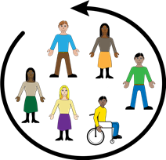 | ܐܵܗܵܐ ܟܬܵܒ݂ܵܐ ܝܼܠܹܗ ܒܘܼܬ ܙܸܕܩܵܟ݂ܝ ܠܡܗܲܕܘܼܝܹܐ ܘܠܫܲܘܬܘܼܦܹܐ
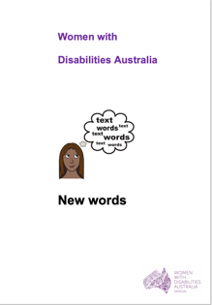  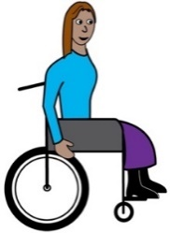 | ܐܲܚܢܲܢ ܟܬܝܼܒ݂ܠܵܢ ܐܵܗܵܐ ܟܬܵܒ݂ܵܐ ܩܵܐ ܢܸܫܹ̈ܐ ܘܒܢܵܬܹ̈ܐ ܕܐܝܼܬܠܗܘܿܢ ܫܲܦܠܘܼܬܵܐ. ܩܪܝܼ ܒܘܼܫ ܙܵܘܕܵܐ ܒܘܼܬ ܫܲܦܠܘܼܬܵܐ ܓܵܘ ܟܬܵܒܲܢ New Words (ܚܲܒܪܵܢܹ̈ܐ ܚܲܕܬܹ̈ܐ).  .
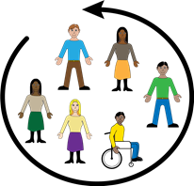 | ܫܲܘܬܲܦܬܵܐ  ܐܵܗܵܐ ܡܲܥܢܵܝܹܗ ܝܼܠܹܗ ܠܫܲܘܬܘܼܦܹܐ ܓܵܘ ܡܸܢܕܝܼܵܢܹ̈ܐ. ܐܲܝܟ݂
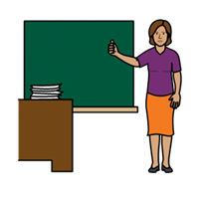 | - ܡܵܨܝܲܬܝ ܕܐܵܙܲܠ݇ܬܝ ܠܡܲܕܪܲܫܬܵܐ
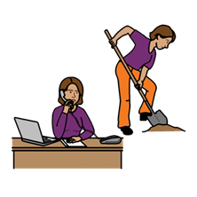 | - ܡܵܨܝܲܬܝ ܕܦܵܠܚܲܬܝ
      - ܡܵܨܝܲܬܝ ܕܐܵܙܲܠ݇ܬܝ ܠܩܲܘܲܡܝܵܬ̈ܐ.

ܘ
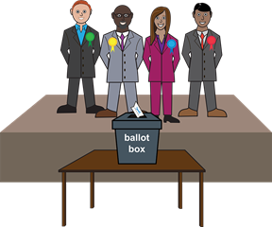 | - ܡܵܨܝܲܬܝ ܕܕܵܪܝܲܬܝ ܩܵܠܵܐ ܓܵܘ ܓܲܒܵܝܵܬܹ̈ܐ.
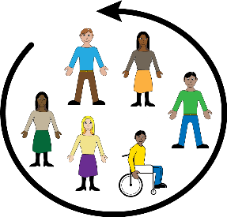 | ܐܲܢ݇ܬܝ ܐܝܼܬܠܵܟ݂ܝ ܙܸܕܩܵܐ ܠܫܲܘܬܘܼܦܹܐ.

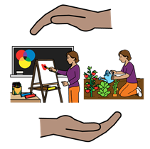 | ܢܸܫܹ̈ܐ ܘܒܢܵܬܹ̈ܐ ܕܐܝܼܬܠܗܘܿܢ ܫܲܦܠܘܼܬܵܐ ܐܝܼܬܠܗܘܿܢ ܙܸܕܩܵܐ ܕܩܲܒܠܝܼ ܗܲܝܲܪܬܵܐ ܕܣܢܝܼܩܹܐ ܝܢܵܐ ܐܸܠܵܗ̇ ܠܫܲܘܬܘܼܦܹܐ. ܐܲܝܟ݂
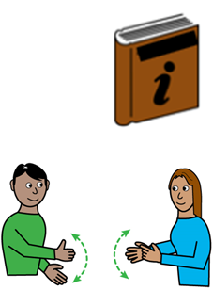 | - ܡܲܘܕܥܵܢܘܼܬܵܐ ܒܐܘܼܪ̈ܚܵܬܹܐ ܦܪ̈ܝܼܫܹܐ. ܐܲܝܵܐ ܒܲܠܟܵܐ ܕܗܵܘܝܵܐ  - ܒܠܸܫܵܢܵܐ ܐܸܢܓܠܸܣܵܝܵܐ ܦܫܝܼܛܵܐ  - ܒܐܵܬܘܵܬܹ̈ܐ ܓܲܪ̈ܘܼܣܹܐ  - ܒܪܸܡܙܹ̈ܐ.
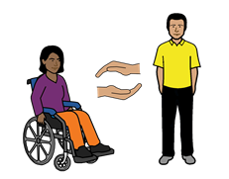 | - ܚܲܕ ܦܵܠܵܚܵܐ ܕܣܢܵܕܬܵܐ ܠܗܲܝܘܼܪܲܟ݂ܝ.
 | ܫܘܼܠܛܵܢܵܐ ܐܘܿܣܬܪܵܠܵܝܵܐ ܓܵܪܲܓ ܕܣܵܢܸܕ ܩܵܐ ܩܘܼܒܘܼܚܝܵܬܹ̈ܐ ܕܦܝܼܫܹܐ ܝܢܵܐ ܡܘܼܪܚܸܛܹܐ ܒܝܲܕ ܢܸܫܹ̈ܐ ܕܐܝܼܬܠܗܘܿܢ ܫܲܦܠܘܼܬܵܐ
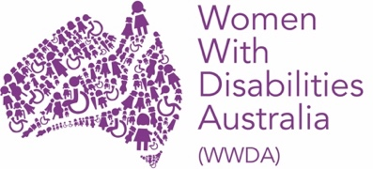 | ܐܲܝܟ݂  - Women with Disabilities Australia  (ܢܸܫܹ̈ܐ ܕܐܝܼܬܠܗܘܿܢ ܫܲܦܠܘܼܬܵܐ ܐܘܿܣܬܪܵܠܝܼܵܐ)
 | - Women with Disabilities Victoria (ܢܸܫܹ̈ܐ ܕܐܝܼܬܠܗܘܿܢ ܫܲܦܠܘܼܬܵܐ ܒ݂ܝܼܟܬܘܿܪܝܵܐ)
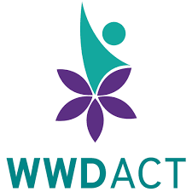 | - Women with Disabilities ACT (ܢܸܫܹ̈ܐ ܕܐܝܼܬܠܗܘܿܢ ܫܲܦܠܘܼܬܵܐ ACT)
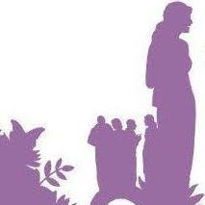 | - Women with Disabilities WA (ܢܸܫܹ̈ܐ ܕܐܝܼܬܠܗܘܿܢ ܫܲܦܠܘܼܬܵܐ WA).
 | ܫܘܼܠܛܵܢܵܐ ܐܘܿܣܬܪܵܠܵܝܵܐ ܐܵܦ ܓܵܪܲܓ
 | - ܕܝܵܗܸܒ݂ ܡܲܘܕܥܵܢܘܼܬܵܐ ܩܵܐ ܢܸܫܹ̈ܐ ܘܒܢܵܬܹ̈ܐ ܕܐܝܼܬܠܗܘܿܢ ܫܲܦܠܘܼܬܵܐ ܒܘܼܬ ܕܵܐܟ݂ܝܼ ܠܫܲܘܬܘܼܦܹܐ ܓܵܘ ܡܸܢܕܝܼܵܢܹ̈ܐ
 | - ܕܝܵܗܸܒ݂ ܙܘܼܙܹ̈ܐ ܠܗܲܝܘܼܪܹܐ ܩܵܐ ܢܸܫܹ̈ܐ ܘܒܢܵܬܹ̈ܐ ܕܐܝܼܬܠܗܘܿܢ ܫܲܦܠܘܼܬܵܐ ܕܫܲܘܬܸܦܝܼ ܘܕܗܵܘܝܼ ܡܗܲܕܝܵܢܹ̈ܐ
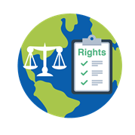 | - ܕܝܵܗܸܒ݂ ܡܲܘܕܥܵܢܘܼܬܵܐ ܩܵܐ United Nations (ܐܸܡܘܵܬܹ̈ܐ ܡܚܲܝܕܹ̈ܐ) ܒܘܼܬ ܢܸܫܹ̈ܐ ܘܒܢܵܬܹ̈ܐ ܕܐܝܼܬܠܗܘܿܢ ܫܲܦܠܘܼܬܵܐ.

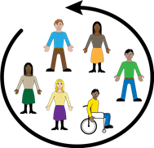 |  | ܬܵܡܵܐ ܐܝܼܬ ܩܵܢܘܿܢܹ̈ܐ ܬܹܒܹܝܠܵܝܹ̈ܐ ܕܒܸܐܡܵܪܵܐ ܝܢܵܐ ܕܢܸܫܹ̈ܐ ܘܒܢܵܬܹ̈ܐ ܕܐܝܼܬܠܗܘܿܢ ܫܲܦܠܘܼܬܵܐ ܐܝܼܬܠܗܘܿܢ ܙܸܕܩܵܐ ܠܫܲܘܬܘܼܦܹܐ. ܐܲܝܟ݂
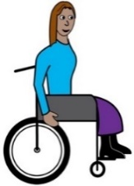  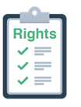 |  | - UN Convention on the Rights of Persons  with Disabilities (ܐܵܘܝܘܼܬܵܐ ܕܐܸܡܘܵܬܹ̈ܐ ܡܚܲܝܕܹ̈ܐ ܥܲܠ ܙܸܕܩܹ̈ܐ ܕܦܲܪ̈ܨܘܿܦܹܐ ܕܐܝܼܬܠܗܘܿܢ ܫܲܦܠܘܼܬܵܐ)
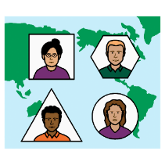 |  | - International Covenant on Economic, Social and Cultural Rights (ܩܝܵܡܵܐ ܬܹܒܹܝܠܵܝܵܐ ܕܙܸܕܩܹ̈ܐ ܐܝܼܩܘܿܢܘܿܡܵܝܹ̈ܐ ܘܫܲܘܬܵܦܵܝܹ̈ܐ ܘܡܲܪ̈ܕܘܼܬܵܢܵܝܹܐ)
 |  | - ܫܘܼܠܛܵܢܵܐ ܐܘܿܣܬܪܵܠܵܝܵܐ ܓܪܝܼܫܵܐ ܝܠܹܗ ܕܪܲܥܢܵܐ ܥܲܠ ܘܵܪܵܩܹ̈ܐ ܒܘܼܬ ܐܲܢܹܐ ܩܵܢܘܿܢܹ̈ܐ. ܫܘܼܠܛܵܢܵܐ ܐܘܿܣܬܪܵܠܵܝܵܐ ܓܵܪܲܓ ܕܫܵܠܸܡ ܠܐܲܢܹܐ ܩܵܢܘܿܢܹ̈ܐ.
ܗܵܘܝܲܬܝ ܒܲܣܝܼܡܬܵܐ

ܡܵܢܝܼ ܟܬܝܼܒ݂ܠܹܗ ܐܵܗܵܐ ܟܬܵܒ݂ܵܐ؟
Women with Disabilities Australia (ܢܸܫܹ̈ܐ ܕܐܝܼܬܠܗܘܿܢ ܫܲܦܠܘܼܬܵܐ ܐܘܿܣܬܪܵܠܝܼܵܐ) ܟܬܝܼܒ݂ܠܗܘܿܢ ܐܵܗܵܐ ܟܬܵܒ݂ܵܐ ܒܫܹܢ݇ܬܵܐ 2019.
ܐܵܗܵܐ ܟܬܵܒ݂ܵܐ ܝܼܠܹܗ ܐܲܚܟ̰ܝܼ ܩܵܐ ܝܘܼܠܦܵܢܵܐ ܘܡܲܘܕܥܵܢܘܼܬܵܐ ܓܵܘܵܢܵܝܹ̈ܐ.

ܙܸܕܩܹ̈ܐ ܕܣܝܵܡܵܐ
© ܙܸܕܩܹ̈ܐ ܕܣܝܵܡܵܐ
Women with Disabilities Australia (WWDA) Inc. 2019
 | ܟܠܲܝܗܝ ܙܸܕܩܹ̈ܐ ܕܡܘܼܠܟܵܢܵܐ ܣܲܟܘܼܠܬܵܢܵܐ، ܒܸܚܒ݂ܵܫܵܐ ܙܸܕܩܸ̈ܐ ܕܣܝܵܡܵܐ ܘܙܘܼܕܵܩܹ̈ܐ ܕܒܵܪܘܿܝܘܼܬܵܐ، ܕܓܵܘ ܐܵܗܵܐ ܟܬܵܒ݂ܵܐ ܝܼܢܐ ܡܵܪܘܼܬܵܐ ܘܦܣܝܼܣܹܐ ܒܝܲܕ Women with Disabilities Australia Inc.
ܗܵܘܝܼܬܘܿܢ ܒܲܣܝܼܡܹܐ ܩܵܐ ܙܘܼܙܹ̈ܐ
The National Disability Insurance Scheme (ܐܸܣܟܝܼܡܵܐ ܐܘܼܡܬܵܝܵܐ ܕܥܲܪܵܒ݂ܘܼܬܵܐ ܕܫܲܦܠܘܼܬܵܐ) ܝܗܝܼܒ݂ܠܗܘܿܢ ܚܕܵܐ ܟܡܵܝܘܼܬܵܐ ܕܙܘܼܙܹ̈ܐ ܩܵܐ Women with Disabilities Australia (ܢܸܫܹ̈ܐ ܕܐܝܼܬܠܗܘܿܢ ܫܲܦܠܘܼܬܵܐ ܐܘܿܣܬܪܵܠܝܼܵܐ) ܠܗܲܝܘܼܪܹܐ ܒܒܢܵܝܬܵܐ ܕܐܵܗܵܐ ܫܵܘܦܵܐ ܐܹܠܸܟܪܘܿܢܵܝܵܐ.

ܨܘܼܪܝܵܬܹ̈ܐ ܡܘܼܦܠܸܚܹܐ ܓܵܘ ܐܲܝܵܐ ܘܲܪܵܩܬܵܐ ܕܡܲܘܕܥܵܢܘܼܬܵܐ
Easy on the I Images © 2018 Leeds and York Partnership NHS Foundation Trust. ܦܝܼܫܹܐ ܝܢܵܐ ܡܘܼܦܠܸܚܹܐ ܒܦܣܵܣܵܐ. www.easyonthei.nhs.uk
ܨܲܠܡܹ̈ܐ ܕܫܘܼܬܐܵܣܹ̈ܐ ܕܐ݇ܢܵܫܹ̈ܐ ܕܐܝܼܬܠܗܘܿܢ ܫܲܦܠܘܼܬܵܐ. ܦܝܼܫܹܐ ܝܢܵܐ ܡܘܼܦܠܸܚܹܐ ܒܦܣܵܣܵܐ.

