Women with
Disabilities Australia(ܢܸܫܹ̈ܐ ܕܐܝܼܬ ܠܗܘܿܢ ܫܲܦܠܘܼܬܵܐ ܐܘܿܣܬܪܵܠܝܼܵܐ)
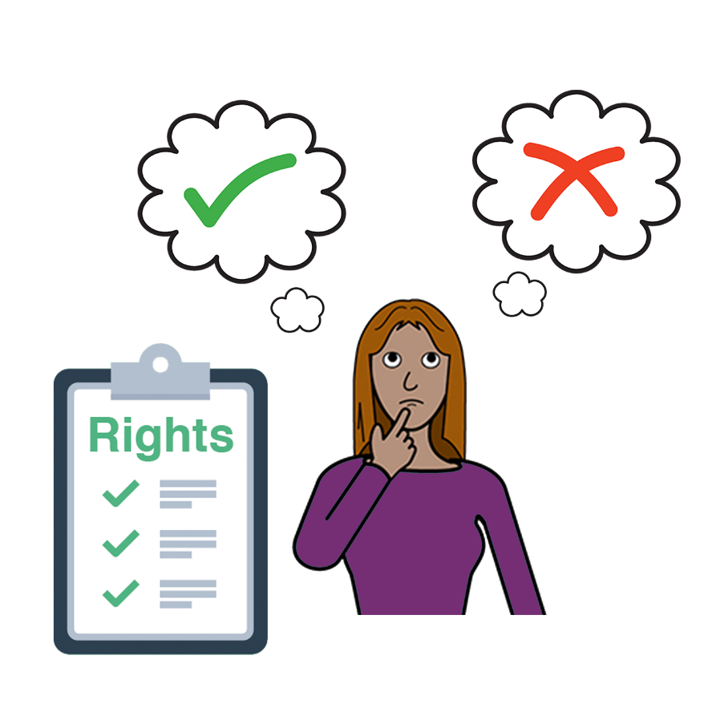

ܙܸܕܩܵܘܟ݂ܘܿܢ ܠܸܥܒ݂ܵܕܵܐ ܓܘܼܒܵܝܹ̈ܐ

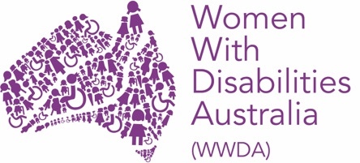
ܐܲܚܢܲܢ ܝܼܘܲܚ Women with Disabilities Australia (ܢܸܫܹ̈ܐ ܕܐܝܼܬܠܗܘܿܢ ܫܲܦܠܘܼܬܵܐ ܐܘܿܣܬܪܵܠܝܼܵܐ).
ܒܸܕ ܟܵܬܒܲܚ WWDA ܐܝܼܡܲܢ ܕܗܲܡܙܸܡܲܚ ܒܘܼܬ ܓܵܢܲܢ.
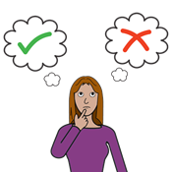 | ܐܵܗܵܐ ܟܬܵܒ݂ܵܐ ܝܼܠܹܗ ܒܘܼܬ ܓܘܼܒܵܝܹ̈ܐ.
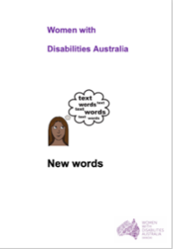  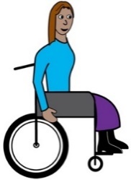 | ܐܲܚܢܲܢ ܟܬܝܼܒ݂ܠܲܢ ܐܵܗܵܐ ܟܬܵܒ݂ܵܐ ܩܵܐ ܢܸܫܹ̈ܐ ܘܒܢܵܬܹ̈ܐ ܕܐܝܼܬܠܗܘܿܢ ܫܲܦܠܘܼܬܵܐ. ܩܪܝܼ ܒܘܼܫ ܙܵܘܕܵܐ ܒܘܼܬ ܫܲܦܠܘܼܬܵܐ ܓܵܘ ܟܬܵܒܲܢ New Words (ܚܲܒܪܵܢܹ̈ܐ ܚܲܕܬܹ̈ܐ).

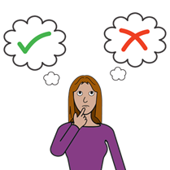 | ܡܘܿܕܝܼ ܝܠܹܗ ܚܲܕ ܓܘܼܒܵܝܵܐ؟  ܚܲܕ ܓܘܼܒܵܝܵܐ ܝܼܠܹܗ ܐܝܼܡܲܢ ܕܩܵܛܥܲܬܝ ܒܪܸܥܝܵܢܵܟ݂ܝ (ܒܚܝܼܵܠܵܟ݂ܝ) ܒܘܼܬ  ܚܲܕ ܡܸܢܕܝܼ.
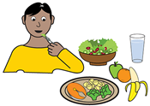 | ܐܲܝܟ݂  - ܡܘܿܕܝܼ ܠܸܐܟ݂ܵܠܵܐ
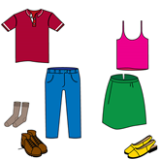 | - ܡܘܿܕܝܼ ܠܸܠܒ݂ܵܫܵܐ
 | ܘ
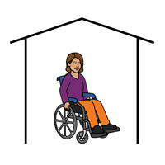 | - ܐܲܝܟܵܐ ܠܸܚܵܝܵܐ.
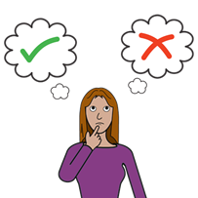 | ܚܲܕܟܡܵܐ ܐ݇ܢܵܫܹ̈ܐ ܟܹܐ ܚܵܫܒ݂ܝܼ ܕܢܸܫܹ̈ܐ ܕܐܝܼܬܠܗܘܿܢ ܫܲܦܠܘܼܬܵܐ ܠܹܐ ܡܵܨܝܼ ܕܥܵܒ݂ܕܝܼ ܓܘܼܒܵܝܹ̈ܐ ܒܘܼܬ ܡܸܢܕܝܼܵܢܹ̈ܐ
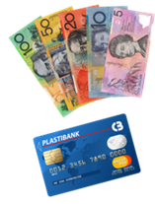 | ܐܲܝܟ݂  - ܒܘܼܬ ܙܘܼܙܲܝ̈ܢ
 | - ܒܘܼܬ ܚܘܼܠܡܵܢܲܢ
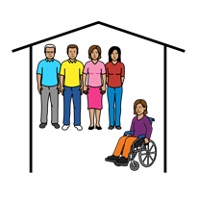 | - ܒܘܼܬ ܥܲܡ ܡܵܢܝܼ ܠܸܚܵܝܵܐ.
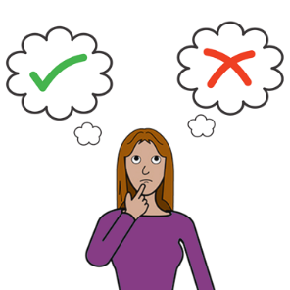 | ܙܸܕܩܹ̈ܐ  ܢܸܫܹ̈ܐ ܘܒܢܵܬܹ̈ܐ ܕܐܝܼܬܠܗܘܿܢ ܫܲܦܠܘܼܬܵܐ ܡܵܨܲܚ ܕܥܵܒ݂ܕܲܚܠܗܘܿܢ ܓܘܼܒܵܝܹ̈ܐ ܕܓܵܢܲܢ ܒܓܵܢܲܢ.
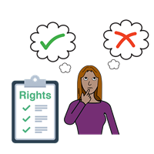 | ܐܲܢ݇ܬܝ ܐܝܼܬܠܵܟ݂ܝ ܙܸܕܩܵܐ ܕܥܵܒ݂ܕܲܬܝ ܠܗܘܿܢ ܓܘܼܒܵܝܹ̈ܐ ܕܓܵܢܵܟ݂ܝ ܒܓܵܢܵܟ݂ܝ.
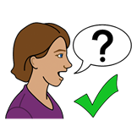 | ܚܲܕܟܡܵܐ ܢܸܫܹ̈ܐ ܘܒܢܵܬܹ̈ܐ ܕܐܝܼܬܠܗܘܿܢ ܫܲܦܠܘܼܬܵܐ ܒܲܠܟܵܐ ܕܣܵܢܩܝܼ ܠܗܲܝܲܪܬܵܐ ܠܸܥܒ݂ܵܕܵܐ ܓܘܼܒܵܝܹ̈ܐ.
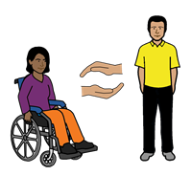 | ܐܲܢ݇ܬܝ ܐܝܼܬܠܵܟ݂ܝ ܙܸܕܩܵܐ ܕܩܲܒܠܲܬܝ ܟܠ ܗܲܝܲܪܬܵܐ ܕܣܵܢܩܲܬܝ ܐܸܠܵܗ̇.
ܫܘܼܠܛܵܢܵܐ ܐܘܿܣܬܪܵܠܵܝܵܐ

ܫܘܼܠܛܵܢܵܐ ܐܘܿܣܬܪܵܠܵܝܵܐ ܓܵܪܲܓ

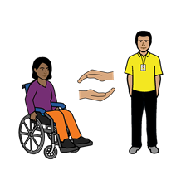  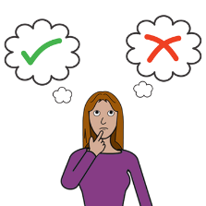 | - ܕܣܵܢܸܕ ܩܵܐ ܢܸܫܹ̈ܐ ܕܐܝܼܬܠܗܘܿܢ ܫܲܦܠܘܼܬܵܐ ܕܥܵܒ݂ܕܝܼܠܗܘܿܢ ܓܘܼܒܵܝܹ̈ܐ ܕܓܵܢܲܝܗܝ ܒܓܵܢܲܝܗܝ
 | - ܕܝܵܗܸܒ݂ ܩܵܐ ܢܸܫܹ̈ܐ ܘܒܢܵܬܹ̈ܐ ܕܐܝܼܬܠܗܘܿܢ ܫܲܦܠܘܼܬܵܐ ܡܲܘܕܥܵܢܘܼܬܵܐ ܕܐܵܢܝܼ ܡܵܨܝܼ ܕܦܲܪܡܝܼܠܵܗ̇
 | - ܕܬܵܒܸܥ ܠ UN Convention on the Rights of Peoples with Disabilities (ܐܵܘܝܘܼܬܵܐ ܕܐܸܡܘܵܬܹ̈ܐ ܡܚܲܝܕܹ̈ܐ ܥܲܠ ܙܸܕܩܹ̈ܐ ܕܦܲܪ̈ܨܘܿܦܹܐ ܕܐܝܼܬܠܗܘܿܢ ܫܲܦܠܘܼܬܵܐ).

ܗܵܘܝܲܬܝ ܒܲܣܝܼܡܬܵܐ

ܡܵܢܝܼ ܟܬܝܼܒ݂ܠܹܗ ܐܵܗܵܐ ܟܬܵܒ݂ܵܐ؟
Women with Disabilities Australia (ܢܸܫܹ̈ܐ ܕܐܝܼܬܠܗܘܿܢ ܫܲܦܠܘܼܬܵܐ ܐܘܿܣܬܪܵܠܝܼܵܐ) ܟܬܝܼܒ݂ܠܗܘܿܢ ܐܵܗܵܐ ܟܬܵܒ݂ܵܐ ܒܫܹܢ݇ܬܵܐ 2019-2020.
ܐܵܗܵܐ ܟܬܵܒ݂ܵܐ ܝܼܠܹܗ ܐܲܚܟ̰ܝܼ ܩܵܐ ܝܘܼܠܦܵܢܵܐ ܘܡܲܘܕܥܵܢܘܼܬܵܐ ܓܵܘܵܢܵܝܹ̈ܐ.
ܙܸܕܩܹ̈ܐ ܕܣܝܵܡܵܐ
© ܙܸܕܩܹ̈ܐ ܕܣܝܵܡܵܐ
Women with Disabilities Australia (WWDA) Inc. 2020

ܟܠܲܝܗܝ ܙܸܕܩܹ̈ܐ ܕܡܘܼܠܟܵܢܵܐ ܣܲܟܘܼܠܬܵܢܵܐ، ܒܸܚܒ݂ܵܫܵܐ ܙܸܕܩܸ̈ܐ ܕܣܝܵܡܵܐ ܘܙܘܼܕܵܩܹ̈ܐ ܕܒܵܪܘܿܝܘܼܬܵܐ، ܕܓܵܘ ܐܵܗܵܐ ܟܬܵܒ݂ܵܐ ܝܼܢܐ ܡܵܪܘܼܬܵܐ ܘܦܣܝܼܣܹܐ ܒܝܲܕ Women with Disabilities Australia Inc.

ܗܵܘܝܼܬܘܿܢ ܒܲܣܝܼܡܹܐ ܩܵܐ ܙܘܼܙܹ̈ܐ ܠܸܟܬܵܒܹܗ ܐܵܗܵܐ ܟܬܵܒ݂ܵܐ.
The National Disability Insurance Scheme (ܐܸܣܟܝܼܡܵܐ ܐܘܼܡܬܵܝܵܐ ܕܥܲܪܵܒ݂ܘܼܬܵܐ ܕܫܲܦܠܘܼܬܵܐ) ܝܗܝܼܒ݂ܠܗܘܿܢ ܚܕܵܐ ܟܡܵܝܘܼܬܵܐ ܕܙܘܼܙܹ̈ܐ ܩܵܐ Women with Disabilities Australia (ܢܸܫܹ̈ܐ ܕܐܝܼܬܠܗܘܿܢ ܫܲܦܠܘܼܬܵܐ ܐܘܿܣܬܪܵܠܝܼܵܐ) ܠܗܲܝܘܼܪܹܐ ܒܒܢܵܝܬܵܐ ܕܐܵܗܵܐ ܫܵܘܦܵܐ ܐܹܠܸܟܪܘܿܢܵܝܵܐ.

ܨܘܼܪ̈ܝܵܬܹܐ ܡܘܼܦܠܸܚܹܐ ܓܵܗ ܐܵܗܵܐ ܟܬܵܒ݂ܵܐ
Easy on the I Images © 2019 Leeds and York Partnership NHS Foundation Trust. ܦܝܼܫܹܐ ܝܢܵܐ ܡܘܼܦܠܸܚܹܐ ܒܦܣܵܣܵܐ. www.easyonthei.nhs.uk

The Picture Communication Symbols © 2019 by Mayer Johnson LLC a Tobii Dynavox company. ܦܝܼܫܹܐ ܝܢܵܐ ܡܘܼܦܠܸܚܹܐ ܒܦܣܵܣܵܐ. www.tobiidynavox.com
ܨܲܠܡܹ̈ܐ. ܦܝܼܫܹܐ ܝܢܵܐ ܡܘܼܦܠܸܚܹܐ ܒܦܣܵܣܵܐ.

