Kirriji kuntta Disabilities Australia kana

Book 4

Sex kapi akkinyi ngattu

Wangukuna apina

Wangka 000-kka

Anyul ngini kirriji Disabilities Australia anyul ngini pakinjarl WWDA alaparra anyul wangkan

Book 4
Ngala book gnini sex kapi akkinyi ngattu-kku

Ngala book ngini kirriji-kki kapi partarta-kka appa ajjul kuntta Disabilities jangu ngala disability.

Akkinyi health-kki kapi rights

Angi kuntta right akiny-kki yurrkurrliji-kki

Angi kuntta right nyirrinjiki choices akkinyi-kki ngattu-kki

Angi kuntta right wangkijiki yama medication-kki

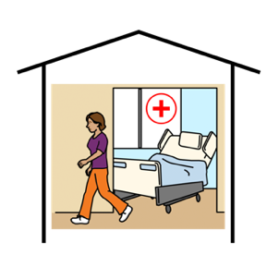
Health services-kka
Angi kuntta right yurrkurrlijiki, angi parri

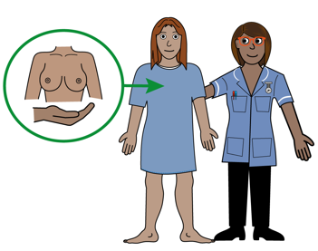

- Ngamana nyanjiki kapi

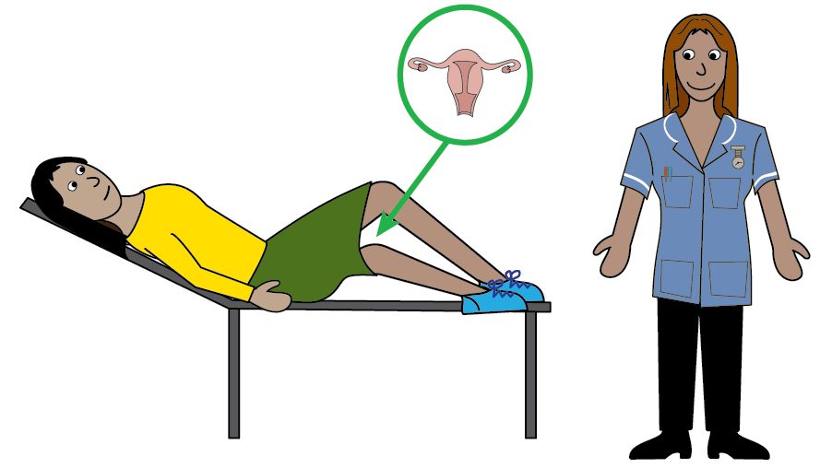
- Yurrkurrliji nyanjiki kapi kirriji-kari yurrkurrliji nyanjiki

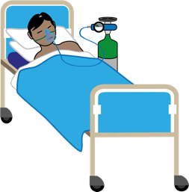
- Hospital nyinjiki kapi wanginjiki

Kamanta kunjuki sex

Angi kuntta right parrinyjiki nyayi angi kunjarl

Kamanta kunjuki sex

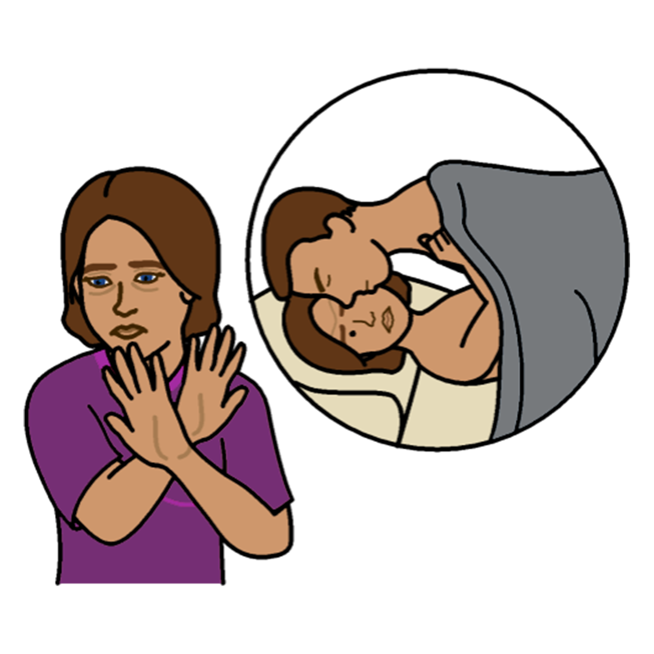

Angi kuntta right wangkijiki yama

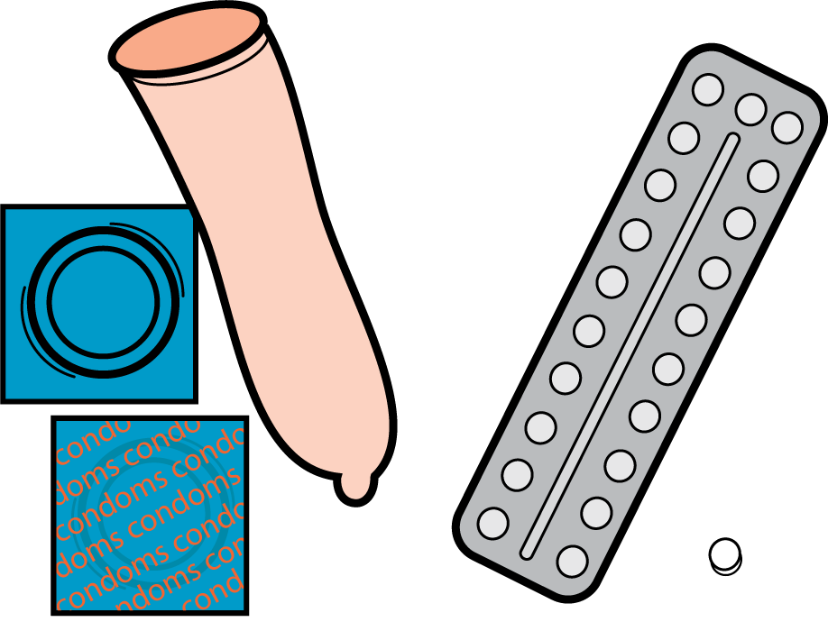
Contraception
Contraception ngini angi jukunjarl kimpin purru kaji kapi munkku jinji kaji alaparra angi kuntta sex

You have a right to choose contraception. Like

- Rubber arntiji

- Kapi wangangu

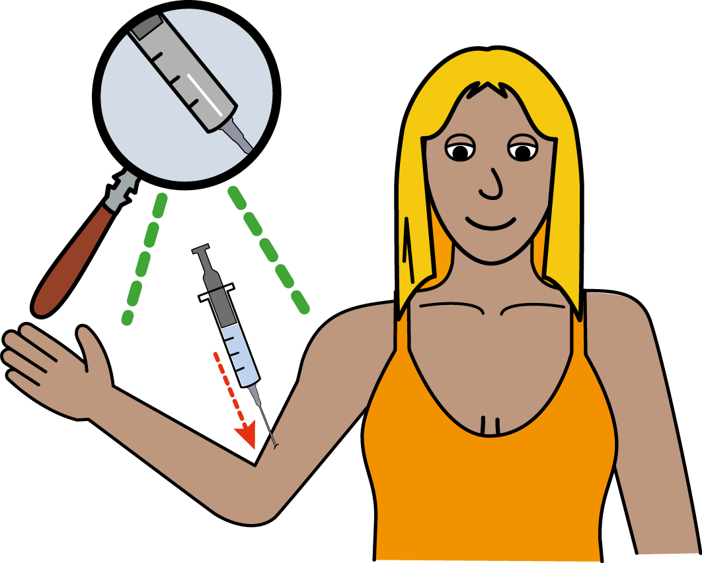
- Ngala implant ajjul nyirrinta karnttu nyurru-kana needle jangu

Angi wangkijiki ankkinyi yurrkurrliji jangu contraception-kki

Ngala ngini akkinyi choice!

Pregnancy and Choices
Alaparra angi munkku-jinjarl angi kuntta right choice pangkarl kunjuku

Angi kunjarl ala pululu nyinjarl angi karnanti

Angi kunjarl abortion ngala ngini warra angi munkku

Angi kunjarl ala pululu nyunjarl angi adoption-kki parninya angi nyunjarl ala pululu karriny-kki jinakunjuku

Ngala Australian government-jji:

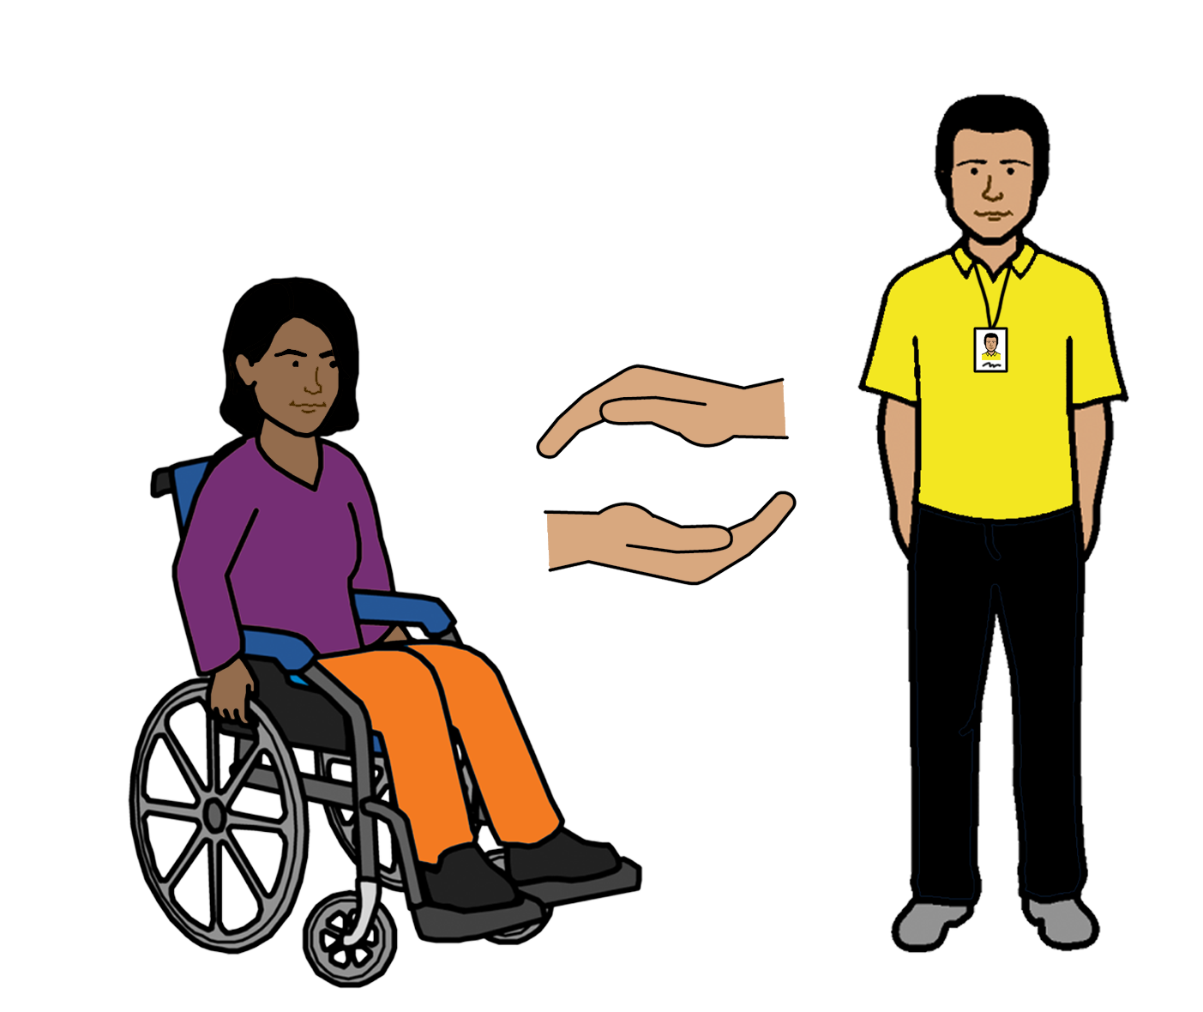
- Support kirriji kapi partarta partarta disability jangu arjurnunginyi choice health-kki kapi sex

- Nyuwa information sex-ngarra kapi health

- Alapoura angi kuntta access ngini health-kka kapi service angi parri

Manarra
Angi wangkiji

- Parngarnja jangu
- Karrinyi jangu

- Yurrkurrliji jangu

- Angkinyi karrinyi planning service
Apparr karrinyi planning alliance Australia
Website ngini
familyplanningallianceaustralia.org.au/services/

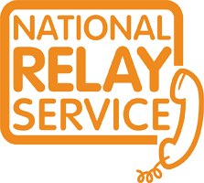
Angi apijiki National Relay service-kka
Alaparra angi wangki service ngala
Wangkka 1800 555 677
TTY 133 677

Kalyaparra translator-kka
Wangkka 131 450

Kamanta
Nyayinji pakinyi ngala book
Kirriji-jji kuntta Disabilities Australia-jja pakinyi ngala book 2019

Ngala book-ngini general education kapi information-kki

Copyright
© Copyright
Kirriji-jji kuntta Disabilities Australia (WWDA) Inc 2019

Wakkappi intellectual property kapi rights including copyright kapi patents. Ngala book arjurnunginyi kapi licenced kirriji-kirriji-kki appa ajjul kuntta Disabilities Australia Inc

Kamanta Wangari-kki appa ajjul pakinyi ngala book
Ngala National Disability Insurance Scheme-jji nyunyu Wangari nyirrinjiki website

Ngala images ajjul nyirrinyi karnttu fact sheet-kana
Ngala ngini 1 images © 2018 leed kapi York partnership NHS foundation kapi trust used-kki kapi permission ngala www.easyonthei.nhs.uk

