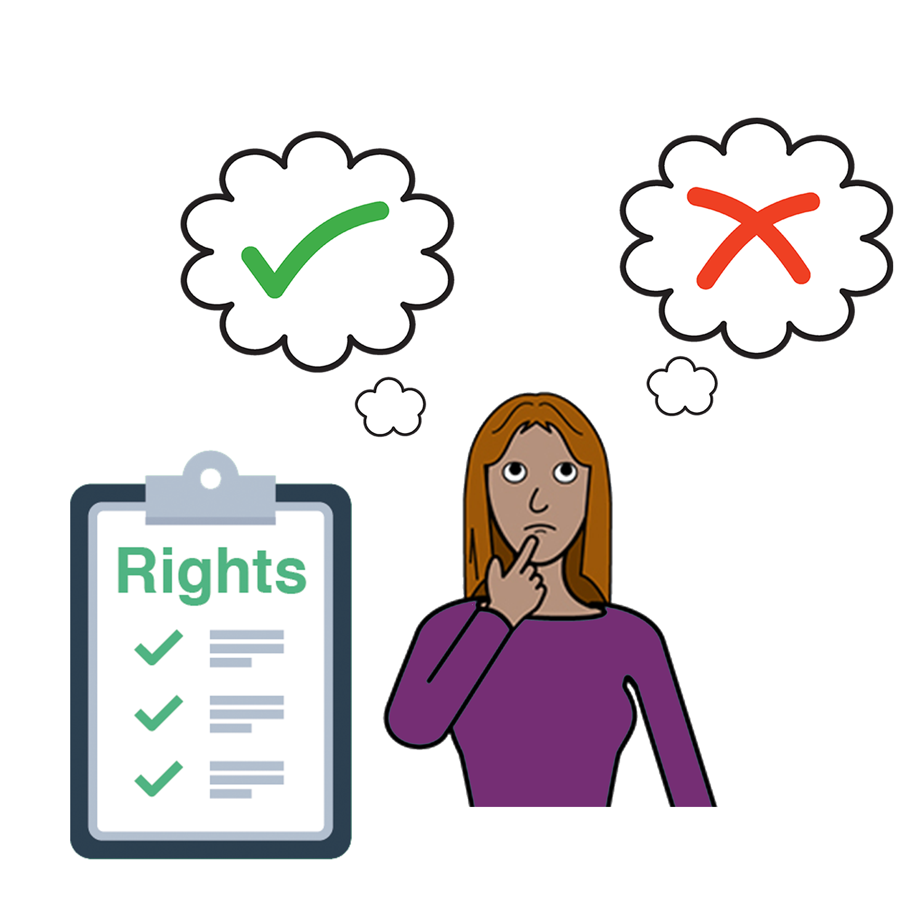
Women with
Disabilities Australia

Yu gad rait po po chuz wanem yu wande mekem
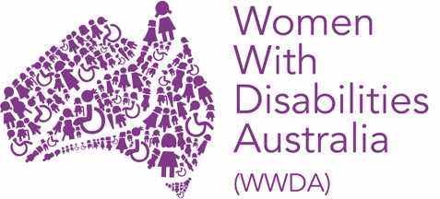

Mipla ya e Women with Disabilities Australia.
Wen wi tokbaut mipla wi go raitem diskain WWDA.

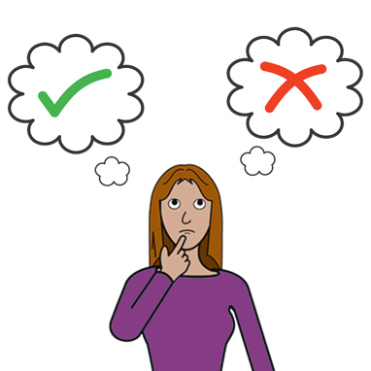

Dis buk e baut wanem yu wande mekem.

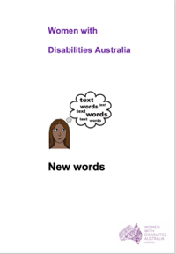
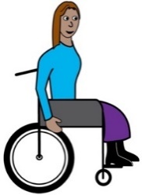
Wi bin rait dis buk po oman ane gel uda gad disabilti. Yu ken rid mo baut disabiliti wea da buk New Words.

Wanem Choice?
Choice is diskain, wen yu disaid yuselp wanem yu wande mekem baut samting.

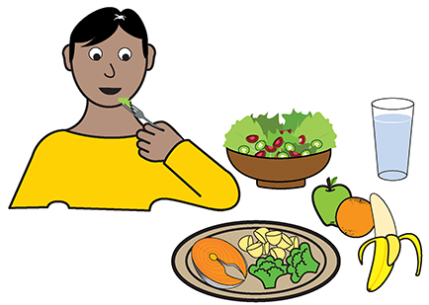
Wase diskain
- wanem yu wande kaikai

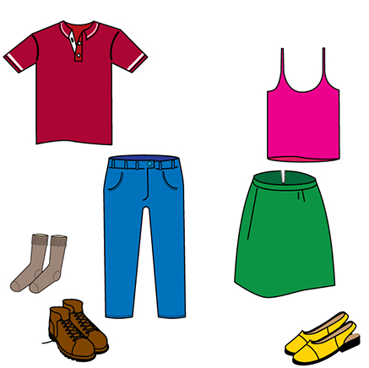
- wanem yu wande werem

ane
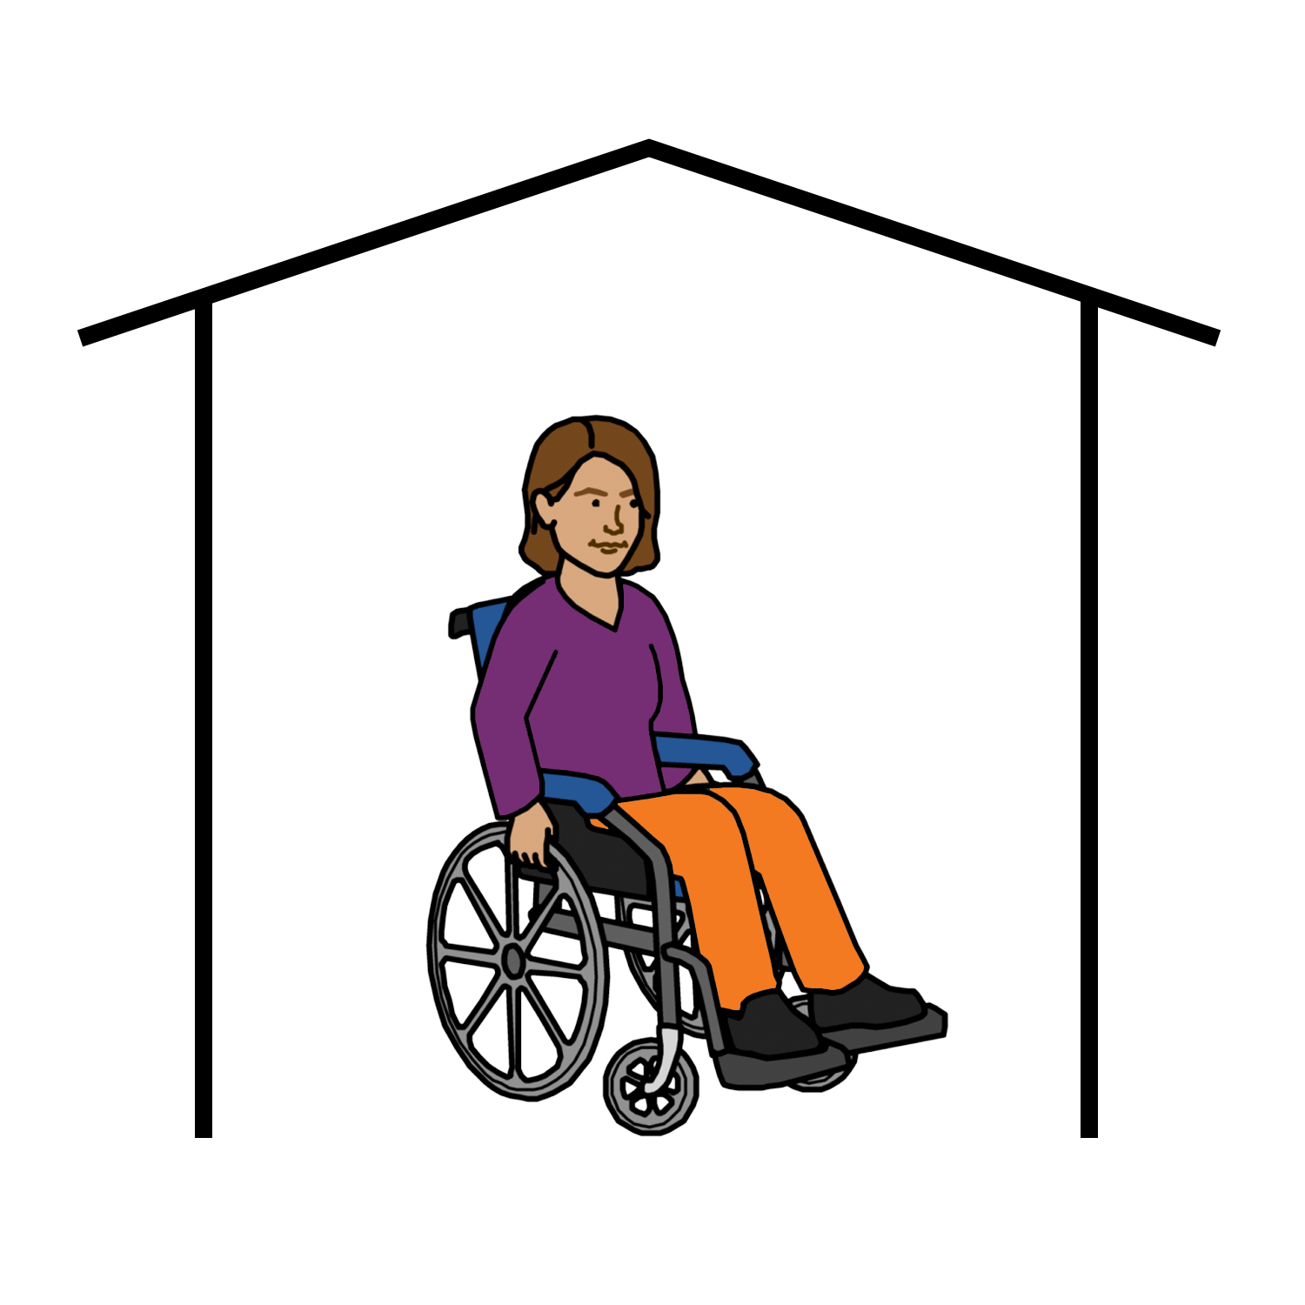

- wea yu go stap.

Sam pipol rekan oman uda gad disabiliti no sabe wiskain po chuzem wanem po mekem baut dipren ting.

Wase
- baut mani

- baut elth blo yu

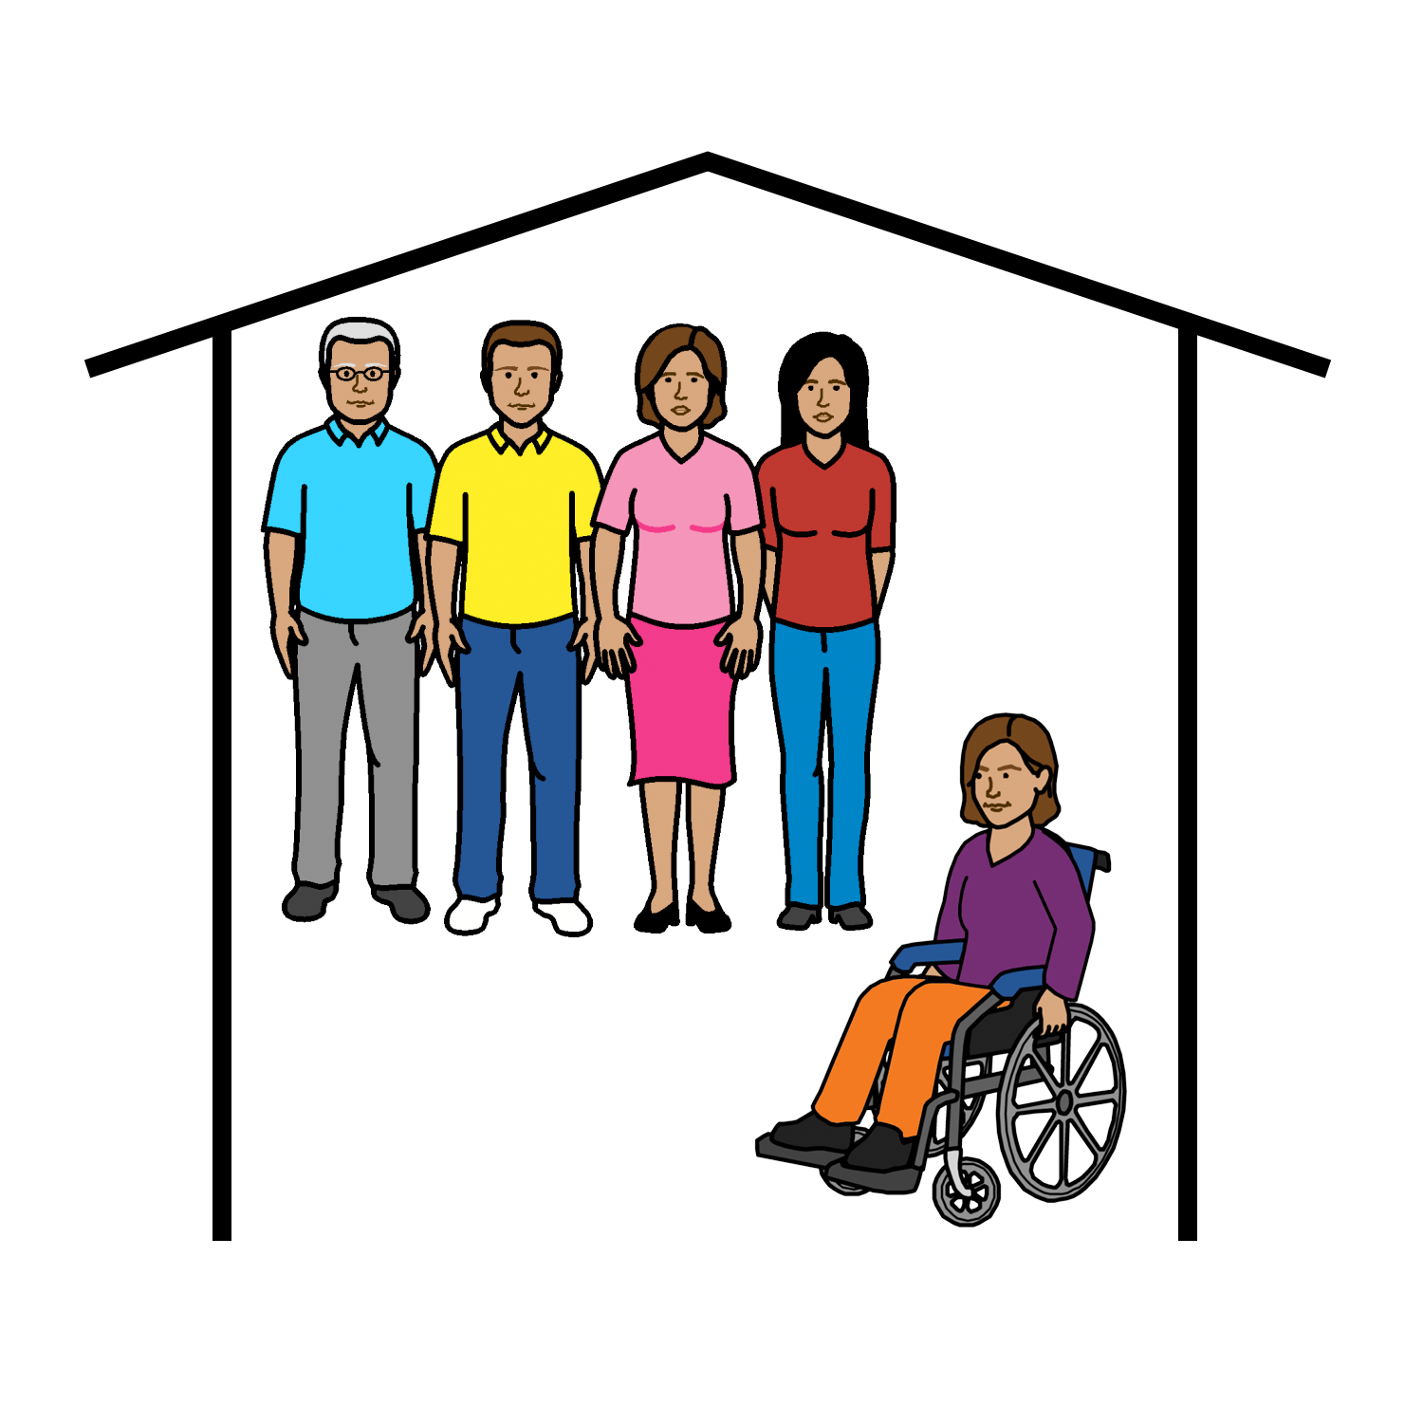

- baut yu go lib wea udat.

Raits
Oman and gel uda gad disabiliti ken chuz wanem dempla wande mekem.

Yu gad rait po chuz wanem yu wande mekem.

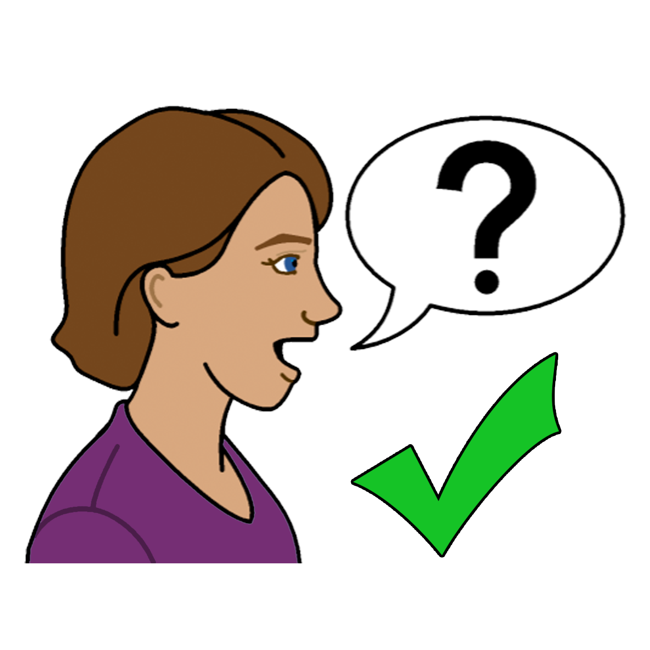
Sam oman and gel uda gad disabiliti mait nid po gede elp wen dempla wande disaid wanem po mekem.

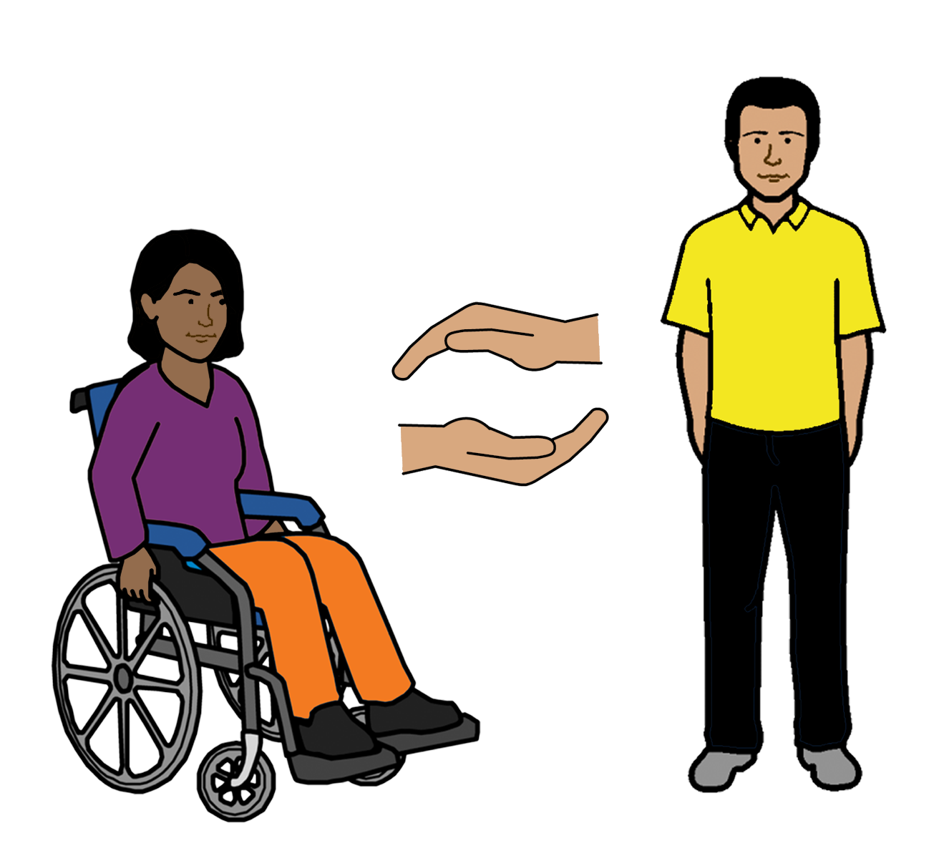

Yu gad rait po gede eni elp yu wandem.

Da Australian Government

Da Australian Government mas

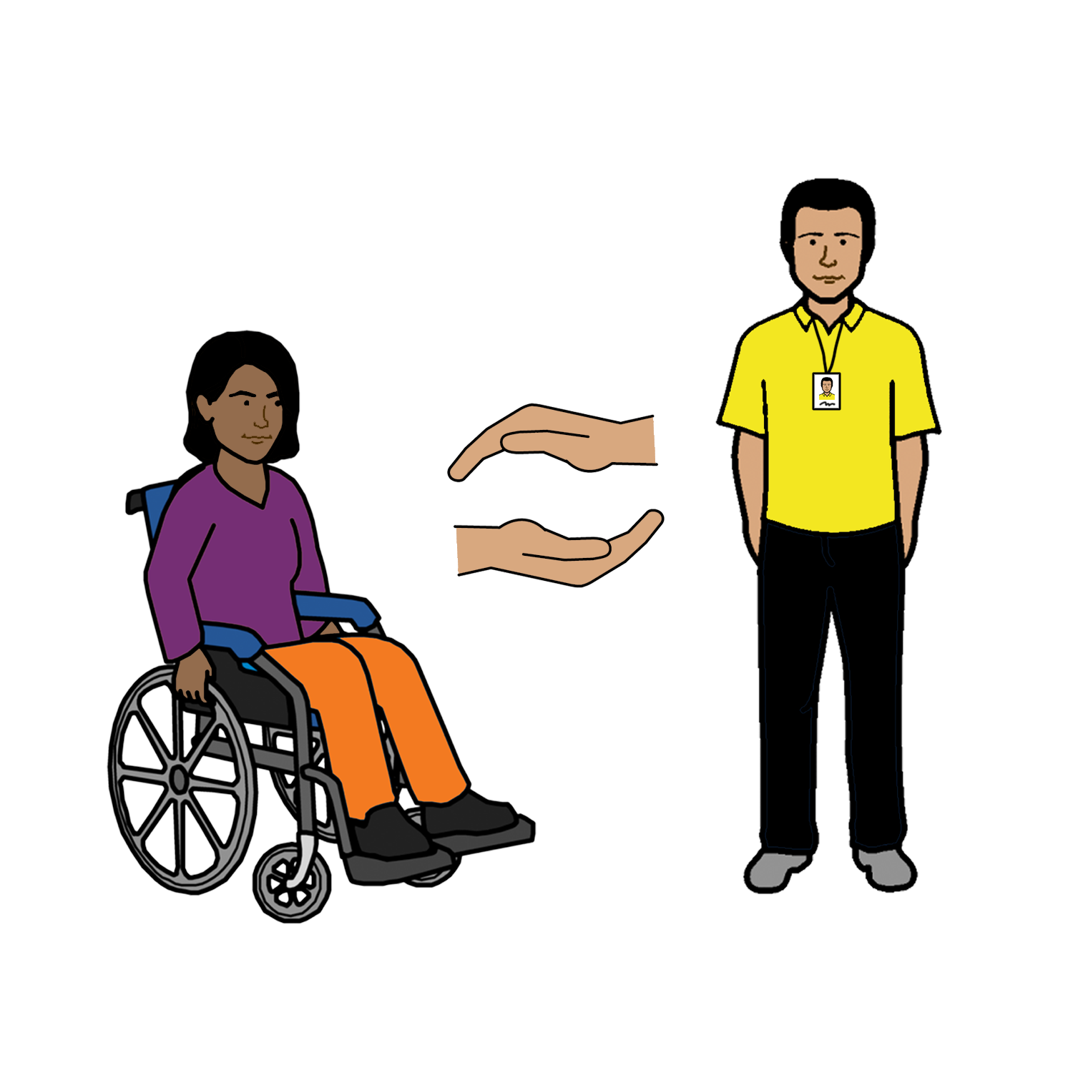
- sapot oman ane gel uda gad disabiliti po disaid wanem demplaselp wande mekem

- mas gibe oman ane gel uda gad disabiliti wanem inpomeisan dempla ken andastan

- mas pole da UN Convention on the Rights of Peoples with Disabilities.

Eso
Uda bin raite dis buk?
Women with Disabilities Australia bin rait dis buk lo 2019-2020.
Dis buk i po elp pipol po lan mo ane e po inpomeisan.

Copyright
© Copyright
Women with Disabilities Australia (WWDA) Inc. 2020.

All intellectual property rights, including copyright and patents, in this book is owned and licensed by Women with Disabilities Australia Inc.

Eso po dem pipol uda bin gibe mani po raite dis buk.
National Disability Insurance Scheme bin gibe Women with Disabilities Australia mani po elpe meke dis websait.

images used in this fact sheet
Easy on the I Images © 2019 Leeds and York Partnership NHS Foundation Trust. Used with permission. www.easyonthei.nhs.uk
The Picture Communication Symbols © 2019 by Mayer Johnson LLC a Tobii Dynavox company. Used with permission. www.tobiidynavox.com

Logos. Used with permission.

