# **Kirriji-jji kuntta Disabilities Australia**

# **Book 5**

**Kirriyirrmurra angi right**



Anyul ngini kirriji-jji kuntta Disabilities Australia Anyul pakinjarl WWDA alayarra anyulurnu wangkan



**Book 5.**

Ngala book ngini ankkinyi rights-kki

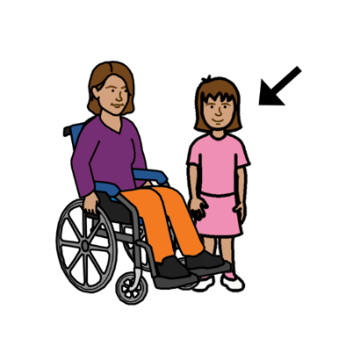Ngala book ngini kirriji-kki kapi partarta-kka appa ajjul kuntta disability.

**Nyayi rights ngini**

Wakkappi-jji kuntta rights

 Rights ngini mukku angi nyinjiki

* Pangkarl angi nurse nyinjiki
* Holiday-kki angi apirrjiki
* Pangkarl angi kunjarl pikkapikka

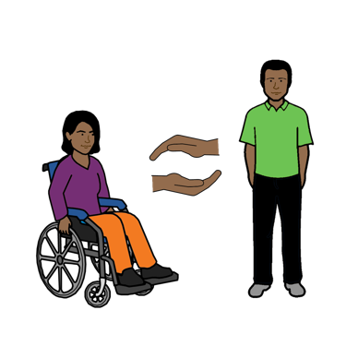

Kirriji-jji kapi partarta-jja kuntta disability kunjuku ajjul rights panikurangi wakkappi-jji-kunta

Warra nyayingkki jukurnjarl rights akkinyi

## **A picture containing outdoor Description automatically generatedBasic rights**

Angi kuntta rights basis mukku-kku akinyi jangarlki kana ngala ngini:

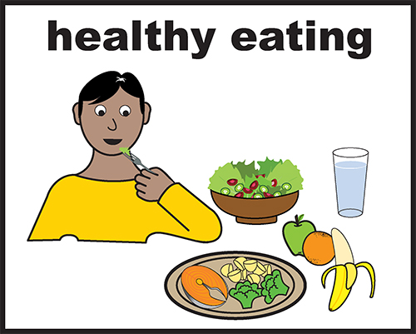

* Yukunuku kapi ngappa

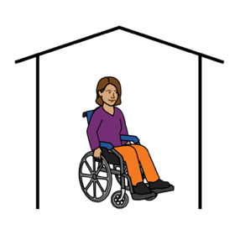

* Ngunjuku piliyi-kana

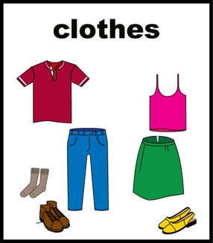

* Piliyi wawarta jarrpinjiki

**A picture containing vector graphics Description automatically generatedPiliyi nyinjiki**

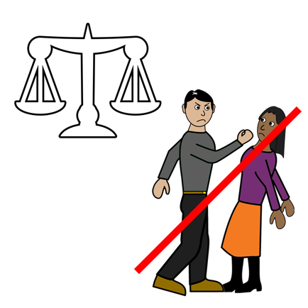

Wakkapi kirriji kapi partarta-jja kuntta disability right ajjul kuntta piliyi nyinjiki wangu- ngarra

Ngala anyinginyi book angi kuntta rights piliyi nyijnjiki wangu-ngarra

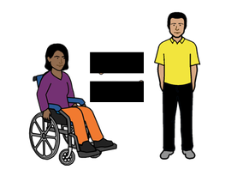

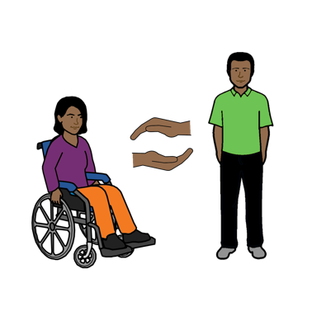

Angi kuntta right nyinjiki panikurangi

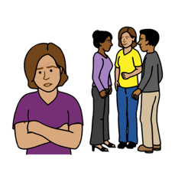 Appa ajuluunku warra piliyi ngarra kuntta papulanji ajjul maranta discrimination nyanjiki angi ngala book apparr-jangu page

6- kana

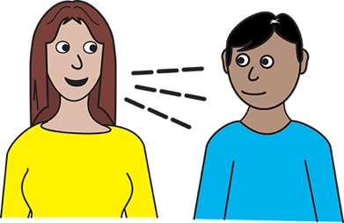 Angi kuntta rights wangkijki

* Angi kuntta rights wangkijki

**Kapi**

* Alaparra warra angi piliyi ngarra arjulunku fair way nyinta

**Rights akkiny life-kki**

## 

## Wakkappi kieeiji kapi partarta appa ajjul kuntta disability-jji kuntta right

* Kapi choices



* Kunjuku Wangari



* Kapi nyangirr ngunjuku

## **Kapi**

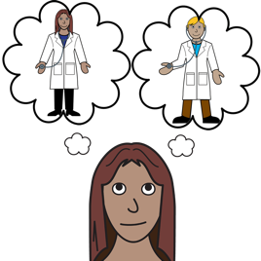

* What health people you see like a new doctor

**Kapi**

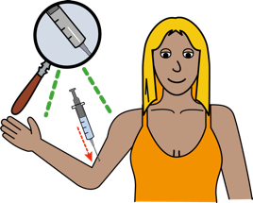

* 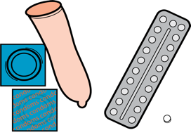Nyirrinjiki-kki
* Wanganguku-kki
* Needles-kki
* Creams-kki

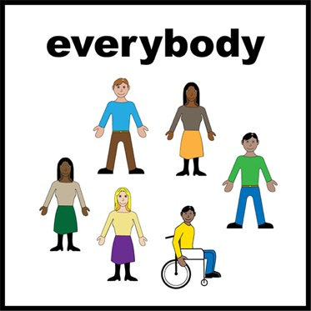**Right ajjul jukunjuku**

Kirriji kapi partarta partarta-jja disability- jangu kuntta ajjul right muikku-kku wakkapi kirriji kapi partarta partarta- jja like

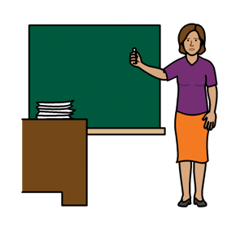

* school-kku apijiki

* Work-kki apijiki
* Parrinjiki Wangari appa ajjul pukunjinta

* Kapi elections-kki apijiki

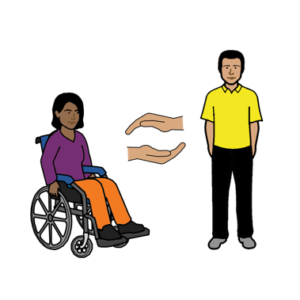**Right to services-kka kapi support-kka**

Kirriji kapi partarta partarta disability jangu

* **services-kka**
* **supports-kka**



Ngala ngini ankikiny health-kk like

* Apirrjiki akkinyi yurrkurrli-kki
* Nyanjiki ngamuna
* X-ray parrinjiki.



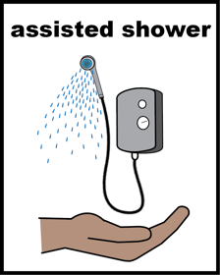 Kapi workers yirrtirr-kki

* Takanjuku kangurr wanpijiki
* Kunjuku Wangari
* Kapi jukunjuku.

 Parrinjiki Wangari Government ngarra:

* Nyirrinjiki rent-kka
* Pension-kka



Kapi information-kki ngala information

* Angi pinanjiki
* A drawing of a cartoon character

  Description automatically generatedKumppu ajjul pakanta
* Kapi sign-kana
* Jarttu jarttu apparr

## **Right kunjuku sex-kki kapi akkinyi ngattu**

Kirrji kapi partarta partarta-jji Disability janju



* Kunjuku relationship
* Ngattu jinjiki

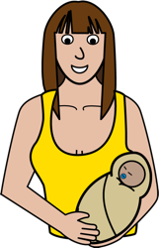

* have children

* be respected.

 **You can talk to someone about your rights**

**Angi wangkijiki akkinyi rights-kki**



**Australian Human Rights Commission**



Wangka 02 9284 9600

## **or**

## A screenshot of a computer Description automatically generatedA picture containing object, monitor Description automatically generatedApijiki website-kana

## www.humanrights.gov.au

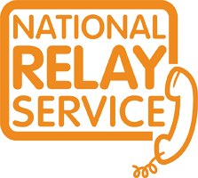 Angi apijiki National Relay Service-kka

Ngala ngini Australian Human Rights Commission

Wangka 1800 555 677

TTY 133 677



Kalyapa parra Translator-kka

Wangka 131 450

**Kamanta**

Nyayinji pakinyi ngala book

Kirriji-jji kuntta Disabilities Australia-jja pakinyi ngala book 2019

Ngala book ngini general education-kki kapi information-kiki

**Copyright**

© Copyright

Kirriji-jji kuntta disabilities Australia (WWDA) Inc 2019

Wakkappi intellectual property rights including copyright kapi patents karnttu ngala book- kana arjurnunginyi kapi licenced kirriji-ngarra appa ajjul kuntta Disabilities Australia Inc

**Kamanta ngala Wangari-kki**

Ngala National Disability Insurance Scheme-jji nyunyu kirriji-jji appa ajjul kuntta Disabilities Australia Wangari ajjul nyunyu nyirrinjiki ngala website.

**Ngala images nyirrinya karnttu fact sheet-kana**

Easy ngala 1 images © 2018 Leeds York mappu-kka NHS Foundation. Trust kuntta ajjul permission [www.easyonthei.nhs.uk](http://www.easyonthei.nhs.uk)