Kirriji-jji Kuntta Disabilities Australia

Book 2

Akkinyi right
nyirrinyjiki choices

Anyul ngini kirriji-jji kuntta Disabilities Australia
Anyul pakinjarl WWDA appa anyul wangkijarl anyulurnu

Book 2
Ngalanya ngini book kari choices

Ngala book ngini kirriji-kki kapi partarta-kka appa ajjul kuntta disability.

What is a Choice?
Ngala choice ngini alapoura akkinyi kumpumpu nyayngirri-jinta

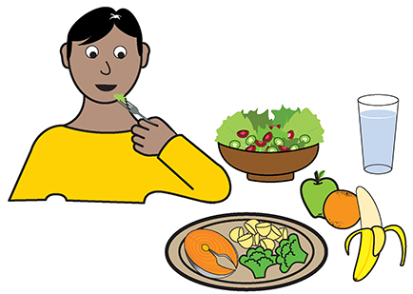
Like
- Nyayi angi jaji

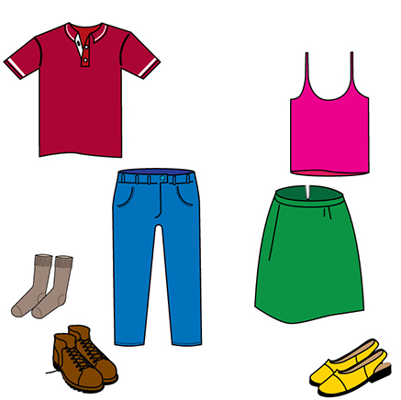
- Nyayi angi jarpirr

Kapi
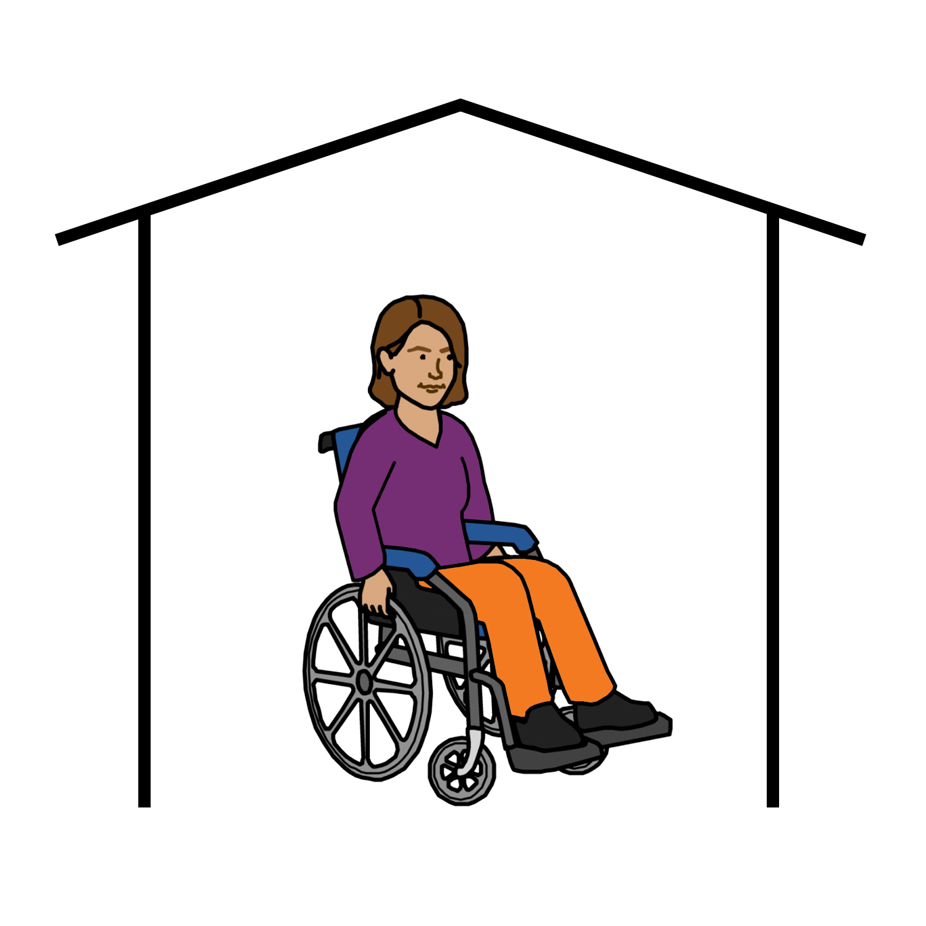

- Kapi wanyanta angi nguntta

Karrinyi kapi kirriji disability jangu arjurlunu choices nyiirrinta

Like
- Anyinginyi Wangari ngarra

- Anyinginyi health ngarra

- Nyayi jangu anyul nyinta

Rights
Kirriji kapi partarta disability jangu nyirrinjiki arjurnunginyi choice

Awururnukula kuntta piliyi ngara akinyi choice

Kirriji-jji kapi partarta- jja kuntta disability nyirrinjiki choice

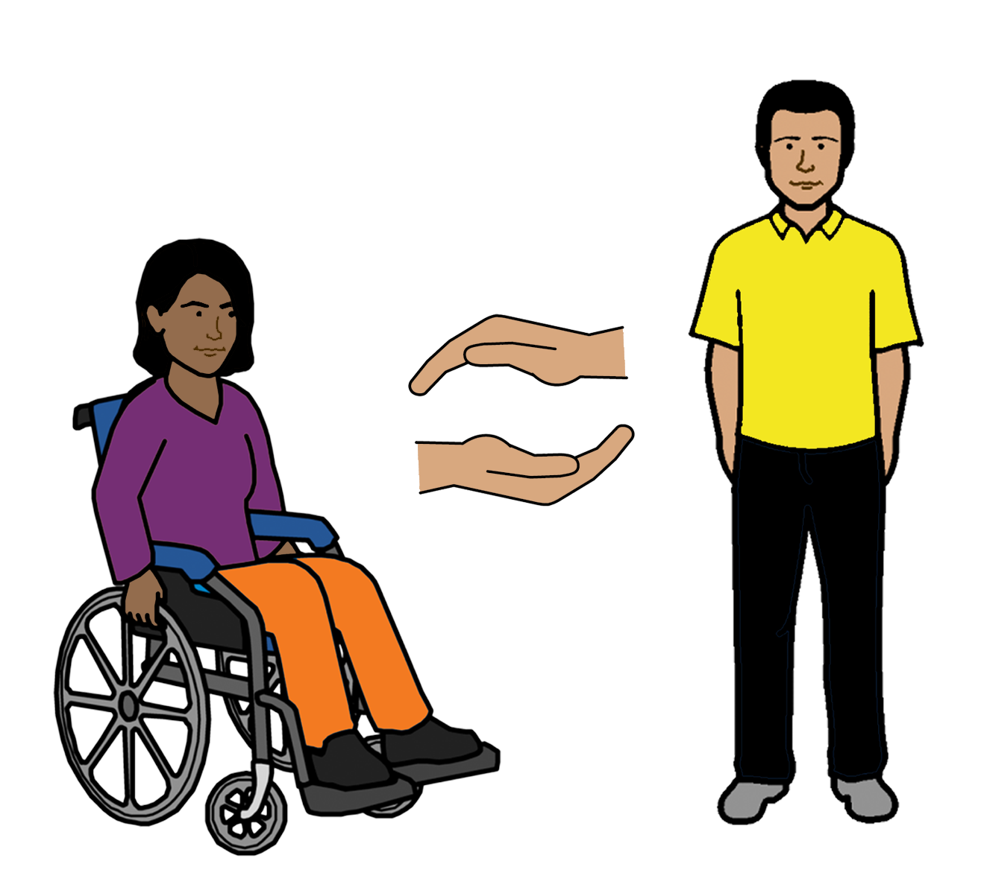

Angi kuntta right parra help awurnukula

Ngala Australian Government

Ngala Australian Government ajjul

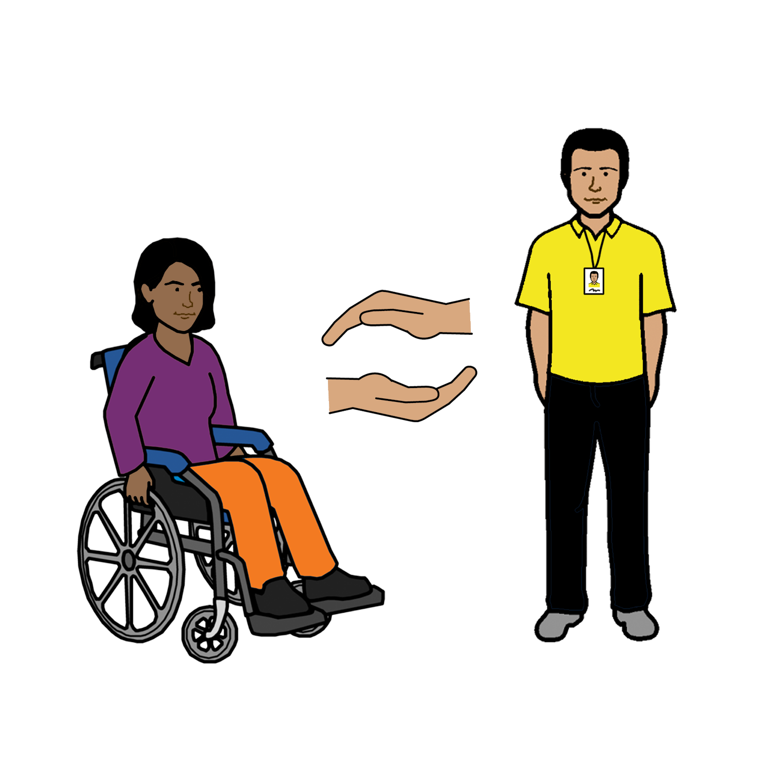
- Kirriji-jji apajjul kuntta disability nyirrinjiki ajjul kinamparl choices

- Kirriji kapi partarta-jja kuntta disability information-kka ajjul kayirrimunta

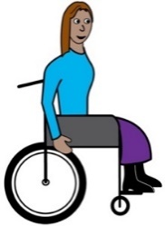
- Ngala CIN Convention jana, Rights alaparra Karrinyi disabilities jangu

Kamanta
Nyayinji pakinyi ngala book
Kirriji Disabilities jangu Australia-jja pakinyi ngala book 2019
Ngala book ngini general education-kki

Copyright
© Copyright
Copyright kirriji Disabilities jangu Australia (WWDA) Inc 2019

Wakkapi intellectual property kapi right copyright ngini kapi patents karnttu ngala book-kana kapi liecened kirriji kirriji Disabilities jangu Australia Inc.

Kamanta ngala Wangari-kki
Thankyou ngala Wangari-kki ngala National Disability Insurance Scheme nyu nyu kirriji-kki appajjal kuntta Disabilities Australia Wangari nyirrinyi nyirrinjiki website.

Ngala images nyirrinya karnttu fact sheet-kana

Ngala 1 images ngini karnttu ngala sheet-kana easy jana images © 2018 ngarunyu-munta nyurkartiki NHS Foundation trust Kalyapanjiki permission www.easyonthei.nbs.uk

