Kirriji appaajjul Kuntta Disabilities Australia-kana

Book 1

Angi piliyi nyinjiki warlpunju-ngarra

Wangukuna apina

Wangka 000-kka

Anyul ngini kirriji-kirriji kuntta Disabilities Australia.
Anyul-ngini pakanjarl WWDA appa anyul wangkijarl
anyungkku

Book 1.
Ngala ngini book warlpunjarra-kka
Ngala ngini wangu book

Ngala book ngini kirriji-kki kapi partarta-kka appa ajjul kuntta disability.

Kirriji kapi partarta partarta disability jangu

Wakkapi kirriji kapi partarta partarta disability jangu nyinta ajjul violence jangu wipanta, jartu ngarra jartu ngarra

- Wakkapi ngurraji-kana

- Hospital kana

- Kapi karrinyi-kari ngurraji-kana
Violence ngini wangu kapi ajjul kirlirji appari

- Karntta School-kana

- Karnttu workplace-kana

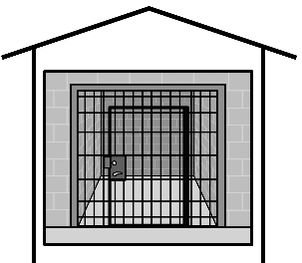

- Karnttu prison-kana

Violence ngini kirriji kirriji-kki kapi partarta partarta-kka disability- jangu ngini wangu

Kirriji kirriji kapi partarta-kka disability- jangu. Kuntajjul right nyinjiki piliyi-ngara

Wakkappi violence ngini larrpan law kana-ngini

WWDA janta jana kirriji kirriji-kki kapi partarta partarta-kka kuntta appa ajjul disability janga kapi violence
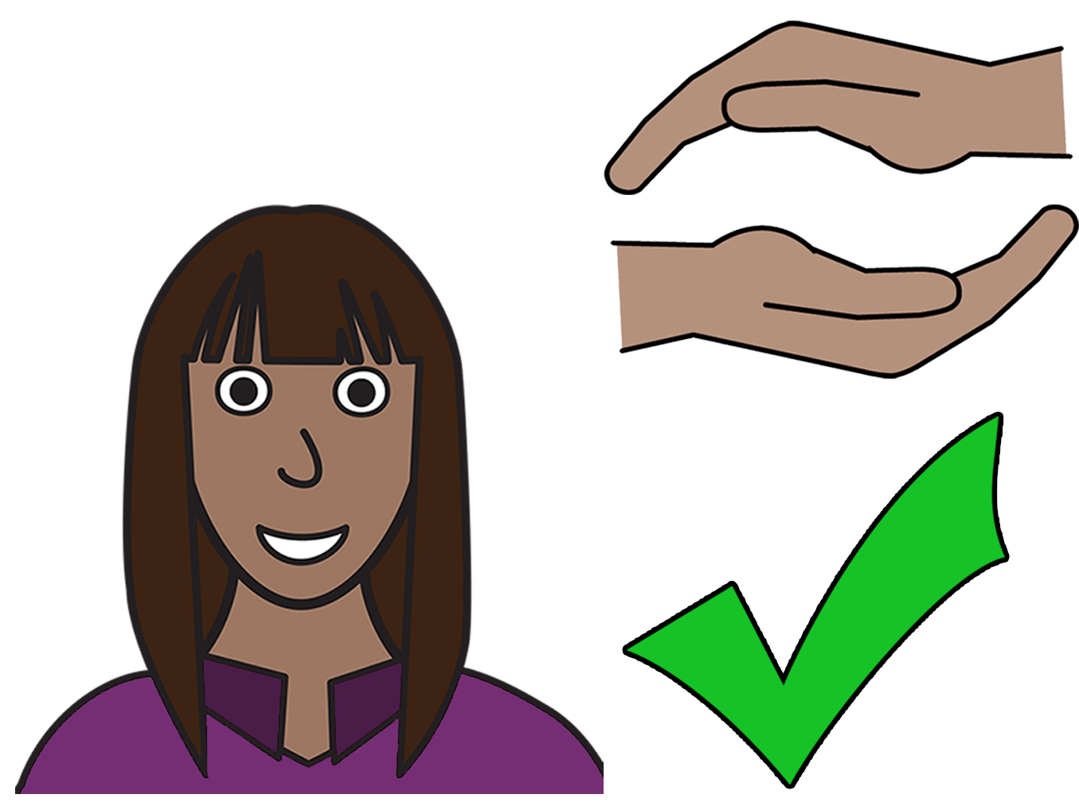
Akkinyi rights
Angi kuntta right piliyi ngarra nyinjika violence
ngarra.

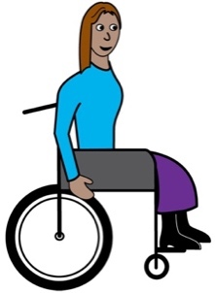
Ngala law ngini angkku help-kki
Ngala ngini United Nations Convention on rights-kki kapi karriny disabilities- jangu anyul ngini pakinjarl UNCRPD appajjul arjurnu wangkijarl

Australia-jja ngirrkanjiki CINCRRD

Australia ngini nyangirr munjarl ajjul violence ngini kirriji kirriji ngarra kapi partarta partarta ngarra disability jangu

Kuwarta-partta!

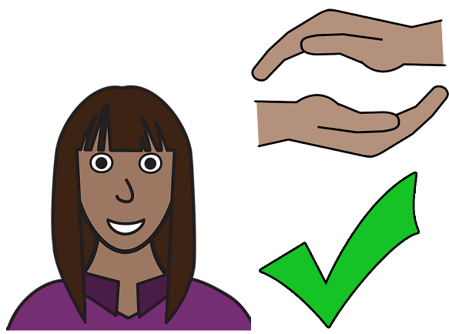

Angi kuntta right nyinjiki piliyi ngarra vilolence ngarra

Wangkka angarjurnu Nyayi-kki pangkka violence ngarra

1800 PILIYINGARRA 1800 PILIYI- NGARRA

Wangkka 1800 737 732

Kapi

Wangaka online kana kapi www.1800respect.org.au

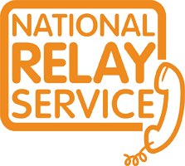
Angi parrinjiki National Relay Service ngata 1800 Respect.
Wangkka 1800 555 677
TTY 133 677
Kalyapanjika 1800 737 732

Kalyapa parra Translator-kka
Wangkka 131 450
Kalyapajika 1800 737 732.

Kamanta
Nyayiji pakiriyi ngala book kirriji-jji pakinyi ngala book 2019
Ngala book ngini general education kapi information-kki

Copyright
© Copyright
Kirriji-jji kuntta disabilities Australia (WWDA) Inc 2019

Wakkapi intellectual arjununginyi right kapi copyright kapi patents. Karnttu ngala book-kana, arjurnunginyi kapi licenced kirriji ngarra kuntta Disabilities Australia Inc

Kamanta ngala Wangari-kki

Thankyou ngala Wangari-kki ngala National Disability Insurance Scheme nyu nyu kirriji-kki appajjal kuntta Disabilities Australia Wangari nyirrinyi nyirrinjiki website.

Ngala images nyirrinya karnttu
Ngala 1 images ngini karnttu ngala sheet-kana easy jana images © 2018 ngarunyu-munta nyurkartiki NHS Foundation trust Kalyapanjiki permission www.easyonthei.nbs.uk

