Women with

Disabilities Australia

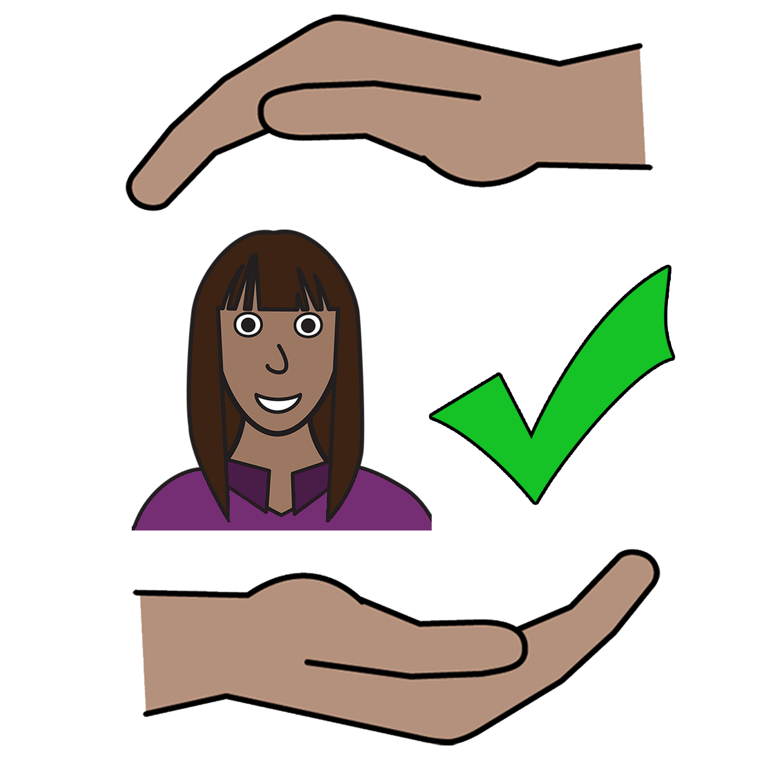

Bla yu raits bla jidan seifwan brom bailens

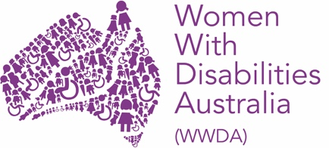

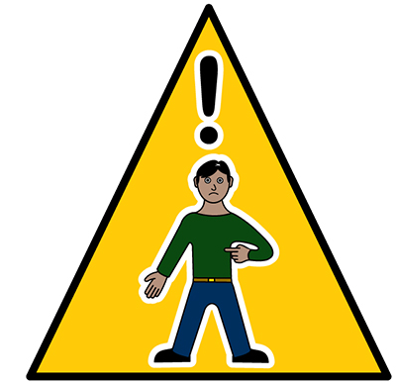
Abumbat trabul nau?

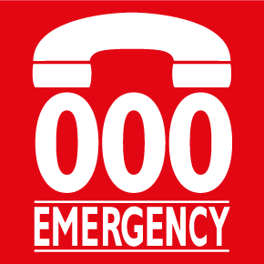
Kol la 000
Melabat gulum mijal ‘Wumen gada Disibiliti Australia’. O, la Ingglish: “Women with Disabilities Australia”. Mela garra gulum mijal WWDA la dis buk.

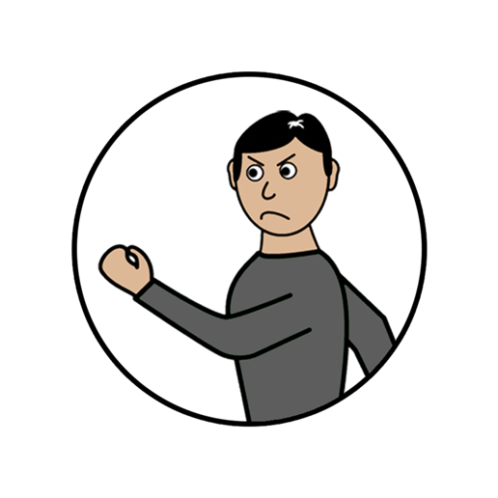
Dijan buk im bla bailens.
Yu gin rid bla wanim bailens min la det najawan buk gulum Nyuwan Weds (New Words).

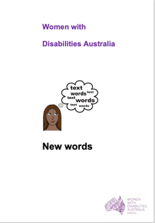
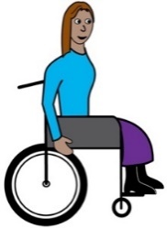
Mela bin rait dijan buk bla ola wumenmob en gelmob gada disibiliti. Rid mowa bla disibiliti la mela buk gulum Nyuwan Weds (New Words).

Wumenmob en gelmob garra disibiliti
Bigmob wumenmob en gelmob hu garra disibiliti abum bailens la alabat laif. Im gin hepen eniweya, laik…

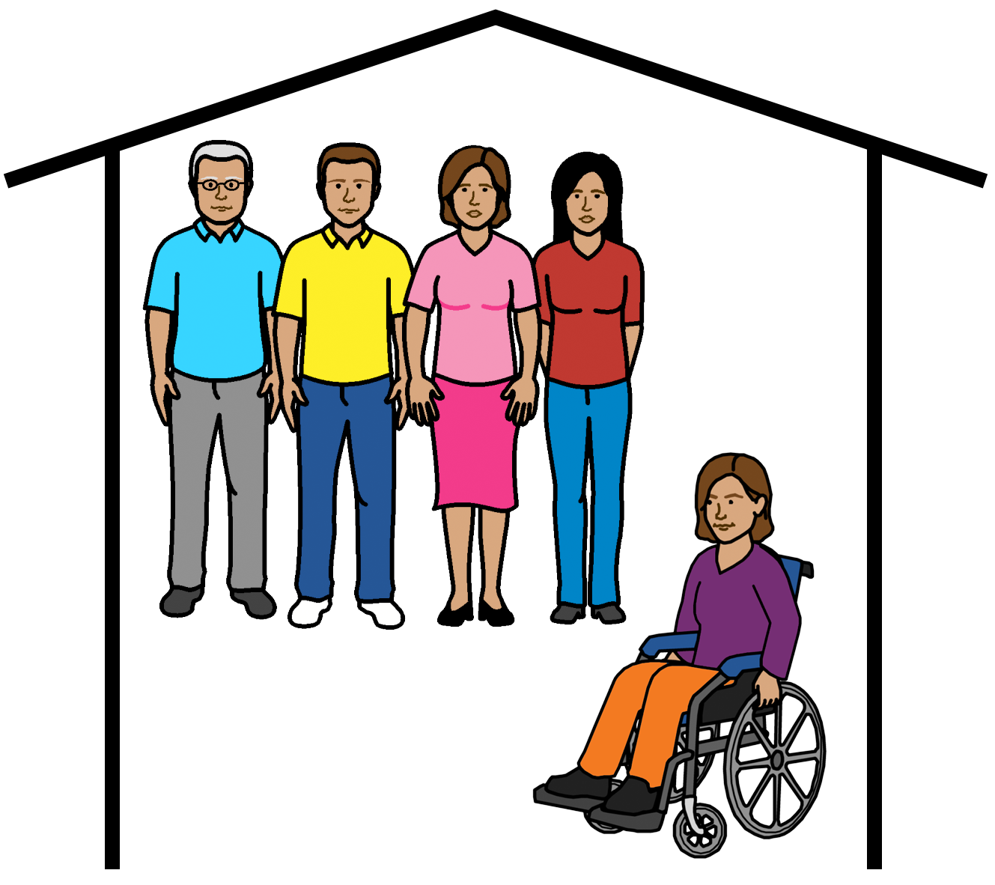

      - la gruphoum

      - la hospel

      - la kemp.

Bailens gin hepin eniweya du, laik

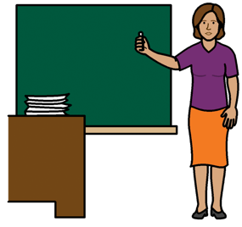
      - la skul

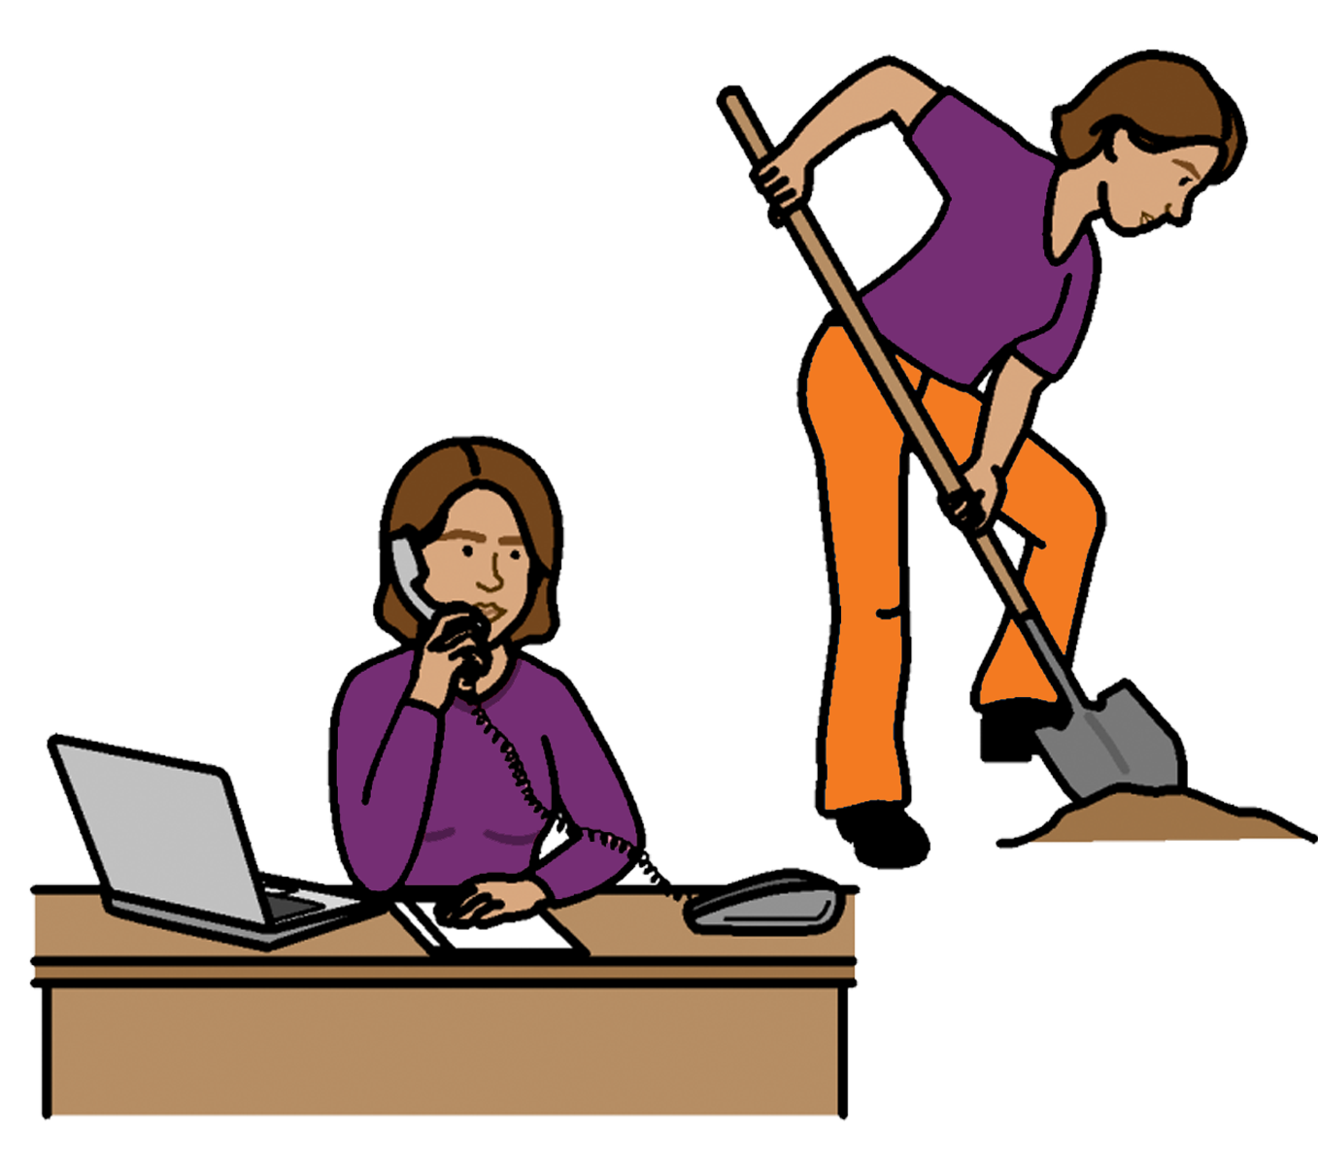
      - la wekpleis

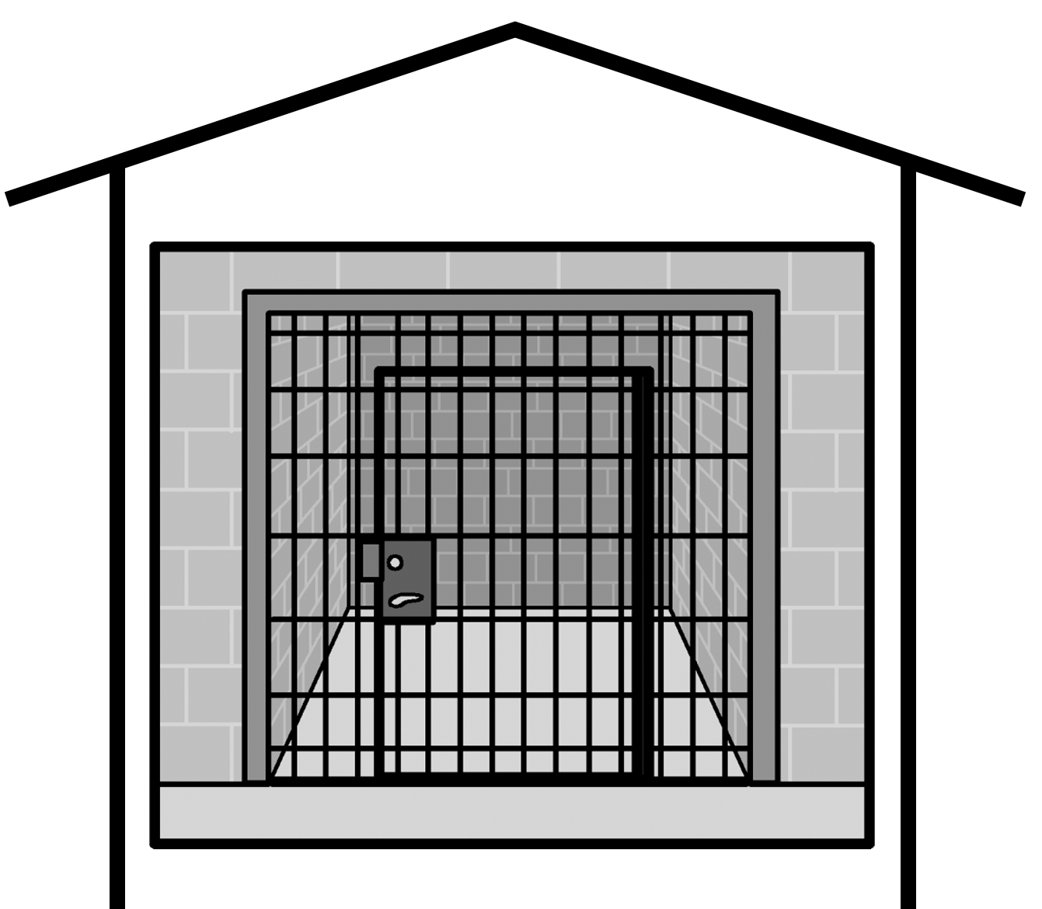

      - la jeil

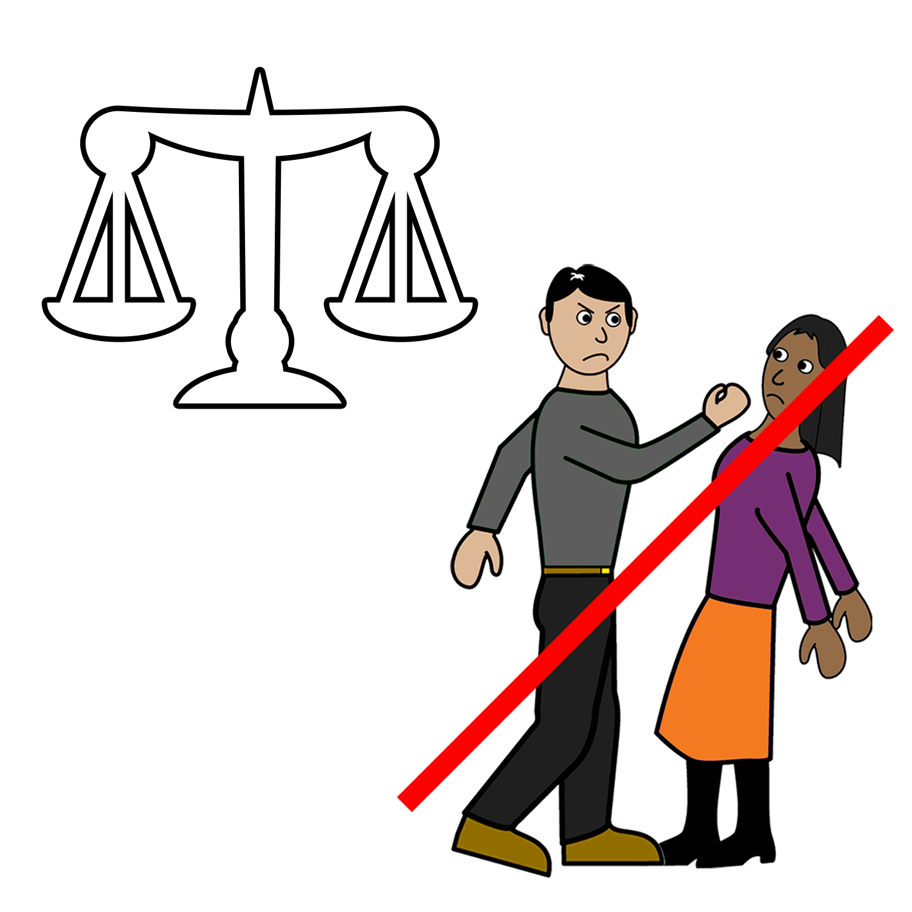
Eni bailens det hepin la ola wumenmob en gelmob hu garrim disibiliti im nogud.

Ebri wumenmob en gelmob hu garrim disibiliti garrim raits bla jidan seifwan brom bailens

Ebri bailens im rong la munanga lowa.

WWDA im sapot ola wumen en gelmob hu garrim disibiliti en hu lib gada bailens.

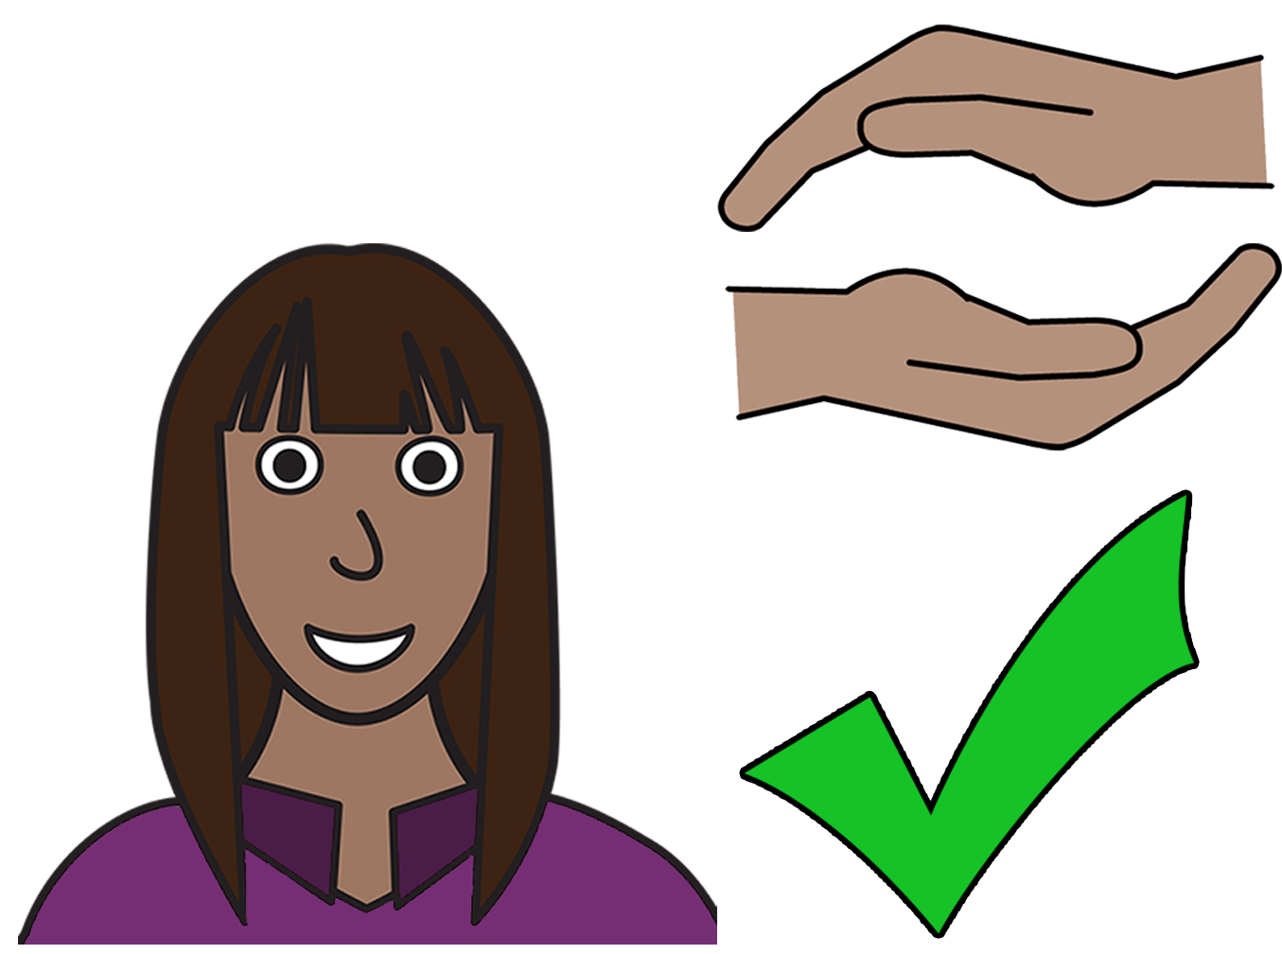

Bla yu raits
Yu garrim raits bla jidan seifwan brom bailens.

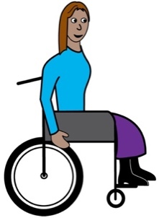
Munanga lowa jeya bla album yu.
Detmob gulum United Nations bin raidimdan ola raits bla pipul gada disibiliti. Dei bin gulum detmob raits det United Nations Convention on the Rights of Persons with Disabilities. Mela jis budum UNCRPD wen mela tok bla detmob raits brom United Nations.

Australia lafta bulurum det UNCRPD.

Australia lafta dum ebrijing bla stapum bailens wen im hepen la wumenmob en gelmob hu garrim disibiliti.

Yumob rimemba!

Yumob garrim det rait bla jidan seifwan brom bailens.

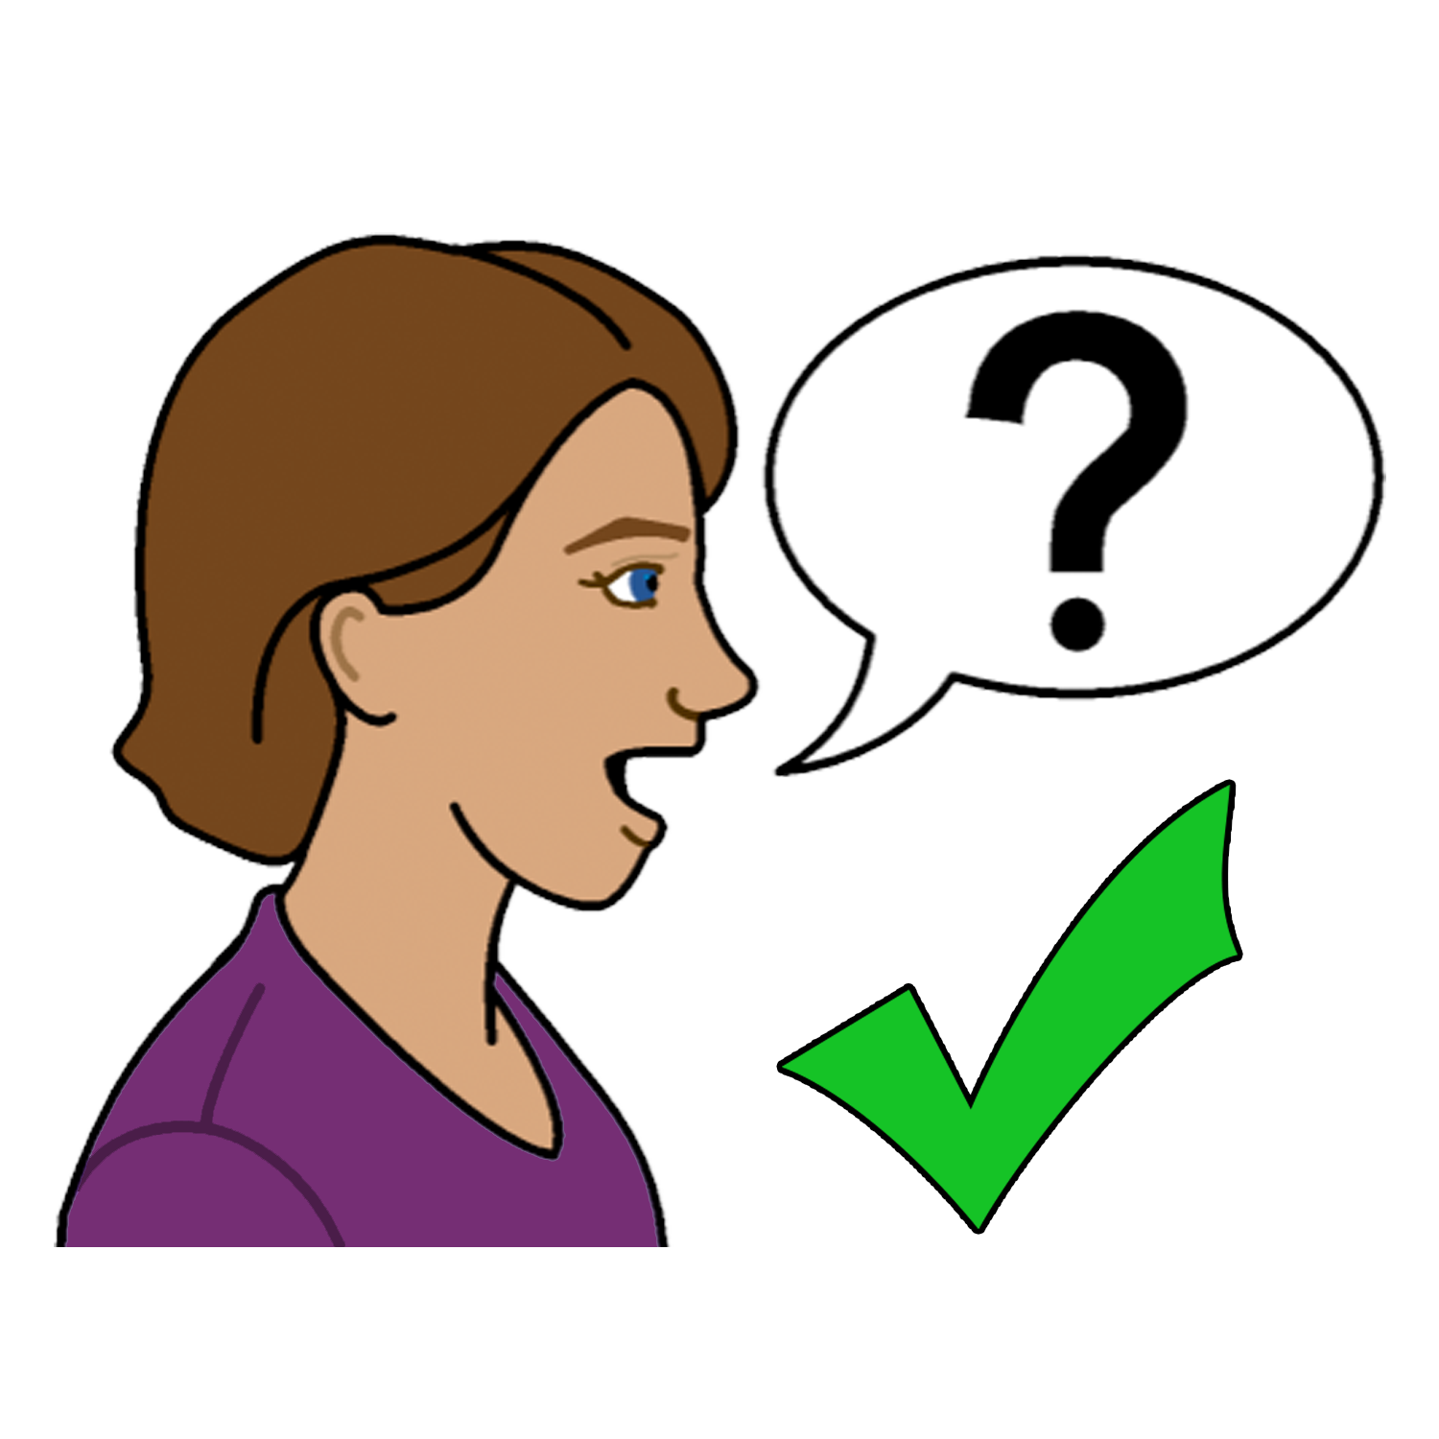
Yu gin tok la sambodi bla
bailens

1800 Respect

Kol la 1800 737 732

o

Gu la det websait www.1800respect.org.au

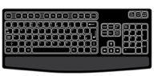

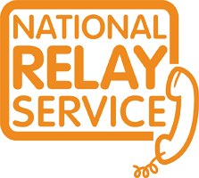
Yu gin yusim det Neshnul Rilei Sebis (National Relay Service) gada 1800Respect
Kol la 1800 555 677
TTY 133 677
Askim bla 1800 737 732

Wandim sambodi bla album yu tok?
Kol la 131 450
Askim bla 1800 737 732.

Theingk yu
Hu bin rait dijan buk?
Women with Disabilities Australia bin rait dijan buk 2019-2020.
Dijan buk im bla gibit infameishin thasol.

Copyright
© Copyright
Women with Disabilities Australia (WWDA) Inc. 2020.

All intellectual property rights, including copyright and patents, in this book is owned and licensed by Women with Disabilities Australia Inc.

Theingk yu bla det mani bla rait dijan buk.
Det National Disability Insurance Scheme bin gibit Women with Disabilities Australia sambala mani bla album bla meigim dijan websait.

The images used in this fact sheet
Easy on the I Images © 2019 Leeds and York Partnership NHS Foundation Trust. Used with permission. www.easyonthei.nhs.uk
The Picture Communication Symbols © 2019 by Mayer Johnson LLC a Tobii Dynavox company. Used with permission. www.tobiidynavox.com

Logos. Used with permission.

