# **Women with**

# **Disabilities Australia**

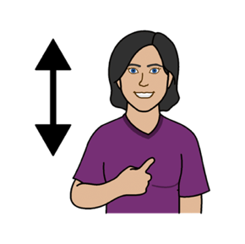

**Sabe wanem raits yu gad**

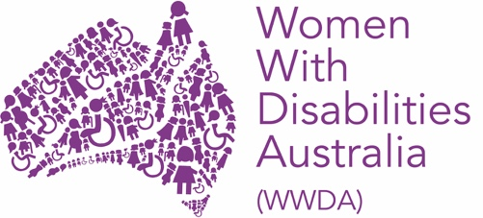

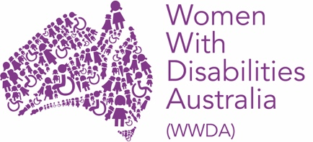 Mipla ya e Women with Disabilities Australia.

Wen wi tokbaut mipla wi go raitem diskain em **WWDA**.



Dis buk e baut wanem **raits yu gad**.

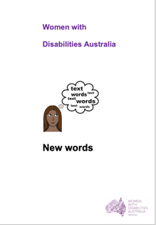

Wi bin rait dis buk po oman ane gel uda gad **disabiliti**. Yu ken rid mo baut **disabiliti** wea da buk **New Words.**

**Raits e wanem tingat are rights?**

Ebriwan i gad raits.



Raits i diskain. Wanem yu wande

* **kam.** Wase yu wande kam nurs.
* **mekem.** Wase yu wande go holidei
* **abem.** Wase yu wande abe pikinini.

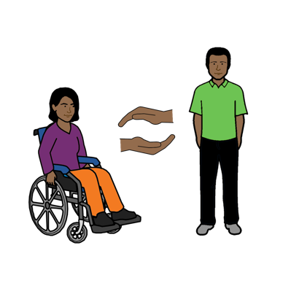

Oman ane gel uda gad disabiliti e gad **seimkain raits** wase ebribodi.



Nobodi ken tekemaut dem raits prom yu.

.

## **A picture containing outdoor Description automatically generatedDem raits blo ebribodi**

Yu gad raits po dem ting blo ebridei laip.

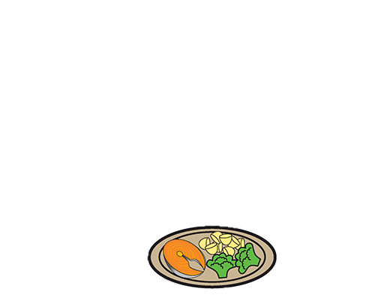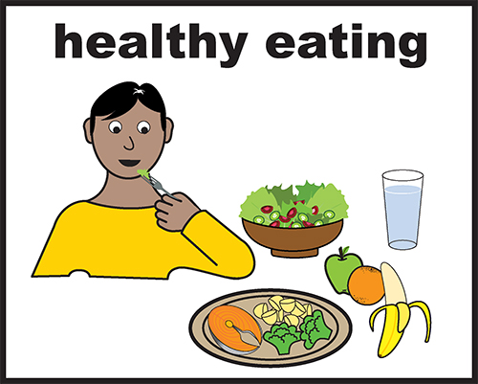

* kaikai ane wata

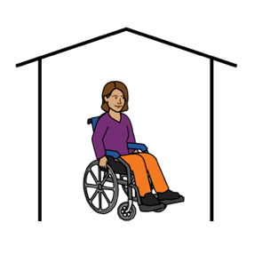

* seip ples po lib

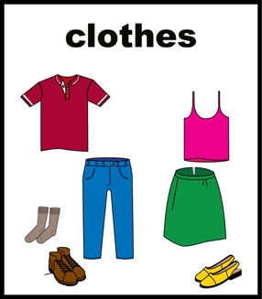

* dem rait klos po werem.

**Rait po bi seip**

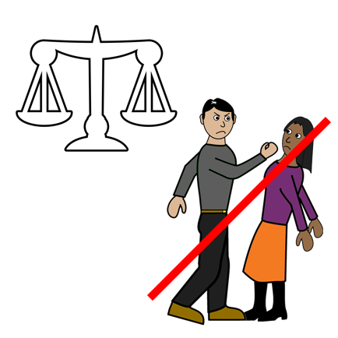

Wen i gad argu ane paiting ebri oman ane gel uda gad disabiliti e gad rait po bi seip.

Yu ken rid baut diswan wea da buk blo mipla

**Yu gad rait po bi seip wen e gad argu ane pait.**

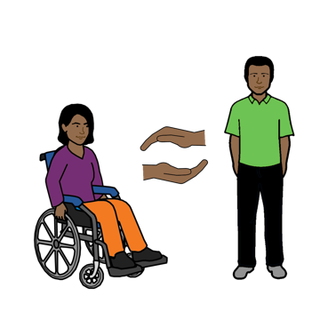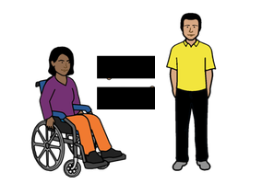 Yu gad rait po pipol po trite yu wea gud wei.

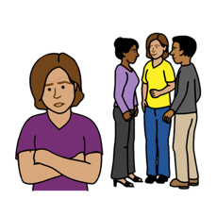 Wen pipol no trite yu wea gud wei, pipol i kole diswan **discrimination**. Yu ken rid mo baut dis wan wea da buk **New Words** lo peiz 6.

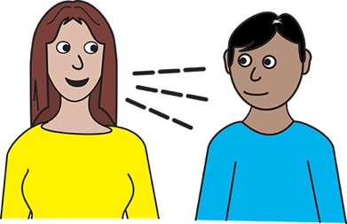 Yu gad rait po spikaut wen i gad

* argu ane pait

**ane**

* wen pipol no trite yu wea gudwei.

**Raits baut laip blo yu**

## 

## Ebri oman ane gel uda gad disabiliti e gad rait po

* chuz wanem dempla wande mekem



* po gad mani





* chuz wea dempla wande stap

## **ane**

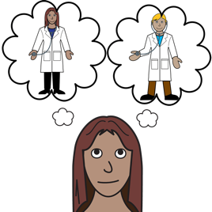

* wanem elth pipol yu wande go luk. Wase ip yu wande go po dipren dokta

**ane**

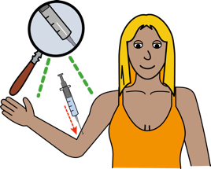

* 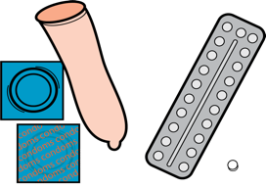 chuz baut demting yu wande tekem wase
* tablet
* nidol
* krim medisin

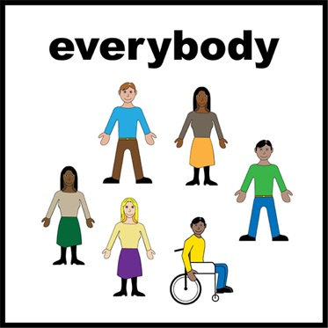**Rait po du wanem yu wandem**

Oman ane gel uda gad disabiiti e gad **rait po du wanem ebri oman ane gel laik po mekem**. Wase

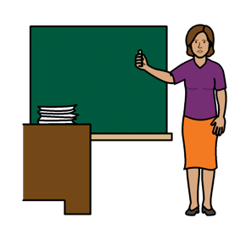

* go po skul



* **A close up of a logo

  Description automatically generated** go po wok
* po gede mani wen yu wok

* po vote wen i taim po vote.

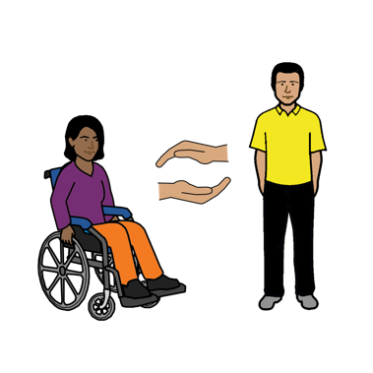**Rait po yuze dem dipren serbis ane sapot pipol**

Woman ane gel uda gad disabiliti e gad raits po

* **gede dem dipren serbis pipol po elpe dempla**
* **po gede dem dipren sapot pipol po elpe dempla.**



DIskain sapot e mait bi po elth blo yu. Wase

* taim po go luk dokta
* elp po go gede x-ray
* elp po go gede test po paindaut ip susu blo yu elthi.



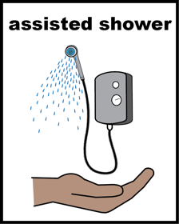Diskain e ken bi po sapot wok. Wase

* elpe yu po swimhelp you have a shower
* elpe wea gudwei po yuze mani blo yu
* elpe yu po go aut.

Yu mait gad rait po gede mani prom government. Wase

* pension
* elp po pei rent mani.



Dem sapot pipol mait elpe yu po gede inpomeisan.

Wase inpomeisan

* 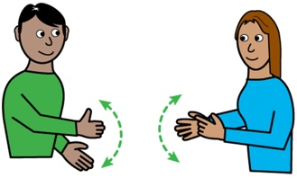yu ken lisen
* lo big leta
* lo sain
* lo izi English
* wea langus blo yu.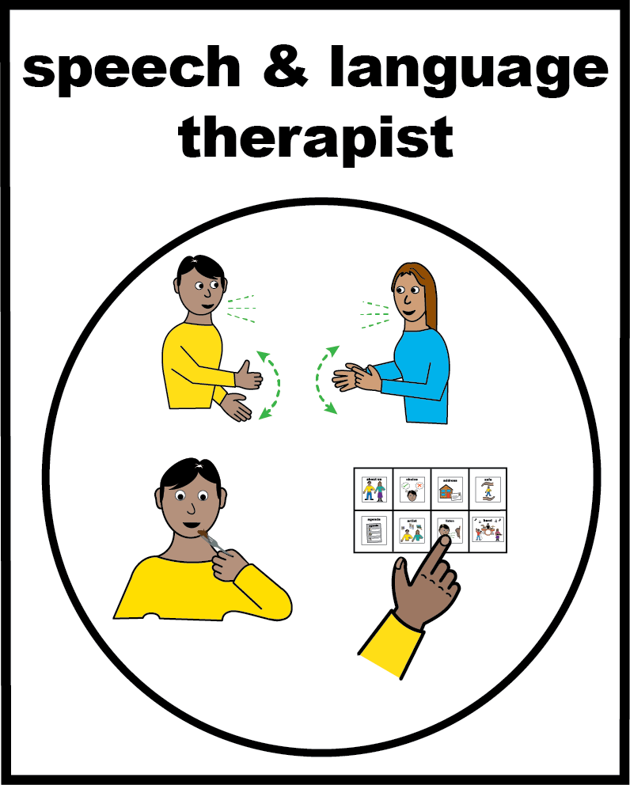

## **Dem raits baut sex ane bodi blo yu**

Oman ane gel uda gad disabiliti e gad rait po

* 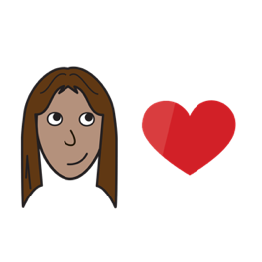abe pren ane meit
* sambodi po labe em

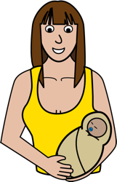

* gad pikinini

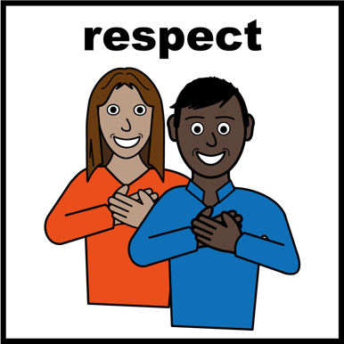

* gad respekt.

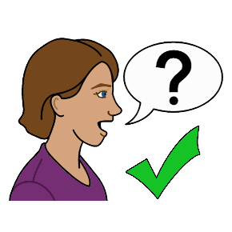

Yu ken tok po sambodi baut **dem raits** wanem yu gad**.**



**Australian Human Rights Commission**



Ring 02 9284 9600

## **or**

## A close up of a logo Description automatically generatedGo po da website

## www.humanrights.gov.au

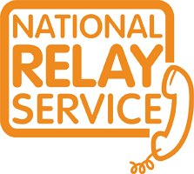 Yu ken yuze da **National Relay service**

wea da Australian Human Rights Commission

ring 1800 555 677

TTY 133 677

Ask po 1800 737 732

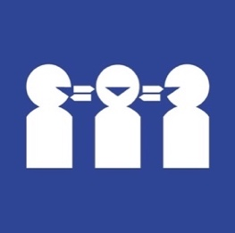Ip yu nide **translator**

Ring 131 450

Ask po 1800 737 732

** Eso**

**Uda bin raite dis buk?**

Women with Disabilities Australia bin rait dis buk lo 2019-2020.

Dis buk i po elp pipol po lan mo ane e po inpomeisan.

**Copyright**

© Copyright

Women with Disabilities Australia (WWDA) Inc. 2020.

All intellectual property rights, including copyright and patents, in this book is owned and licensed by Women with Disabilities Australia Inc.

**Eso po dem pipol uda bin gibe mani po raite dis buk.**

National Disability Insurance Scheme bin gibe Women with Disabilities Australia mani po elpe meke dis websait.

**The images used in this fact sheet**

Easy on the I Images © 2019 Leeds and York Partnership NHS Foundation Trust. Used with permission. [www.easyonthei.nhs.uk](http://www.easyonthei.nhs.uk)

The Picture Communication Symbols © 2019 by Mayer Johnson LLC a Tobii Dynavox company. Used with permission. [www.tobiidynavox.com](http://www.tobiidynavox.com)

Logos. Used with permission.