Women with
Disabilities Australia

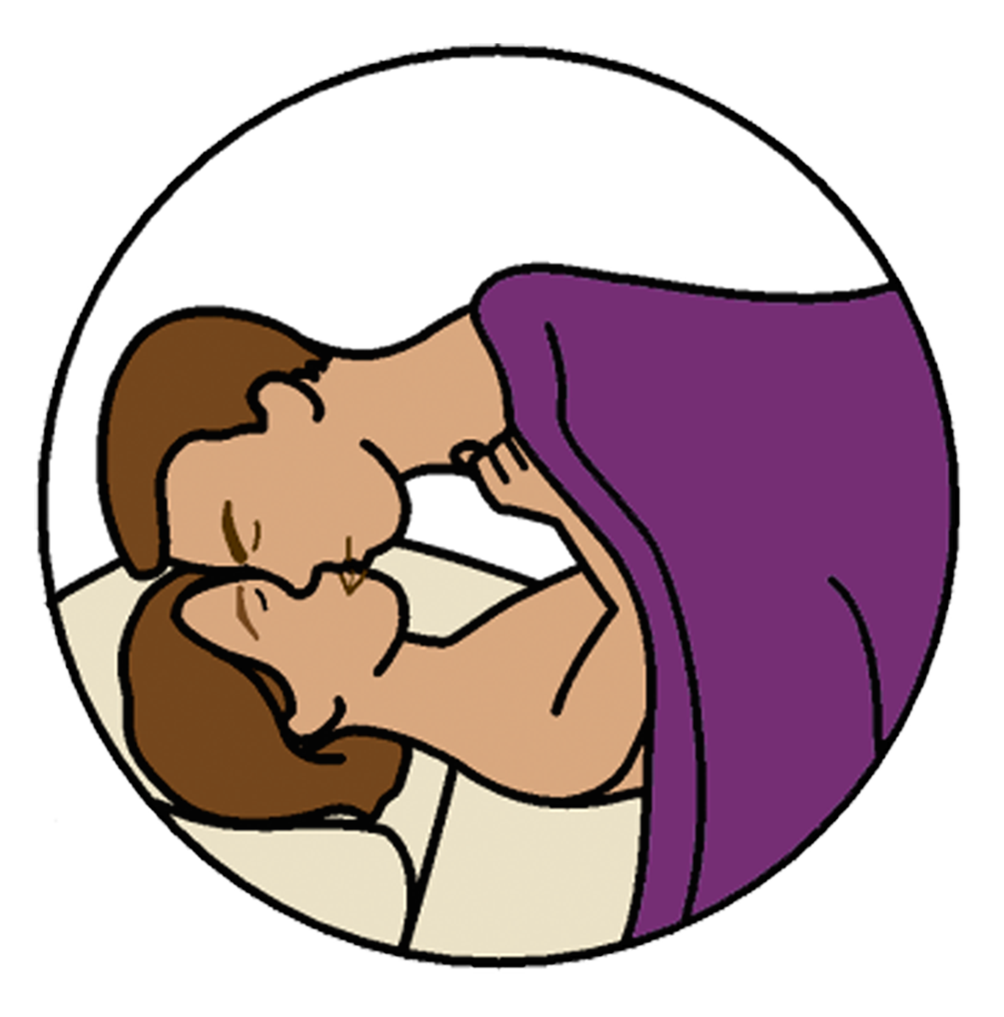
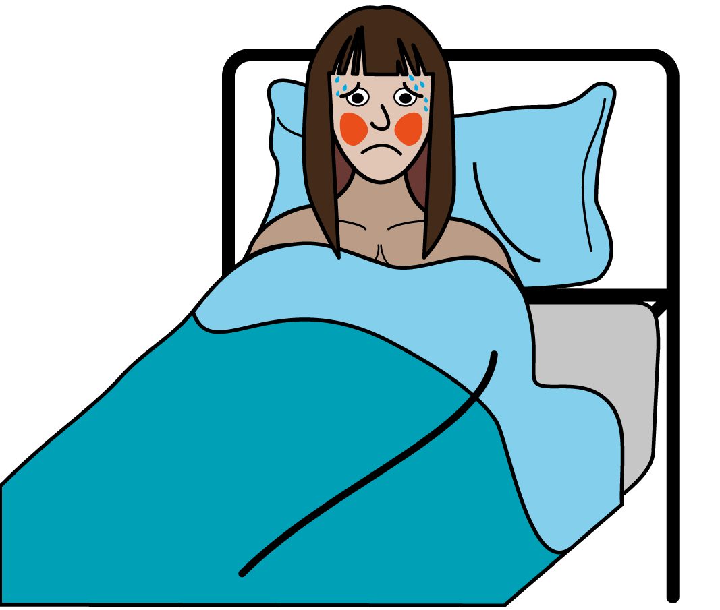

Sexually Transmitted Infections - STIs
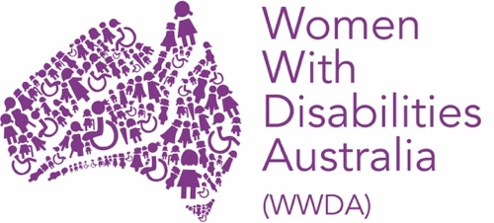

This book is about sex germs. They are also called Sexually Transmitted Infections.
We will write STI when we talk about them.

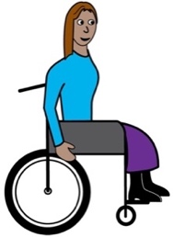
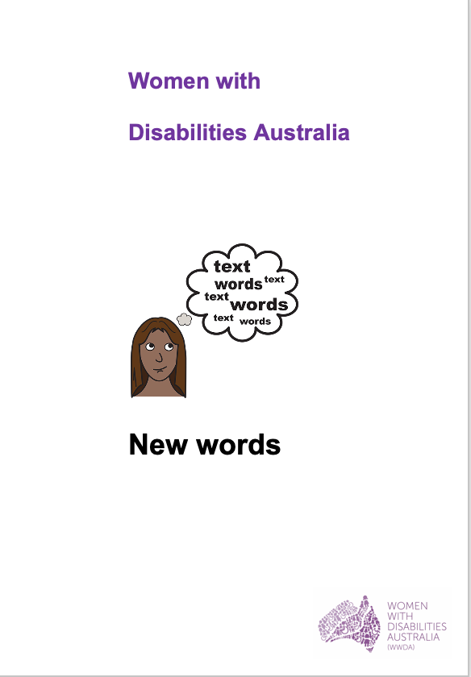
We wrote this book for women and girls
with disability. Read more about disability
in our book New Words.

We are Women with Disabilities Australia .

How do I know if I have a STI?

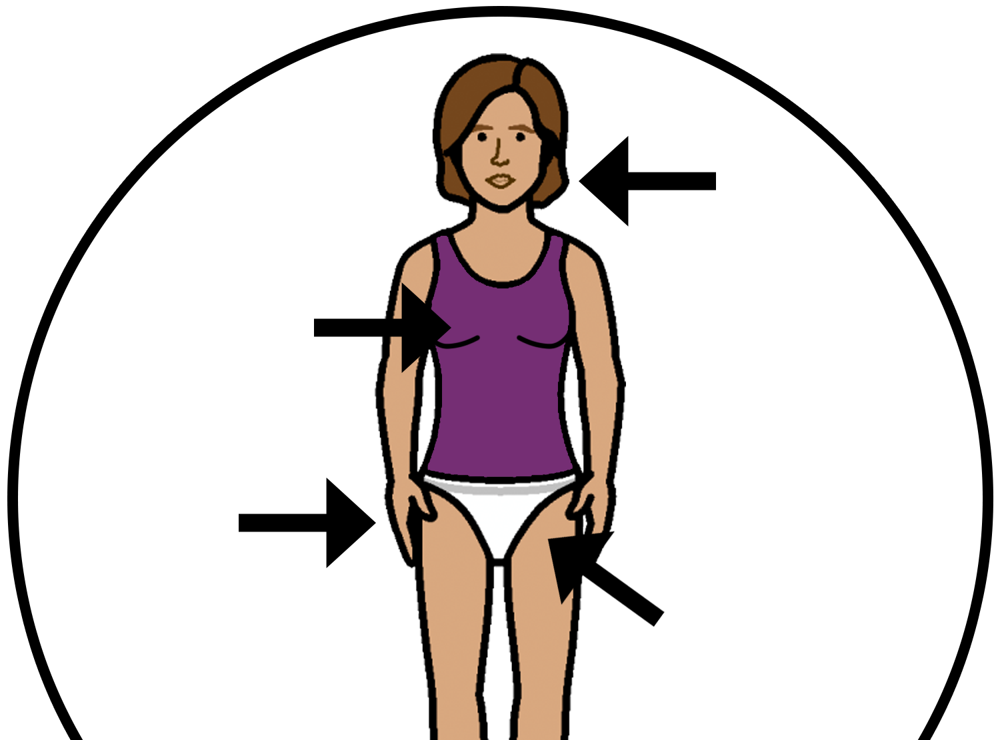
You may have lumps
- on your vagina
or
- your private parts.

Your private parts may be itchy.

Talk to your doctor.

How can I stop getting STIs?

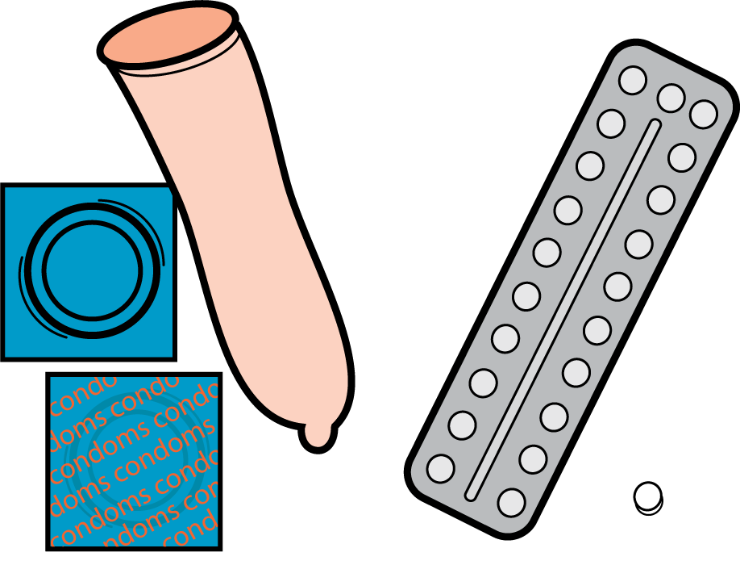
When you have sex use a condom every time.

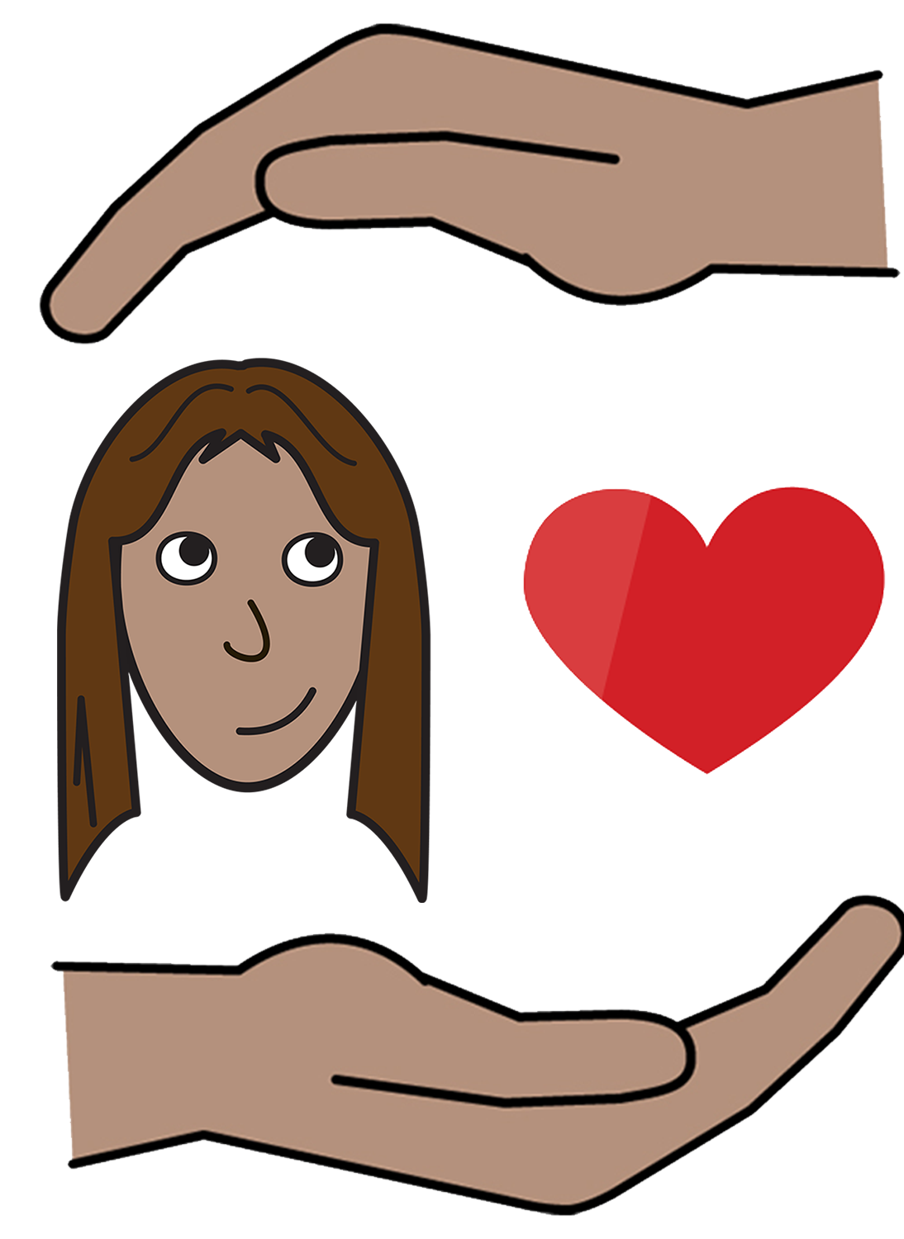
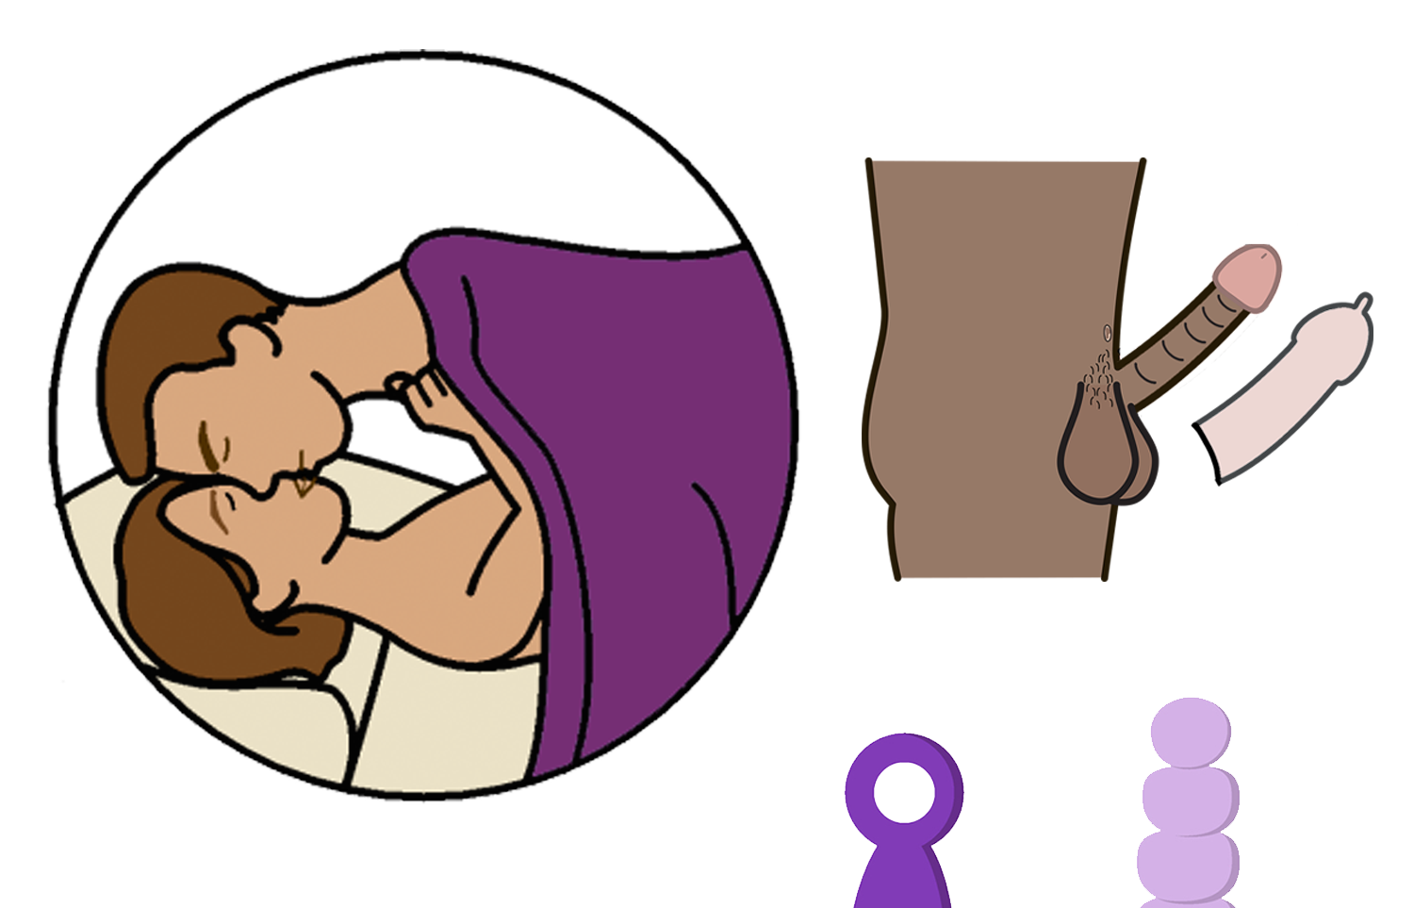
Read more about condoms in our book
Safer Sex and Contraception.

An STI Test

Your doctor may ask to see your private parts.
- your vagina
- your breasts
- your poo hole.

It all helps the doctor know
- what is wrong
- what to give you to get well.

You must say it is ok for the doctor to do this with your private parts. This is called consent.

Remember!

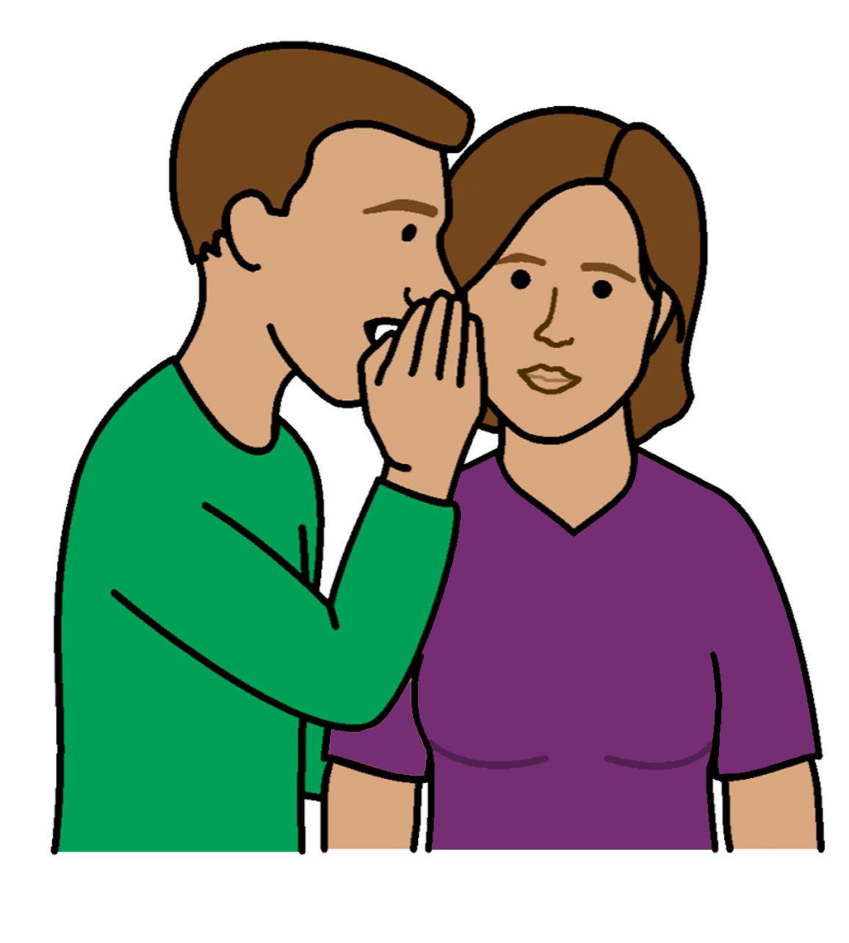

Your private parts are private to you.

When you say no.
The doctor or nurse can not touch
your private parts.

The doctor may also ask for

- some wee in a jar

and

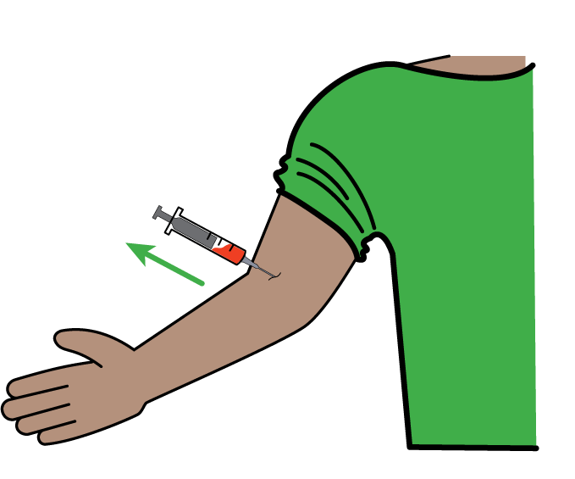
- some blood in a blood test

and

- to test your blood pressure.

For people with a cervix

You may need to do a test called a
cervical screen. This is also called a pap smear.

The doctor will need to see your private parts
to do this.

Your doctor will tell you the answer
in 1 to 2 weeks.

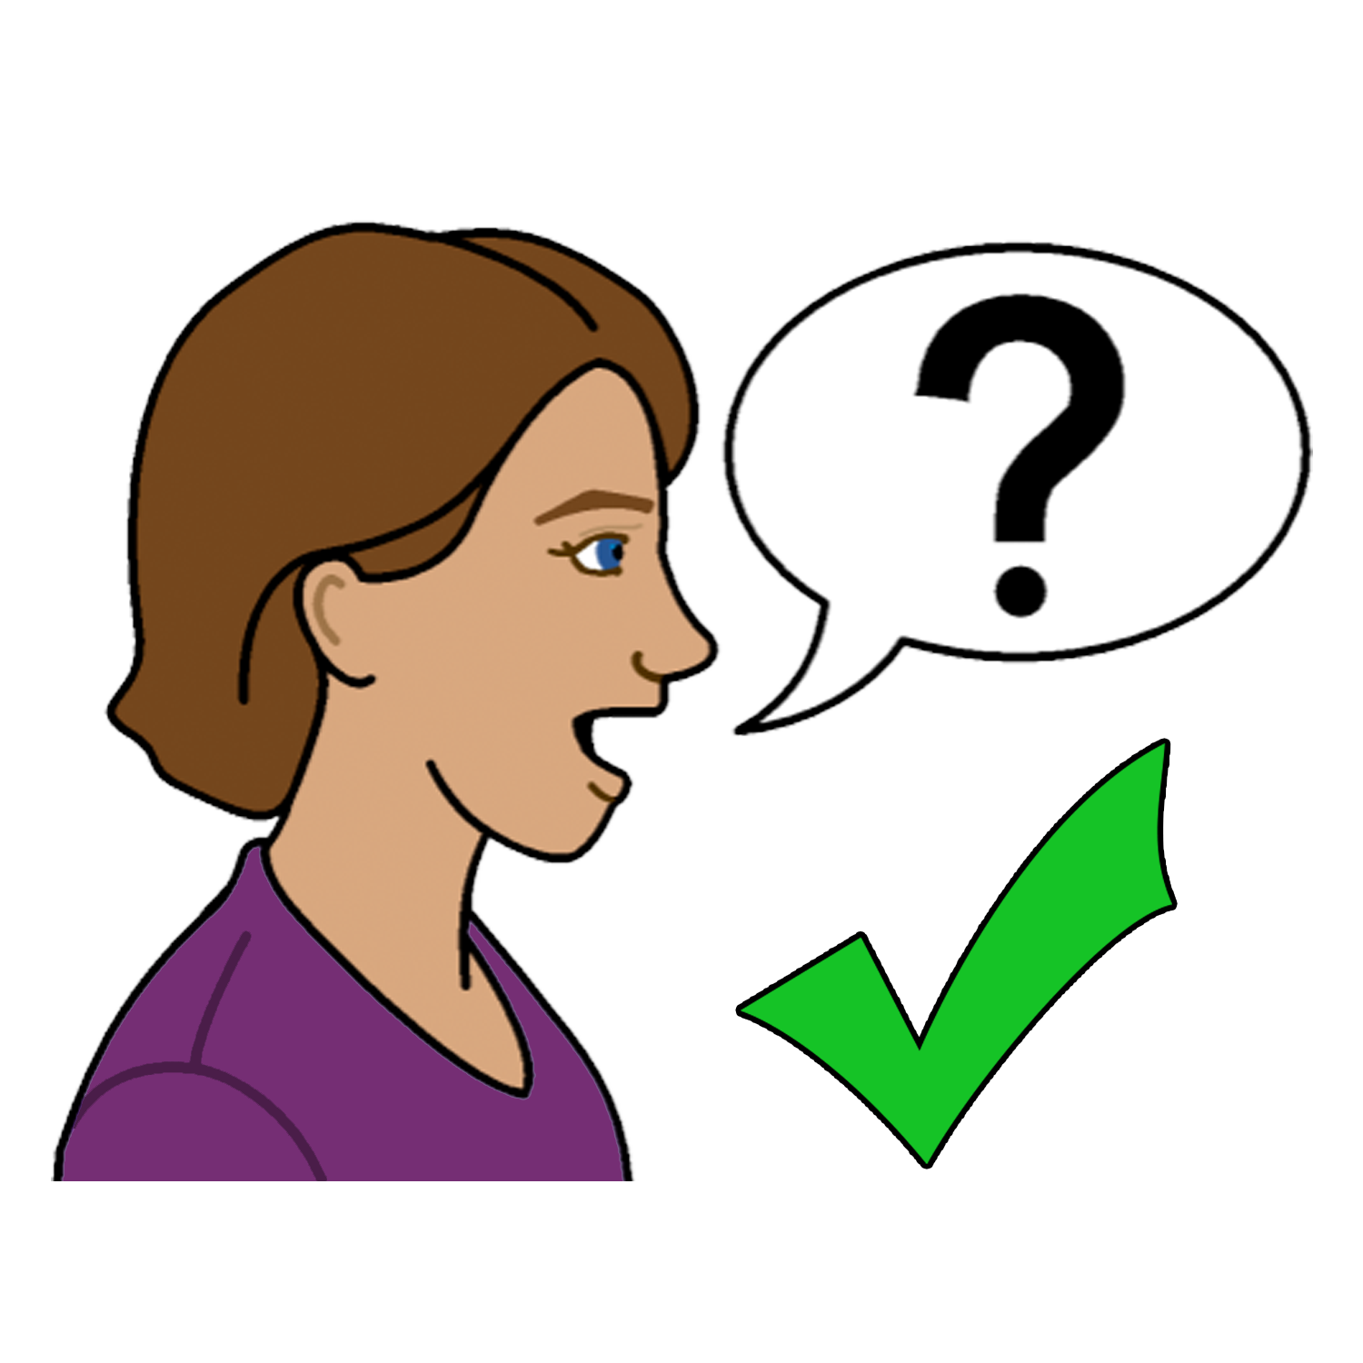
To find out more
Talk to some one you trust. Like

- a friend
- a family member

- your doctor

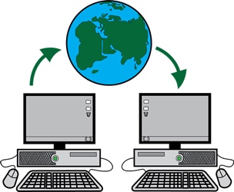
- your local Family Planning service.
Go to www.familyplanningallianceaustralia.org.au/services

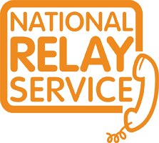
You can use the National Relay service
Call ………. 1800 555 677
TTY ……… 133 677

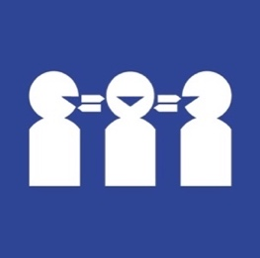
Need a translator
Call ……… 131 450

Thank you
Who wrote this book?
Women with Disabilities Australia wrote this book in 2019-2020.
This book is for general education and information only.

Copyright
© Copyright
Women with Disabilities Australia (WWDA) Inc. 2020.

All intellectual property rights, including copyright and patents, in this book is owned and licensed by Women with Disabilities Australia Inc.

Thank you for the money to write this book.
The National Disability Insurance Scheme gave Women with Disabilities Australia some money to help build this website.

The images used in this fact sheet
Easy on the I Images © 2019 Leeds and York Partnership NHS Foundation Trust. Used with permission. www.easyonthei.nhs.uk
The Picture Communication Symbols © 2019 by Mayer Johnson LLC a Tobii Dynavox company. Used with permission. www.tobiidynavox.com

Logos. Used with permission.

