Women with
Disabilities Australia
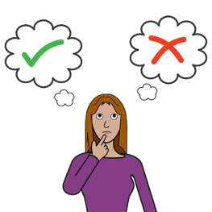

You are pregnant. What can you do?

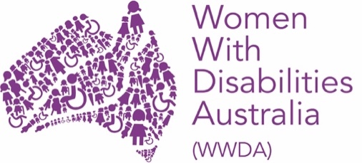

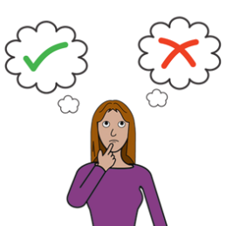
This book is about your choices when
you are pregnant.

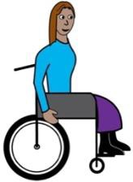

We wrote this book for women and girls with disability.

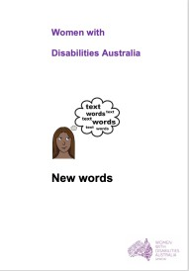

Read more about disability in our book New Words.

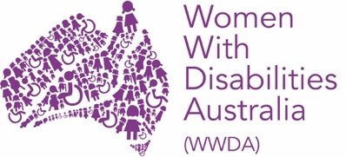
We are Women with Disabilities Australia.

You are pregnant

You have some choices.

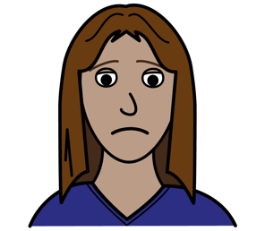

It can be very hard to make this choice.

But
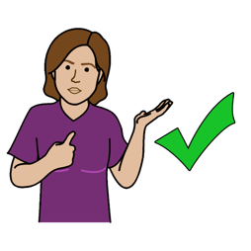

It is your choice.

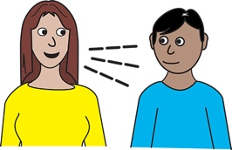
Talk to someone you trust.
Like:

- your doctor

- your partner

- your friend
- a family member

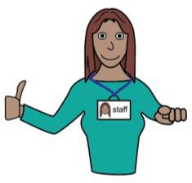

- your support worker

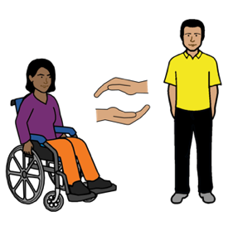

- an advocate

There are 3 choices
It is your choice.

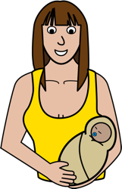
1. Have the baby.
You give birth to the baby.
You are a parent.

2. Have an abortion.
You do something to stop you being pregnant.
You do not have a baby.

3. Adoption or Foster.
You have the baby.
But
You give the baby to a different family.

- Have your baby. Be a parent

You find out you are pregnant.
You need to see your doctor.

Your doctor will help you look after:
- your health
and
- the health of your unborn child.

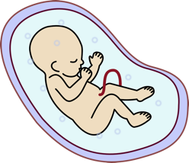

Your unborn child is called a foetus.

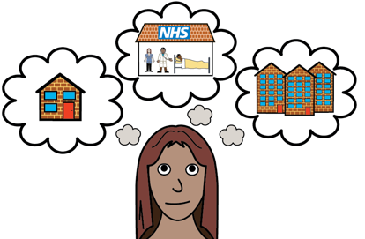
You need to choose where to have
your baby.

It can be:

- in a hospital

or
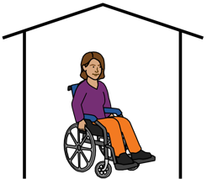

- at home.

Talk to your doctor about this.

- Abortion
You do something to stop being pregnant.

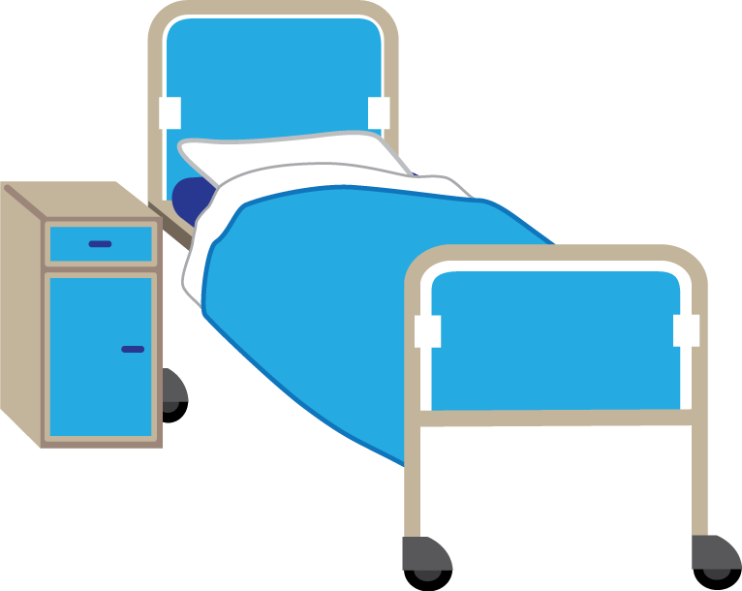
You can:
- have a small operation.
It will be in a hospital.

or
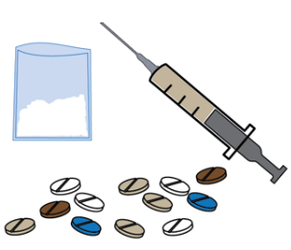

- take some medicine.

Talk to your doctor.
Your doctor will help you choose.

Sometimes your doctor does not want
to help you. That is OK.

but

Your doctor must find you a doctor to help you.

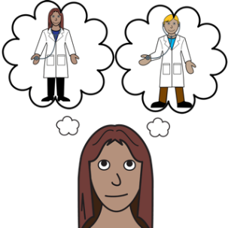

You can also choose to see a different doctor.

- Adoption or Foster
You have the baby.

But

You give the baby to another family.

You will not be a parent.

Talk to your doctor about this.

Your doctor will help you look after:
- your health
and
- the health of the unborn child.

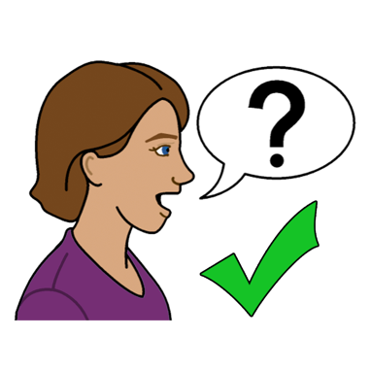

To find out more
You can talk to:

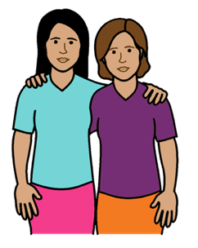
- a friend
- a family member

- your doctor

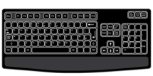
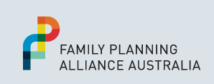
- your local Family Planning Service.
Go to: www.familyplanningallianceaustralia.org.au/services

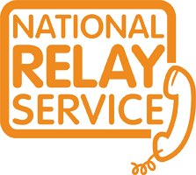
You can use the National Relay Service
when you call a service
Call: ………….. 1800 555 677
TTY: …………. 133 677

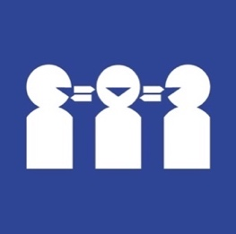

Need a translator
Call ………….. 131 450

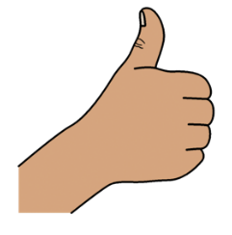
Thank you
Who wrote this book?
Women with Disabilities Australia wrote this book in 2019-2020.
This book is for general education and information only.

Copyright
© Copyright
Women with Disabilities Australia (WWDA) Inc. 2020.

All intellectual property rights, including copyright and patents, in this book is owned and licensed by Women with Disabilities Australia Inc.

Thank you for the money to write this book.
The National Disability Insurance Scheme gave Women with Disabilities Australia some money to help build this website.

The images used in this book
Easy on the I Images © 2019 Leeds and York Partnership NHS Foundation Trust. Used with permission. www.easyonthei.nhs.uk
The Picture Communication Symbols © 2019 by Mayer Johnson LLC a Tobii Dynavox company. Used with permission. www.tobiidynavox.com

Logos. Used with permission.

