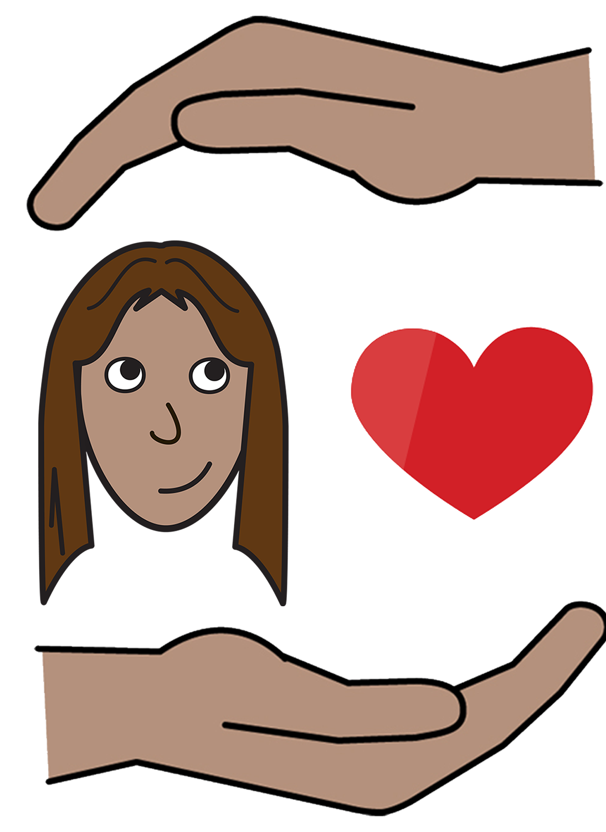
Women with
Disabilities Australia

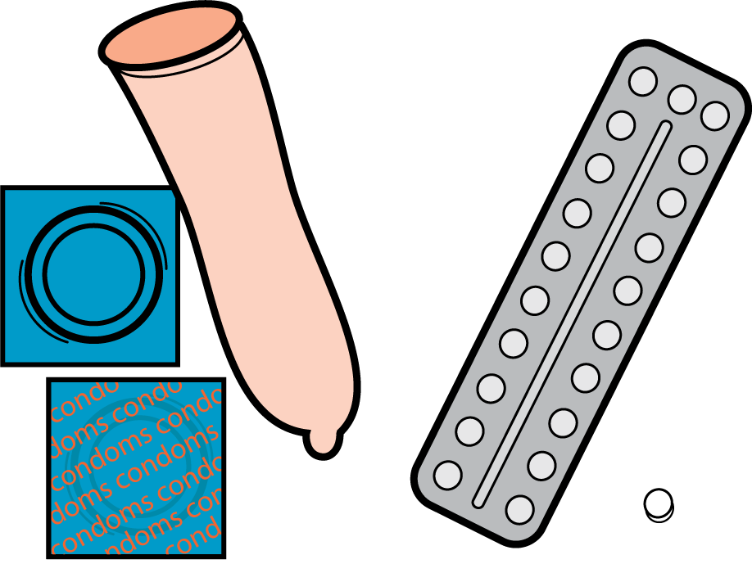

Safer sex
and contraception

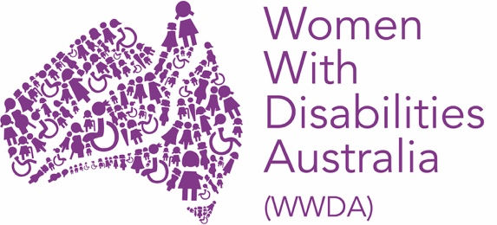

This book is about safer sex and contraception.

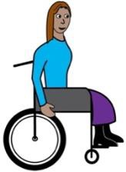

We wrote this book for women and girls with disability.

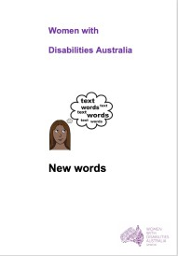

Read more about disability in our book New Words.

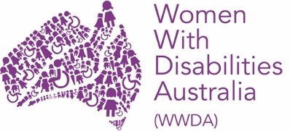
We are Women with Disabilities Australia.

Safer Sex
Safer sex is sometimes called safe sex.

Safer sex is things you do to:

- stay well when you have sex

- only get pregnant when you want to

- feel safe when you have sex
and
- feel happy when you have sex.

Condoms
Condoms help you have safer sex.
They are called contraception.

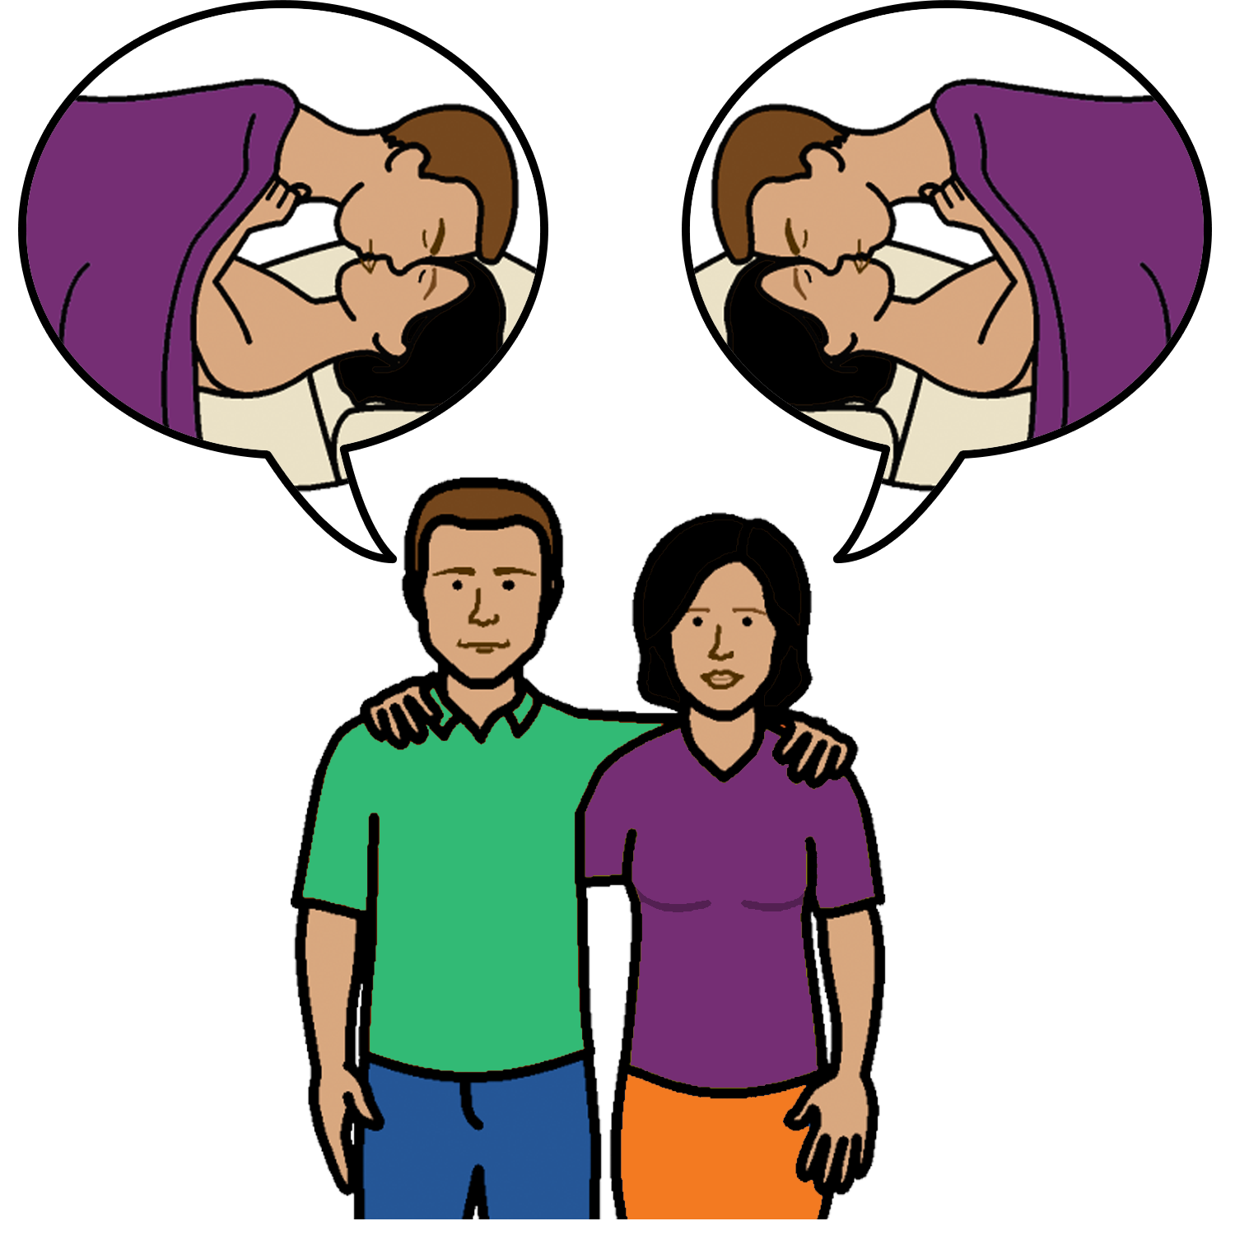
There are condoms for men and women.

Condoms can help to stop you:

- getting pregnant.

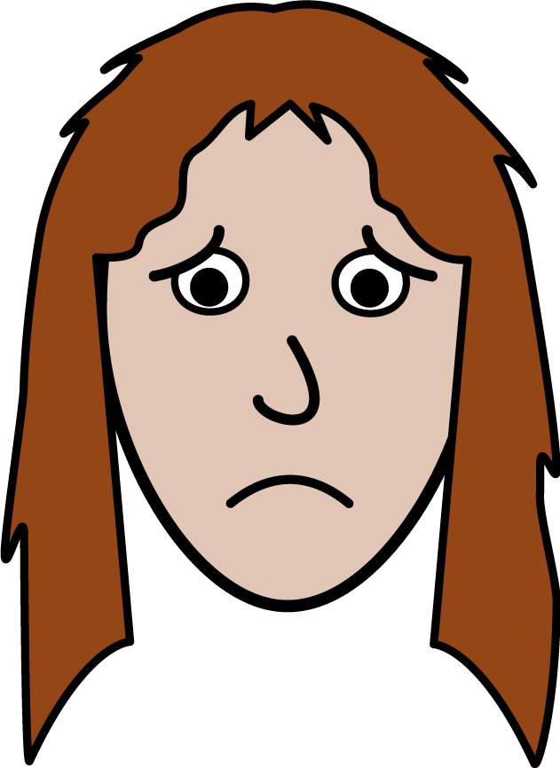

- getting sick.

How to use condoms

Put a condom on before you have sex.

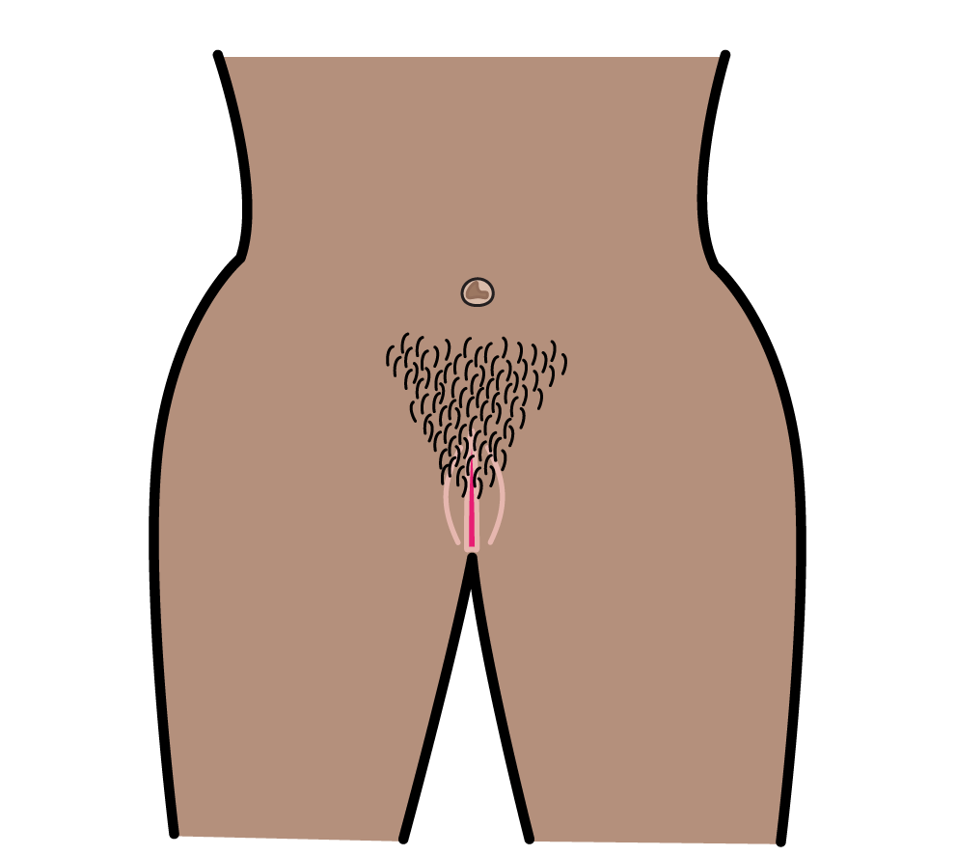
It means before you put:
- a penis in a vagina

or

- a penis in a poo hole

or

- your vagina touches another vagina.

Put a condom on a penis when it is hard.
You unroll the condom on to a penis.
The packet of condoms may have pictures to show you how.

or
Put a condom in to a vagina.

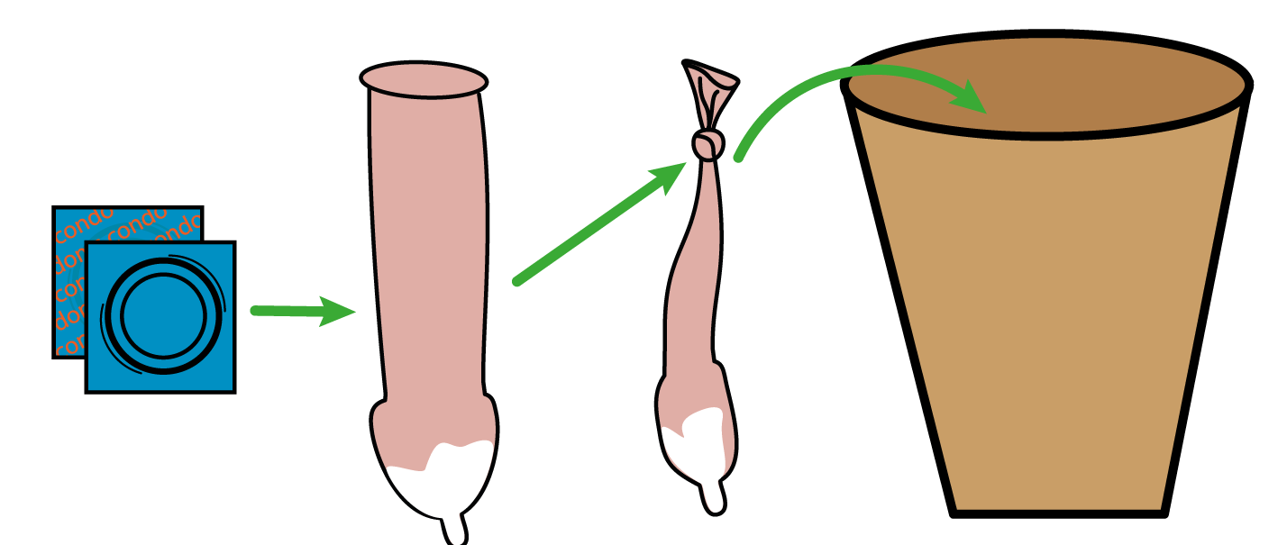
You must use a condom 1 time only.
You need a new condom every time you have sex.
Put the used condom in the bin.

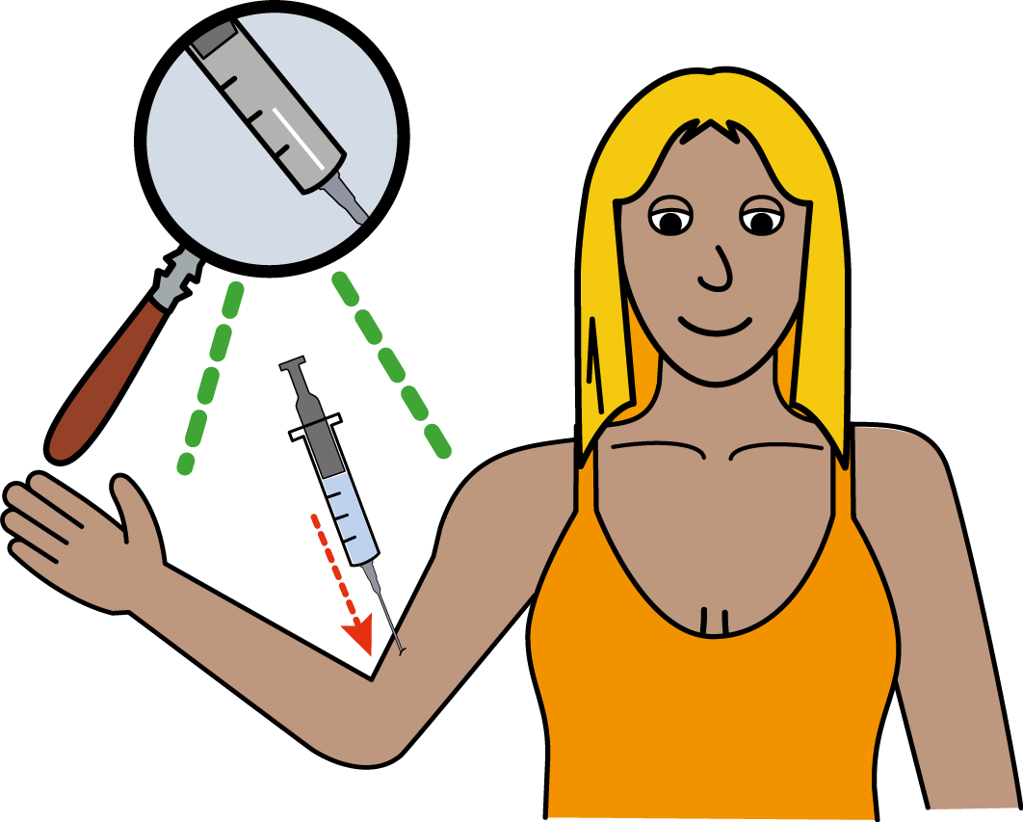
Other things to have Safer Sex.
You can use other things to have safer sex.
These things are also contraception.

You can use a condom and these things at the same time. Some things you can use are:

- a pill

- a small rod in your arm

Talk to your doctor about what is best for you.

How to feel safe

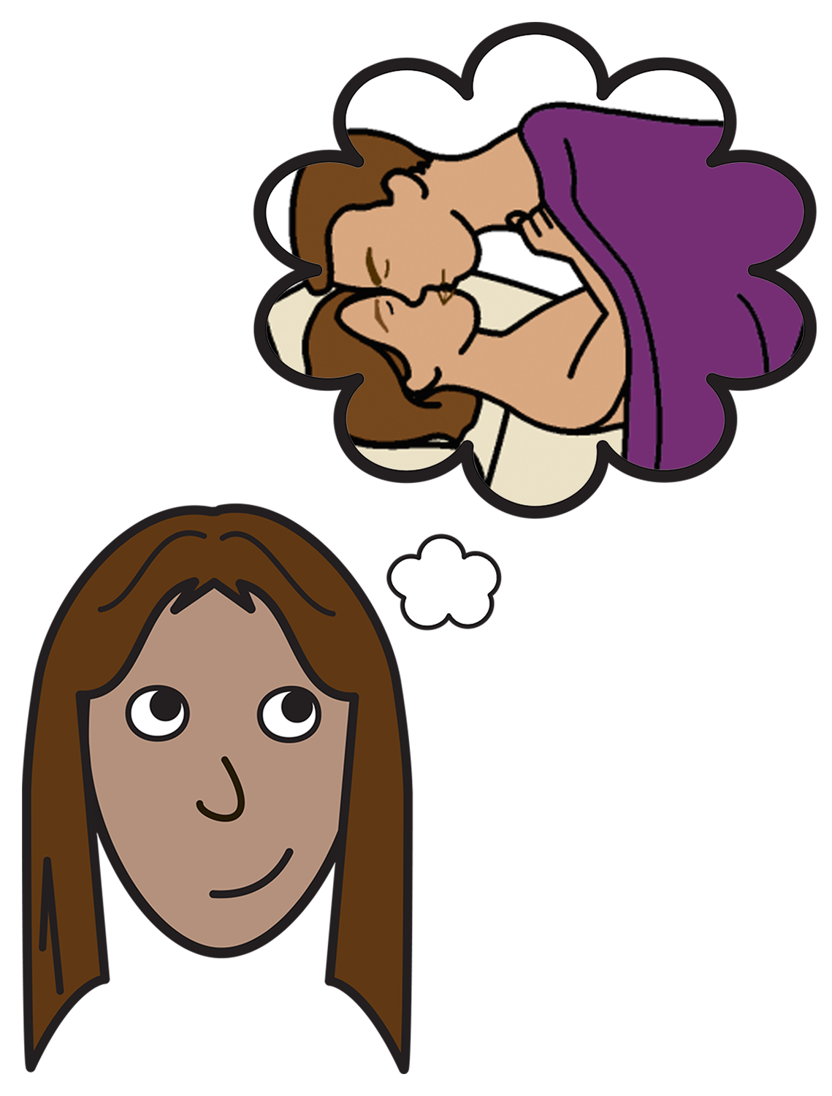
Safer Sex also means:

- you have sex when you want to

- the other person respects you

- you feel good about the sex.

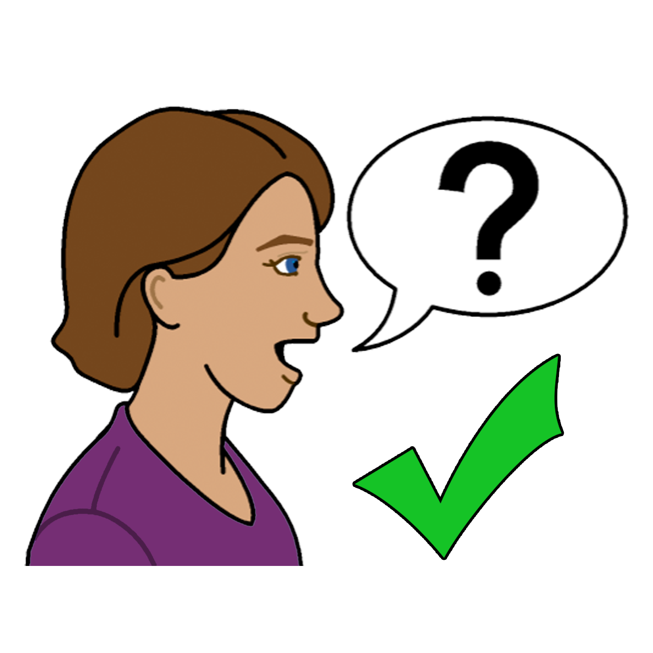
To find out more
Talk to someone you trust.
Like:

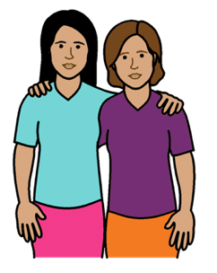
- a friend
- a family member

- your doctor

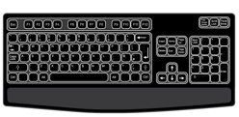
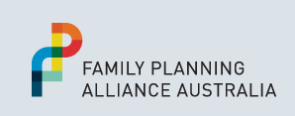
- your local Family Planning Service.
Go to: www.familyplanningallianceaustralia.org.au/services

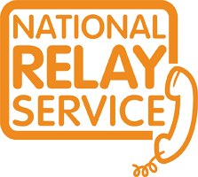
You can use the National Relay Service
when you call a service
Call: ………….. 1800 555 677
TTY: …………. 133 677

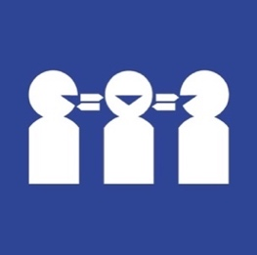

Need a translator
Call ………….. 131 450

Thank you
Who wrote this book?
Women with Disabilities Australia wrote this book in 2019-2020.
This book is for general education and information only.

Copyright
© Copyright
Women with Disabilities Australia (WWDA) Inc. 2020.

All intellectual property rights, including copyright and patents, in this book is owned and licensed by Women with Disabilities Australia Inc.

Thank you for the money to write this book.
The National Disability Insurance Scheme gave Women with Disabilities Australia some money to help build this website.

The images used in this book
Easy on the I Images © 2019 Leeds and York Partnership NHS Foundation Trust. Used with permission. www.easyonthei.nhs.uk
The Picture Communication Symbols © 2019 by Mayer Johnson LLC a Tobii Dynavox company. Used with permission. www.tobiidynavox.com

Logos. Used with permission.

