**Women with**

**Disabilities Australia**

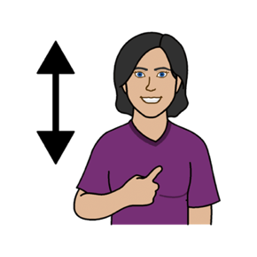

**Know your rights**

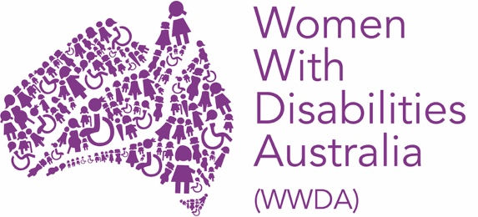



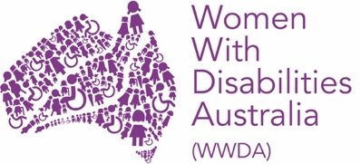

We are Women with Disabilities Australia.

We will write **WWDA** when we talk about us.



This book is about **your rights.**

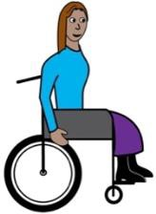

We wrote this book for women and girls with **disability.**

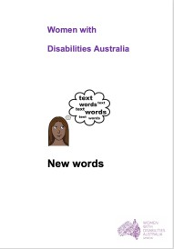

Read more about **disability** in our book **New Words.**

## **What are rights?**

Everyone has rights.

Rights are things you can:

* **be.** Likeyou want to be anurse
* **do.** Like you want to go on a holiday
* **have.** Like you want to have children.

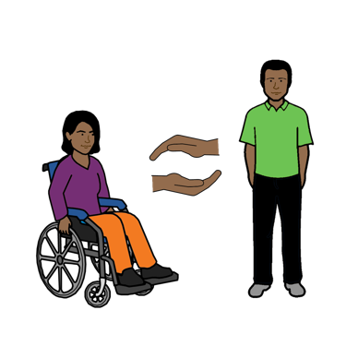

Women and girls with disability have

the **same rights** as everyone else.

No one can take away your rights.

## **Basic rights**

You have the right to basic things in your life.

Like:

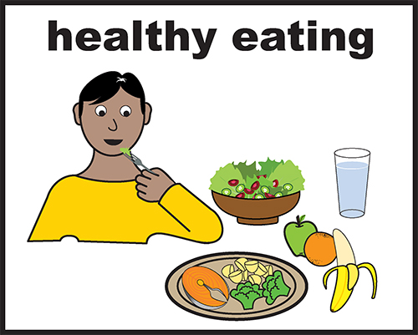

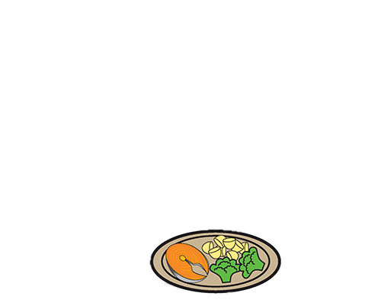

* food and water

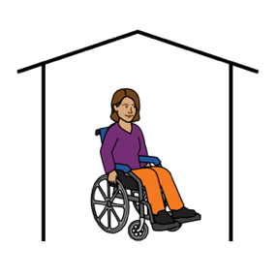

* a safe place to live

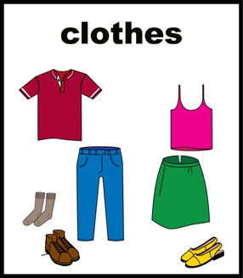

* the right clothes to wear.

**

## **Right to be safe**

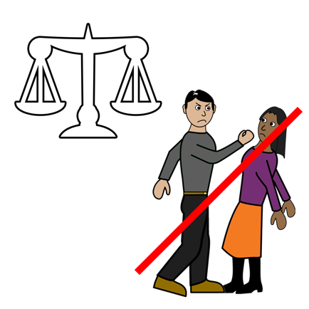

All women and girls with disability have the right

to be safe from violence.

Read more about this in our book:

**You have the right to be safe from violence.**

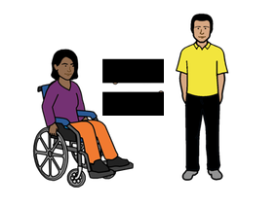

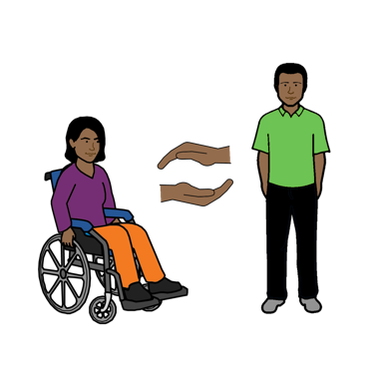

You have the right to be treated in a fair way.

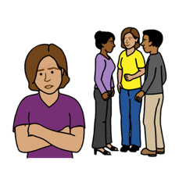

When you are **not** treated in a fair way it is called **discrimination**.

Read more about this in our book **New Words**.

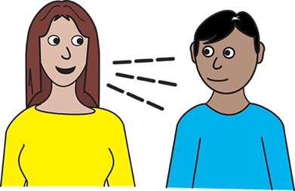

You have the right to speak up about:

* violence

**and**

* when you are **not** treated in a fair way.

**Rights about your life**

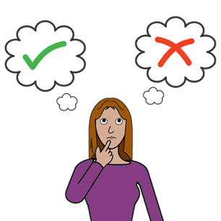

All women and girls with disability have a right to:

* make choices

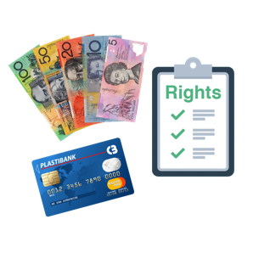

* have money

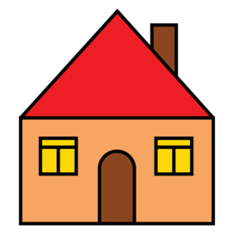

* choose where to live

**and**

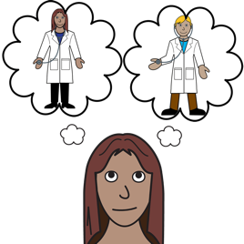

* choose what health people you see.

Like a new doctor

**and**

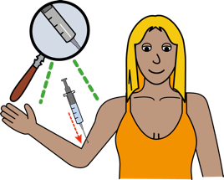

* make choices about your
* pills
* 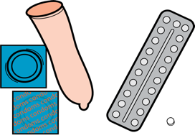needles
* creams.

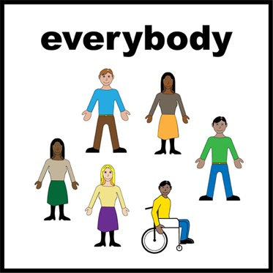**Right to take part**

Women and girls with disability have a right to

**do things that all women and girls do.**

Like:

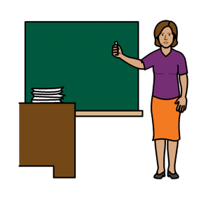

* go to school

* go to work



* be paid for our work

* vote in elections.

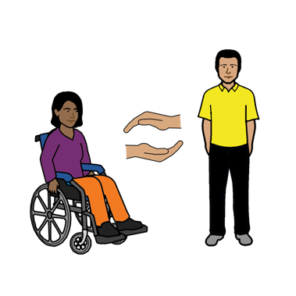**Right to services and supports**

Women and girls with disability have a right to:

* **services**
* **supports.**

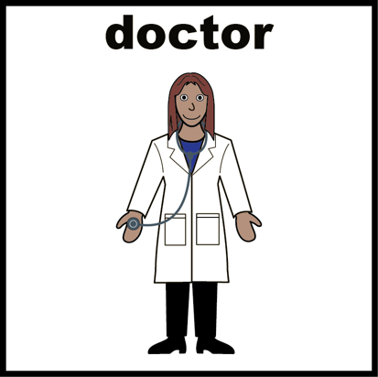

This may be for your health. Like:

* a visit to your doctor
* to get an x-ray
* to have a breast screen.



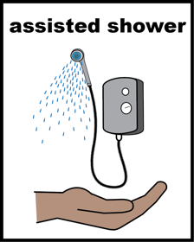This may also be for support workers. Like:

* to help you have a shower
* to help you plan the use of your money
* to help you go out.



This may also be money from the government. Like:

* a pension
* help to pay your rent.

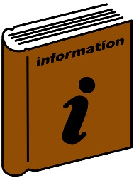

It may also be information that you can use.

Like information:

* 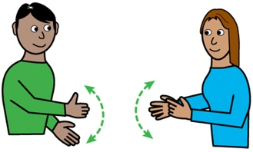you can listen to
* in big writing
* in sign language
* 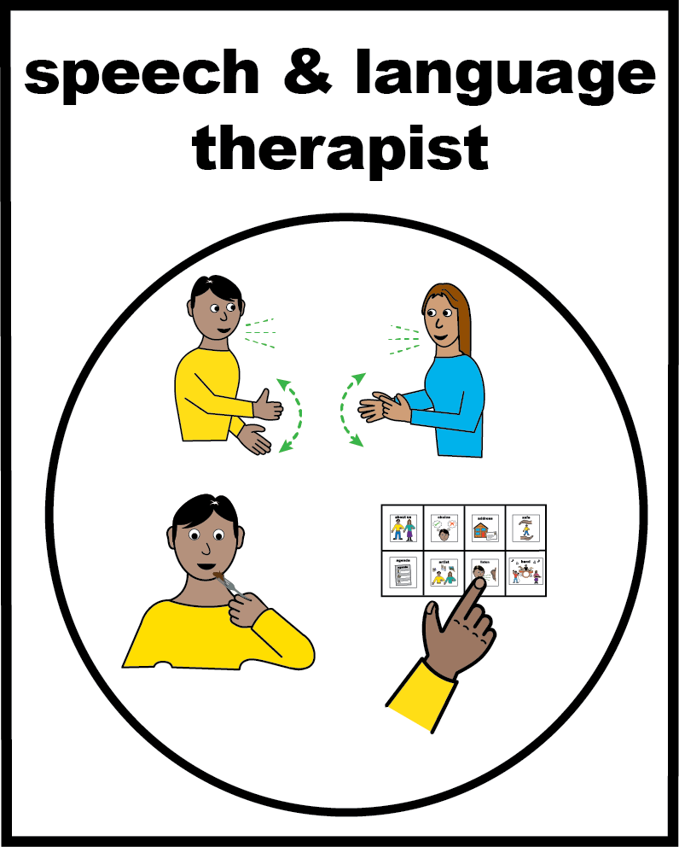in Easy English
* in a different language.

## **Rights about sex and your body**

Women and girls with disability have a right to:

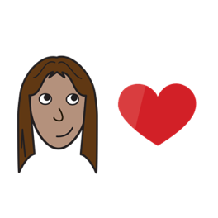

* have relationships
* be loved

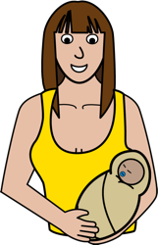

* have children

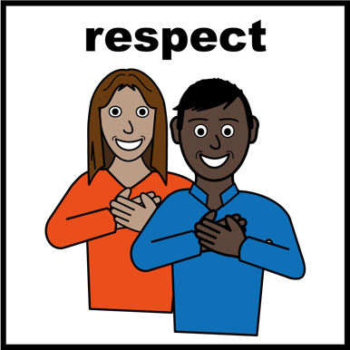

* be respected.

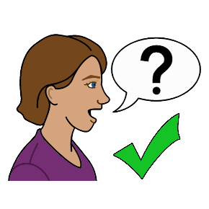

**You can talk to someone**

**about** **your rights**

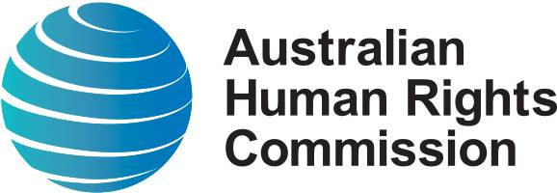

**Australian Human Rights Commission**

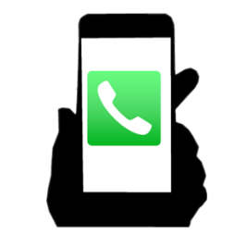

Call: 02 9284 9600

**or**

Go to the website:

www.humanrights.gov.au



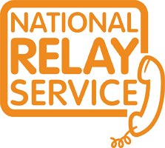You can use the **National Relay Service**

with the Australian Human Rights Commission

Call 1800 555 677

TTY 133 677

Ask for 02 9284 9600

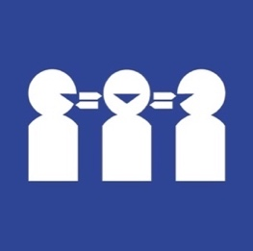

Need a **translator**

Call 131 450

Ask for 02 9284 9600

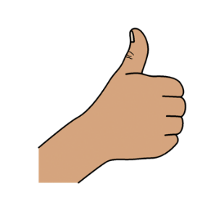

**Thank you**

**Who wrote this book?**

Women with Disabilities Australia wrote this book in 2019-2020.

This book is for general education and information only.

**Copyright**

© Copyright

Women with Disabilities Australia (WWDA) Inc. 2020.

All intellectual property rights, including copyright and patents, in this book is owned and licensed by Women with Disabilities Australia Inc.

**Thank you for the money to write this book.**

The National Disability Insurance Scheme gave Women with Disabilities Australia some money to help build this website.

**The images used in this book**

Easy on the I Images © 2019 Leeds and York Partnership NHS Foundation Trust. Used with permission. [www.easyonthei.nhs.uk](http://www.easyonthei.nhs.uk)

The Picture Communication Symbols © 2019 by Mayer Johnson LLC a Tobii Dynavox company. Used with permission. [www.tobiidynavox.com](http://www.tobiidynavox.com)

Logos. Used with permission.