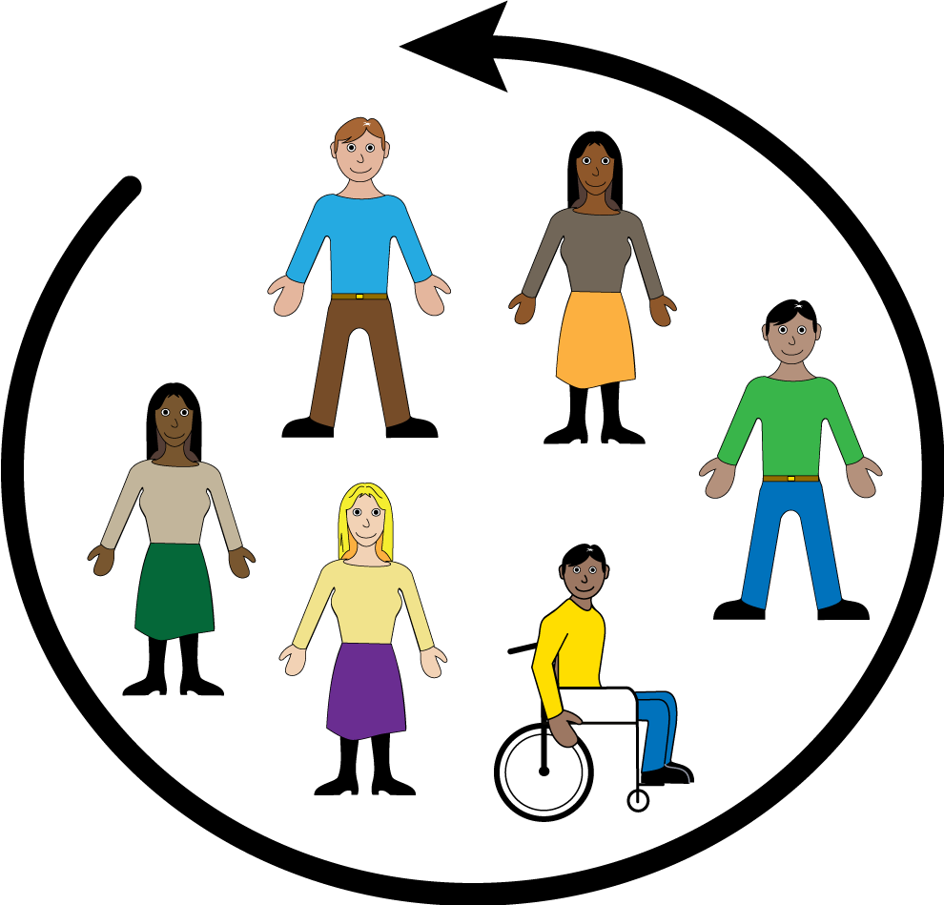
Women with
Disabilities Australia

Lead and take part
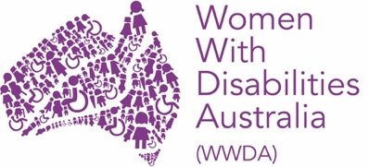
We are Women with Disabilities Australia.
We will write WWDA when we talk about us.

This book is about your right to
Lead and take part.

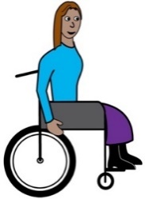
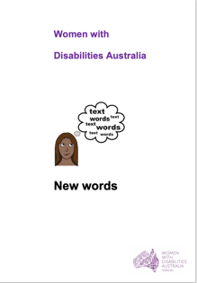
We wrote this book for women and girls
with disability. Read more about disability
in our book New Words.

Participation
This means to take part in things. Like

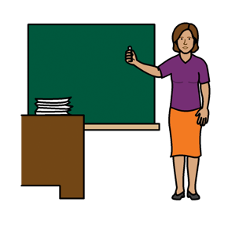

- you can go to school

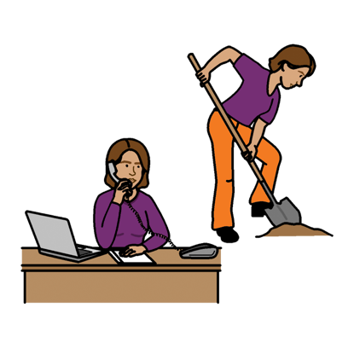

- you can work

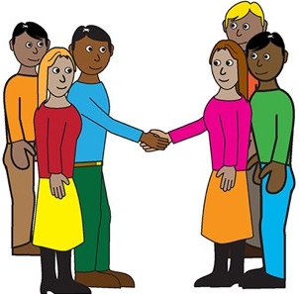

- you can go to events.

and

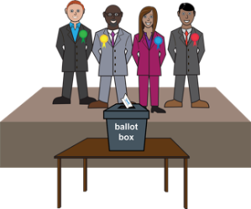
- you can vote in elections.

It is your right to take part.

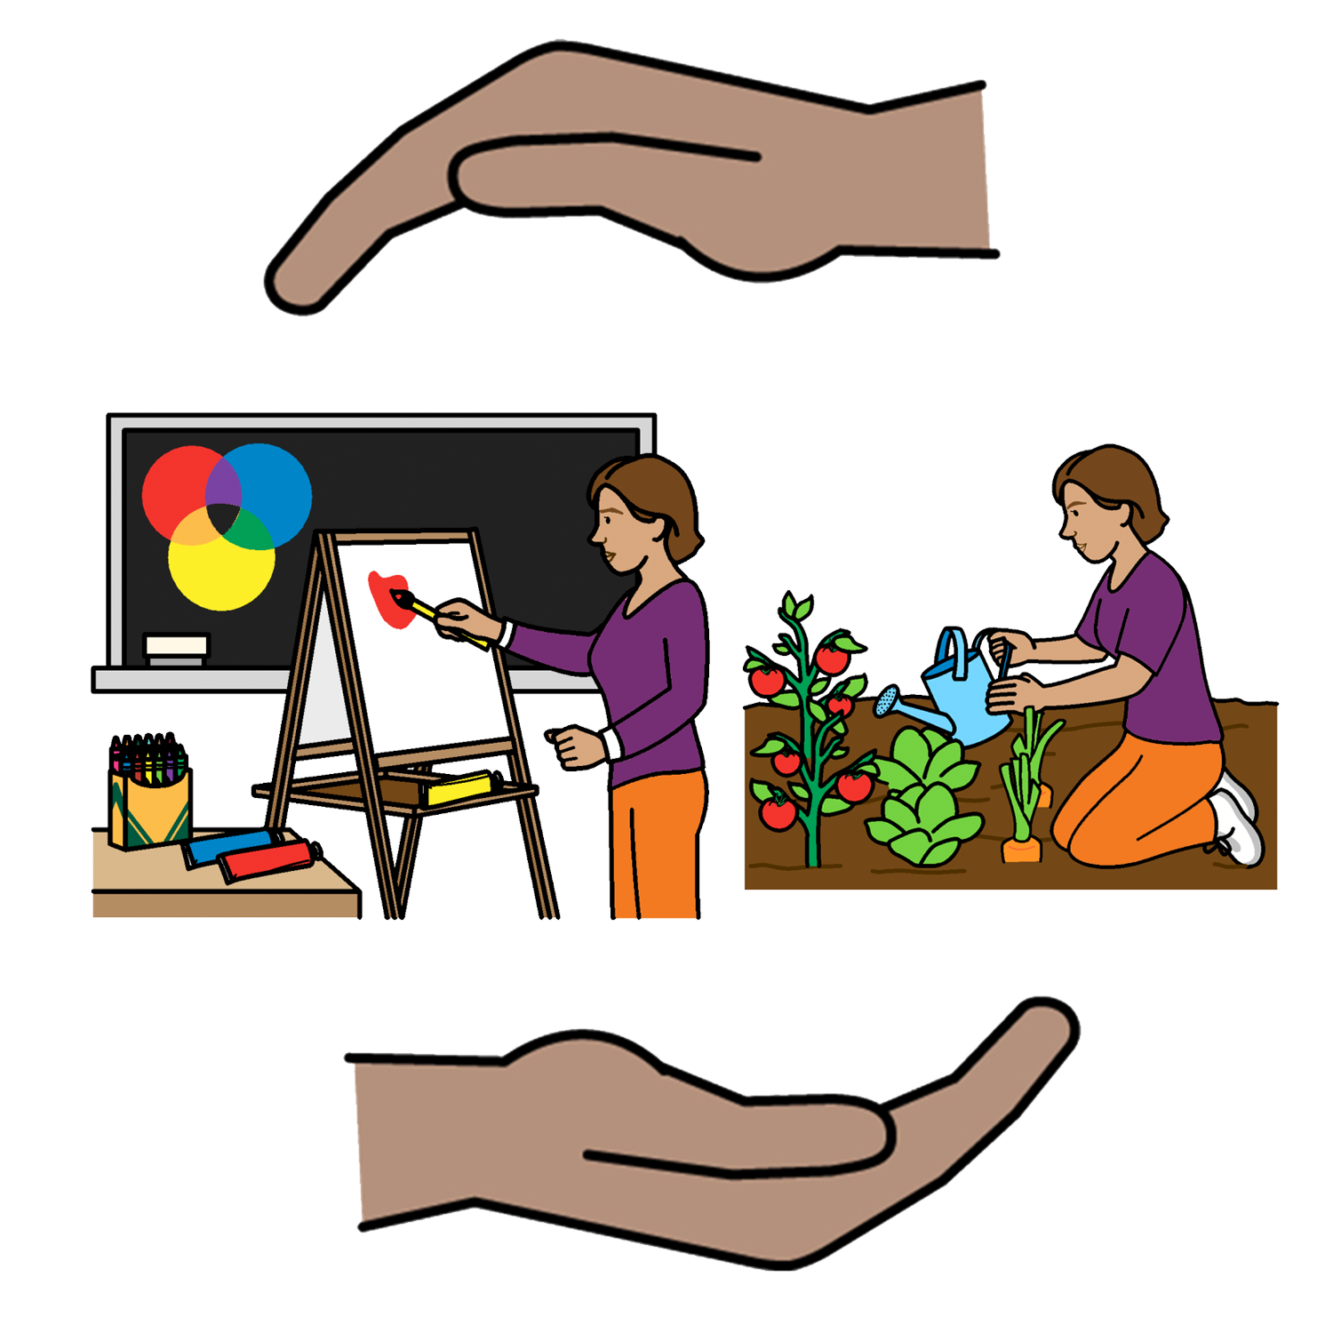
Women and girls with disability have a right to the help they need to take part. Like

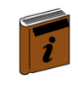
      - information in different ways. This may be
- Easy English
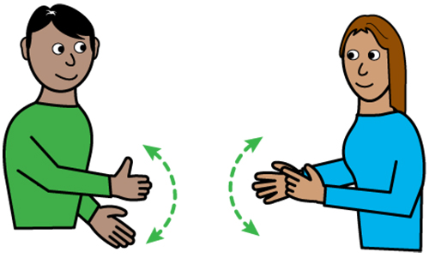
- large writing
- signs.

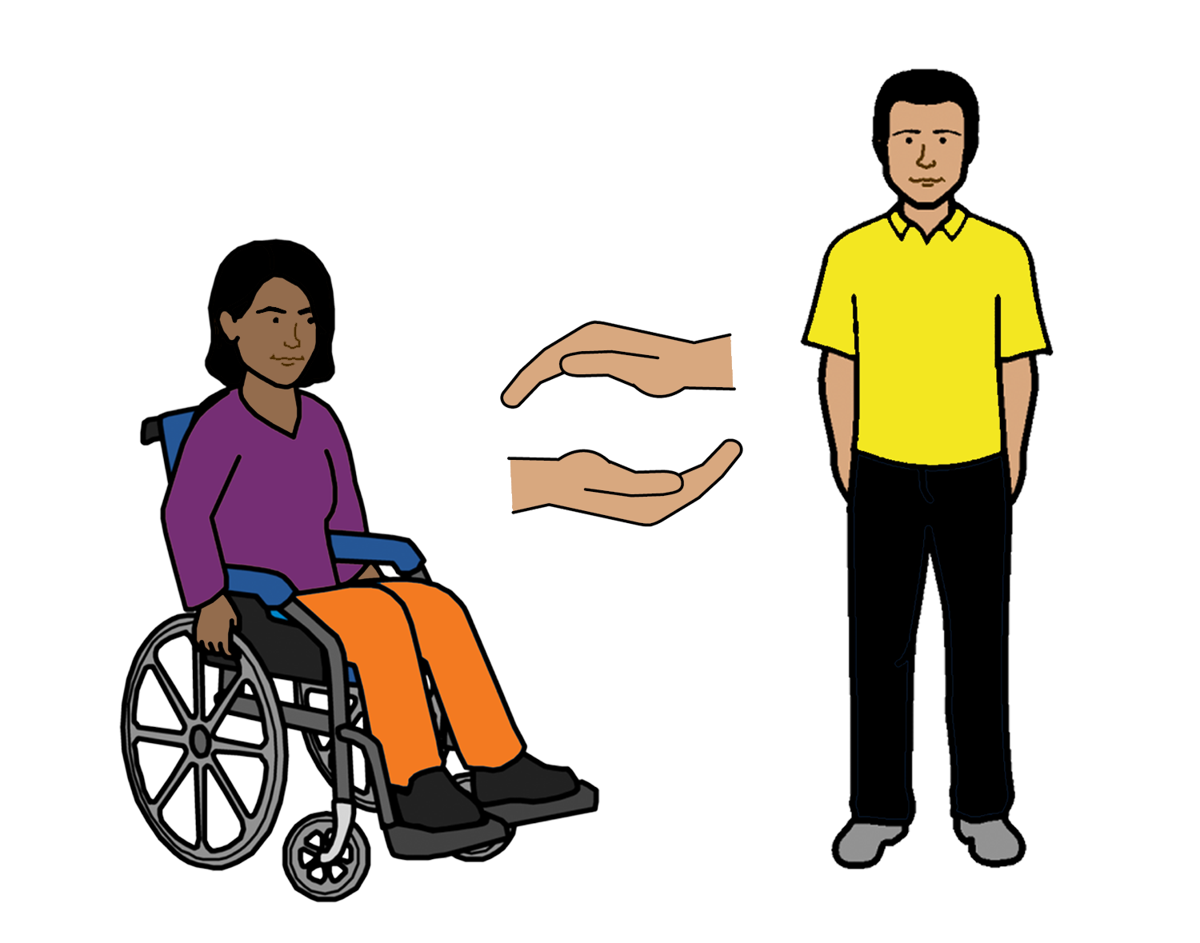

      - a support worker to help.

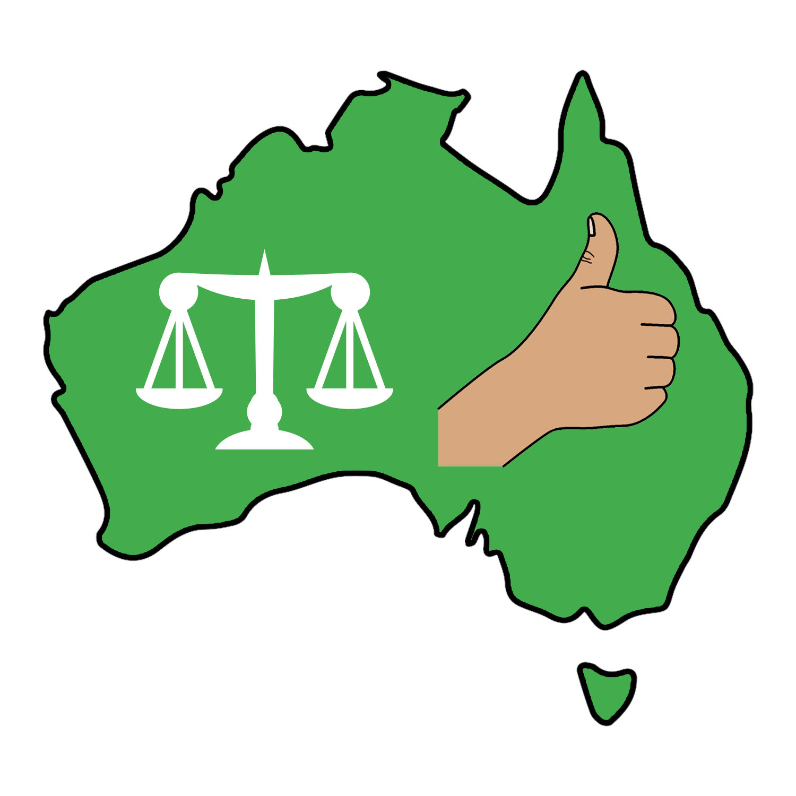
The Australian Government must support groups run by women with disability

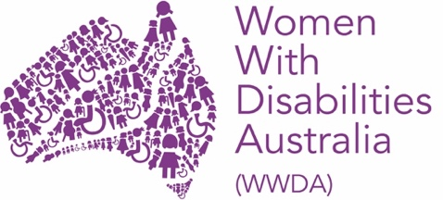
Like
- Women with Disabilities Australia

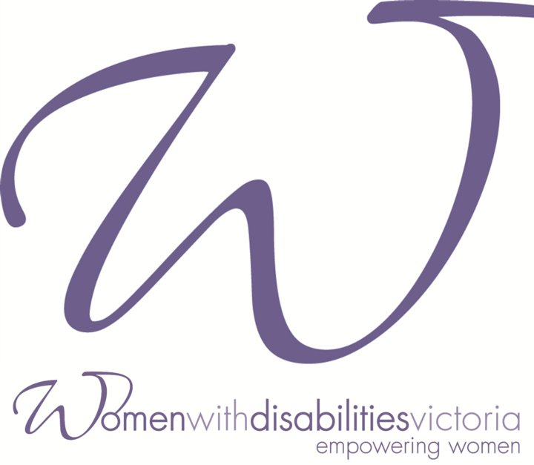
- Women with Disabilities Victoria

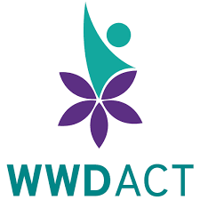
- Women with Disabilities ACT

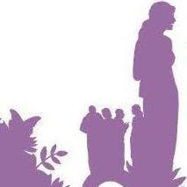
- Women with Disabilities WA.

The Australian government must also

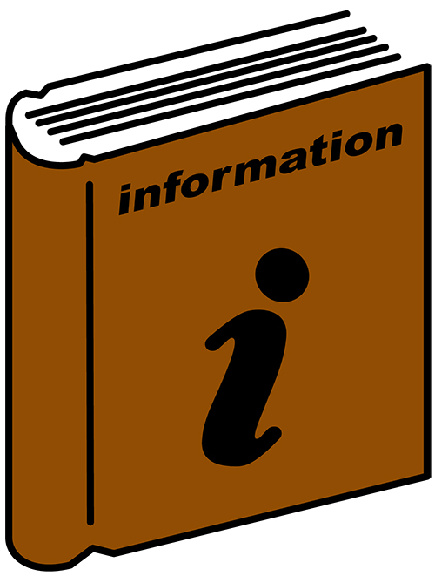
- give information to women and girls with disability about how to take part in things

- give money to help women and girls with disability to take part and be leaders

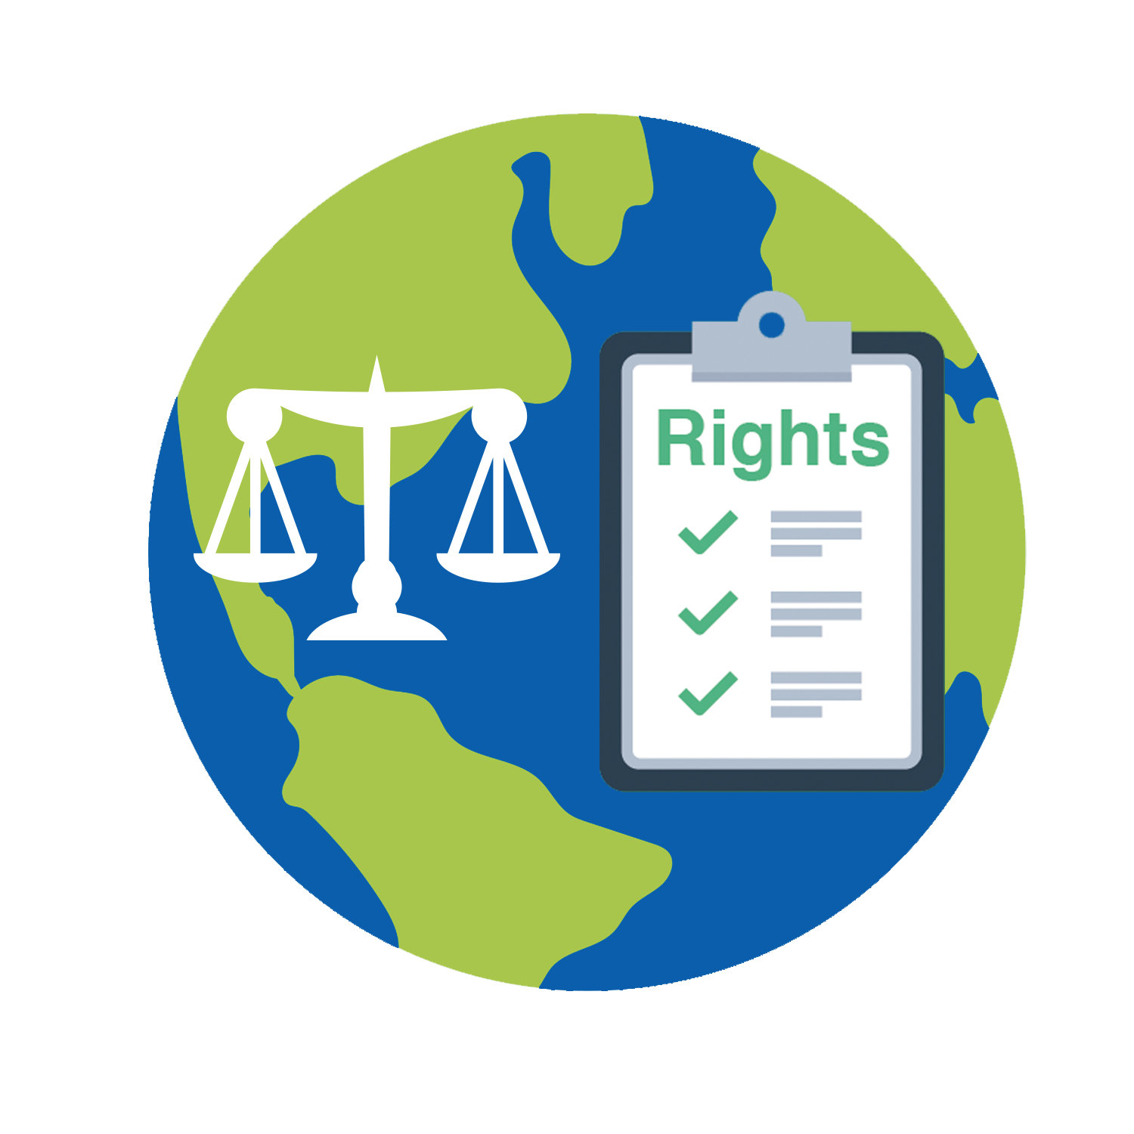
- give information to the United Nations about women and girls with disability.

There are international rules that say women and girls with disability have a right to take part. Like

- UN Convention on the Rights of Persons
with Disabilities

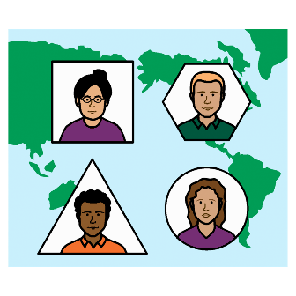
- International Covenant on Economic, Social and Cultural Rights

- The Australian Government has signed the papers about these rules. The Australian Government must follow these rules.

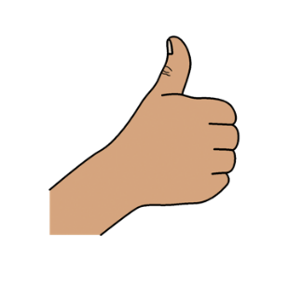
Thank you

Who wrote this book?
Women with Disabilities Australia wrote this book in 2019.
This book is for general education and information only.

Copyright
© Copyright
Women with Disabilities Australia (WWDA) Inc. 2019.

All intellectual property rights, including copyright and patents, in this book is owned and licensed by Women with Disabilities Australia Inc.

Thank you for the money
The National Disability Insurance Scheme gave Women with Disabilities Australia some money to help build this website.

The images used in this fact sheet
Easy on the I Images © 2018 Leeds and York Partnership NHS Foundation Trust. Used with permission. www.easyonthei.nhs.uk
Disabled People’s Organisations logos. Used with permission.

