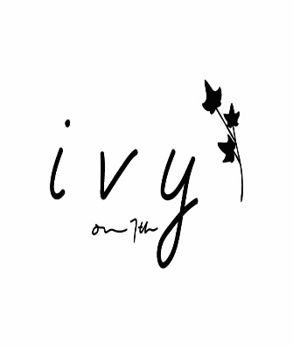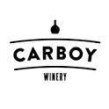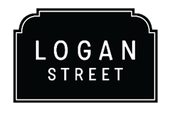
BEVERAGE PACKAGES:
ANGELO’S TAVERNA, CARBOY WINERY, LOGAN STREET, IVY ON 7TH
Guests can choose a package or can choose NO package and order per consumption
*Liquor, beer and wine selections may be subject to change*
Option 1: Beer and Wine $25 pp
- 2 Draft Rotating Beers, Carboy Wines and House Sparkling
- Wine Includes: Carboy White Rotating, Carboy Rose, Carboy Red Rotating
Option 2: Open Bar with basic house spirits and mixers $35 pp
- Well Vodka
- Well Rum
- Well Tequila
- Well Whiskey
- Well Gin
- Carboy Wines
- Rotating Beer Selection

Option 3: Open Bar w. Classic cocktails and Premium Spirits $45
- Premium Vodkas, Gin, Tequila, Rum and Bourbon and Specialty cocktails
- Carboy Wines
- Rotating Beer Selection
- *Specialty liquors/scotch priced above $20 not included
Alcohol Packages are for a 3-hour period of time. After the initial 3 hours, additional drinks will be rung in on a per consumption basis.

