KubeCon Goes Virtual
What a difference a year makes!
This year in the midst of the COVID-19 global pandemic, we attended Kubecon and CloudNativeCon North America again, but virtually. The main stage sure looked different from last year. Of course managing the complexity of running a 4-day conference with thousands of attendees and running the many sessions and meeting rooms is a significant undertaking. Hats off to CNCF pulling off this virtual event!

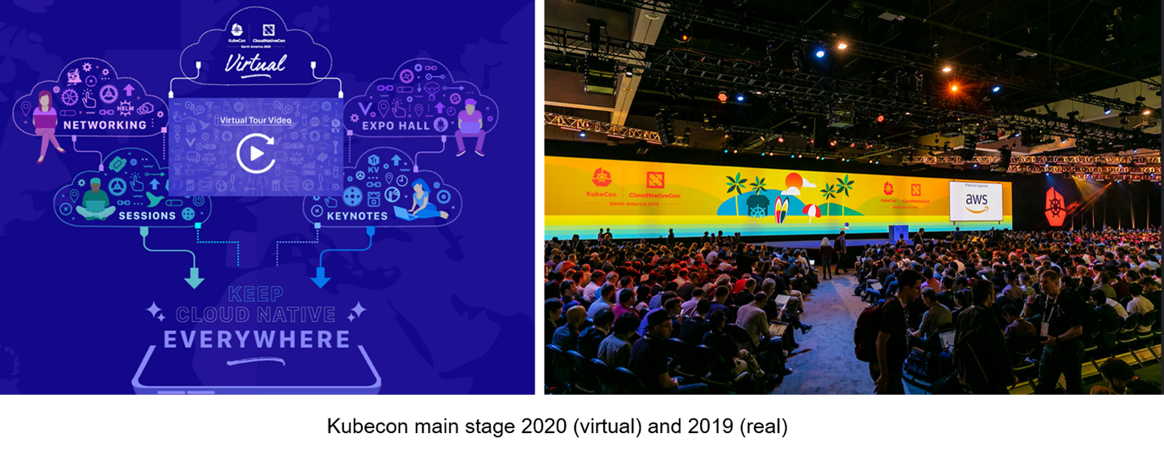
If KubeCon + CloudNativeCon Europe 2020 virtual conference attendance was an indicator, this year’s KubeCon North America was probably attended virtually by more than 12,000 attendees who attended KubeCon North America 2019.
Here are some other key takeaways from this year's conference.

Attendance vs. Engagements: Pros and Cons
Going virtual has its advantages and disadvantages. Speaking from OpsCruise’s experience, we had a chance to compare this year’s experience versus last year’s.
OpsCruise had presented at the Observability Summit at Kubecon 2019 in person. It was well-attended with nearly 200 or more active participants during the session and in hallway exchanges and discussions. This year OpsCruise had a virtual booth, and we have over 450 visitors. We recorded more attendee visits from a wider geographic area, many outside of North America. However, chats versus conversations were shorter. This is not surprising given that more registrants could attend more sessions and drop into booths quickly without being bound by distance and time. But it did result in less in-depth and shorter conversations.

Cloud-Native Stack: Enterprise Adoption
You have probably seen the 2019 CNCF survey released earlier this year that shows continuing growth in adoption of cloud native projects in production: Kubernetes (78%), Prometheus (72%), . . . Fluentd (64%). I believe this trend is continuing.
While this year’s virtual sessions were fewer, and had more talks from vendors than end users, there were some big names presenters including Apple, Airbnb, and Adobe especially in the use of open observability instrumentation.
Another sector that was visibly present was the financial sector. Recognizable names included Fidelity, which had also presented last year, Mastercard, Capital One, Intuit as well as the recent Alibaba spinout financial giant Ant Financial talking about SLO-driven reliability of large scale Kubernetes clusters. As the trend of using open source monitoring frameworks for metrics to traces keeps growing, I expect we will hear from more established financial firms as well as other enterprises as they leverage Kubernetes ecosystems in production environments.

Service Mesh: Exploration Continues
Service mesh related projects appear to be getting more interest both for telecom and 5G as well as for more general service latency monitoring. There were a few end user presentations: Lyft, one of the names behind Isto, Airbnb, and interestingly, HEB, a well-known Texas based grocery chain using Linkerd for monitoring and securing their digital fulfillment orders during Covid! It will be interesting to see how the service mesh adoption correlates with increased adoption of Kubernetes in the near future.

CNCF Projects: No Big Announcements
At the last Kubecon Open Telemetry got the spotlight on stage and since then Jaeger has garnered a lot of attention. This year there were no such big announcements, but a few incubating projects updates that were highlighted on the first day caught my attention: security, Falco, which reached 700K downloads in 10 days; monitoring, Thanos on HA scaling of Prometheus, since it graduated 3 years ago; and storage, Rook, for managing storage providers. They will be some of the ones to watch in the near future.

Final Thoughts
I am glad CNCF is continuing their tradition of hosting their annual North America and Europe conferences and that the attendance has grown despite the pandemic. With increasing use of cloud-native applications, the need for the open Kubernetes ecosystems is undeniable so I expect it will keep going. So I hope I will see you at the next one in person.

