We aim to:

* Teach English using everyday conversational topics and current events.
* Teach English structure and grammar through reading and writing activities.
* Introduce the person of Jesus Christ through DVDs, the Bible and discussions.
* Give opportunities to the learners to develop a relationship with Jesus Christ.

Free for All Levels

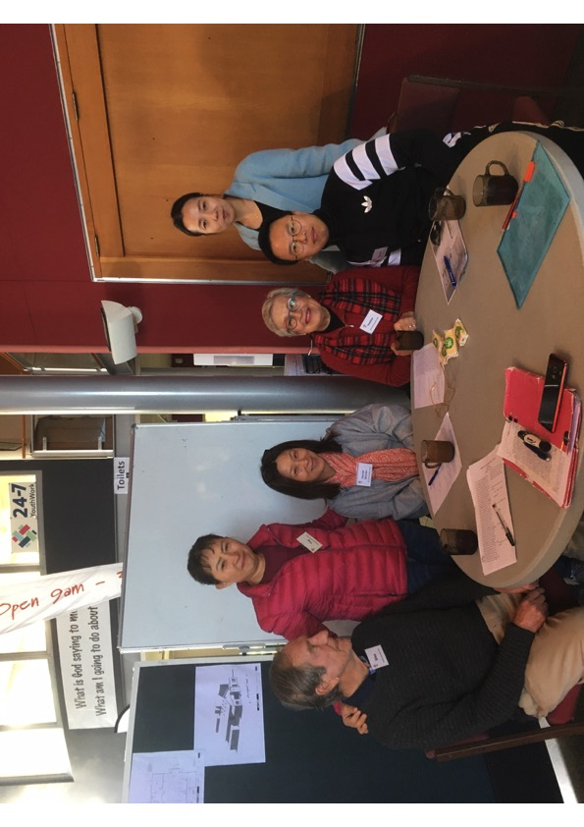

ESOL Christian Conversation Classes have been running at Holy Trinity for

over 14 years with all our learners being successful in improving their English skills.

ESOL Christian Conversation Class is a time of fun, fellowship and learning for those who want to improve their conversational English and grammar. We have classes for beginners through to advanced speakers.

Learners have come from many nations, including Russia, China, Iran, Taiwan, Bulgaria, Hong-Kong, Japan, Nepal, Bangladesh, Korea, Turkey, Chile, Vanuatu, Iraq, Brazil, Argentina, Germany, Sweden and Bolivia.

Free for All Levels

Cnr of 3rd Ave and Devonport Road, Tauranga

Phone: 578 7718 www.holytrinitytauranga.com

Email: reception@holytrinitytauranga.com

English

Conversation

Class

A Christian Conversation and

ESOL Programme of



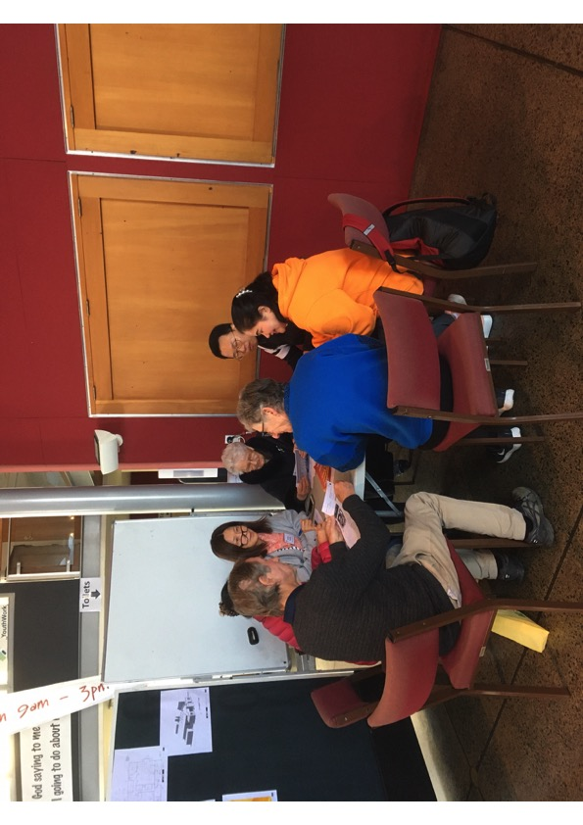

Free for All Levels

**Term Dates 2020**

**Term 1**  **Term 2 Term 3 Term 4**

**10 Feb to 7 April** **27 April to 30 June 20 July to 22 Sep 12 Oct to 24 Nov**

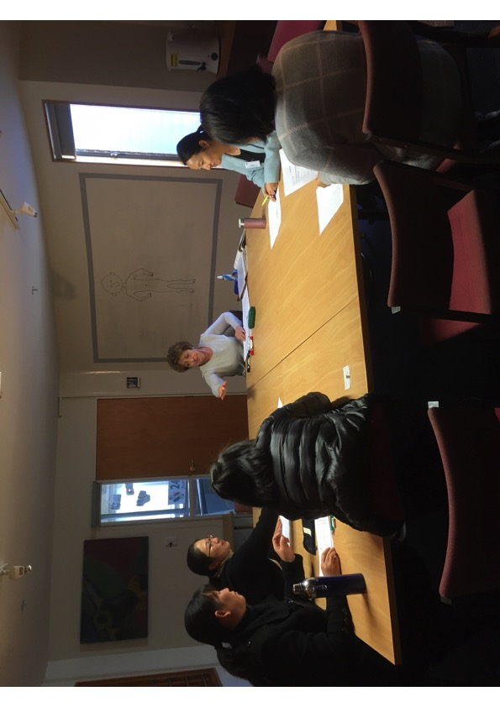

Free for All Levels