Stop Motion Animation & Audio Curriculum

What is Stop Motion Animation?
Stop motion animation (also called stop frame animation) is animation that is captured one frame at time, with physical objects that are moved between frames. When you play back the sequence of images rapidly, it creates the illusion of movement.

Examples
Examples of Stop motion Animation Movies include Wallace & Gromit, The Nightmare Before Christmas, & Fantastic Mr. Fox. When teaching Stop Motion, it’s important to show examples of what it is to give students the idea of what they’ll be making and also to inspire them.

Short Examples:
Pes Films: https://www.youtube.com/user/PESfilm

Storytelling
When making stop motion animation, it’s important to plan out what the students will be making. We like to describe films as narrative or experimental. Narrative are stories with a beginning, middle, & end which takes more planning and might require a script. Experimental films are more abstract and visual.

Using Affinities
When students create, they are much more likely to be engaged and inspired when they are using their affinity – something that they love and feel deeply connected to. With special needs students this is often something like Disney, Trains, or Pokemon. We encourage them to use these affinities by printing characters or objects that they like or brining their own objects in. (ie: legos, action figures)

Presenting Work
After a workshop if there’s time we like students to present their work. We encourage them to show what they’ve done but do not pressure them if they absolutely don’t want to. Most of the time they are very eager to. We make sure we tell all other students to be respectful and not call out during their peers’ presentations. We also describe what constructive criticism is and tell them to describe one thing they like and one thing they think their peer can work on to improve their project.

Software & Programs
Video:
Photo Booth – Available on all Mac Computers
Adobe Premiere – Video Editing for Teens
iMovie – Video Editing for Young Students
Audio:
Audacity - for editing sound clips
KeepVid.com – for downloading music and sounds from youtube
Freesound.org – for downloading sound effects and sound clips

Using Photo Booth to Take Sequential Photos
Start off by showing students the technique of stop motion animation before going into what they actually want to be making.

Step 1.) Make sure all photos from Photo Booth are deleted. This will make it easier to select all photos that you take at once without combing through them later.
Step 2.) Position computer to capture your workspace. This is easier to do with a laptop but if you push an iMac computer back you can more easily do this.
Step 3.) Start taking sequential photos. The 3 seconds allowed in Photo Booth makes it easier to bring your hand away from the screen as you position your objects or drawing.
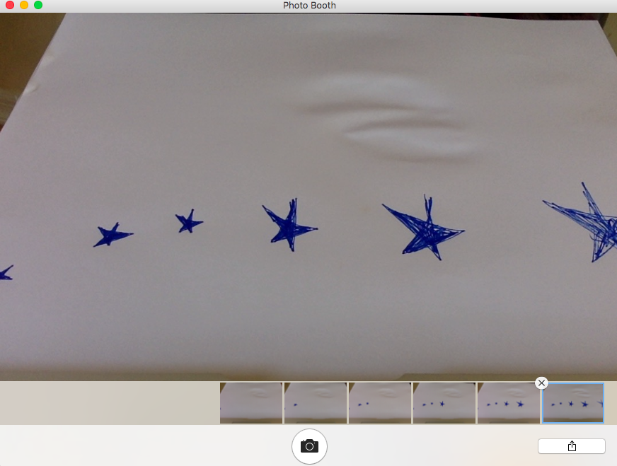
Step 4.) Press Command + A (Select All) to select your photos. Create a Folder on the desktop where you’ll drag your photos into. It’s good to make folders for each scene in case you have a more complex film. This keeps things organized.

Creating Film with iMovie
Step 1.) Create a New Project and rename it. The screen you see might vary depending on your version of iMovie but you want to click no theme and stay with the defaults.

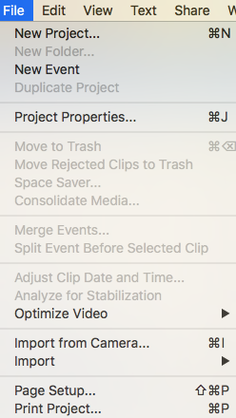
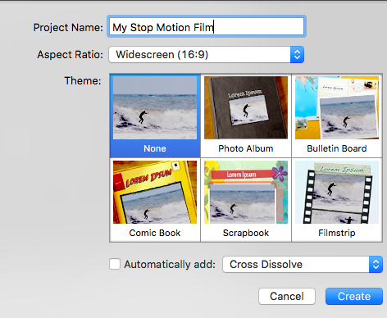

Step 2.) Drag your stills into the project area from your folder. As you can see the default duration of these stills is too long to move seamlessly and give the appearance of movement. We want to change that.
Step 3.) Go to Project Properties to change the duration of all stills. On the top tab you want to go to “Timing”. Change the Photo Duration to 1 second or less depending how fast you want it. Check off “Applies to all photos” and change initial photo placement to “fit in frame”.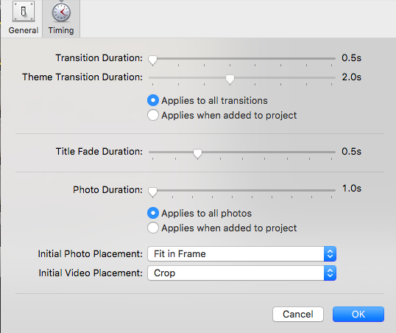

Step 4.) Dragging in Audio – Dragging in audio can be done the same way as dragging in clips. If you’d like to edit audio down you can click the settings icon on your audio clip and go to clip trimmer. You can also move your audio around.
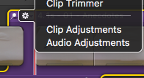

Step 5.) Adding Titles and Credits – On the lower middle corner of iMovie is where you’ll find a “T” for titles. Students can drag whatever title screen and credits they like to the beginning and end of their movie to make it more complete. On the right hand side they can edit the text of the title they choose.
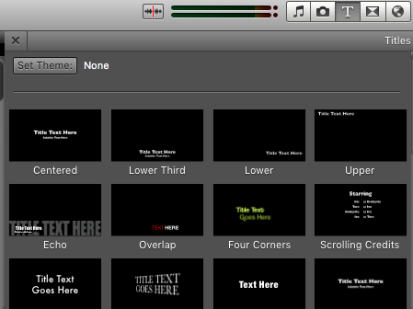
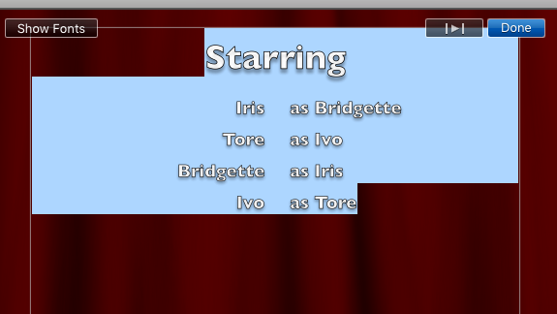

Step 6.) Exporting: On the top tool bar there’s a button called “Share”. The easiest way to share so that they have a file with them later is to click “Export Using Quicktime”. This will create a .mov file.
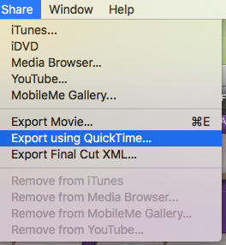

Creating Film with Adobe Premiere
Adobe Premiere is more robust than iMovie but a little more complicated. It’s good for working with teens because it gives them used to industry standard software which is more in depth than software used by the average user. However, iMovie is a good program to use for teens that are having trouble with Premiere and younger students. It’s okay to switch back to iMovie if Adobe Premiere is frustrating students.*

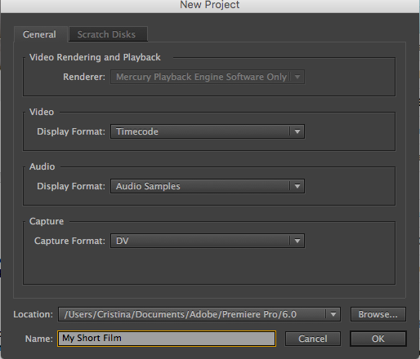
Step 1.) When Adobe Premiere Opens it prompts a screen where you can click to open a project or create a new project. Click on create new project and keep all defaults the same besides the title of the film.

Step 2.) Go to File > Import to import your photos. You can also drag photos into the media window on the bottom left hand corner.
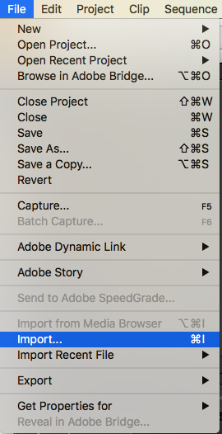

Step 2.) Click Command + A to Select all clips and drag them into the timeline on the right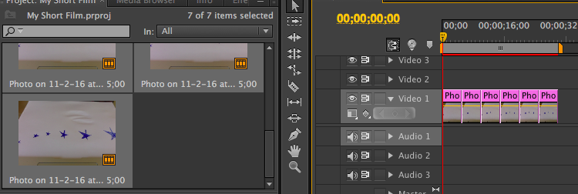

Step 3.) Your clips will be too long and you can see this when you click play. You want to change the duration so it gives the illusion of movement and your clips need to be shorter. If there’s a particular clip that needs to be longer or shorter, you can always change this later. Select all clips by clicking Command + A. Right click or click Control + Click to go to Speed/Duration…

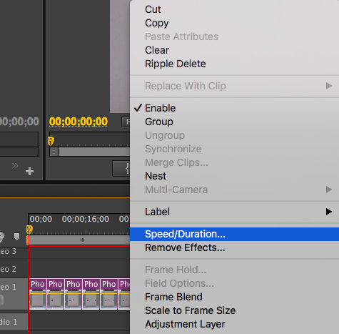

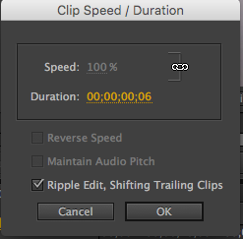
Step 4.) Change the Duration of the clip by clicking and dragging your mouse left to right or by manually typing a number. This should be shorter than a second but experiment to get the speed you like. Make sure that “Ripple Edit, Shifting Trailing Clips” is ticked on. If it is not, there will be giant spaces between clips.

Step 5.) You can drag audio in the same way you drag photos in. You can then place this where you want in the timeline. The razor tool allows you to cut clips. You can also drag the clip to make it shorter or longer.
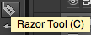

Step 6.) Titles – Go to Title > New Title > Default Still… to create a new title

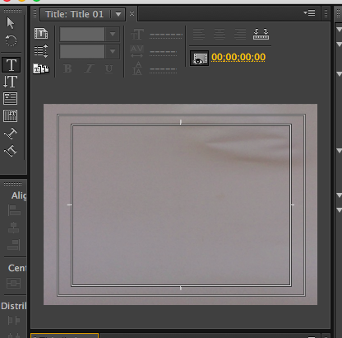

Depending on where your cursor is on the timeline that is what the background will show up as on the screen. However, the background will change to wherever you place it automatically. IE: If I move it to where I do not have a photo or video, my background will automatically be black. To save a title, just exit out of the title screen. It will automatically be in your project clips. You can then move this wherever you’d like.
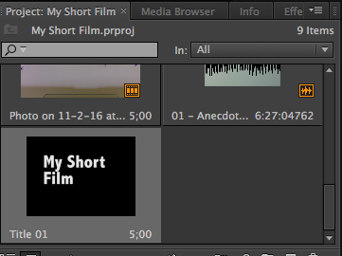

Step 7.) Export by going to File > Export > Media…

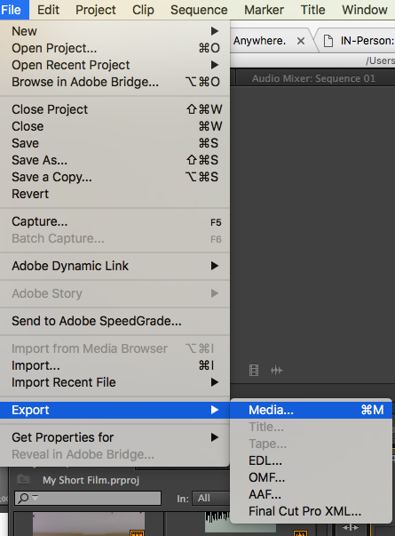

Downloading Audio

You can download .mp3 files from Youtube using online programs such as keepvid.com

STEPS: Copy URL and paste into Keep Vid
The URL can be found at the top of your browser
Click the grey DOWNLOAD button and then click “Download mp3”

You can also download sound clips from freesound.org. You will need a login to do so.
Our is :
U: techkidsu
P: tech123

