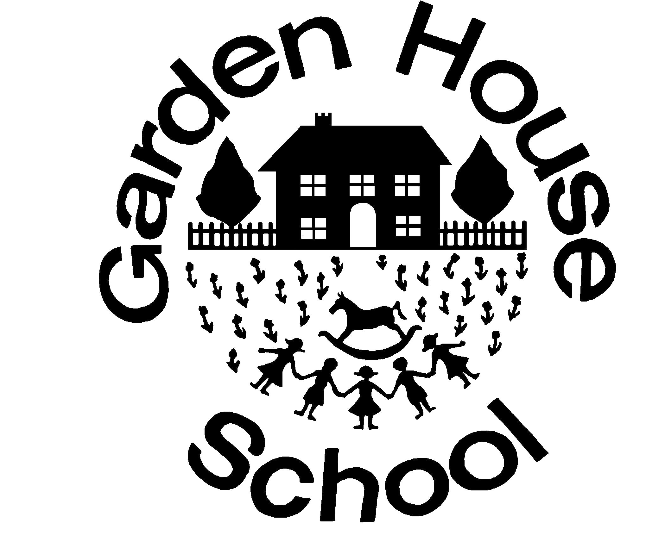

Name of Policy: | English as an Additional Language (EAL) Policy  For the whole school including the EYFS
GHS Policy Number: | 22
ISI Regulation: | Quality of Education Provided (Part 1)
ISI Paragraph: | Curriculum (Paragraph 2)
Linked Policies: | Curriculum  Equal Opportunities  Learning Support  Teaching and Learning
Reviewed by:  (including license to edit and update) | Dan Jameson, Head, Boys’ School  Emma Studd, Head, Girls’ School  Julia Adlard, Head, Early Years  Nicola Cornish, Deputy Head  Sally Wells, SENDCo  Rosie Hufton, Boys’ School Secretary
Date of review: | September 2020
Date of next review: | September 2021*  *Reviews ongoing due to COVID-19 pandemic

Introduction

This policy is written with due regard to the Equality Act 2010.

Many children who attend Garden House are bilingual and/or have English as an additional language. Most children have a parent or nanny at home who is a fluent English speaker. We feel that this is essential so that a child can be supported at home – this is always suggested at interview. Parents have chosen Garden House because they want a curriculum which is delivered in English and therefore as a school we encourage language support at home to enhance learning at school. All children speak some English on entry into the school and will reach a good standard in the English Language during their time at Garden House. It must be understood that learning an additional language is an ongoing process. While social fluency may be acquired quickly, it will take EAL pupils time to gain the skills and understanding to participate fully in an educational system, in-line with mother tongue speakers of English.

Principles

All Garden House Staff are considered to be teachers of English as an Additional Language.

We firmly believe that language learning is most successful, for EAL speakers where:
- It is taught within the context of the mainstream curriculum.
- Oral language is central to all curriculum work.
- Pupils value and make use of the cultural and linguistic diversity within the school community.
- The informed contribution of parents to their children’s education is seen as vital to the children’s progress.

Aims

The aims of this policy are to enable pupils who are learning to use English as an Additional Language to have full access to the National Curriculum, together with providing equality of opportunity, in order that each learner will fulfil their academic and educational potential.

Objectives

Class Teachers, Teachers’ Assistants and LED (SEND) teachers will help to develop English language knowledge and skills:
- For social communication.
- For conceptual understanding across the whole range of curriculum contexts.

Support

Class Teachers support the school in identifying the language needs of EAL pupils. They will plan appropriate tasks and activities to meet the child’s needs. They will work with targeted pupils, mainly in the classroom, on curriculum-focused tasks.

Much support takes place within the classroom with the help of Classroom Assistants, but the wide distribution of EAL pupils across the school occasionally necessitates the withdrawal of individual pupils or small groups for specific teaching activities with LED (SEND) staff.

Strategies

To achieve these aims Garden House will:
- Assign a member of the Learning Enrichment and Development team to update and maintain details of EAL children in the school and to liaise with staff to ensure that those children’s learning is not being compromised.
- Facilitate the language development of these pupils across the curriculum as necessary.
- Acknowledge the cultural and educational value of pupils’ mother tongues.
- Recognise the pupil’s home language and boost the pupil’s self-esteem
- Reflect the linguistic and cultural diversity of the school in its resources, texts, materials, and displays.
- All pupils will follow the full school curriculum. The school will provide text and resources that suit the pupils’ ages and levels of learning.
- EAL pupils will be supported through various means of differentiation with lessons. If necessary additional support will be provided by a Teaching Assistant, Learning Support Teacher or other adult, either within lessons, outside of lessons or through withdrawal from lessons
- Ensure that there are effective opportunities for talking and that talking is used to support writing
- Encourage pupils to transfer their knowledge, skills and understanding of one language to another.

Early Years

- Although English is the main language spoken in the setting, children are provided with opportunities to play in their own language. Their home culture is celebrated through topics such as ‘Ourselves’ and parent activities. Parents are also invited to read stories to the children in their home language. Children are taught English through phonics sessions, discussions, stories, poems, songs and play.

The Role of the Class Teacher in Supporting EAL Pupils

- Assess the English language performance and progress of EAL pupils.
- Analyse the performance of EAL children in the curriculum.
- Support EAL pupils in gaining access to the curriculum.
- Make the curriculum accessible through the provision of differentiated materials.
- Alert LED (SEND) staff if additional support/advice is felt necessary.

Opportunities for Pupils to Utilise their First Language at School

- Our modern foreign languages department runs an early morning club for native French and German speakers from Preparatory upwards, providing these children with a chance to engage in fluent conversation and engage with a variety of activities for up to an hour each week.

