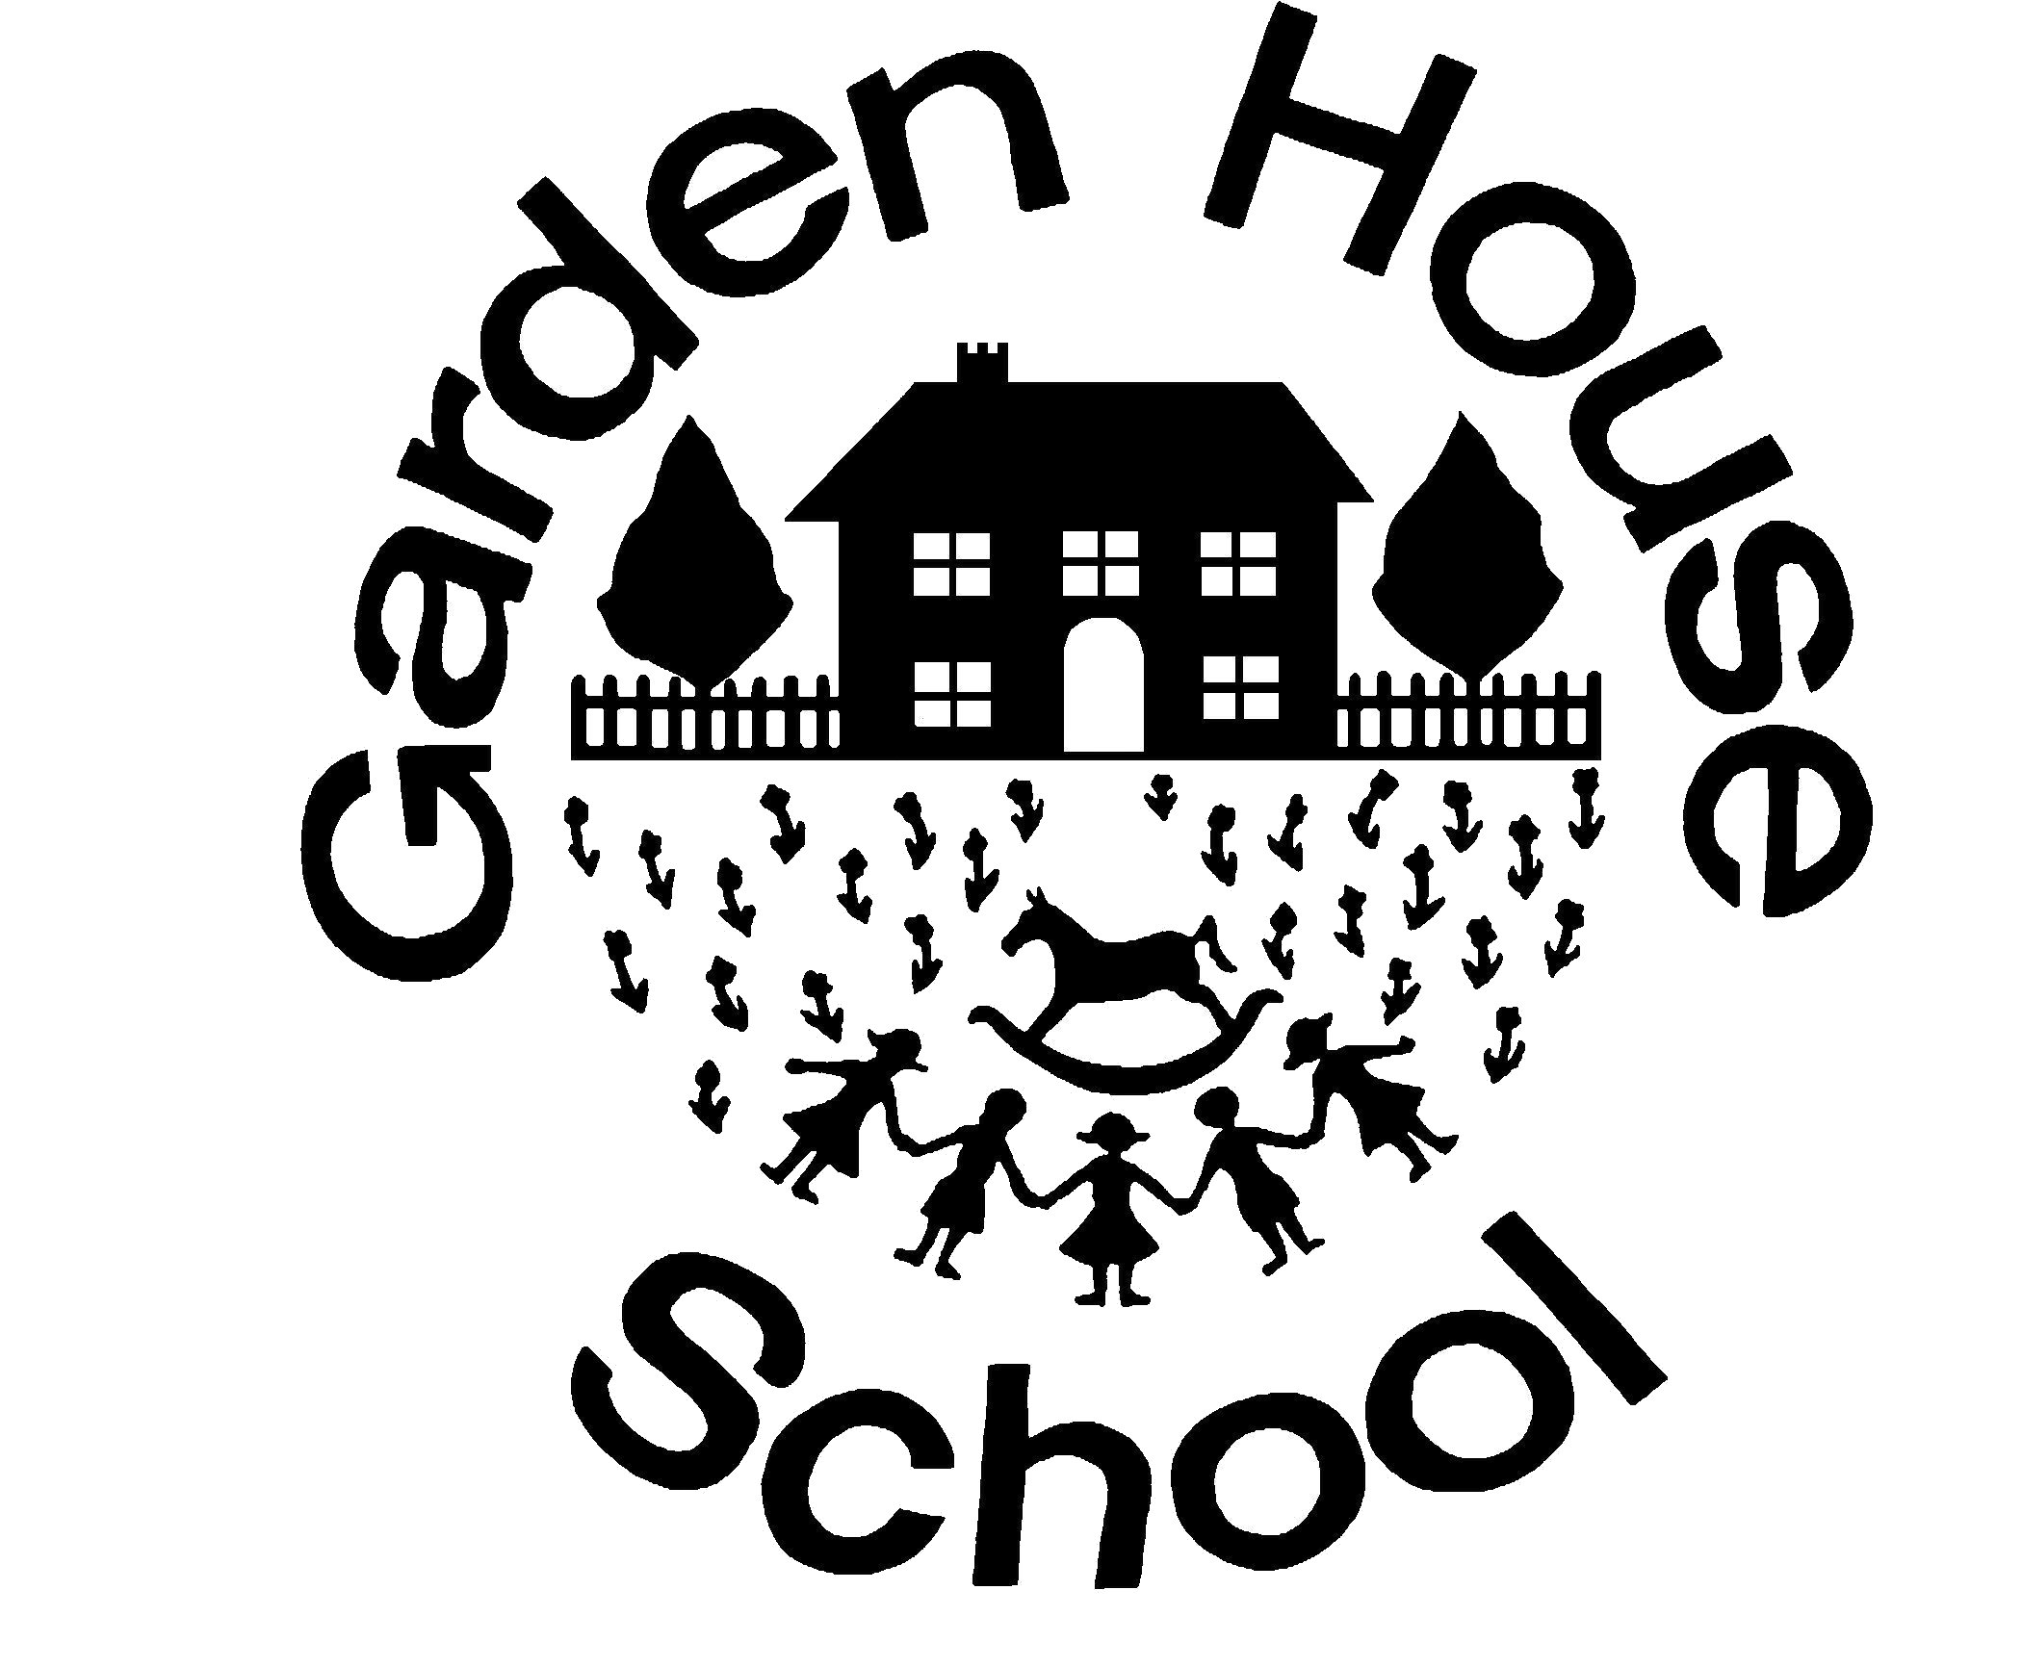

Name of Policy: | Relationships Education (RSE)  (for the whole school including EYFS)
GHS Policy Number: | 60b
ISI Regulation: | Quality of Education (Part 1)
ISI Paragraph: | Relationships and sex education (Paragraph 2a: 78-98)
Linked Policies: | Able, Gifted and Talented  Assessment, Recording and Reporting  Curriculum  English as an Additional Language (EAL)  EYFS  Learning Support  Life and Culture (PSHE)  Safeguarding  Sport
Reviewed by:  (including license to edit and update) | Dan Jameson, Head, Boys’ School  Emma Studd, Head, Girls’ School  Julia Adlard, Head, Early Years  Nicola Cornish, Deputy Head  Morven MacDonald, Assistant Head (Academic)  Kate O’Sullivan, Assistant Head (Pastoral)  Natalie Richmond Elvy, Head of Life and Culture (PSHE)  Rosie Hufton, Boys’ School Secretary
Date of review: | September 2020
Date of next review: | September 2021*  *Reviews ongoing due to COVID-19 pandemic

Introduction

At Garden House School, we are aware that our children are growing up in an increasingly complex world. Many of these opportunities are positive and exciting but they will also face challenges and risks.

We define Relationships Education as preparing our children to build positive, safe and respectful relationships both online and in the real world. To avoid any confusion with Religious Education (RE), Relationships Education has been initialised to ‘RSE’ which also takes into account its full title: Relationships Education, Relationships and Sex Education (RSE) and Health Education.

This policy is statutory from September 2020. It has been completed with due regard to the Equality Act 2010, and following consultation with parents, pupils and staff.

Aims

Our teaching of Relationships Education (RSE) intends to provide children with the knowledge, skills and understanding to lead happy and healthy lives within society, including online; becoming effective citizens who positively contribute to the world around them. Relationships Education is taught to help children build healthy and meaningful relationships based on mutual respect, tolerance and understanding. Children also develop an understanding of the importance of family in whatever form it takes. At Garden House, we work with our parents to share the aims of the Relationships Education policy so that they are equipped to support their children with their social, moral and emotional development at home.

Teaching and Learning

At Garden House, the topics in place are the key building blocks and characteristics of positive relationships, with particular reference to friendships, family relationships, and relationships with other children and with adults. The principles of positive relationships also apply online and therefore teachers address online safety and appropriate behaviour in a way that is relevant to pupils’ lives. Relationships Education also creates an opportunity to enable pupils to be taught about positive emotional and mental wellbeing, including how friendships can support mental wellbeing. The Kindness Code is embedded in all elements of school life where children are taught to treat others with mutual respect and tolerance.

We include the statutory Relationships Education within our whole school Life and Culture (PSHE) Programme of study which is taught by class teachers. This predominantly takes places in a single sex class. Assemblies and visiting speakers also help achieve key objectives on the curriculum. The subject is monitored and evaluated by the Head of Life and Culture (PSHE).

Our holistic approach through a broad and balanced curriculum ensures the learning is reinforced throughout the year within Science, RE, Computing and Sport. Class teachers also look to make meaningful links with the English curriculum. In accordance with school policy the curriculum will be accessible to all pupils including those with SEND and all reasonable adjustments will be made to ensure this happens will be made.

EYFS

The EYFS curriculum constantly provides learning opportunities which achieve the Relationships Education objectives. Within the Development Requirements one of the Prime Areas is ‘Personal, social and emotional development’ which focuses on self-confidence and self-awareness, managing feelings and behaviour and making relationships. Teachers model how to form positive relationships and use all areas of the curriculum to generate meaningful discussion surrounding this.

‘Understanding the World’ and ‘Independent Play’ both provide many clear opportunities for children to understand similarities and differences between one another and to learn about different cultures and traditions.

KS1 and KS2

The topics of Relationships Education at Garden House School are (see Appendix I):

- Families and people who care for me
- Caring friendships
- Respectful relationships
- Online relationships
- Being safe
The topics of Health Education at Garden House School are:

- Mental wellbeing
- Internet Safety and harms
- Physical health and fitness
- Healthy eating
- Drugs, alcohol and tobacco
- Health and prevention
- Basic First Aid
- The changing adolescent body
Sex Education is not compulsory in Primary Schools, however, in line with Government guidance, we provide discussion opportunities in Year 6 (single sex) where we cover:

- Physical and emotional changes during puberty
- How to cope with these changes
- Menstruation
The national curriculum for science also includes subject content in related areas, such as the main external body parts, the human body as it grows from birth to old age (including puberty) and reproduction in some plants and animals.

Right to be excused from Sex Education

Prior to the Sex Education discussions, parents will be advised that these discussions will be taking place and will be made aware of the content of these sessions. Parents have the right to request that their child is withdrawn from these discussions. At this point it is good practice for the Head to discuss the request with parents and the benefits of the child receiving this education. This process will be documented. Heads will automatically grant a request to withdraw a pupil from Sex Education, other than as part of the science curriculum. Parents do not have the right to remove their child/ren from Relationships Education.

Managing difficult questions

When children ask teachers questions these may go beyond what is set out in the Relationships Education scheme of work. The teacher will answer these questions in an age appropriate way, ensuring answers are appropriate for all children in the class to hear. In some circumstances it may be more appropriate to talk to children in small groups or one to one or to refer these questions back to parents.
Given ease of the access to the internet, it is felt that if questions remain unanswered children may turn to inappropriate sources of information.

APPENDIX I

By the end of Garden House:

Families and  people who  care for me | Pupils should know:  • that families are important for children growing up because they  can give love, security and stability.  • the characteristics of healthy family life, commitment to each  other, including in times of difficulty, protection and care for  children and other family members, the importance of spending  time together and sharing each other’s lives.  • that others’ families, either in school or in the wider world,  sometimes look different from their family, but that they should  respect those differences and know that other children’s families  are also characterised by love and care.  • that stable, caring relationships, which may be of different types,  are at the heart of happy families, and are important for children’s  security as they grow up.  • that marriage13 represents a formal and legally recognised  commitment of two people to each other which is intended to be  lifelong.  • how to recognise if family relationships are making them feel  unhappy or unsafe, and how to seek help or advice from others if  needed.

Caring  friendships | Pupils should know:  • how important friendships are in making us feel happy and secure,  and how people choose and make friends.  • the characteristics of friendships, including mutual respect,  truthfulness, trustworthiness, loyalty, kindness, generosity, trust,  sharing interests and experiences and support with problems and  difficulties.  • that healthy friendships are positive and welcoming towards  others, and do not make others feel lonely or excluded.  • that most friendships have ups and downs, and that these can  often be worked through so that the friendship is repaired or even  strengthened, and that resorting to violence is never right.  • how to recognise who to trust and who not to trust, how to judge  when a friendship is making them feel unhappy or uncomfortable,  managing conflict, how to manage these situations and how to  seek help or advice from others, if needed.
Respectful  relationships | Pupils should know:  • the importance of respecting others, even when they are very  different from them (for example, physically, in character,  personality or backgrounds), or make different choices or have  different preferences or beliefs.  • practical steps they can take in a range of different contexts to  improve or support respectful relationships.  • the conventions of courtesy and manners.  • the importance of self-respect and how this links to their own  happiness.  • that in school and in wider society they can expect to be treated  with respect by others, and that in turn they should show due  respect to others, including those in positions of authority.  • about different types of bullying (including cyberbullying), the  impact of bullying, responsibilities of bystanders (primarily  reporting bullying to an adult) and how to get help.  • what a stereotype is, and how stereotypes can be unfair, negative  or destructive.  • the importance of permission-seeking and giving in relationships  with friends, peers and adults.

13 Marriage in England and Wales is available to both opposite sex and same sex couples. The Marriage (Same Sex
Couples) Act 2013 extended marriage to same sex couples in England and Wales. The ceremony through which a
couple get married may be civil or religious.
Online  relationships | Pupils should know:  • that people sometimes behave differently online, including by  pretending to be someone they are not.  • that the same principles apply to online relationships as to face-to  face relationships, including the importance of respect for others  online including when we are anonymous.  • the rules and principles for keeping safe online, how to recognise  risks, harmful content and contact, and how to report them.  • how to critically consider their online friendships and sources of  information including awareness of the risks associated with  people they have never met.  • how information and data is shared and used online.
Being safe | Pupils should know:  • what sorts of boundaries are appropriate in friendships with peers  and others (including in a digital context).  • about the concept of privacy and the implications of it for both  children and adults; including that it is not always right to keep  secrets if they relate to being safe.  • that each person’s body belongs to them, and the differences  between appropriate and inappropriate or unsafe physical, and  other, contact.  • how to respond safely and appropriately to adults they may  encounter (in all contexts, including online) whom they do not  know.  • how to recognise and report feelings of being unsafe or feeling  bad about any adult.  • how to ask for advice or help for themselves or others, and to  keep trying until they are heard.  • how to report concerns or abuse, and the vocabulary and  confidence needed to do so.  • where to get advice e.g. family, school and/or other sources.

