Black Belt Christian Beliefs & Behaviors

1) Black Belt Christians Love and Forgive All People, Even Their Enemies
Jesus of Nazareth our Grandmaster said: “But I tell you: Love your enemies and pray for those who persecute you…’”
After 21-year-old Dylann Roof massacred 9 church goers at Charleston Emmanuel Church, we saw this radicalism openly displayed in the response of the family members of the massacre victims. According to reporters in the courtroom: Relatives of the Emanuel church victims stood up one by one in the courtroom, offering forgiveness to the man accused of murdering their sons, mothers and grandfathers in cold blood. Could you imagine what would happen to our schools, families, workplaces, and wider society if such radical forgiveness took hold?

2) Black Belt Christians Don’t Practice Sex Outside of Marriage
Contrary to our “enlightened” society, God’s plan is for the pleasures of sex to be enjoyed exclusively in the context of marriage and for marriage to be between a man and a woman pledged to each other exclusively for the duration of their natural lives together.
Because of the sexual revolution that we’ve had, we have a pandemic of STD’s, AIDS, and teen pregnancies. Imagine no longer would their girls ‘put out’ sexually to porn-addicted boyfriends, or to older men at parties. Boys have been drawn into sexual addicting pornography, videos, and stereotypes that do not respect girls/women. Our children are being taught gender models that are not truthful or godly by our advertising media.
Black Belt girls no longer base their self-worth on their looks or sexual attractiveness; rather, they view themselves as Christ sees them – one of His cherished creations. Black Belt boys likewise do not see girls as sex objects but fellow humans to be respected as capable of complementing their abilities and gifts.

3) Black Belt Christians Believe That the Unborn Are Not ‘Clumps Of Cells’, But Human Babies
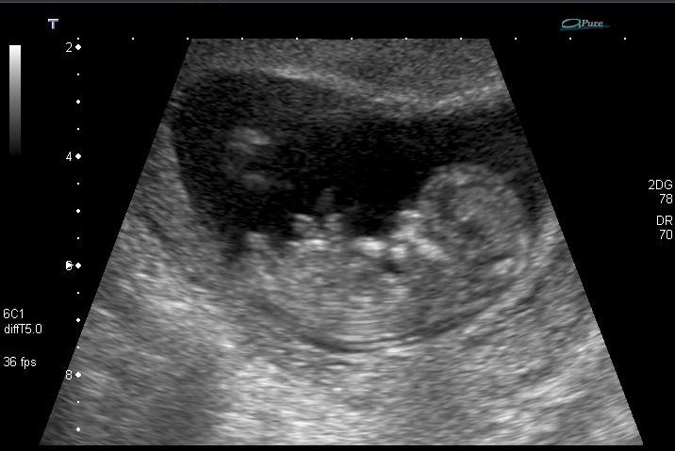
Psalm 139:13-17 says, “For You formed my inward parts; You wove me in my mother’s womb. I will give thanks to You, for I am fearfully and wonderfully made; Wonderful are Your works, and my soul knows it very well. My frame was not hidden from You, When I was made in secret, And skillfully wrought in the depths of the earth; Your eyes have seen my unformed substance; And in Your book were all written The days that were ordained for me, When as yet there was not one of them. How precious also are Your thoughts to me, O God! How vast is the sum of them!”

The Black Belt Christian sees a baby in the ultrasound picture and sees that a 12-week old fetus has eyes, ears, reflexes, liver (making bile), kidneys, and brainwaves. A Black Belt Christian accepts believe that a 12-week old fetus squirms if the abdomen of the pregnant woman is prodded.

4) Black Belt Christians Believe in Moral Absolutes
Society’s attitudes and laws may change, but God’s moral law doesn’t change – nor does it need to.

Getting Serious About Being a Black Belt Christian – Black Belt Christians Shine the Light of Christ.
JN 8:12 Then Jesus again spoke to them, saying, “I am the Light of the world; he who follows Me will not walk in the darkness, but will have the Light of life.”

“You are the light of the world. A town built on a hill cannot be hidden. Neither do people light a lamp and put it under a bowl. Instead they put it on its stand, and it gives light to everyone in the house. In the same way, let your light shine before others, that they may see your good deeds and glorify your Father in heaven." Matthew 5:14-16

5) All Christians have the Light – not just some!
"You are the light ..."
Having the Light of Christ isn't for just a few special people. Every single person who has given their life over to Christ by faith has the light! Black Belt Christians realize this and desire to display Christ through their life.
6) Christians are to shine the Light in the World - not church buildings!
"You are the light of the world ..."
Too much of what we do to shine the Light of Christ happens in building tucked away from the real world. The people who need to see the Light of Christ are not coming into our church buildings. Christ told us to go shine His light in the world. Black Belt Christians actively engage in their communities and desire to meet the needs of others to the glory of Christ.
7) Christians are to display the Light – not hide it!
"A town built on a hill cannot be hidden. Neither do people light a lamp and put it under a bowl. Instead they put it on its stand, and it gives light to everyone in the house."
Black Belt Christians do not hide the light away so nobody knows that they follow Christ. Instead, they shine His light in a way that lots of people can see it and benefit from it. They do that through services of love to those in need and through solving problems in communities by Biblical means.
8) Good deeds help display the Light – not just words!
"let your light shine before others, that they may see your good deeds"
Black Belt Christians know that doing good deeds or loving actions is a way to display God’s love into people's lives so they can see Christ through each of us.
9) The goal is to glorify God – not ourselves!
"glorify your Father in heaven"
The goal of shining the Light of Christ is for people to glorify God the Father. It should never be our aim to get the glory for ourselves. Black Belt Christians don’t credit themselves. When others give them glory, they give credit to Christ. The glory always belongs to God and God alone!

10) The Black Belt Christian exhibits the Attributes Held in Common Across Most Cultures:
Honor, Honesty, Humility, Heroism, Generosity, Integrity, and (Gratitude)

