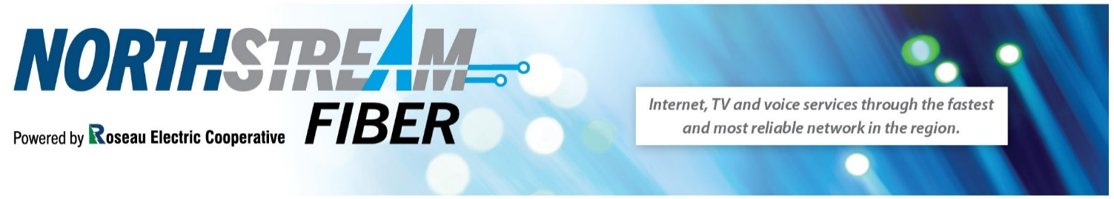
Business Service Package 24 Hr. Help Desk 218-463-0440
Fiber-to-the-Home Internet
Upload/Download Speed Price
25/25 Mbps $ 60.00/mo.
50/50 Mbps $ 80.00/mo.
75/75 Mbps $ 120.00/mo.
100/100 Mbps $ 140.00/mo.
150/150 Mbps $ 180.00/mo.
Up to 1 gigabit available. Call for pricing.

Equipment & Services
Rental 844e Managed Router and Wi-Fi $ 7.50/mo.
Wi-Fi Mesh Repeaters $ 3.50/mo.
Rental Managed Router, Wi-fi 6 Blast $ 11.00/mo.
Rental Managed Router, Wi-fi 6 Max $ 15.00/mo.
Free installation to the router any additional wiring/faceplates needed $65/hr
No email addresses are available. Web Hosting have your own domain name hosted on Wikstrom’s servers for $10.00/month. For more information go to https://wiktel.com/webhosting

Telephone Service (Must have internet package to have phone service)
One time Connect Fee $ 35.00
Business starting at $ 32.50/mo.
Expanded area local 30 minutes FREE long distance. After 30 minutes, 10¢/min. No monthly fees.
No service contract needed. Many free features – free voicemail, keep your existing phone number.

Surge Protectors
Cyberpower 6 outlet $ 10.00
Cyberpower 8 outlet $ 20.00

ALL prices are for residential service as of May 2021 and are subject to change. Please call for business pricing.

