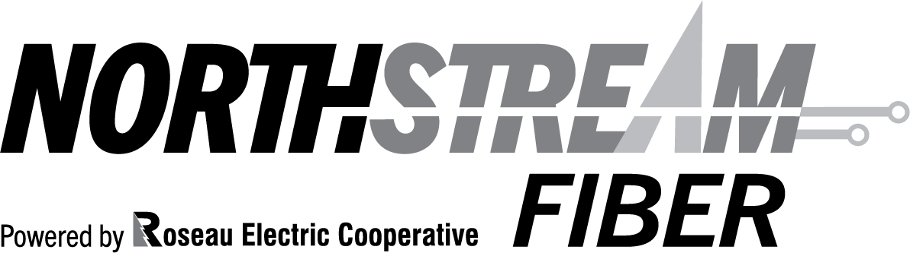
Residential Service Agreement

Service Agreement
NorthStream Fiber, provided by Roseau Electric Cooperative, Inc., will provide to you the agreed upon services indicated below. We will bury the fiber optic to your house for a pre-paid $150.00 contribution, which does not include your monthly charges.

Termination and Early Termination Fee
You may terminate this agreement for all of the listed services at any time by calling NorthStream Fiber at 218-463-1543 or 888-847-8840. In addition to the corresponding monthly charge, any applicable late fee,
equipment fees, and taxes may be applied. NorthStream Fiber requires that the Optical Network Terminal (ONT) and batteries, if applicable, be returned to our office before any disconnection of service can be completed. The subscriber is responsible for notifying NorthStream Fiber to schedule an appointment for our technician to remove the equipment within 30 days of discontinuing service. The subscriber is responsible for any damage to the ONT or battery. Subscribers will be billed $300 for a damaged or unreturned ONT and $100 for a damaged or unreturned battery unit.

Subscriber Name | Telephone | Customer Number
Subscriber Signature |  | Date

Internet Monthly Fee (Circle One)
25 Mbps | 50 Mbps | 75 Mbps | 100 Mbps | 150 Mbps | Up to 1 Gb Available Call for Pricing
$45.00 | $65.00 | $90.00 | $104.00 | $140.00
All prices subject to change.

Installation Date:
 | Yes | No | Wireless Routers | Yes | No
Installation Charge |  |  | 844e
Deposit Required |  |  | Blast
Telephone
ONT:803
ONT:812

NorthStream Fiber, powered by Roseau Electric Cooperative, Inc.
1107 3rd St NE | PO Box 100 | Roseau, MN 56751 218-463-1543 | 888-847-8840 | www.roseauelectric.com
Email Stacy Rose at srose@roseauelectric.com

