SimDH Social Media Posts:

Please link to the SimDH website: www.simdh.com

Social Media Accounts:
Twitter: @sbiLondon
Linkedin: @South Bank Innovation
Instagram: @SouthBankInnovation
Facebook: @sbi.business

- Twitter

We're proud to announce that we're joining SimDH's Cohort 3!
SimDH is a health tech accelerator programme from @sbiLondon, match-funded by European Regional Development Fund.
Find out more about the programme and the cohort at www.simdh.com

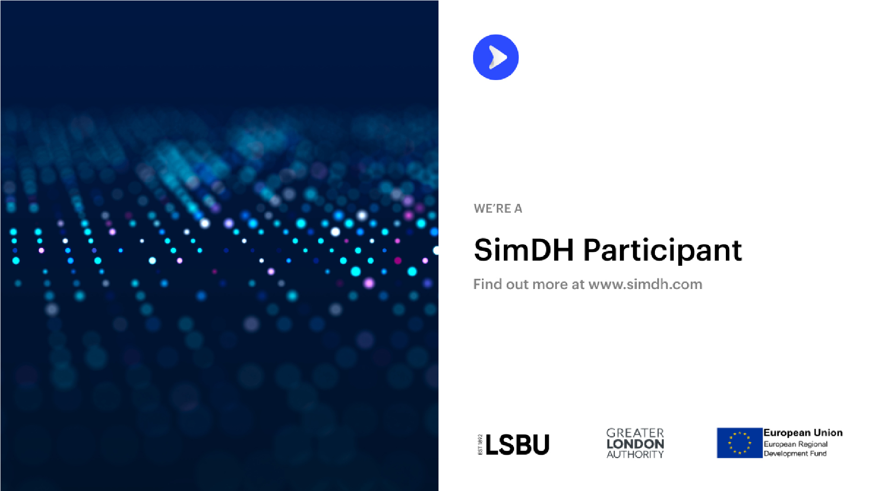

2. Linkedin, Instagram & Facebook

We're proud to announce that we're joining SimDH's third cohort!

We are one of 25 healthtech SMEs, covering the areas such as:
- Sport
- Maternity, Parenting and Education
- Diagnostics
- LGBTQ+ Mental Health Support
- Holistic medicine and wellness
- Nutrition
- Artificial Intelligence
- Pain Management
- Medical Imaging

SimDH (Simulation for Digital Health) is an ERDF-funded programme from London South Bank University. It aims to fast-track London-based digital health startups through to the next stage of their journey.

The cohort programme involves five months of webinars, consultancy, mentoring and support.

Find out more about the programme and the cohort at: www.simdh.com

