SimDH Social Media Posts:

Please link to the SimDH website: www.simdh.com

1.Twitter

We're proud to announce that we're joining SimDH's Cohort 2!
SimDH is a health tech accelerator programme from @LSBU_REI, match-funded by European Regional Development Fund.
Find out more about the programme and the cohort at www.simdh.com

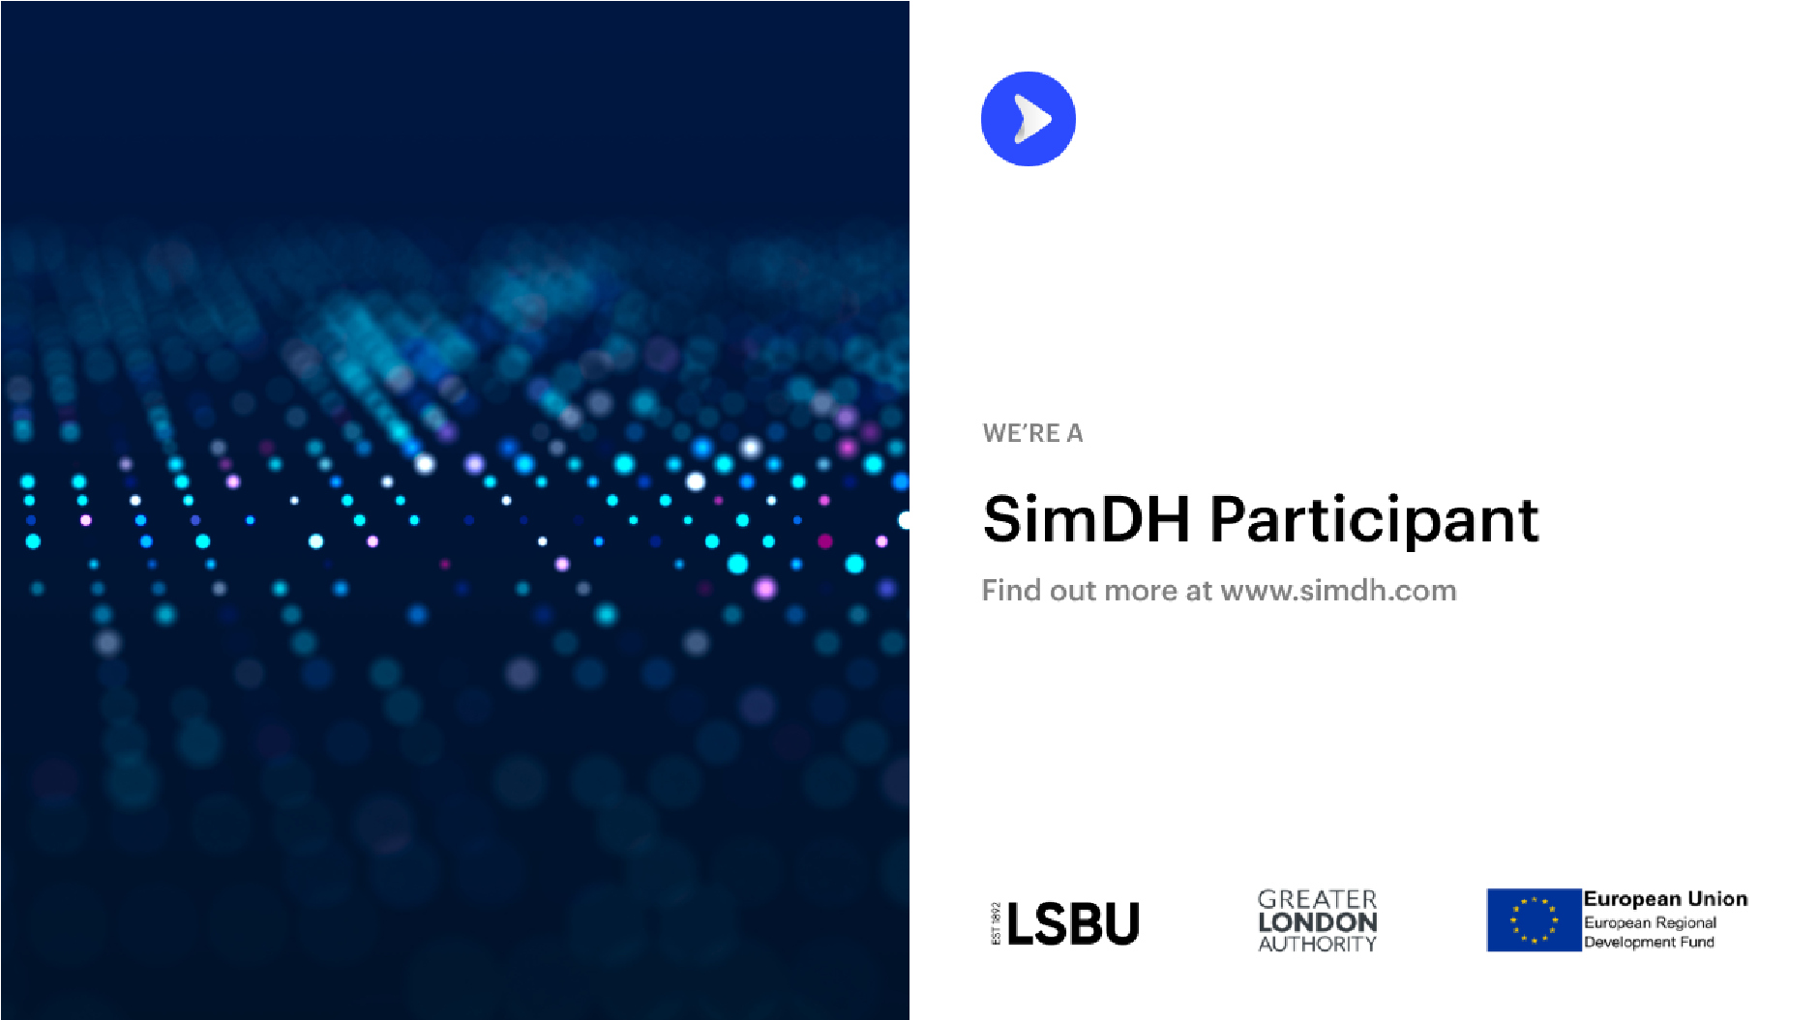

2. Linkedin, Instagram & Facebook

We're proud to announce that we're joining SimDH's second cohort!

We are one of 17 SMEs accepted onto the programme, covering the areas of:
- Diagnostic Tools
- Family Planning
- Mental Health
- Paediatric care
- Medical Training
- Management of Long Term Health Conditions
- Remote healthcare and telemedicine

SimDH (Simulation for Digital Health) is an ERDF-funded programme from London South Bank University. It aims to fast-track London-based digital health startups through to the next stage of their journey.

The cohort programme involves five months of webinars, consultancy, mentoring and support.

Find out more about the programme and the cohort at: www.simdh.com

