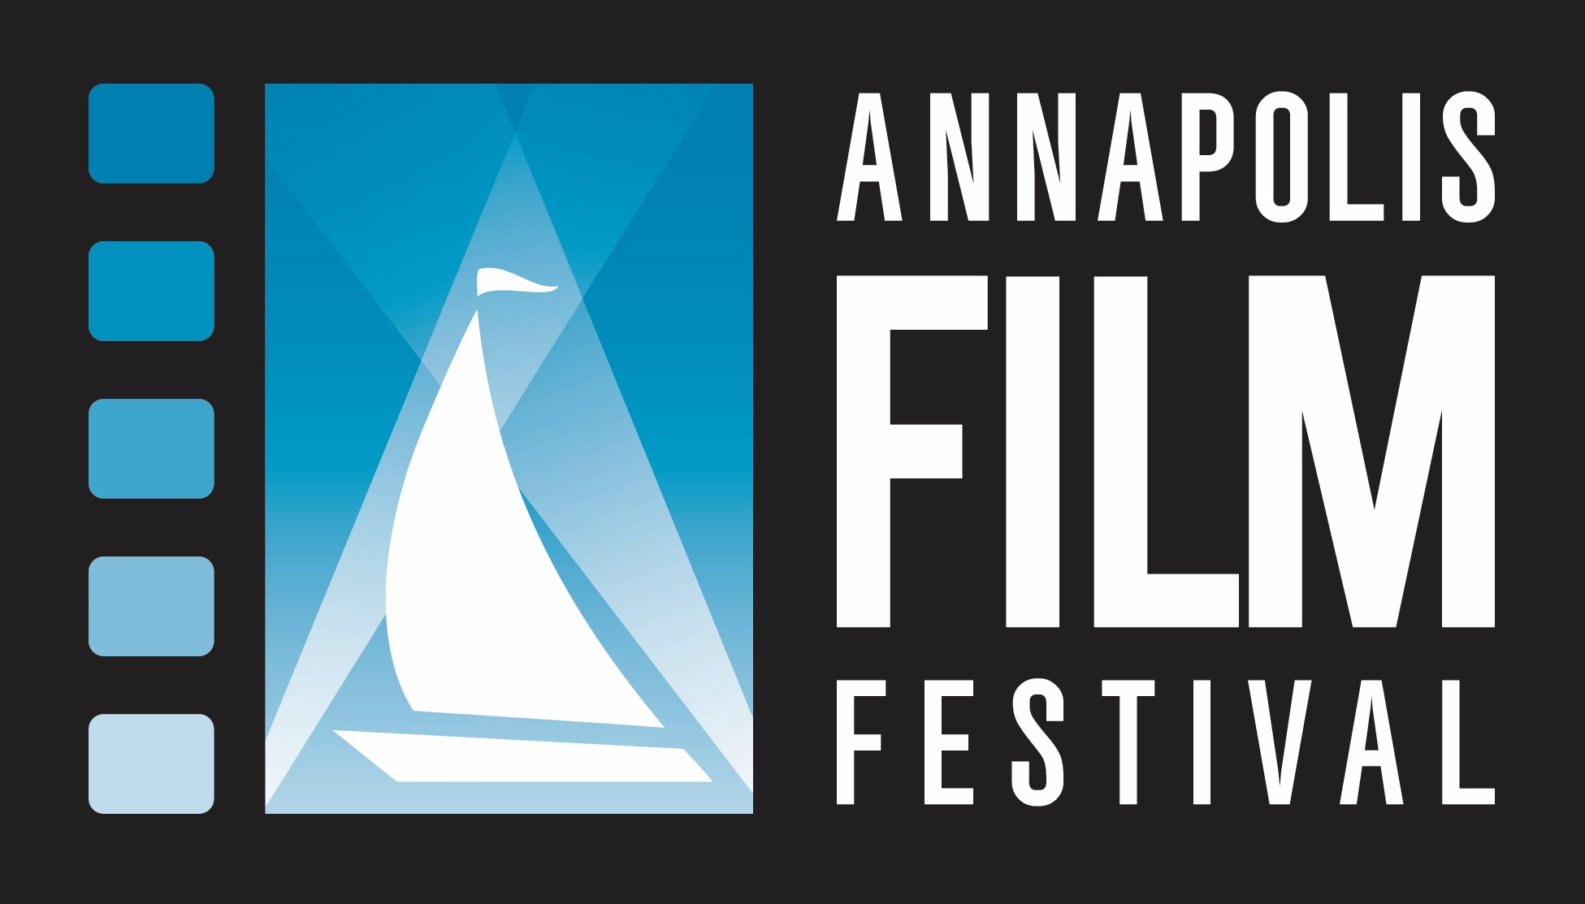
2021 AFF Underwriting Sponsorship

Company/Individual Name:
(Please print name as you would like it listed in the program and onscreen.)

Contact Name: _________________________________________________________________________________
Address: ______________________________________________________________________________________
City: __________________________________________ State: _______________ Zip: _________________
Email address(es): ______________________________________________________________________________
Cell Phone: __________________________________ Work or Home: ______________________________

I/We will underwrite the following:
☐ $10,000 Opening Night ☐ $2,500 Spotlight Film
Name of Film: _____________________________________
☐ $5,000 Showcase
- African American Experience ☐ $1,500 Feature Film
- Diversity Name of Film: _____________________________________
- Environmental
- Jewish Experience ☐ $500 Short Film
- Sailing/Boating Name of Film: _____________________________________

Total: ____________________

NAME OF FILM: (if known)_____________________________________________________________
Enclosed is my check payable to Annapolis Film Festival, Inc. in the amount of $__________________________

Sign:________________________________________ Date: __________________________

Please print name: ____________________________________

Annapolis Film Festival, Inc. is a 501(c)(3) organization, EIN #36-4730103. Donations in excess of the value of goods or services provided by AFF are tax deductible to the extent provided by applicable law.

Completed forms should be sent via mail or email as soon as possible but no later than February 26, 2021 to:
2021 Annapolis Film Festival
Attn: Patti White or Lee Anderson
107 Annapolis Street, Suite J
Annapolis, MD 21401
Phone: 410.263.3444
Email: support@annapolisfilmfestival.net

