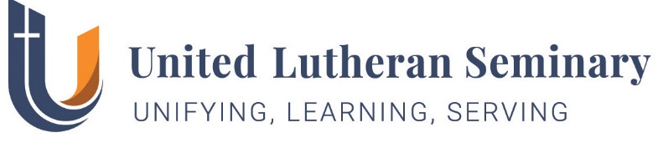

Office of Contextual Formation
Webpage: http://my.uls.edu/contextual-formation/
Dates To Remember Regarding Ministerial Immersion
(Internship)

(1) | Video Orientation Session for Ministerial Immersion  for Students from Traditions Other Than Lutheran | Available online
 | (YouTube Link)
(2) | Orientation Session for ELCA Ministerial Immersion Students – both campuses  (Zoom Meeting) | Monday, November 18, 2019  3:00pm-4:00pm  Gettysburg – Valentine 314 Philly – Brossman 320
(2) | Deadline for Student Horizon International  Paperwork, due directly to Global Mission/ ELCA | October 30, 2019
(3) | Deadline for Regular Student Internship applications to the Contextual Formation Office | September 15th, annually
(4) | Deadline for Church/Site Applications  ELCA Congregational Application for an Intern | January 31st, annually
(5) | Discussion of Matching Workshop for Students.  Spouses, partners & significant others welcome.  (Zoom Meeting) | Monday, February 3rd  6:00 pm-Val. 314/Brossman 320
(6) | Internship Matching Workshop (Students/Pastors/ Lay Persons) - Gettysburg campus | Thurs/Fri, February 20-21, 2020
(7) | Announcement of Assignments | Approx. March 30, 2020
(8) | Team-Building Workshop (Students/Supervisors) Location: Philadelphia Campus, ULS | Wednesday, May 20, 2020

