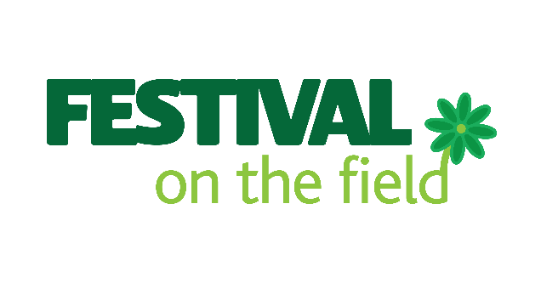

PRESS RELEASE

FOR IMMEDIATE RELEASE – 08.00 25TH MARCH

Festival on the Field 2020 – POSTPONED TO JULY 3RD 2021

For very obvious reasons Festival on the Field 2020 has been postponed.

We will hold the Festival NEXT YEAR on SATURDAY JULY 3rd.

As has been made clear in previous announcements, all tickets will be valid for next year’s event and we hope very much that you will continue to support us by holding onto your tickets and saving the date for next year. However, if you are unable to attend, please email us and we will issue a full refund. This may take a bit of time so please bear with us.

We are living in ‘interesting’ times – let’s hope we can all enjoy a great Festival in 2021 when the times are a bit less interesting.

We wish you all good health and wellbeing and look forward to celebrating together next year.

From: The Festival on the Field Committee

Email: festivalonthefield@gmail.com

For more information please contact festivalonthefield@gmail.com

