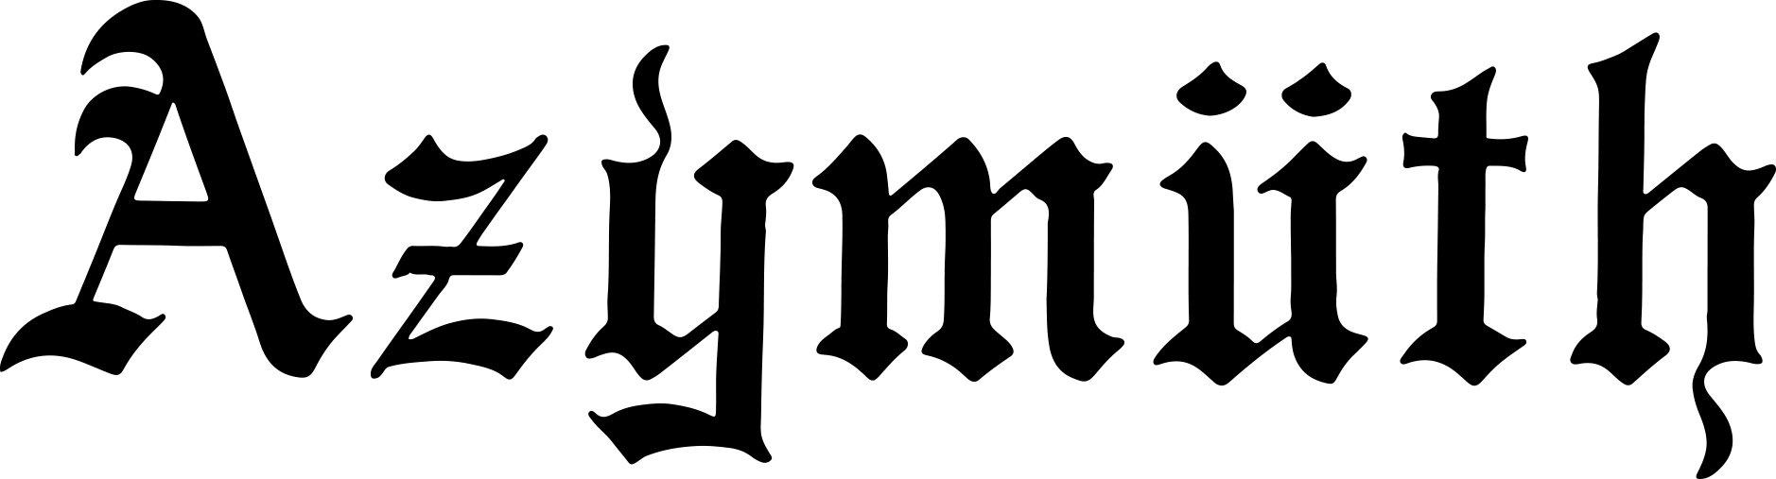
50th ANNIVERSARY TOUR

“Samba jazz legends” MOJO
"Innovators in dance/world fusion" Billboard
"Dance music played by human beings rather than computers, fantastic" Sunday Times
"Azymuth are crate-digger favourites evangelised by indie hip-hop producer Madlib" UNCUT
“Brazilian cult trio” Q
“Arguably the most successful band to come out of Brazil…you’re in the hands of masters.” Songlines

Celebrating an astounding 50 year career, the legendary Brazilian jazz-funk trio AZYMUTH will tour Europe in Summer 2023!

Responsible for carving out an entirely new sound, fusing jazz-funk with samba to create their own unique genre, referred to as ‘samba doido’, Azymuth are one of Brazil’s most influential bands and surely one of the world’s longest running.

They have played with just about everyone throughout Brazil’s golden era of MPB, jazz, soul and funk, including Jorge Ben, Milton Nascimento, Tim Maia, Elis Regina and Marcos Valle to name just a few. Indeed it was Marcos Valle who gave Azymuth their name in 1973 during the recordings of his soundtrack for the film O Fabuloso Fittipaldi. In that same year, Azymuth began recording their now critically acclaimed Demos (1973-75) which sat in their archives until 2019 when they were released by London based label Far Out Recordings.

50 years since they began, Azymuth have released over thirty albums and are still going as strong as ever, writing, recording and performing with the same energy and enthusiasm as when they started out.

As well as their influence on jazz and funk, Azymuth’s contribution to electronic music around the globe is unquestioned, and they’ve collaborated with the likes of 4hero, Madlib and Jazzanova, and been remixed by Theo Parrish, Ron Trent, Global Communication and Daniel Maunick amongst others.

Since the passing of keyboard maestro Jose Roberto Bertrami in 2012, remaining members Ivan Conti and Alex Malheiros have worked tirelessly to keep the spirit of Azymuth alive, enlisting keyboardist Kiko Continentino (Milton Nascimento, Gilberto Gil, Djavan), who co-wrote and recorded Azymuth’s critically acclaimed 2016 album Fenix.

An Azymuth live show is a journey through the full spectrum of their brilliantly coloured expressionist funk, with all the cosmic energy and masterful musicianship you’d expect from the world's greatest three-man orchestra.

AZYMUTH LIVE VIDEOS:
‘JAZZ CARNIVAL @ DEKMANTEL FESTIVAL (Instagram)’
‘JAZZ CARNIVAL @ BOILER ROOM’
‘DEAR LIMMERTZ @ NEW MORNING’

LISTEN TO AZYMUTH ON:
SPOTIFY
YOUTUBE

BOOKINGS:
joe@faroutrecordings.com

