Margarita
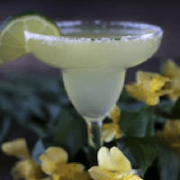

Martini
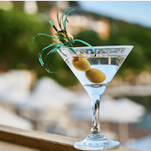

Ingredients
- 2 oz. tequila
- 1 oz. Cointreau
- 1 oz. lime juice
- 1 lime slice
- 1 pinch salt (for rim)

Preparation
- Coat rim of glass with salt and fill with ice
- Add tequila, Cointreau, lime juice, and ice to a shaker
- Shake
- Strain into glass
- Garnish with slice of lime

Ingredients
- 3 oz. gin
- 1.5 oz. dry vermouth
- 1 speared olive or lemon twist

Preparation
- Pour gin and vermouth into a mixer with ice cubes, stir
- Strain into a chilled martini glass
- Garnish with an olive or lemon twist

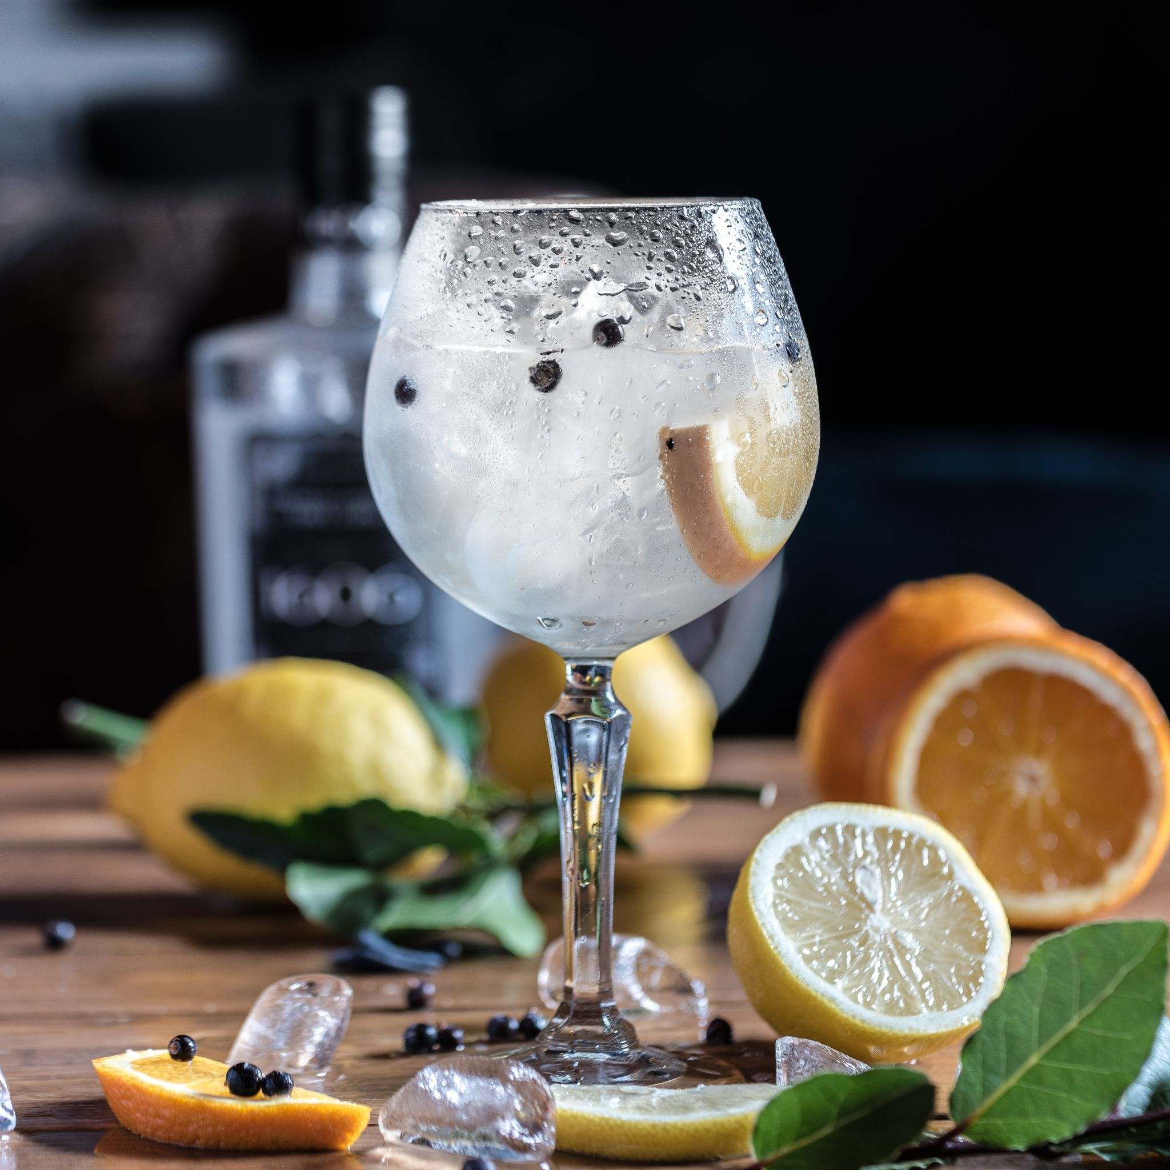
Gin and Tonic

Old-Fashioned
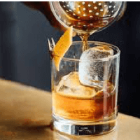

Ingredients
- 2 oz. gin
- 4-6 oz. tonic water
- Lime wedge

Preparation
- Fill highball glass with ice
- Pour gin, then top with tonic to taste
- Gently stir, then garnish with lime wedge

Ingredients
- 1.5 oz. bourbon whiskey
- 1 sugar cube
- 2 dashes Angostura bitters
- 1 teaspoon water
- 1 orange slice or cherry

Preparation
- Place sugar cube in an old-fashioned glass and cover in bitters
- Add a teaspoon of water, muddle until sugar cube dissolved
- Fill glass with ice, add whiskey
- Garnish with orange slice or cherry

Bloody Mary
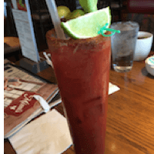

Ingredients
- 2 oz. vodka
- 6 oz. tomato juice
- 1 tablespoon ground horseradish
- 2 dashes hot sauce
- 2 dashes Worcestershire sauce
- 1 pinch celery salt
- 1 pinch ground black pepper
- 1 lemon slice
- 1 celery stalk
- 2 speared green olives

Preparation
- Coat the rim of a highball glass with celery salt and fill with ice
- Squeeze lemon juice into shaker, add vodka, tomato juice, horseradish, hot sauce, Worcestershire sauce, and black pepper and shake with ice
- Strain shaker into highball glass
- Garnish with a celery stalk and green olive spear

