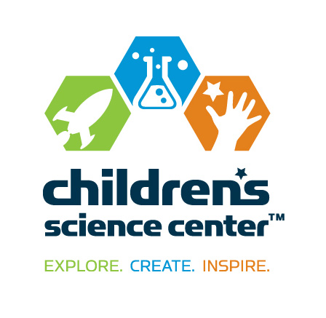
CONTACT:
Vicki Bendure
540-687-3360 o/202-374-9259 c
Vicki@Bendurepr.com

NEWS
FOR IMMEDIATE RELEASE

Brian Snodgrass Joins Children’s Science Center Board of Directors

DULLES, Va., Aug. 20, 2015—Tanya La Force, chairman of the board of the Children’s Science Center, announced the appointment of Brian Snodgrass to the board of directors.

Snodgrass is director of programs with Northrop Grumman Information Systems and is responsible for information technology system and service deployment supporting federal customer programs. Prior to this role, he was responsible for overseeing IT service delivery and program operations for the Commonwealth of Virginia. His background includes work as an executive director of New York City’s Department of Information Technology and Telecommunications Wireless Technologies Division, and he spent more than 10 years working for Nextel Communications.

“We are fortunate to have Brian join the board of directors,” said La Force. “Brian's professional and non-profit experience combined with his dedication to inspire all children to love STEM learning will benefit this project tremendously.”

The Children’s Science Center recently opened the Children’s Science Center Lab at Fair Oaks Mall, becoming Northern Virginia’s first interactive museum where children, families and school groups can explore science, technology, engineering, and mathematics (STEM) concepts through fun, engaging hands-on exhibits, activities and programs.

Snodgrass has a Bachelor’s of Science in electrical engineering and a Master’s of Science in computer engineering from Manhattan College and an MBA from Columbia University.

He resides in Ashburn, Va. with his wife and two children. He is a foundation board member and active with Virginia FIRST, the regional organization responsible for the FIRST Robotics Competition in Md., D.C. and Va.

About the Children’s Science Center:
The Children’s Science Center’s mission is to instill a love of learning science, technology, engineering, and mathematics (STEM) in all children by providing unique opportunities to explore, create and be inspired. The Children’s Science Center Lab is located at Fair Oaks Mall and is Northern Virginia’s first interactive museum where children, families and school groups can explore STEM concepts through fun, engaging hands-on exhibits, activities and programs. In addition to the Lab and community programs, the Center is working to fulfill the vision of a full-scale, world-class children’s science museum to be located in Dulles, VA. The Children’s Science Center is a 501 (c)(3) non-profit organization. Learn more at www.childsci.org.
# # #

