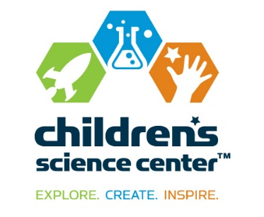  NEWS  FOR IMMEDIATE RELEASE | CONTACT:  Dorothy Ready  Children’s Science Center  703-963-6699  media@childsci.org  Vicki Bendure  540-687-3360 o/202-374-9259 c  Vicki@Bendurepr.com
Booz Allen Hamilton Sponsors Children’s Science Center Lab

FAIRFAX, Va., July 29, 2015 –- The Children’s Science Center announced today that Booz Allen Hamilton has awarded a signature exhibition sponsorship to the Children’s Science Center Lab located at Fair Oaks Mall. “The Children’s Science Center is excited for this new leadership gift from one of the region’s largest and most influential employers,” stated Children’s Science Center Executive Director, Nene Spivy.

This gift from Booz Allen Hamilton will assist with the capital needs of the Lab build-out as well as fund a future exhibit, the Robotic Arm, to be unveiled in summer 2016.

Recently opened, the 5,400 sq. ft. Lab at Fair Oaks Mall is the region’s first interactive museum where families and school groups can explore STEM concepts through hands-on exhibits, activities, and programs. The site’s experience zones include: Inspiration Hub, Tinker Shop, Experiment Bar, Discovery Zone and a multipurpose program space called the Garage.

"At the heart of much of our business and our future strategy is the application of STEM to our clients' toughest challenges," says Joe Sifer, executive vice president and leader of Booz Allen's engineering and science business thrust. "We are committed to STEM as a first principal in our business and for our future. As such, our enthusiasm for and support of early STEM education goes well beyond altruism and community support; it is essential to our business model and aspirations."

“The Children’s Science Center is grateful to Booz Allen Hamilton for their leadership and support as we open our first physical museum site this summer at the Lab,” added Spivy. “We appreciate Booz Allen Hamilton’s commitment to STEM education in Northern Virginia, and in particular in recognizing the potential to deepen our relationship with the community and bring future exhibits to the Lab in 2016.”

About the Children’s Science Center:
The Children’s Science Center’s mission is to instill a love of learning STEM in all children by providing unique opportunities to explore, create and be inspired. The Children’s Science Center Lab is located at Fair Oaks Mall and is Northern Virginia’s first interactive museum where children, families and school groups can explore science, technology, engineering, and mathematics (STEM) concepts through fun, engaging hands-on exhibits, activities and programs. In addition to the Lab and community programs across the region, the Center is working to fulfill the vision of a full-scale, world-class children’s science museum to be located in Dulles, Va. The Children’s Science Center is a 501 (c)(3) non-profit organization. Learn more at www.childsci.org.

About Booz Allen Hamilton

Booz Allen Hamilton has been at the forefront of strategy and technology for more than 100 years. Today, the firm provides management and technology consulting and engineering services to governments in the civil, defense, and intelligence markets, global corporations, and not-for-profit organizations. Booz Allen partners with private and public sector clients to solve their most difficult challenges. Headquartered in McLean, Virginia, the firm employs more than 22,500 people globally, and had revenue of $5.27 billion for the 12 months ended March 31, 2015. To learn more, visit www.boozallen.com. (NYSE: BAH)

# # #

