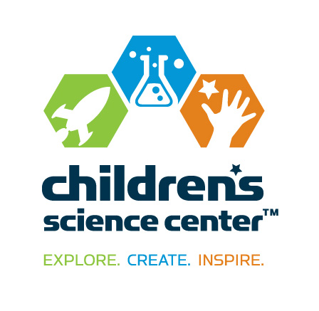
CONTACT:
Vicki Bendure
540-687-3360 o/202-374-9259 c
Vicki@Bendurepr.com

NEWS
FOR IMMEDIATE RELEASE

Susan Carroll Joins Children’s Science Center Board

DULLES, VA, July 29, 2015—Nene Spivy, executive director of the Children’s Science Center, announced the appointment of Susan Carroll to the board of directors.

Carroll is the chief executive officer of Inova Alexandria Hospital. Prior positions included serving as vice president of Inova Cancer Institute and Inova Translational Medicine Institute. She has been in healthcare management for 18 years and with Inova since 1998.

“We are delighted to announce that Susan is joining our board,” stated Spivy. “Susan brings a wealth of management and organizational skills as well as science and medical knowledge to our organization. She will be a great asset to the organization at-large as well as our new science lab.” The Children’s Science Center recently opened a Lab at Fair Oaks Mall that is Northern Virginia’s first interactive museum where children, families and school groups can explore science, technology, engineering, and mathematics (STEM) concepts through fun, engaging hands-on exhibits, activities and programs.

Carroll has a master’s in health management and an MBA. She has been awarded the status of Fellow in the American College of Healthcare Executives, the highest certification given to healthcare leaders. She is an advocate for cancer prevention and outreach. In 2012, she was awarded the Champion Award by the National Cherry Blossom Breast Cancer Society.

Carroll resides in Ashburn, VA with her husband and two children. She enjoys traveling, skiing and spending time with her family.

About the Children’s Science Center:
The Children’s Science Center’s mission is to instill a love of learning science, technology, engineering, and mathematics (STEM) in all children by providing unique opportunities to explore, create and be inspired. The Children’s Science Center Lab is located at Fair Oaks Mall and is Northern Virginia’s first interactive museum where children, families and school groups can explore STEM concepts through fun, engaging hands-on exhibits, activities and programs. In addition to the Lab and community programs, the Center is working to fulfill the vision of a full-scale, world-class children’s science museum to be located in Dulles, VA. The Children’s Science Center is a 501 (c)(3) non-profit organization. Learn more at www.childsci.org.

# # #

