DIFFERENT FLUIDS FOR TRANSFORMER COOLING

By Subhas Sarkar and John K. John
Virginia Transformer Corp.

Introduction
In liquid filled transformers, the liquid performs two major functions, namely as a dielectric and as the cooling medium. The choice of the liquid is based on the combined performance on both these factors.
Another important criterion is the fire hazard. Fire hazard issues are more prominent in indoor installations. Liquids with high flash point represent less fire hazard and their use in transformers results in less insurance rate. For outdoor installations, the problem of fire hazard is less severe and thus the choice of cooling fluid is wider.

(1) Fire point and Flash Point:
(a) Fire Point: The fire point of a liquid is the temperature at which it will continue to burn after ignition for at least 5 seconds. NEC 450-23 requires “less flammable liquids” to have Fire point more than 300 C. Conventional mineral oil does not meet this requirement. See table 1 for comparative data.
(b) Flash point: The flash point of a flammable liquid is the lowest temperature at which it can form an ignitable mixture in air. At this temperature the vapor may cease to burn when the source of ignition is removed.
(2) Other important Technical properties:--

(a) Dielectric Strength of an insulating material, the maximum electric field strength that it can withstand intrinsically without breaking down. This is an important electrical property for the insulating liquid. The solid insulation (like paper or pressboard) when impregnated with the liquid offers a better dielectric property than the original material. A higher dielectric strength of the liquid makes the overall insulation system better.
(b) Dissipation Factor (“power factor”): An “ideal” insulating material would not dissipate any power within itself. But all practical insulating materials do dissipate a small amount of energy as heat. Thus the dissipation factor measures the “inefficiency” of an insulating material; a lower factor means a better insulator. Dissipation factor is a significant indicator of contamination or deterioration. Dissipation factor is temperature dependent. Dissipation factor is sometimes popularly called “power factor”.

(c) Viscosity: Viscosity describes a fluid's internal resistance to flow and may be thought of as a measure of fluid friction. In everyday terms, viscosity is "thickness". Thus, water is "thin"; having a lower viscosity, while honey is "thick" having a higher viscosity. The efficiency of cooling depends on fluid flow within the transformer and also through the cooling equipments like radiators. Therefore, a liquid with low viscosity is better for improved cooling (heat and mass transfer).

Table 1

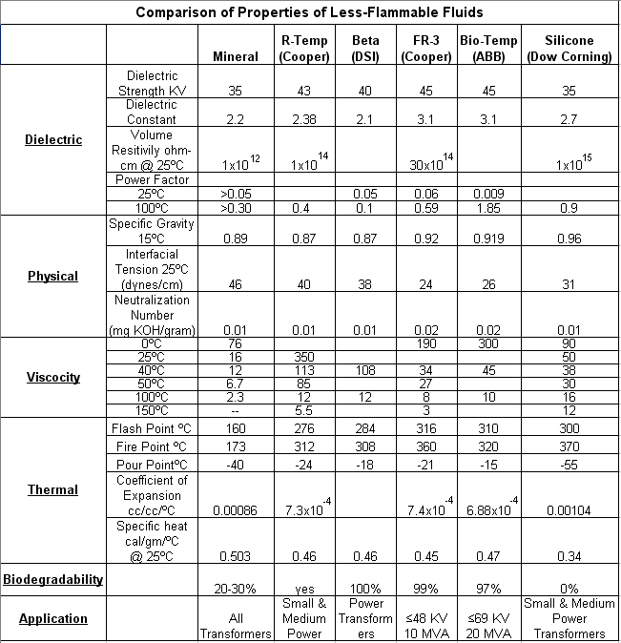

(3) Important features of the major fluids:
Though many different liquids were available in the market at various times, many of them (including R-Temp recently) were withdrawn for various reasons. Today there are four generally accepted liquids, namely: Mineral oil, Silicone, Beta fluid and Envirotemp (FR3). Another fluid, Bio-temp is somewhat similar to FR3.

(a) Mineral Oil: It has been used as the dielectric fluid for several generations of transformers. It has a longstanding record of good performance and low costs. It is considered a top choice for transformers for outdoor installations. It has very good dielectric and thermal performance. In fact, most of the norms for liquid filled transformers have been based on mineral oil.
However, mineral oil is considered to be a flammable liquid and therefore, suffers from certain restrictions on its use and containment

(b) Silicone fluid: For several decades this was the preferred fluid when a “less-flammable” liquid was required. It has a relatively high fire point and is generally self-extinguishing when the source of ignition is removed. Silicone has been used for many years in indoor applications, generally in vaulted areas.
However, at high temperatures silicone can produce some chemicals which can be a health hazard.
Also, it is the most expensive insulating fluid.

(c) Beta Fluid: It is a blend of petrochemical oils and is 100% hydrocarbon. It has a fire point which is higher than mineral oil, thus qualifying as “less-flammable” liquid. However, its fire point is lower than either silicone or Envirotemp (FR3).
Also, it is more expensive than mineral oil.

(d) Envirotemp (FR3): It is a soy-based natural ester dielectric fluid which meets the requirements of “less-flammable” liquid. It is bio-degradable and is environment friendly. Cooper Power system claims that FR3 can extend the insulation life by drawing out moisture from paper insulation.
The heat transfer properties are inferior to that of mineral oil and transformers have to be suitably designed for that, adding to cost. Also, certain precautions are needed during manufacture when using this liquid. It is much costlier than mineral oil and makes the initial cost of the transformer higher.
The inherent dissipation factor of FR3 is higher than mineral oil and as a result the power factor of the whole transformer with FR3 is higher than one with mineral oil. The existing norms for acceptance for power factor of a new transformer are based on mineral oil and cannot be met with FR3.
This fluid is still more expensive than Beta Fluid.

(4) Mixing, contamination, retro-filling.
(a) Envirotemp with mineral oil: FR3 is fully miscible with mineral oil. However, mineral oil content greater than 7% in FR3 will lower the fire point below 300 C.
(b) Silicone is miscible with mineral oils. Even a small amount of contamination of silicone in mineral oil can cause foaming while degassing/ reclaiming.
A 5% mineral oil content in silicone drastically lowers the flash point by as much as 90C.
Silicone fluid must not come in contact with any silicone rubber seals or gaskets, as the latter gets affected by silicone fluid.
- Beta fluid is fully miscible with mineral oil. However, the fire point becomes affected severely if the amount of mineral oil in Beta fluid is more than 4%.
(d) There have been reports that a large number of transformers have been retro-filled with FR3. Some of these are in medium power range in terms of size.

(5) Exposure and precautions. :
If a core & coil soaked in FR3 is exposed to oxygen at elevated temperature, it polymerizes to form an irreversible film, which results in higher power factor. This is particularly important when a soaked core & coil is heated in an air-drying oven.

(6) Handling and Storage: Biodegradability:
From environmental and health point of view, the liquids should have the following properties: essentially non-toxic, non-hazardous, re-conditionable, chemically inert, having low-risk thermal by-products.
Mineral oil is also biodegradable: 30 % biodegradation in 21 days
Some states require removal and replacement of soil in which mineral oil was spilled.

(7) Reference to applicable standards
(a) NEC code 450-23. : This deals with Less-Flammable Liquid-Insulated Transformers:
Part A Indoor Installations
Part B Outdoor Installations
(b) ASTM D92: gives the method of testing Fire Point.

(8) Design precautions & Cost impact;
(a) Since silicone fluid is more viscous than mineral oil, it results in higher winding gradients and lesser heat dissipation by radiators.
(b) Beta fluid is even more viscous than silicone. The thermal characteristics are slightly lower than mineral oil.
(c) The thermal characteristics of Envirotemp FR3 are somewhat inferior. It requires some design modifications compared to mineral oil. If retro-filled, a FR3 filled transformer will run a few degrees hotter.
(d) Approximate Price Comparison:
The relative price of various fluids compares to Mineral Oil to a base of 1.0.
Table 2
Mineral Oil | 1.0
Beta Fluid | 4.0
FR3 | 5.0
Bio-Temp | 6.0
Silicone | 7.0

(9) Application in LTC’s,
Since most of the tap-changers were developed historically for mineral oil transformers, it is necessary to check with the manufacturer of the LTC if it can be filled with the other liquids. At this time, Reinhausen (MR) does allow some restricted use of Envirotemp fluid in their LTC’s.

(10) DETC’s: It is necessary to check the suitability of the particular DETC for a given fluid. Some types of DETCs can develop bad contact resistance when used in silicone fluid. In this context, the reader may refer to the work done in the IEEE task force headed by Phil Hopkinson.

(11) Application in cold temperatures:
Liquids like Silicone and Beta fluids show high viscosity at low temperatures, thus making it difficult to flow through the windings and the radiators.
The parameter to watch for low temperature is Pour Point, which is the temperature at which the liquid starts to gel and becomes very viscous.
There are special oils available which is suitable for operation at very low temperatures, like – 50 C.
However, if a transformer has been stored (unexcited) at a cold temperature, it is some times necessary to “thaw” the liquid before it can be electrically energized.

================ X ====================== X ==================

